**Name______________**

**Mitosis questions - recap /22**

**Q1.**

This question is about the cell cycle.

(a)  Chromosomes are copied during the cell cycle.

Where are chromosomes found?

Tick **one** box.

|  |  |
| --- | --- |
| Cytoplasm |  |
| Nucleus |  |
| Ribosomes |  |
| Vacuole |  |

**(1)**

(b)  What is the name of a section of a chromosome that controls a characteristic?

___________________________________________________________________

**(1)**

**Figure 1** shows information about the cell cycle.

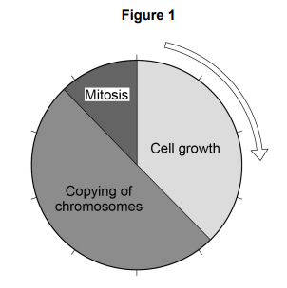

(c)  Which stage of the cell cycle in **Figure 1** takes the most time?

Tick **one** box.

|  |  |
| --- | --- |
| Cell growth |  |
| Copying of chromosomes |  |
| Mitosis |  |

**(1)**

(d)  During mitosis cells need extra energy.

Which cell structures provide most of this energy?

Tick **one** box.

|  |  |
| --- | --- |
| Chromosomes |  |
| Cytoplasm |  |
| Mitochondria |  |
| Ribosomes |  |

**(1)**

(e)  The cell cycle in **Figure 1** takes two hours in total.

The cell growth stage takes 45 minutes.

Calculate the time taken for mitosis.

___________________________________________________________________

___________________________________________________________________

___________________________________________________________________

___________________________________________________________________

Time = ____________________ minutes

**(2)**

**Figure 2** shows some cells in different stages of the cell cycle.

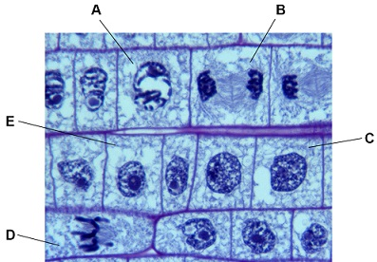

(f)   Which cell is **not** dividing by mitosis

Tick **one** box.



**(1)**

(g)  Cell **E** in **Figure 2** contains 8 chromosomes.

Cell **E** divides by mitosis.

How many chromosomes will each new cell contain?

Tick **one** box.

|  |  |
| --- | --- |
| 2 |  |
| 4 |  |
| 8 |  |
| 16 |  |

**(1)**

(h)  Why is mitosis important in living organisms?

Tick **one** box.

|  |  |
| --- | --- |
| To produce gametes |  |
| To produce variation |  |
| To release energy |  |
| To repair tissues |  |

**(1)**

**(Total 9 marks)**

**Q2.**

**Figure 1** shows a human cheek cell viewed under a light microscope.

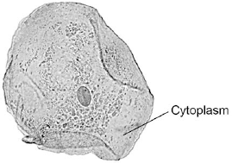

© Ed Reschke/Photolibrary/Getty Images

(a)     Label the nucleus **and** cell membrane on **Figure 1**.

**(2)**

(b)     Cheek cells are a type of body cell.

Body cells grow through cell division.

What is the name of this type of cell division?

|  |  |
| --- | --- |
| Tick **one** box. |  |
| Differentiation |  |
| Mitosis |  |
| Specialisation |  |

**(1)**

**Q3.**

**Figure 1** shows photographs of some animal cells at different stages during the cell cycle.

**Figure 1**

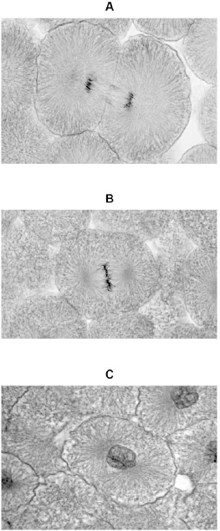

(a)     Which photograph in **Figure 1** shows a cell that is **not** going through mitosis?

Tick **one** box.

|  |  |  |  |  |  |  |  |  |
| --- | --- | --- | --- | --- | --- | --- | --- | --- |
|  | **A** |  |  | **B** |  |  | **C** |  |

**(1)**

(b)     Describe what is happening in photograph **A**.

___________________________________________________________________

___________________________________________________________________

___________________________________________________________________

___________________________________________________________________

___________________________________________________________________

**(2)**

(c)     A student wanted to find out more about the cell cycle.

The student made a slide of an onion root tip.

She counted the number of cells in each stage of the cell cycle in one field of view.

The table below shows the results.

|  |  |  |  |  |  |  |  |
| --- | --- | --- | --- | --- | --- | --- | --- |
|  |  |  | **Stages in the cell cycle** | | | |  |
|  |  | **Non-dividing cells** | **Stage 1** | **Stage 2** | **Stage 3** | **Stage 4** | **Total** |
|  | **Number of cells** | 20 | 9 | 4 | 2 | 1 | 36 |

Each stage of the cell cycle takes a different amount of time.

Which stage is the fastest in the cell cycle?

Give a reason for your answer.

Stage _____________________

Reason ____________________________________________________________

___________________________________________________________________

**(2)**

(d)     The cell cycle in an onion root tip cell takes 16 hours.

Calculate the length of time **Stage 2** lasts in a typical cell.

Give your answer to 2 significant figures.

___________________________________________________________________

___________________________________________________________________

___________________________________________________________________

___________________________________________________________________

Time in **Stage 2** = ________________________ minutes

**(3)**

**(Total 9 marks)**

**Q4.**

**Diagram 1** shows the nucleus of a body cell as it begins to divide by mitosis.

**Diagram 1**

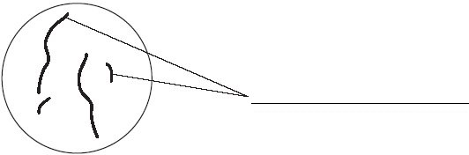

(a)     Use a word from the box to label **Diagram 1**.

|  |
| --- |
| **alleles**             **chromosomes**             **gametes** |

**(1)**

(b)     Complete **Diagram 2** to show what the nucleus of one of the cells produced by this mitosis would look like.

**Diagram 2**

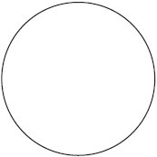

**(1)**

Mark schemes

**Q1.**

(a)  nucleus

**1**

(b)  gene(s)

*allow allele(s)*

**1**

(c)  copying of chromosomes

**1**

(d)  mitochondria

**1**

(e)  60 − 45

**or**

120 − 105

**1**

15 (minutes)

**1**

*an answer of 15 (minutes) scores* ***2*** *marks*

(f)   C

**1**

(g)  8

**1**

(h)  to repair tissues

**1**

**[9]**

**Q2.**

(a)     nucleus labelled correctly

**1**

cell membrane labelled correctly

**1**

(b)     mitosis

**1**

(c)     electron (microscope)

**1**

(d)     higher magnification

**1**

(e)     45 (mm)

**1**

45 / 250 **or** 0.18 (mm)

*allow ecf*

**1**

180 (µm)

**1**

*allow 180 (µm) with no working shown for* ***3*** *marks*

(f)     0.2 µm

**1**

**[9]**

**Q3.**

(a)     **C**

**1**

(b)     cytoplasm **and** cell membrane dividing

*accept cytokinesis for* ***1*** *mark*

**1**

to form two identical daughter cells

**1**

(c)     stage 4

**1**

only one cell seen in this stage

**1**

(d)     (4 / 36) × 16 × 60

**1**

107 / 106.7

**1**

110 (minutes)

*allow 110 (minutes) with no working shown for* ***3*** *marks*

**1**

(e)     binary fission

*do* ***not*** *accept mitosis*

**1**

(f)     shortage of nutrients / oxygen

**1**

so cells die

**or**

death rate = rate of cell division

**1**

**[11]**

**Q4.**

(a)     chromosomes

**1**

(b)     diagram showing four separate chromosomes two long and two short  
(as in diagram 1)

*allow each chromosome shown as two joined chromatids  
do* ***not*** *allow if chromosomes touching each other*

**1**

(c)     (i)      any **two** from:

•        can grow into any type of tissue / named tissue

•        used in medical research

•        used to treat human diseases

•        large numbers can be grown

**2**

(ii)     any **two** from:

•        expensive

•        grow out of control / ref cancers

•        may be rejected

•        need for drugs (for rest of life)

**2**

**[6]**

**Q5.**

(a)     23

**1**

(b)     chromosome     nucleus      gene     cell

2                    3             1          4

**1**

(c)     (i)      any **one** from

(cells which are bigger) take up more space

(cells) have to get bigger **or** mature to divide

**1**

(ii)     chromosomes duplicate **or**make exact copies of self

*accept forms pairs of chromatids*

**1**

nuclei divide

*accept chromatids* ***or****chromosomes separate*

**1**

identical (daughter) cells formed

*accept for example, skin cells make  
more skin cells* ***or*** *cells are clones*

**1**

(d)     any **two** from

*Differentiation mark*babies need **or** are made of different types of cells **or** cells that have  
different functions

*accept different cells are needed  
for different organs*

*Division or specialisation mark*as fertilised egg starts to divide each cell specialises to form a part of the body

*accept specialised cells make  
different parts of the body*

*Growth mark*specialised cells undergo mitosis to grow further cells

*accept cells divide* ***or*** *reproduce  
to form identical cells*

**2**

**[8]**