

**Foundation IGCSE (9 – 1) Revision Pack**

**Compound Measures**

**Name --------------------------------**

**Questions**

**Q1.**



Find the pressure exerted by a force of 810 newtons on an area of 120 cm2  
Give your answer in newtons/m2

........................................................... newtons/m2

**(Total for question = 3 marks)**

**Q2.**

The density of gold is 19.3 g/cm3  
A gold bar has volume 150 cm3

Work out the mass of the gold bar.

........................................................... g

**(Total for question = 2 marks)**

**Q3.**

Wendy travelled on the Eurostar train from St Pancras station to the Gare du Nord station.  
The Eurostar train travelled a distance of 495 km.  
The journey time was 2 hours 15 minutes.

Work out the average speed of the Eurostar train in kilometres per hour.

...........................................................km/h

**(Total for question = 3 marks)**

**Q4.**

Yoko flew on a plane from Tokyo to Sydney.  
The plane flew a distance of 7800 km.  
The flight time was 9 hours 45 minutes.

Work out the average speed of the plane in kilometres per hour.

............................................................km/h

**(Total for question = 3 marks)**

**Q5.**

The diagram shows a solid cube.   
The cube is placed on a table so that the whole of one face of the cube is in contact with   
the table.

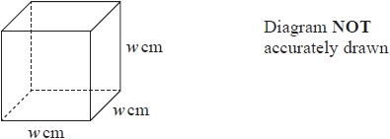

The cube exerts a force of 56 newtons on the table.   
The pressure on the table due to the cube is 0.14 newtons/cm2



Work out the volume of the cube.

........................................................... cm3

**(Total for question = 4 marks)**

**Q6.**

The average speed for an aeroplane flight from Dubai to London is 750 km/h.   
The flight time from Dubai to London is 7 hours 18 minutes.

(a)  Work out the flight distance from Dubai to London.

........................................................... km

**(3)**

(b)  Change 750 kilometres per hour to a speed in metres per second.   
       Give your answer correct to the nearest whole number.

........................................................... m/s

**(3)**

**(Total for question = 6 marks)**

**Q7.**

A block of wood has a mass of 3.5 kg.   
The wood has density 0.65 kg/m3

(a)  Work out the volume of the block of wood.

Give your answer correct to 3 significant figures.

m3

**(3)**

(b)  Change a speed of 630 kilometres per hour to a speed in metres per second.

m/s

**(3)**

**(Total for question = 6 marks)**

**Q8.**

The currency in Bangladesh is the taka.   
1 pound (£) = 119 taka

(a)  Change 3500 taka to pounds.

Give your answer correct to 2 decimal places.

£ ...........................................................

**(2)**

The currency in Thailand is the baht.   
1 pound (£) = 52 baht

(b)  Change 8500 baht to taka.

Give your answer correct to the nearest whole number.

........................................................... taka

**(3)**

An aeroplane takes 2 hours and 24 minutes to fly from Bangkok to Dhaka.   
The aeroplane flies a distance of 1534 km.

(c)  Work out the average speed of the aeroplane.

Give your answer in kilometres per hour correct to 3 significant figures.

........................................................... kilometres per hour

**(3)**

**(Total for question = 8 marks)**

**Q9.**

Change a speed of *x* kilometres per hour into a speed in metres per second.   
Simplify your answer.

........................................................... m/s

**(Total for question = 3 marks)**

**Q10.**

A plane flew from Bogotá to Quito.

The distance the plane flew was 725 km.   
The time taken by the plane was 1 hour 24 minutes.

Work out the average speed of the plane.   
Give your answer correct to 3 significant figures.

........................................................... km/h

**(Total for question = 3 marks)**

**Q11.**

A plane flew 8740 km from Nairobi to Hong Kong.   
The flight time was 13 hours 15 minutes.

Work out the average speed of the plane.   
Give your answer, in kilometres per hour, correct to the nearest whole number.

........................................................... kilometres per hour

**(Total for question = 3 marks)**

**Q12.**

An aeroplane flew from Qatar to Bahrain.   
The distance flown was 135 km.   
The average speed was 180 km/h.

Work out the time taken.   
Give your answer in minutes.

........................................................... minutes

**(Total for question is 3 marks)**

**Q13.**

(a) Rachael uses her car for work.   
Her company pays her 32 cents for every kilometre she travels by car.  
Yesterday, her company paid her $48 for the distance she travelled by car.

Work out the distance she travelled by car yesterday.

........................................................... km

(b) The length of the journey from her home to work is 72 km.   
The journey takes 1 hour 20 minutes.

Work out her average speed in km/h.

........................................................... km/h

**(3)**

**(Total for question = 6 marks)**

**Q14.**

A coach travels along a motorway.

The coach leaves Ashley Service Station at 11 45 am and arrives at Benscliffe Service Station at 2 45 pm.

(a)   Write 2 45 pm using the 24-hour clock.

...........................................................

**(1)**

(b)   Work out the length of time, in hours, between 11 45 am and 2 45 pm.

........................................................... hours

**(1)**

The coach leaves Benscliffe Service Station and travels to Clayton Service Station.   
The coach travels for 4 hours at an average speed of 65 km/h.

(c)   Calculate the distance, in kilometres, between Benscliffe and Clayton Service Stations.

........................................................... km

**(2)**

**(Total for Question is 4 marks)**

**Q15.**

A plane flew from Frankfurt to Hong Kong.

The flight time was 10 hours 45 minutes.

The average speed was 852 km/h.

Work out the distance the plane flew.

........................................................... km

**(Total for Question is 3 marks)**

**Q16.**

There were 2.1 million people living in Dubai in 2013   
1.75 million of these people were not born in Dubai.

(a)  Work out 1.75 as a percentage of 2.1   
Give your answer correct to 1 decimal place.

...........................................................%

**(2)**

The unit of currency in Dubai is the dirham.   
The exchange rate is £1 = 5.52 dirham.

The cost of a pair of running shoes in Dubai is 343 dirham.   
The cost of an identical pair of running shoes in the UK is £54.99

The pair of running shoes is more expensive in Dubai than in the UK.

(b)  How much more expensive?   
Give your answer to the nearest dirham.

...........................................................dirham

**(3)**

A plane flies a distance of 5522 km from London to Abu Dhabi in 7 hours 24 minutes.

(c)  Work out the average speed of the plane.   
Give your answer in kilometres per hour, correct to 3 significant figures.

........................................................... kilometres per hour

**(3)**

**(Total for question = 8 marks)**

**Q17.**



Find the pressure exerted by a force of 810 newtons on an area of 120 cm2  
Give your answer in newtons/m2

newtons/m2 ...........................................................

**(Total for question = 3 marks)**

**Q18.**

The density of gold is 19.3 g/cm3  
A gold bar has volume 150 cm3

Work out the mass of the gold bar.

........................................................... g

**(Total for question = 2 marks)**

**Mark Scheme**

Q1.

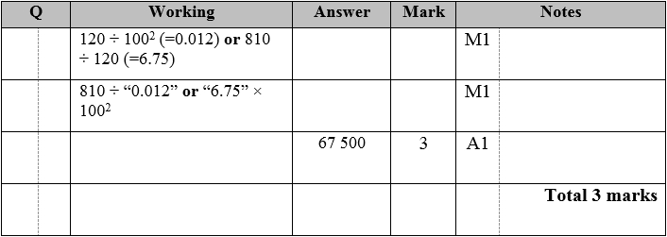

**Q2.**

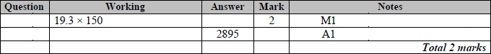

**Q3.**

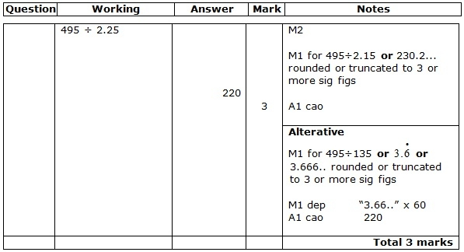

**Q4.**

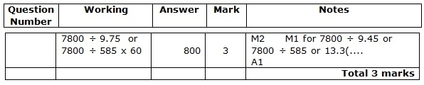

**Q5.**

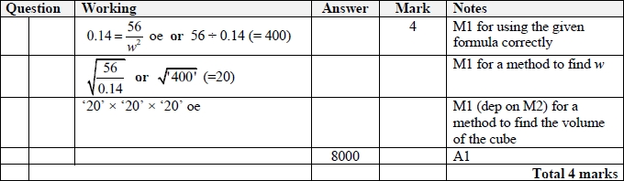

**Q6.**

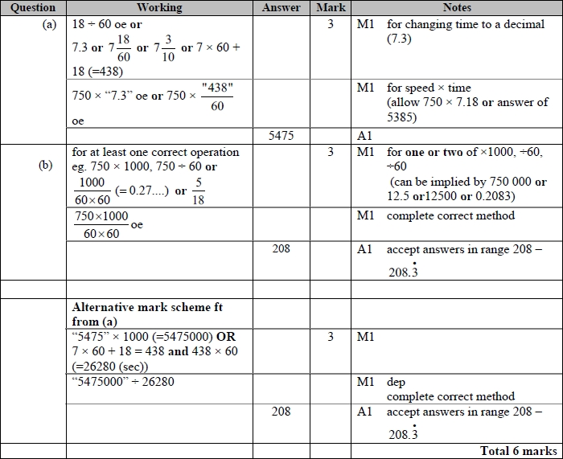

**Q7.**

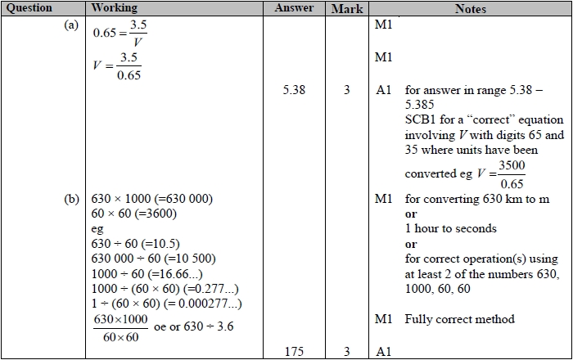

**Q8.**

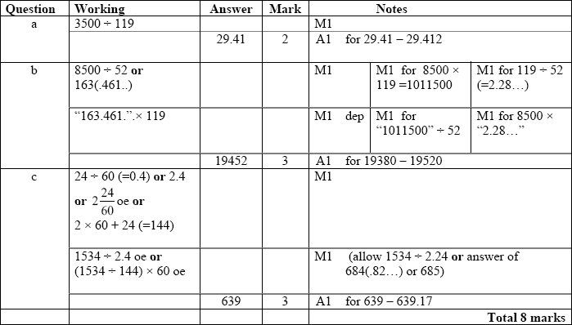

**Q9.**

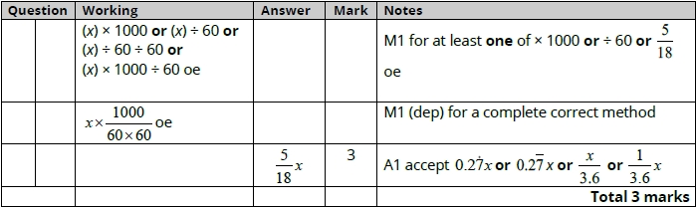

**Q10.**

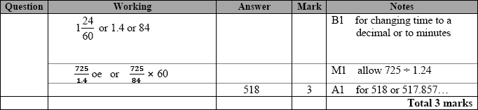

**Q11.**

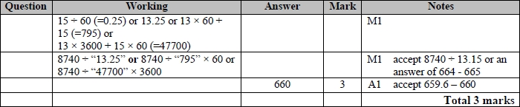

**Q12.**

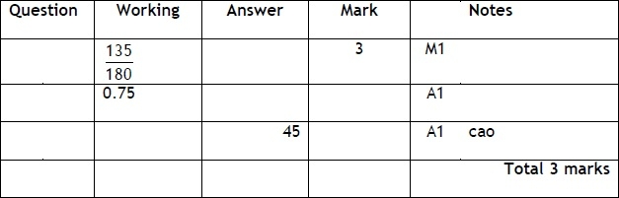

**Q13.**

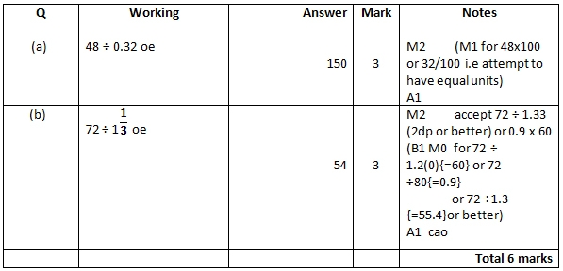

**Q14.**

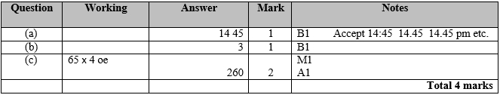

**Q15.**

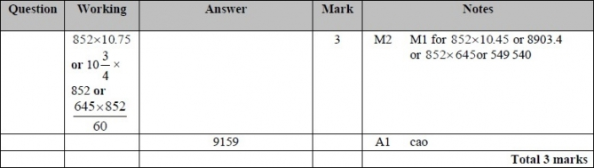

**Q16.**

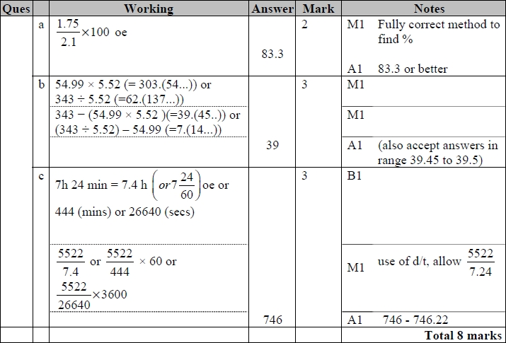

**Q17.**

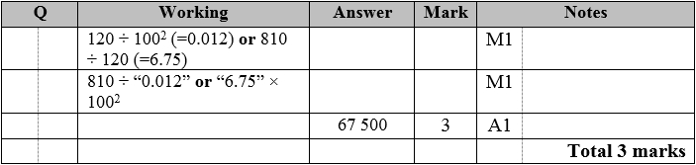

**Q18.**

