3.3.4 Marketing Mix (part 2)

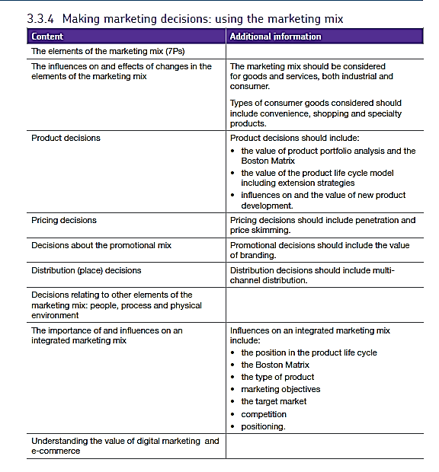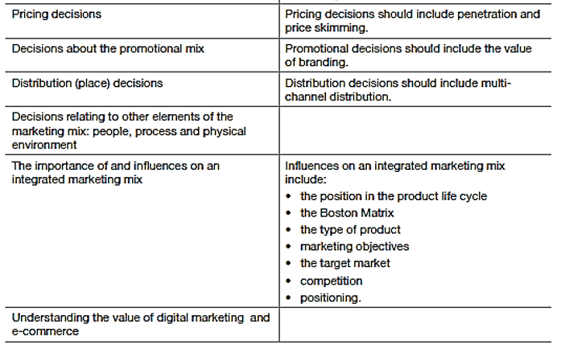

# Price

Price is:

The **money charged for a product or service,** everything that a customer has to give up in order to acquire a product or service, the price a business charges for its product or service is **one of the most important business decisions**management make.

For example, unlike the other elements of the marketing mix (product, place & promotion), pricing decisions affect revenues rather than costs. Pricing also has an important role as a competitive weapon to help a business exploit market opportunities.

Pricing also has to be consistent with the other elements of the marketing mix, since it contributes to the **perception** of a product or service by customers. Setting a price that is too high or too low will - at best - limit the business growth. At worst, it could cause problems for sales and cash flow.

So pricing is important. The bad news for entrepreneurs is that pricing is a really tough to get right. There are so many factors to consider, and much uncertainty about whether a price change will have the desired effect. The law of demand states that, for nearly all products, the higher the price the lower the demand. In other words, sales will fall if prices are put up. However higher prices can also mean higher profits.

## Pricing Strategies and Tactics

Pricing is a very powerful weapon in marketing, but there are many different ways to use it to help achieve marketing objectives. It is important to make a distinction between pricing strategies and pricing tactics

### **Pricing strategies**

These are adopted over the medium to long term to achieve marketing objectives, they have a significant impact on marketing strategy.

### Pricing **tactics**

These are adopted in the short run to suit particular situations Tactics have only limited impact beyond short-term sales of the product itself.  It may also be that the pricing strategies a business can implement are constrained by the competitive position of the business.

It is often said that there are **four categories of position** a business can find itself in which influence the control it has over pricing:

**(1) Price taker**

Here, a business has no option but to charge the ruling market price.

**(2) Price maker**

For a price maker, the business has a strong enough competitive position to be able to fix its own price – either higher or lower than the competition.

**(3) Price leader**

A price leader is often a market leader whose market share is so strong that its price changes are closely followed (and often copied) by rivals

**(4) Price follower**

A business that just follows the price-changing lead of the market leader (ignoring the rest of the competition).

## Penetration Pricing

You often see the tagline "special introductory offer" – the classic sign of **penetration pricing**. The aim of penetration pricing is usually to increase **market share** of a product, providing the opportunity to increase price once this objective has been achieved.

Penetration pricing is the pricing technique of setting a relatively low initial entry price, usually lower than the intended established price, to attract new customers. The strategy aims to encourage customers to **switch** to the new product because of the lower price.

Penetration pricing is most commonly associated with a **marketing objective** of increasing market share or sales volume. In the short term, penetration pricing is likely to result in lower profits than would be the case if price were set higher. However, there are some significant benefits to long-term profitability of having a higher market share, so the pricing strategy can often be justified.

Penetration pricing is often used to support the launch of a new product, and works best when a product enters a market with relatively little product differentiation and where demand is price elastic – so a lower price than rival products is a competitive weapon.

**Amongst the advantages claimed for penetration pricing include:**

* Catching the competition off-guard / by surprise
* Encouraging word-of-mouth recommendation for the product because of the attractive pricing (making promotion more effective)
* It forces the business to focus on minimising unit costs right from the start (productivity and efficiency are important)
* The low price can act as a barrier to entry to other potential competitors considering a similar strategy
* Sales volumes should be high, so distribution may be easier to obtain

**Penetration pricing strategies do have some drawbacks, however:**

* The low initial price can create an expectation of permanently low prices amongst customers who switch. It is always harder to increase prices than to lower them
* Penetration pricing may simply attract customers who are looking for a bargain, rather than customers who will become loyal to the business and its brand (repeat business)
* The strategy is likely to result in retaliation from established competitors, who will try to maintain their market share

## Price Skimming

Price skimming involves setting a high price before other competitors come into the market.

This is often used for the launch of a new product which faces little or no competition – usually due to some technological features. Such products are often bought by "early adopters" who are prepared to pay a higher price to have the latest or best product in the market.

There are some other problems and challenges with this approach:

Price skimming as a strategy cannot last for long, as competitors soon launch rival products that put pressure on the price.

Distribution (place) can also be a challenge for an innovative new product. It may be necessary to give retailers higher margins to convince them to stock the product, reducing the improved margins that can be delivered by price skimming.

A final problem is that by price skimming, a firm may slow down the volume growth of demand for the product. This can give competitors more time to develop alternative products ready for the time when market demand (measured in volume) is strongest.

# Promotion

**Promotion is all about communication**. Promotion is the way in a business makes its products known to the customers, both current and potential.

It is a common mistake to believe that promotion by business is all about advertising. It isn't. There are a variety of approaches that a business can take to get their message across to customers, although advertising is certainly an important one.

Promotion can be either **informative** or **persuasive.** Informative promotion is intended to increase consumer awareness of the product and its features. Persuasive promotion is intended to encourage consumers to purchase the product through messages that emphasise its desirability.

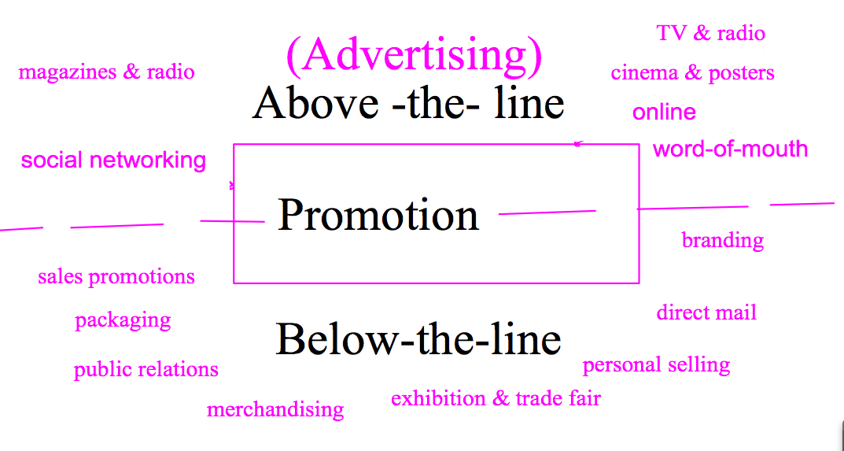Promotion is categorised into:

Above the line promotions which involves advertising through media (newspapers, TV, radio, cinema and posters etc.).

Below the line promotion which involves all other aspects of promotion such as public relations, merchandising, sponsorship, direct marketing, personal selling and competitions.

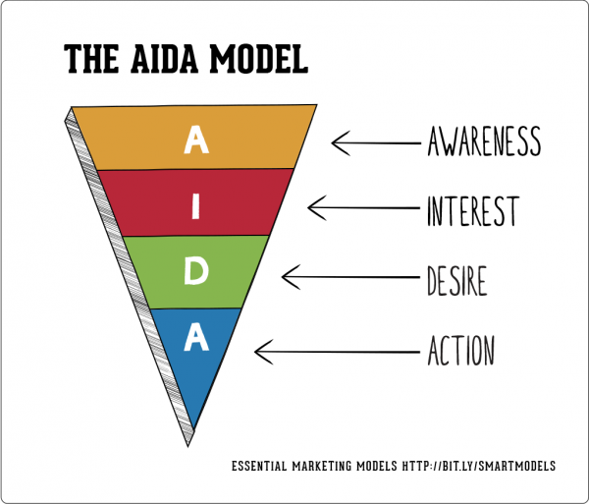

Promotion has many different aims. A popular model that is used to demonstrate the different aims of promotion is **AIDA** which stands for Attention, Interest, Desire and Action.

The main aim of promotion is to ensure that customers are **aware** of the existence and positioning of products. Promotion is also used to **persuade** customers that the product is better than competing products and to remind customers about why they may want to buy.

It is important to understand that a business will use more than one method of promotion. The variety of promotional methods used is referred to as the **promotional mix.**

Which promotional methods are used depends on several factors:

|  |  |
| --- | --- |
| * **Stage in the life cycle** | * E.g. advertising is important at the launch stage |
| * **Nature of the product** | * How much information is required by customers before they buy |
| * **Competition** | * What are rivals doing? |
| * **Marketing budget** | * How much can the firm afford? |
| * **Marketing strategy** | * Other elements of the mix (price, product, place etc) |
| * **Target market** | * Appropriate ways to reach the target market |

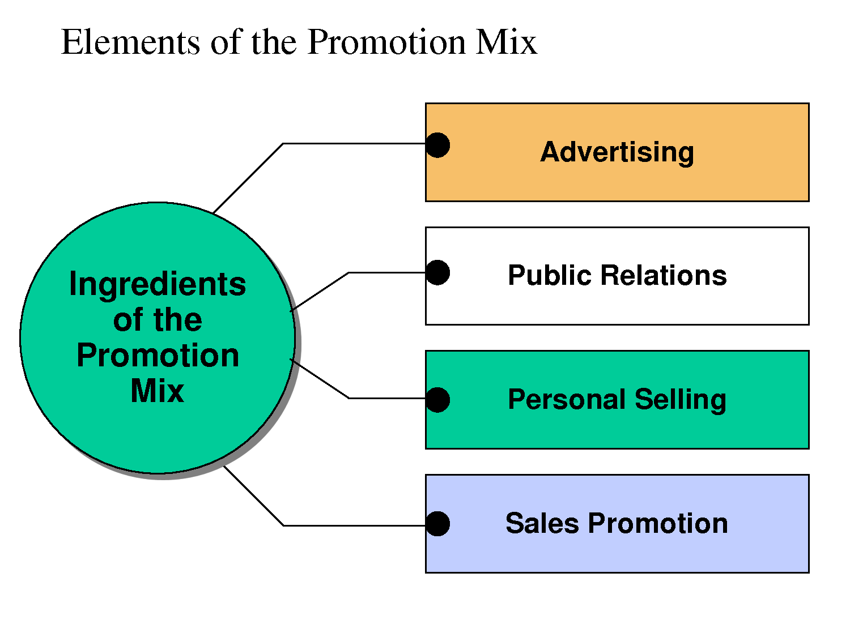

The main methods of promotion are:

* Advertising
* Public relations & sponsorship
* Personal selling
* Direct marketing
* Sales promotion

A business will use a range of promotional activities for its product, depending on the **marketing strategy** and the **budget** available.

# Brands and Branding.

A brand is a product with unique character, for instance in design or image. It is consistent and well recognised. The advantages of having a strong brand are:

* Brands inspire **customer loyalty** leading to repeat sales and word-of mouth recommendation
* The brand owner can usually charge **higher prices**, especially if the brand is the market leader
* Retailers or service sellers want to stock top selling brands. With limited shelf space it is more likely the top brands will be on the shelf than less well-known brands.

Some retailers use **"own-label"** brands, where they use their name of the product rather than the manufacturers like Tesco's "Finest" range of meals and foodstuffs. These tend to be cheaper than the normal brands, but will give the retailer more profit than selling a normal brand.

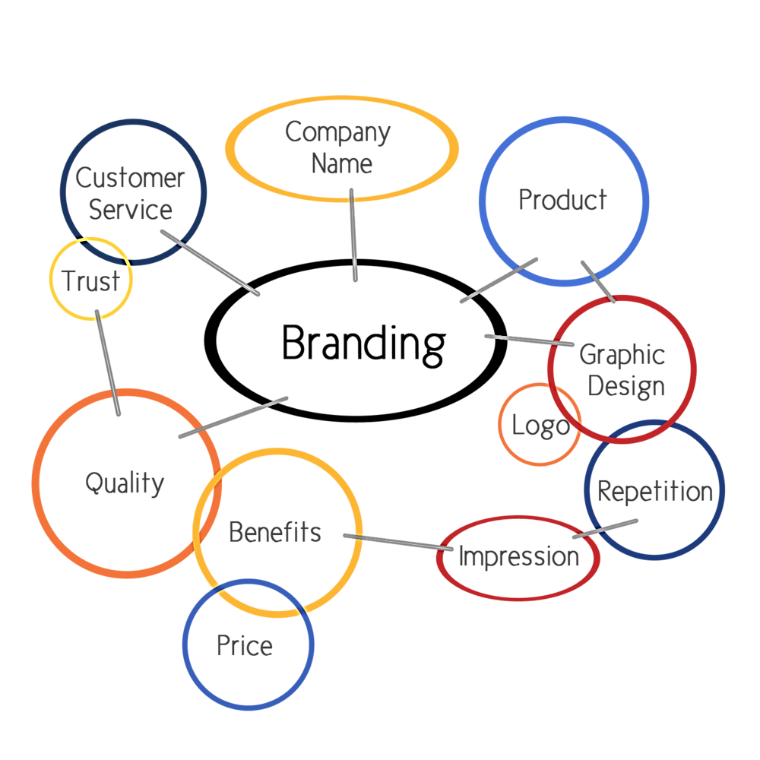Some brands are so strong that they have become **global brands**. This means that the product is sold in many countries and the contents are very similar. Examples of global brands include: Microsoft, Coca Cola, Disney, Mercedes and Hewlett Packard.

The strength of a brand can be exploited by a business to develop new products. This is known as **brand extension** – a product with some of the brand's s characteristics. Examples include Dove soap and Dove Shampoo (both contain moisturiser); Mars Bar and Mars Ice Cream

**Brand stretching** is where the brand is used for a diverse range of products, not necessarily connected. E.g. Virgin Airlines and Virgin Cola; Marks and Spencer clothes and food.

The **logo** on a product is an important part of the product. A logo is a symbol or picture that represents the business. It is important because it is easy to recognise, establishes brand loyalty and can create a favourable image.

# Place (Distribution) - Introduction

Place (or its more common name "distribution") is about how a business gets its products to the customers. It is one thing having a great product, sold at an attractive price. But what if:

* Customers are not near a retailer that is selling the product?
* A competing product is stocked by a much wider range of outlets?
* A competitor is winning because it has a team of trained distributors or sales agents who are out there meeting customers and closing the sale?

Distribution matters for a business of any size – it is a crucial part of the marketing mix.

The objective of distribution is clear. It is to make products available in the right place at the right time in the right quantities

* Distribution is achieved by using one or more distribution channels, including:
* Retailers
* Distributors / Sales Agents
* Direct (e.g. via e-commerce)
* Wholesalers

**A distribution channel can be defined as:**

"all the organisations through which a product must pass between its point of production and consumption"

Looking at that definition, you can see that a product might pass through several stages before it finally reaches the consumer. The organisations involved in each stage of distribution are commonly referred to as "**intermediaries**".

## Why does a business give the job of selling its products to intermediaries?

Using an intermediary means giving up some control over how products are sold and who they are sold to. An intermediary will also want to make a profit by getting involved. The answer lies in efficiency of distribution costs. Intermediaries are specialists in selling. They have the contacts, experience and scale of operation which means that greater sales can be achieved than if the producing business tried to run a sales operation itself.

The main function of a distribution channel is to provide a link between production and consumption. Organisations that form any particular distribution channel perform many key functions:

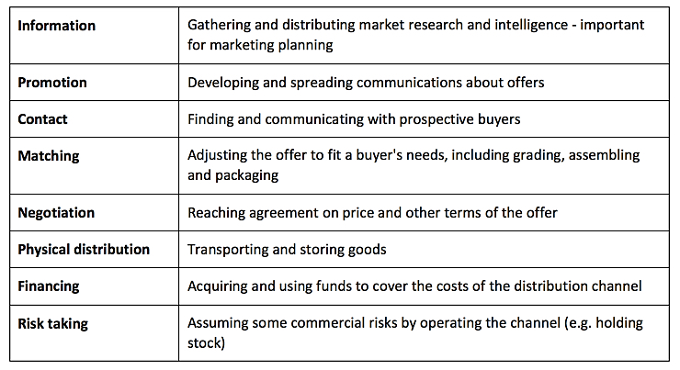

The main function of a **distribution channel**is to provide a link between production and consumption. A distribution channel can be very simple, with just two layers (producer and consumer). A distribution channel can also be very complicated, with several levels.

Each layer of marketing intermediaries that performs some work in bringing the product to its final buyer is a "channel level". The next diagram shows some examples of channel levels for consumer marketing channels:

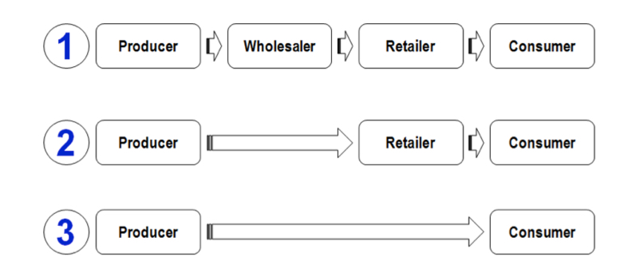

In the figure above, the first two channels are "indirect-marketing channels" – they are not direct between the business and its customers.

Channel 1 contains two intermediary levels - a **wholesaler**and a **retailer.** A wholesaler typically buys and stores large quantities of several producers' goods and then **breaks into the bulk**deliveries to supply retailers with smaller quantities. For small retailers with limited order quantities, the use of wholesalers makes economic sense. This arrangement tends to work best where the retail channel is fragmented - i.e. not dominated by a small number of large, powerful retailers who have an incentive to cut out the wholesaler. A good example of this channel arrangement in the UK is the distribution of drugs.

Channel 2 contains one intermediary. In consumer markets, this is typically a retailer. The consumer electrical goods market in the UK is typical of this arrangement whereby producers such as Sony, Panasonic, Canon etc. sell their goods directly to large retailers and e-tailers such as Comet, Tesco and Amazon which then sell onto the final consumers.

Channel 3 is called a "**direct-marketing" channel**, since it has no intermediary levels. In this case the manufacturer sells directly to customers. An example of a direct marketing channel would be a factory outlet store. Many holiday companies also market direct to consumers, bypassing a traditional retail intermediary - the travel agent.

## What factors should be taken into account in choosing the best distribution channel?

### Nature of the product

* Perishable/fragile? A product with a short-life
* Technical/complex? Complex products are often sold by specialist distributors or agents
* Customised? A direct distribution approach often works best for a product that the end consumer wants providing to a distinct specification
* Type of product – e.g. convenience, shopping, speciality
* Desired image for the product – if intermediaries are to be used, then it is essential that those chosen are suitable and relevant for the product.

### The market

* Is it geographically spread?
* Does it involve selling overseas
* The extent and nature of the competition – which distribution channels and intermediaries do competitors use?

### The business

* Size and scope – e.g. can it afford an in-house sales force?
* Marketing objectives – revenue or profit maximisation?
* Does it have established distribution network or does it need to extend its distribution option
* How much control does it want over distribution? The longer the channel, the less control is available

### Legal issues

* Are there limitations on sale?
* What are the risks if an intermediary sells the product to an inappropriate customer?

# People, process and physical environment.

**Other elements of the marketing mix: people, process and physical environment**

### People

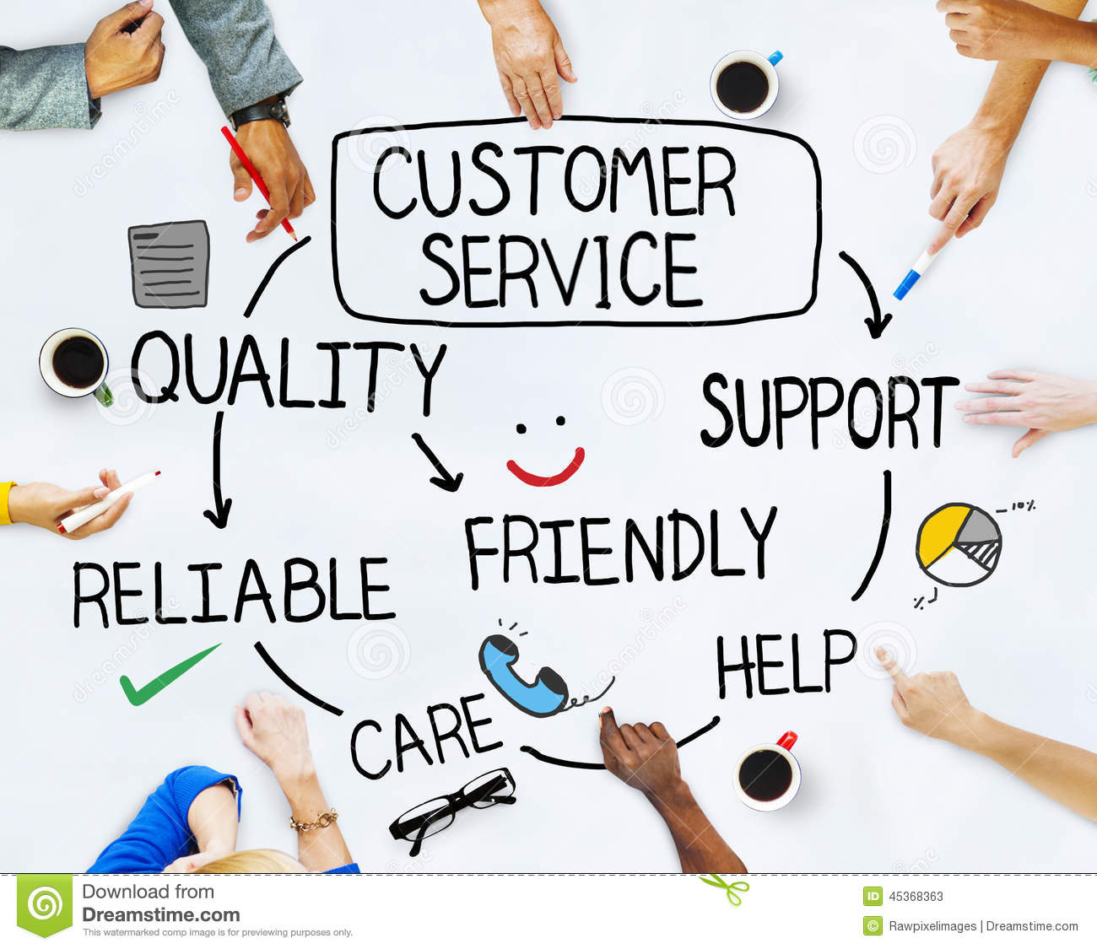‘People’ includes any employee who comes into direct contact with the customer. For a physical good, they are likely to be involved in the initial selling process and those who are responsible for providing the after sales service. For a business providing a service, the people element is even more crucial because they can have a direct effect on customer satisfaction.

To ensure the ‘people’ element of the marketing mix is operating effectively, a business must:

* Recruit the right workers with good attitudes towards customer service.
* Use motivational techniques to ensure employees behave in a positive manner towards customers.
* Provide training to ensure employees have the skills to deliver good customer service.
* Make sure employees understand the importance of after sales service in creating goodwill and repeat purchases.

### Process

Increasingly, customers require a business which is ‘easy to deal with’. Process involves any interaction with the customer whether it is paying for the product or the processes involved in dealing with customer service and offering refunds. These processes need to be as quick and efficient as possible.

Key elements of process include:

* Ensuring customer enquiries are dealt with promptly.
* Minimising queues in a retail context – ensuring there are sufficient staff on the tills at all times.
* Training and empowering all staff to deal with customer complaints so that customers are not passed on to several people in the organisation before a decision is made.
* Communicating effectively so that customers know how promptly they will be dealt with.
* Processing refunds and returned goods efficiently.

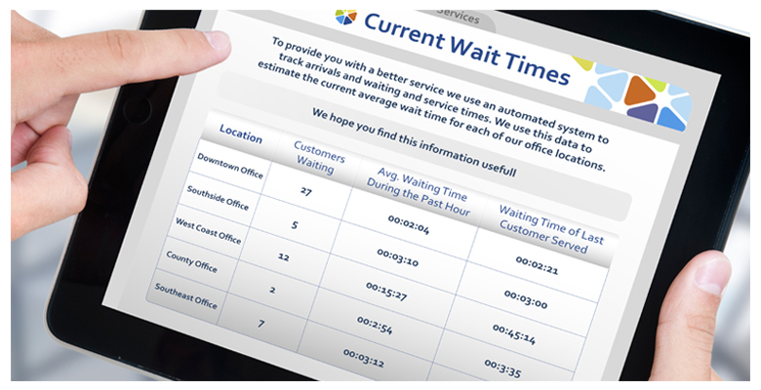

### Physical Environment

The physical environment represents the last of the 7 P’s. Physical environment is often referred to as ‘physical evidence’ and refers to the *tangible* features of a service that can enhance customer experience. Examples include:

* 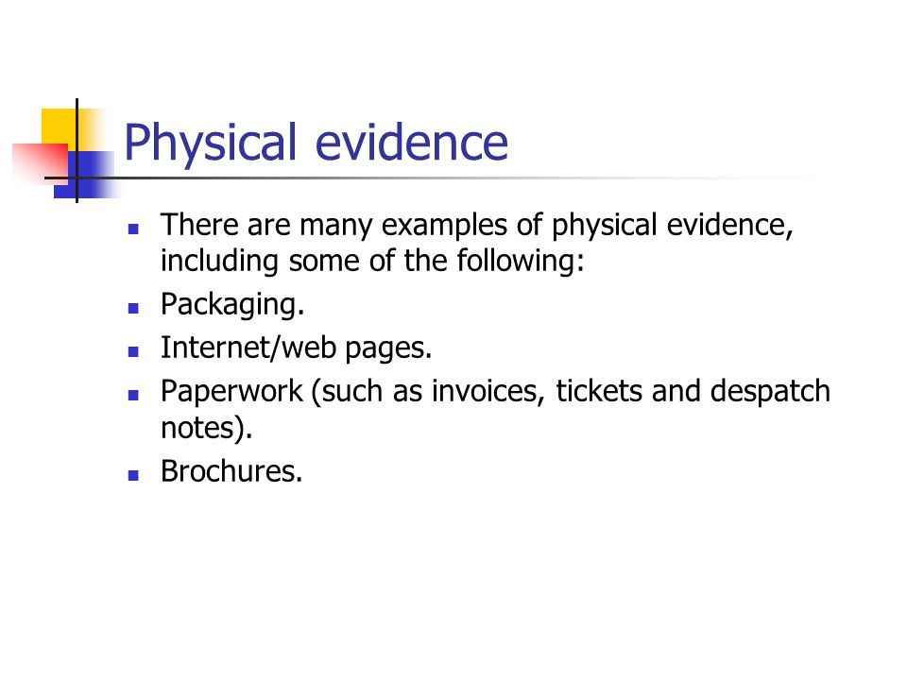The business reception area
* Company brochures
* Letterheads
* The company website
* Signage
* Equipment
* Staff uniforms or the appearance of staff who have direct customer contact
* Physical layout of the environment

For many customers, the physical environment is the first information they process before they decide whether they will purchase the product or service. An unattractive reception area, poor quality brochure and a non-user friendly website are likely to dissuade customers.

# Integrated marketing mix.

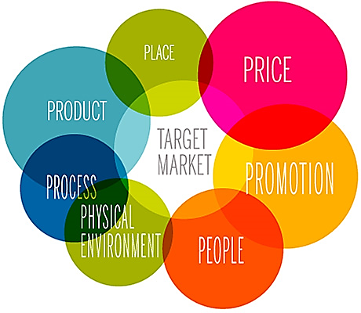The marketing mix refers to all the activities that might affect a customer’s decision to purchase the product. To be effective, the different aspects of the marketing mix must work well together. The marketing mix must be appropriate for the given context. It must take account of:

* The position in the product life cycle. If the product is in decline, then prices will need to be lowered.
* The Boston Matrix; the business may need to invest in problem children and star products to ensure the long term survival of the business.
* The price must be competitive with rivals. If the price is high, then the business must ensure that the benefits and USPs are high.
* Marketing objectives must be considered.
* The target market must be understood if the business is to design a good marketing mix.
* Competitors are important since the business needs to differentiate itself to gain advantage.
* Market positioning must be considered; is the business focusing on low price value products for example?
* The physical environment is important; is the store designed in such a way to attract customers?
* The nature of the staff; are they appropriately trained to deliver good customer service.
* Are the systems and processes efficient in the business? How do they compare to competitors?

**The value of digital marketing and e-commerce**

E-commerce is the buying and selling of products through an electronic medium such as the internet. In recent years, the developments in technology have significantly affected most aspects of business. Digital marketing has allowed the business to:

* Gather information about customers and process it more quickly and more effectively. This has provided much more insight into markets and customers.
* Build relationships with customers more efficiently by being able to track their buying habits and recommend other products they might like.
* Target very specific segments. A business can now set up on line relatively cheaply and focus on quite a small segment of the market.
* Involve customers more in the marketing process. Customers can provide reviews of products to help other potential buyers.
* Target global markets 24 hours per day.

The value of digital marketing and e-commerce depends on how fast and how well a business adopts it. Morrison’s was slow to go on-line and therefore lost market share. Companies like HMV struggled when customers began to download music rather than buy in store. Traditional print newspapers are struggling as customers read on-line. The key factor is that marketing managers should constantly observe the trends and respond accordingly.