

**IGCSE (9 – 1) Revision Pack**

**Solving Linear Equations**

**Name --------------------------------**

**Questions**

**Q1.**

(a) Solve 6*x* + 5 = 20   
Show clear algebraic working.

*x* = ...........................................................

**(2)**

(b) Solve 4(2*y* − 5) = 30   
Show clear algebraic working.

*y* = ...........................................................

**(3)**

**(Total for question = 5 marks)**

**Q2.**

Solve     3(*x* − 4) = 5*x* + 8

Show your working clearly.

*x* = ...........................................................

**(Total for question is 3 marks)**

**Q3.**

(a)  Solve     9 + *x* = 48

*x* = ...........................................................

**(1)**

(b)  Solve     4*y* = 11

*y* = ...........................................................

**(1)**

  
(c)  Solve

Show clear algebraic working.

*m* = ...........................................................

**(3)**

**(Total for question = 5 marks)**

**Q4.**

(a) Simplify

(i) *t* + *t* + *t*

............................................................

(ii) *b* × 5 × *a*

............................................................

**(2)**

(b) Solve

(i) 8*x* − 3 = 9

*x* = ............................................................

(ii) 7*y* − 6 = 2*y* + 8

Show clear algebraic working.

*y* = ............................................................

**(5)**

(c) Expand and simplify

(*x* − 6)(*x* + 9)

............................................................

**(2)**

**(Total for question = 7 marks)**

**Q5.**

Solve 7*x* − 5 = 3*x* + 2   
Show your working clearly.

*x* = ...........................................................

**(Total for question is 3 marks)**

**Q6.**

Solve 3x + 16 = 1 − 2*x*.  
 Show clear algebraic working.

*x* =...........................................................

**(Total for question = 3 marks)**

**Q7.**

Solve

Show clear algebraic working.

*x* = ...........................................................

**(Total for question = 3 marks)**

**Q8.**

Solve    6(3*y* + 5) = 39   
Show clear algebraic working.

*y* = ...........................................................

**(Total for Question is 3 marks)**

**Q9.**

Solve     3(2*x* + 5) = 4 − *x*  
Show clear algebraic working.

*x* = ...........................................................

**(Total for question = 3 marks)**

**Q10.**

Solve 5*x* − 8 = *x* − 10   
Show clear algebraic working.

*x* = ...........................................................

**(Total for question = 3 marks)**

**Q11.**

Solve 3(*x* − 5) = 7*x* + 12   
Show clear algebraic working.

*x* =...........................................................

**(Total for question = 3 marks)**

**Q12.**

(a)  Solve 5*m* + 7 = 24

*m* =

**(2)**

(b)  Make *t* the subject of

**(2)**

(c)  Simplify *p*8 ÷ *p*3

**(1)**

(d)  Simplify *n*0

**(1)**

(e)  Simplify (3*x*2*y*5)3

**(2)**

**(Total for question = 8 marks)**

**Q13.**

(a)   Solve 7*x* − 6 = 2*x* + 17   
Show clear algebraic working.

*x* = ...........................................................

**(3)**

(b)   Expand and simplify fully (*x* + 8)(*x* + 2)

...........................................................

**(2)**

**(Total for Question is 5 marks)**

**Q14.**

(a) Solve     *x* − 4 = 3

*x* = ...........................................................

**(1)**

(b) Solve     3*y* + 7 = 1

*y* = ...........................................................

**(2)**

**(Total for question = 3 marks)**

**Q15.**

The diagram shows a triangle.

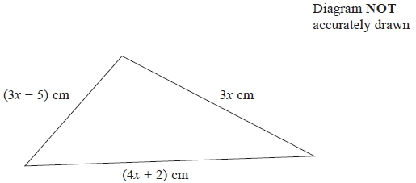

The lengths of the sides of the triangle are 3*x* cm, (3*x* − 5) cm and (4*x* + 2) cm.

The perimeter of the triangle is 62 cm.

Work out the value of *x*.   
Show clear algebraic working.

*x* = ...........................................................

**(Total for question = 4 marks)**

**Q16.**

(a)   Solve *x* – 7 = 11

*x* =...........................................................

**(1)**

(b)   Solve 5*y* + 4 = 39

*y* =...........................................................

**(2)**

(c)   Solve 3(2*z* – 5) = 4*z* + 11   
Show clear algebraic working.

*z* =...........................................................

**(3)**

**(Total for Question is 6 marks)**

**Q17.**

(a)  Solve 7 + *x* = 15

*x* = ...........................................................

**(1)**

(b)  Solve −9 = 8*y* + 3

*y* = ...........................................................

**(2)**

**(Total for question = 3 marks)**

**Q18.**

(a)   Solve 3*x* + 5 = 26   
       Show clear algebraic working.

*x* =...........................................................

**(2)**

(b)   Solve 4(5*y* − 1) = 3(6*y* + 7)   
       Show clear algebraic working.

*y* =...........................................................

**(3)**

**(Total for question = 5 marks)**

**Q19.**

(a)  Solve     9*y* − 3 = 5*y* + 2

*y* = ...........................................................

**(2)**

  
(b)  Solve

Show clear algebraic working.

*x* = ...........................................................

**(3)**

**(Total for question = 5 marks)**

**Q20.**

(a)  Solve     4*p* + 7 = 12

*p* = ...........................................................

**(2)**

(b)  Solve     8*y* − 18 = 3(*y* + 3)   
Show clear algebraic working.

*y* = ...........................................................

**(3)**

**(Total for question = 5 marks)**

**Q21.**

(a)  Solve     4*e* = 20

*e* = ...........................................................

**(1)**

(b)  Solve     15 − *f* = 9

*f* = ...........................................................

**(1)**

(c)  Simplify     5*m* + 4*p* − 2*m* + 7*p*

...........................................................

**(2)**

There are 4 pens in each small box of pens.   
There are 10 pens in each large box of pens.

Harry buys *x* small boxes of pens and *y* large boxes of pens.

(d)  Write down an expression, in terms of *x* and *y*, for the total number of pens Harry buys.

...........................................................

**(2)**

*a* = −5   
*c* = −2

(e)  Work out the value of     2*a*2 + 6*c*

...........................................................

**(2)**

**(Total for question = 8 marks)**

**Q22.**

(a) Solve



(i)

*x* =...........................................................

(ii)

*y* =...........................................................

**(3)**

(b) Simplify

(i) *a* × *a* × *a* × *a*,

...........................................................

(ii) 5*a* × 6*b*,

...........................................................

(iii) *q*8 ÷ *q*2.

..........................................................

**(3)**

(c) *v* = *w*2 − 2*w*.

*v* =...........................................................

**(2)**

**(Total for question = 8 marks)**

**Q23.**

(a)  Solve     4*x* + 5 = 13

*x* = ...........................................................

**(2)**

(b)  Solve     6*t* − 5 = 2*t* + 9   
Show clear algebraic working.

*t* = ...........................................................

**(3)**

(c)  Expand and simplify     3(2*y* + 2) + 2(*y* − 4)

...........................................................

**(2)**

(d)  Simplify fully     4*wxy* ÷ (8*xy*)

...........................................................

**(2)**

**(Total for question = 9 marks)**

**Q24.**

(a) Solve 2*x* + 9 = 1

*x* = ..........................................................

**(2)**

(b) Solve 3(2*y* − 1) = 6   
Show clear algebraic working.

*y* = ..........................................................

**(3)**

**(Total for question = 5 marks)**

**Q25.**

(a)  Solve

(i)  9 + *x* = 27

*x* = ...........................................................

(ii)  6*y* = 18

*y* = ...........................................................

**(2)**

*M* = 2*p* − 4*q*

(b)  Work out the value of *M* when *p* = 10 and *q* = 2

*M* = ...........................................................

**(2)**

*N* = 5*c* − 4*d*

(c)  Work out the value of *c* when *N* = 18 and *d* = 3

*c* = ...........................................................

**(3)**

**(Total for Question is 7 marks)**

**Q26.**

The width of a rectangle is 8 cm less than the length of the rectangle.   
The perimeter of the rectangle is 54 cm.

Find the area of the rectangle.

........................................................... cm2

**(Total for question = 4 marks)**

**Q27.**

(a)  Solve 5*y* + 17 = 10

*y* = ...........................................................

**(2)**

(b)  Solve 5(*q* – 3) = 12 – *q*  
       Show clear algebraic working.

*q* = ...........................................................

**(3)**

(c)  Solve the inequality 3 – 7*t* ≥ 31

...........................................................

**(2)**

**(Total for question = 7 marks)**

**Q28.**

(a)  Solve     *x* − 9 = 15

*x* = ...........................................................

**(1)**

  
(b)  Solve     *y* = 12

*y* = ...........................................................

**(2)**

(c)  Factorise fully     18*c* − 27

...........................................................

**(2)**

(d)  Expand and simplify     (*t* − 4)(*t* + 5)

...........................................................

**(2)**

**(Total for question = 7 marks)**

**Q29.**

The diagram shows a cuboid and a triangular prism.

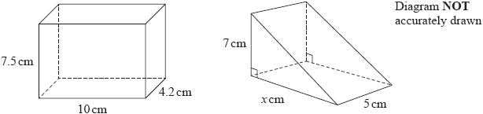

The volume of the cuboid is equal to the volume of the triangular prism.

Work out the value of *x*.

...........................................................

**(Total for question = 4 marks)**

**Q30.**

The diagram shows a rectangle and a right-angled triangle.

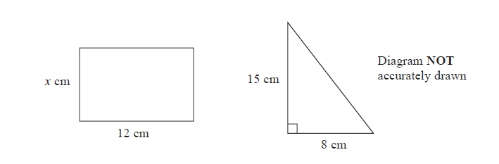

The area of the rectangle is the same as the area of the triangle.

Work out the value of *x*.

*x* =...........................................................

**(Total for question = 3 marks)**

**Q31.**

*M* = 2*t*2 − 7*t*

(a)  Work out the value of *M* when *t* = −3

*M* = ...........................................................

**(2)**

(b)  Solve    4(*x* + 3) = 9*x* − 10

Show clear algebraic working.

*x* = ...........................................................

**(3)**

*y* is an integer.   
−2 < *y* ≤ 3

(c)  Write down all the possible values of *y*.

...........................................................

**(2)**

**(Total for question = 7 marks)**

**Q32.**

Budget Taxis use this rule to work out the cost, in euros (€), for taxi journeys.

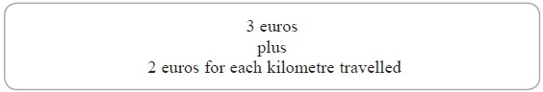

(a)  Claude travelled 4 kilometres in a Budget Taxi.   
What was the cost of Claude's journey?

€ ...........................................................

**(2)**

(b)  Bridgette travelled in a Budget Taxi.   
The cost was 35 euros.   
How many kilometres did Bridgette travel?

........................................................... km

**(2)**

Economy Taxis use this rule to work out their cost, in euros (€), for taxi journeys.

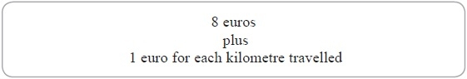

(c)  Find the distance, in kilometres, for which the cost of a journey in a Budget Taxi is the same as the cost of a journey in an Economy Taxi.

........................................................... km

**(2)**

**(Total for Question is 6 marks)**

**Q33.**

(a)  Complete the number machine by writing the correct output on the dotted line.

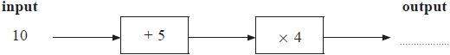

**(1)**

(b)  Complete the number machine by writing the correct input on the dotted line.

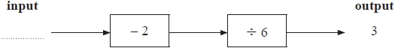

**(2)**

Here is an incomplete number machine.

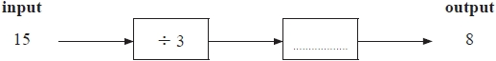

(c)  Complete the number machine.

**(1)**

**(Total for question = 4 marks)**

**Q34.**

(a)  *A* = 2*p* + 3*q*

Work out the value of *A* when *p* = −5 and *q* = 7

*A*...........................................................

**(2)**

(b)  Solve 5(*x* − 4) = 14

*x* = ...........................................................

**(2)**

**(Total for question = 4 marks)**

**Mark Scheme**

Q1.

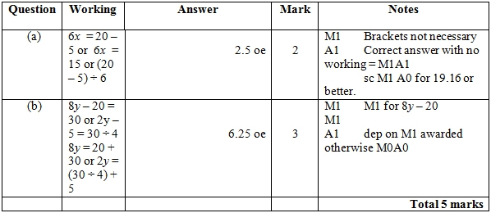

**Q2.**

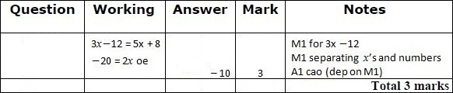

**Q3.**

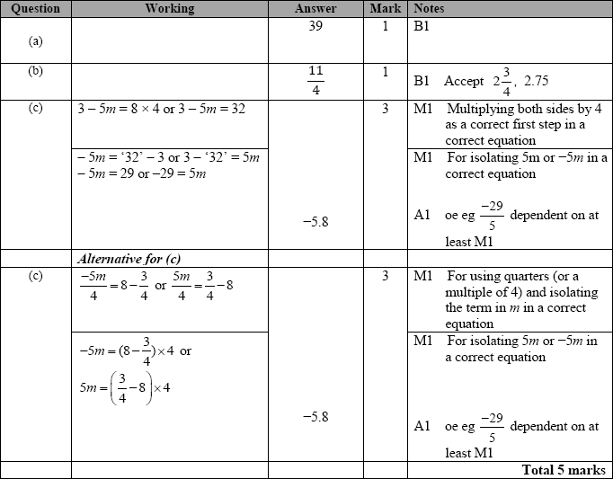

**Q4.**

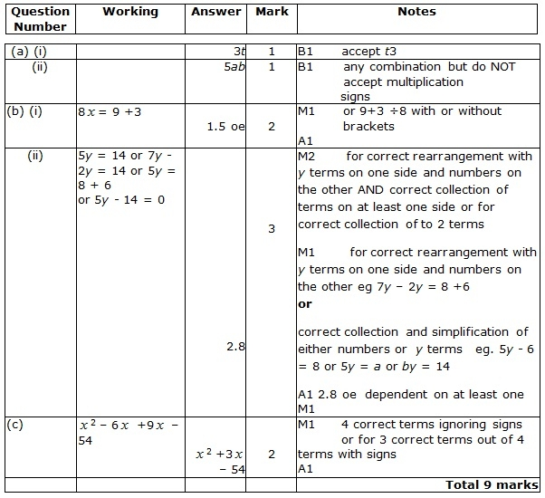

**Q5.**

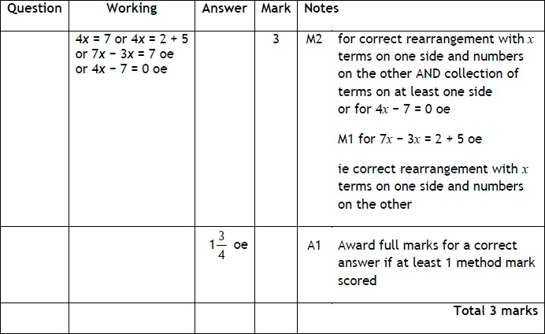

**Q6.**

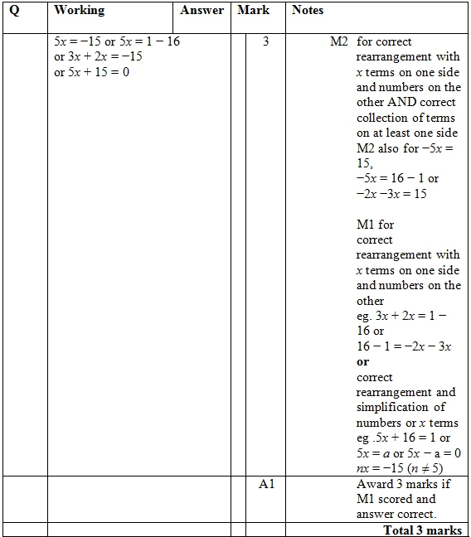

**Q7.**

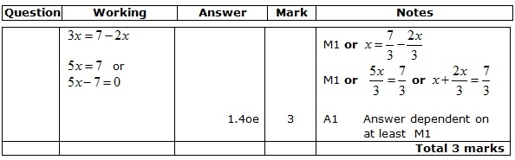

**Q8.**

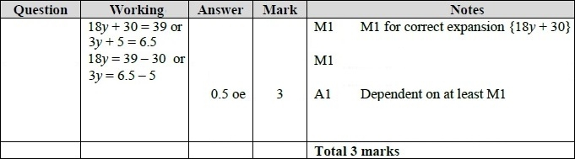

**Q9.**

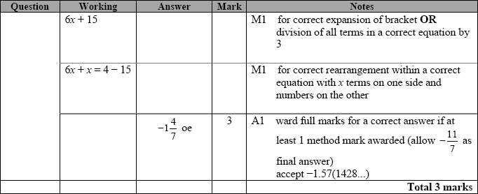

**Q10.**

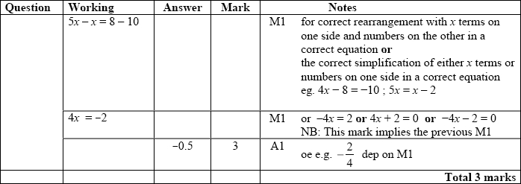

**Q11.**

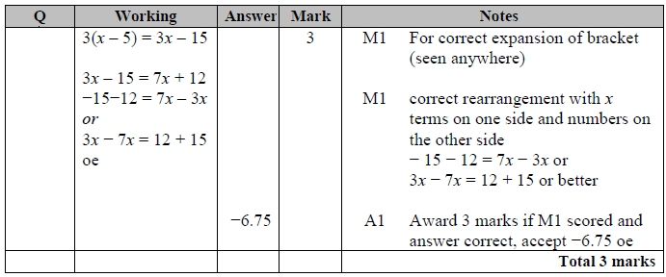

**Q12.**

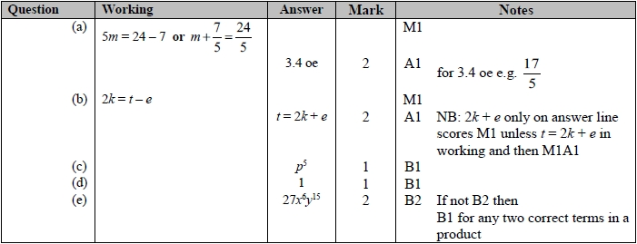

**Q13.**

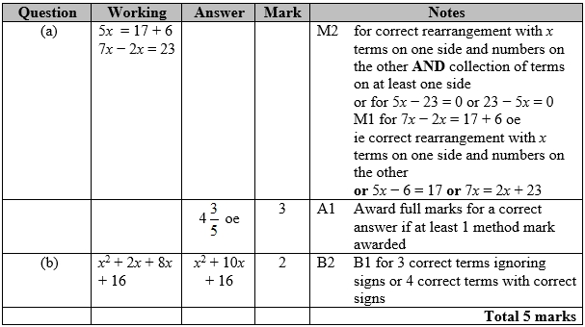

**Q14.**

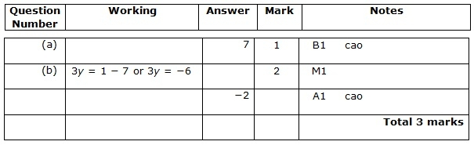

**Q15.**

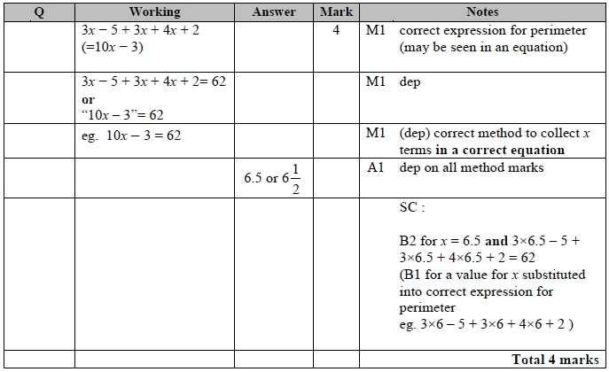

**Q16.**

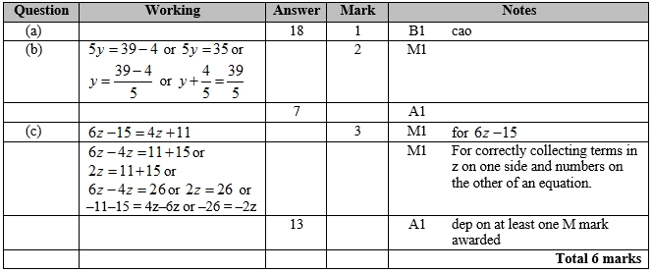

**Q17.**

The correct answer, unless clearly obtained by an incorrect method, should be taken to imply a correct method.

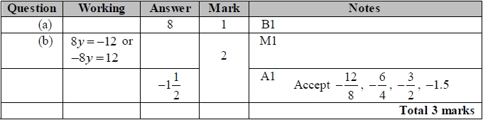

**Q18.**

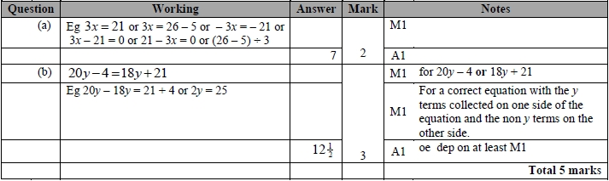

**Q19.**

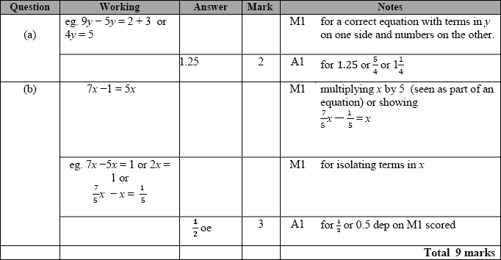

**Q20.**

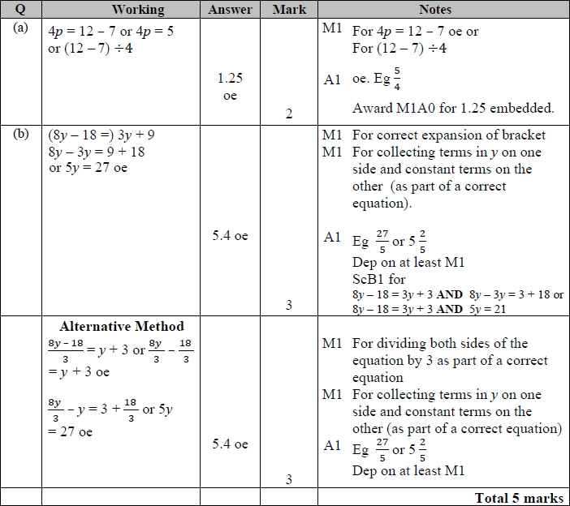

**Q21.**

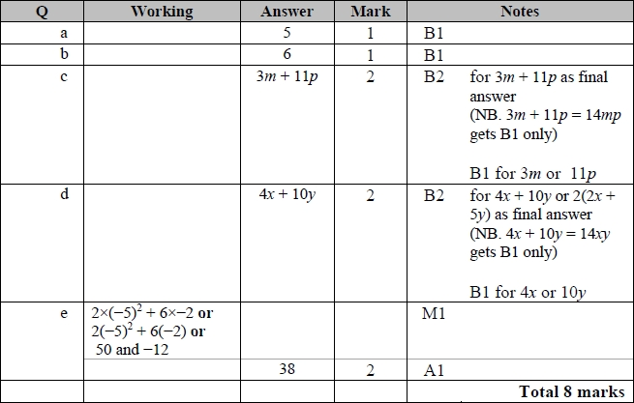

**Q22.**

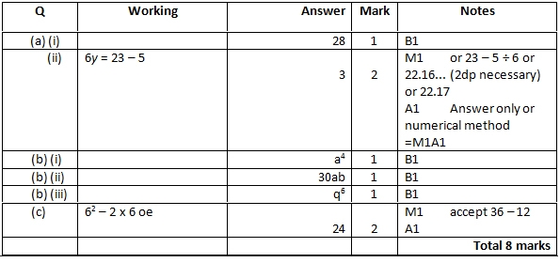

**Q23.**

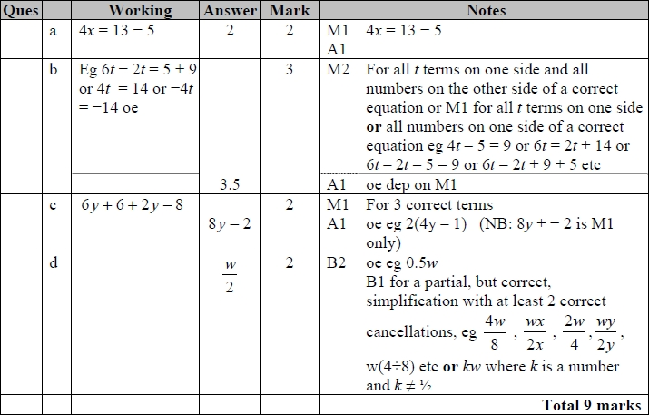

**Q24.**

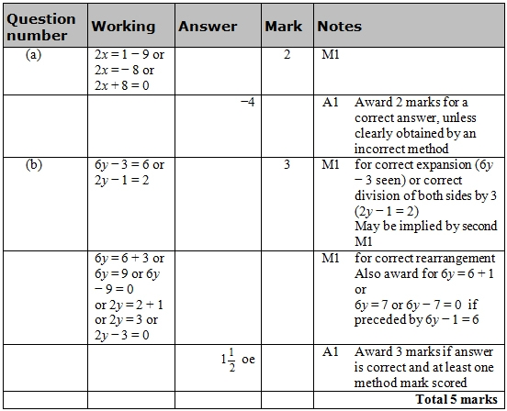

**Q25.**

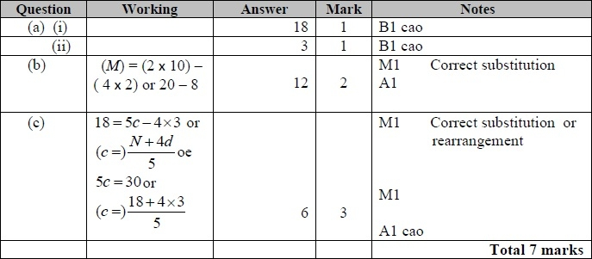

**Q26.**

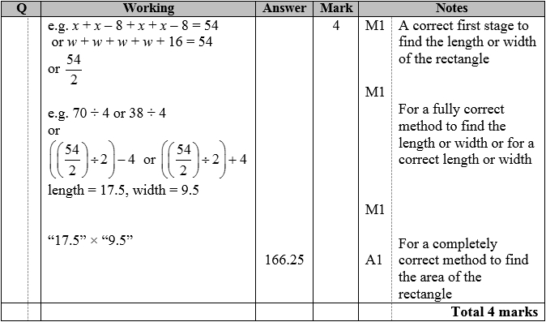

**Q27.**

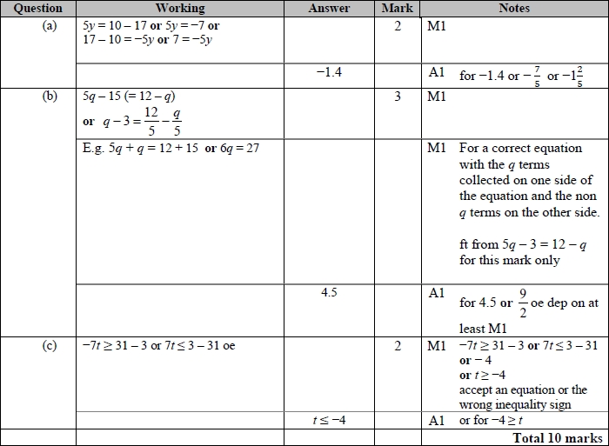

**Q28.**

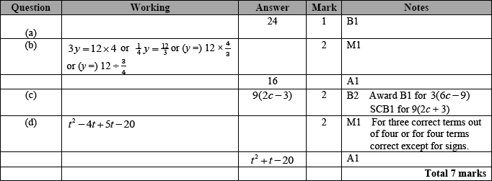

**Q29.**

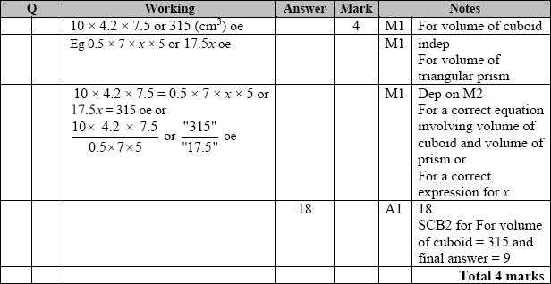

**Q30.**

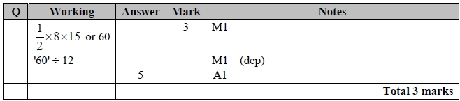

**Q31.**

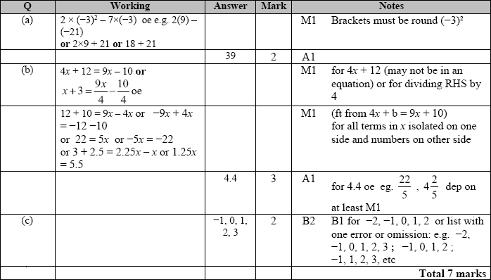

**Q32.**

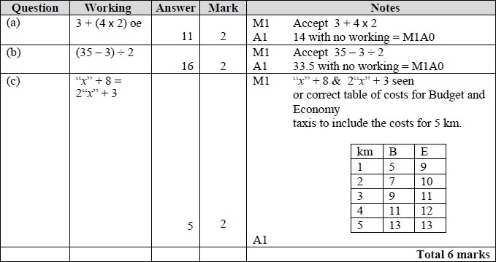

**Q33.**

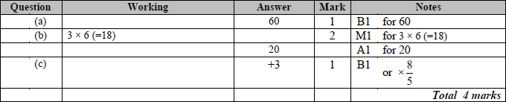

**Q34.**

