Medieval Sieges – Key Features

Feature | Definition | Strengths/weaknesses
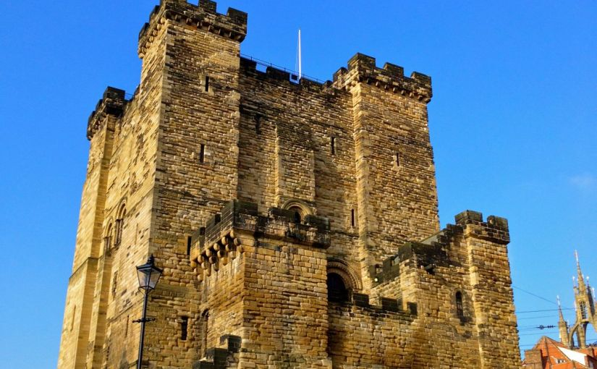  Keep | The inner fortifications of a castle, usually with the living quarters of the owner/  guardian, and last resort for defenders.
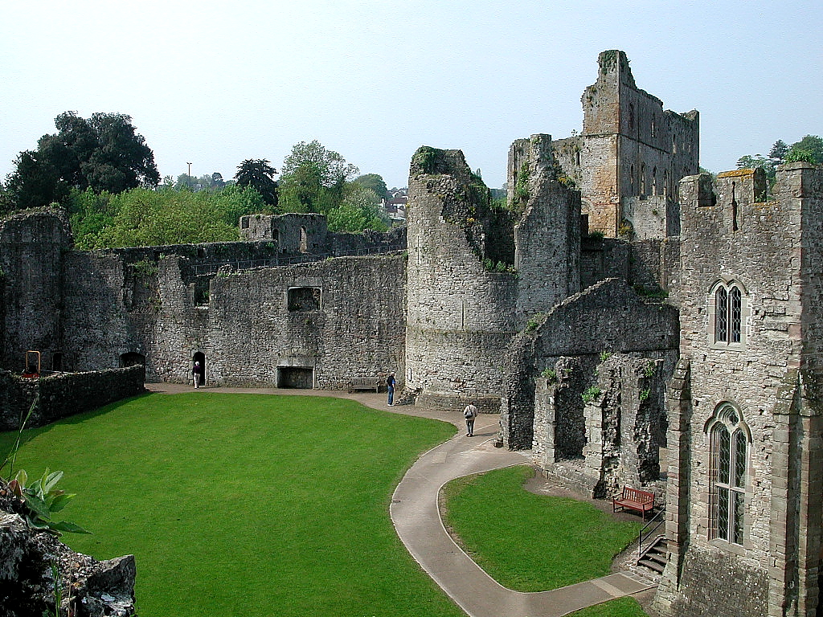  Bailey | The area in between the keep of a castle and the curtain wall. This could become a ‘kill zone’ after an initial breach of the outer walls.
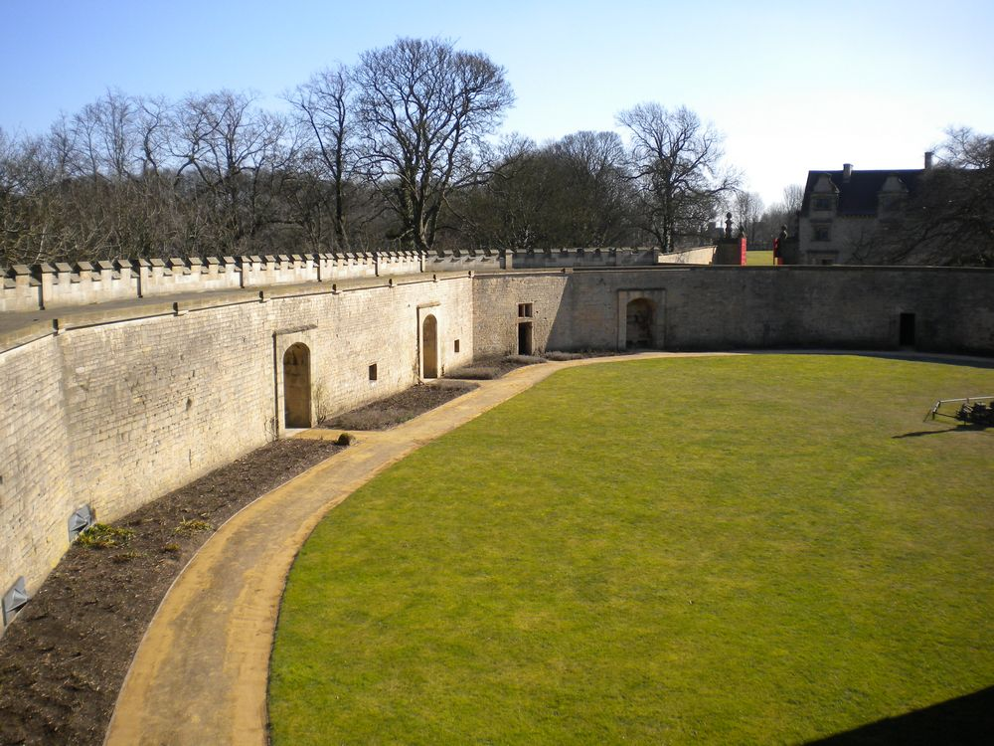  Curtain Wall | The outer walls of a castle that protected the inhabitants and buildings beyond the keep.
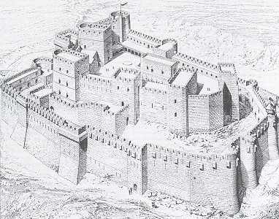  Concentric Walls | Two (or more) curtain walls built to create circuits between each ring of defences.

Medieval Sieges – Key Features

Feature | Definition | Strengths/weaknesses
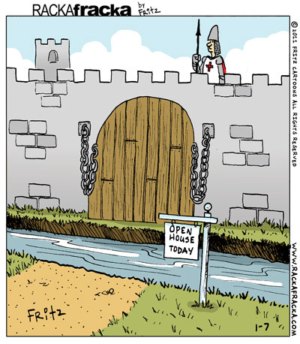  Moat | A ditch, often filled with water (rarer in Outremer, however), that encircled the outer wall.
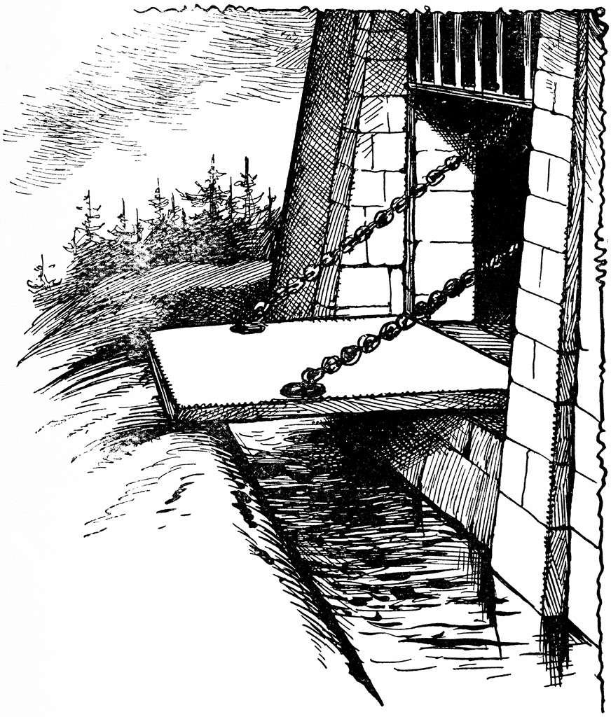  Drawbridge | A board, lowered down from the main gate of the castle, so that a moat could be crossed.
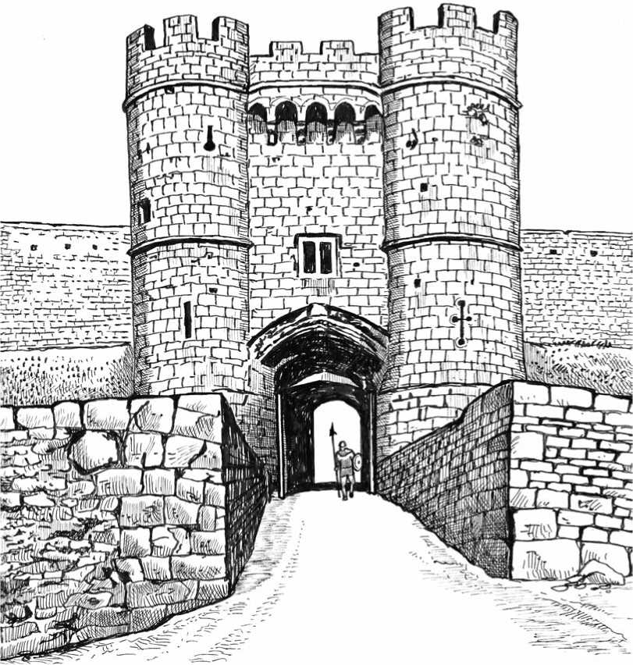  Gatehouse | An extra-fortified section to help defend the entrance of a castle, usually built much higher than the surrounding walls.
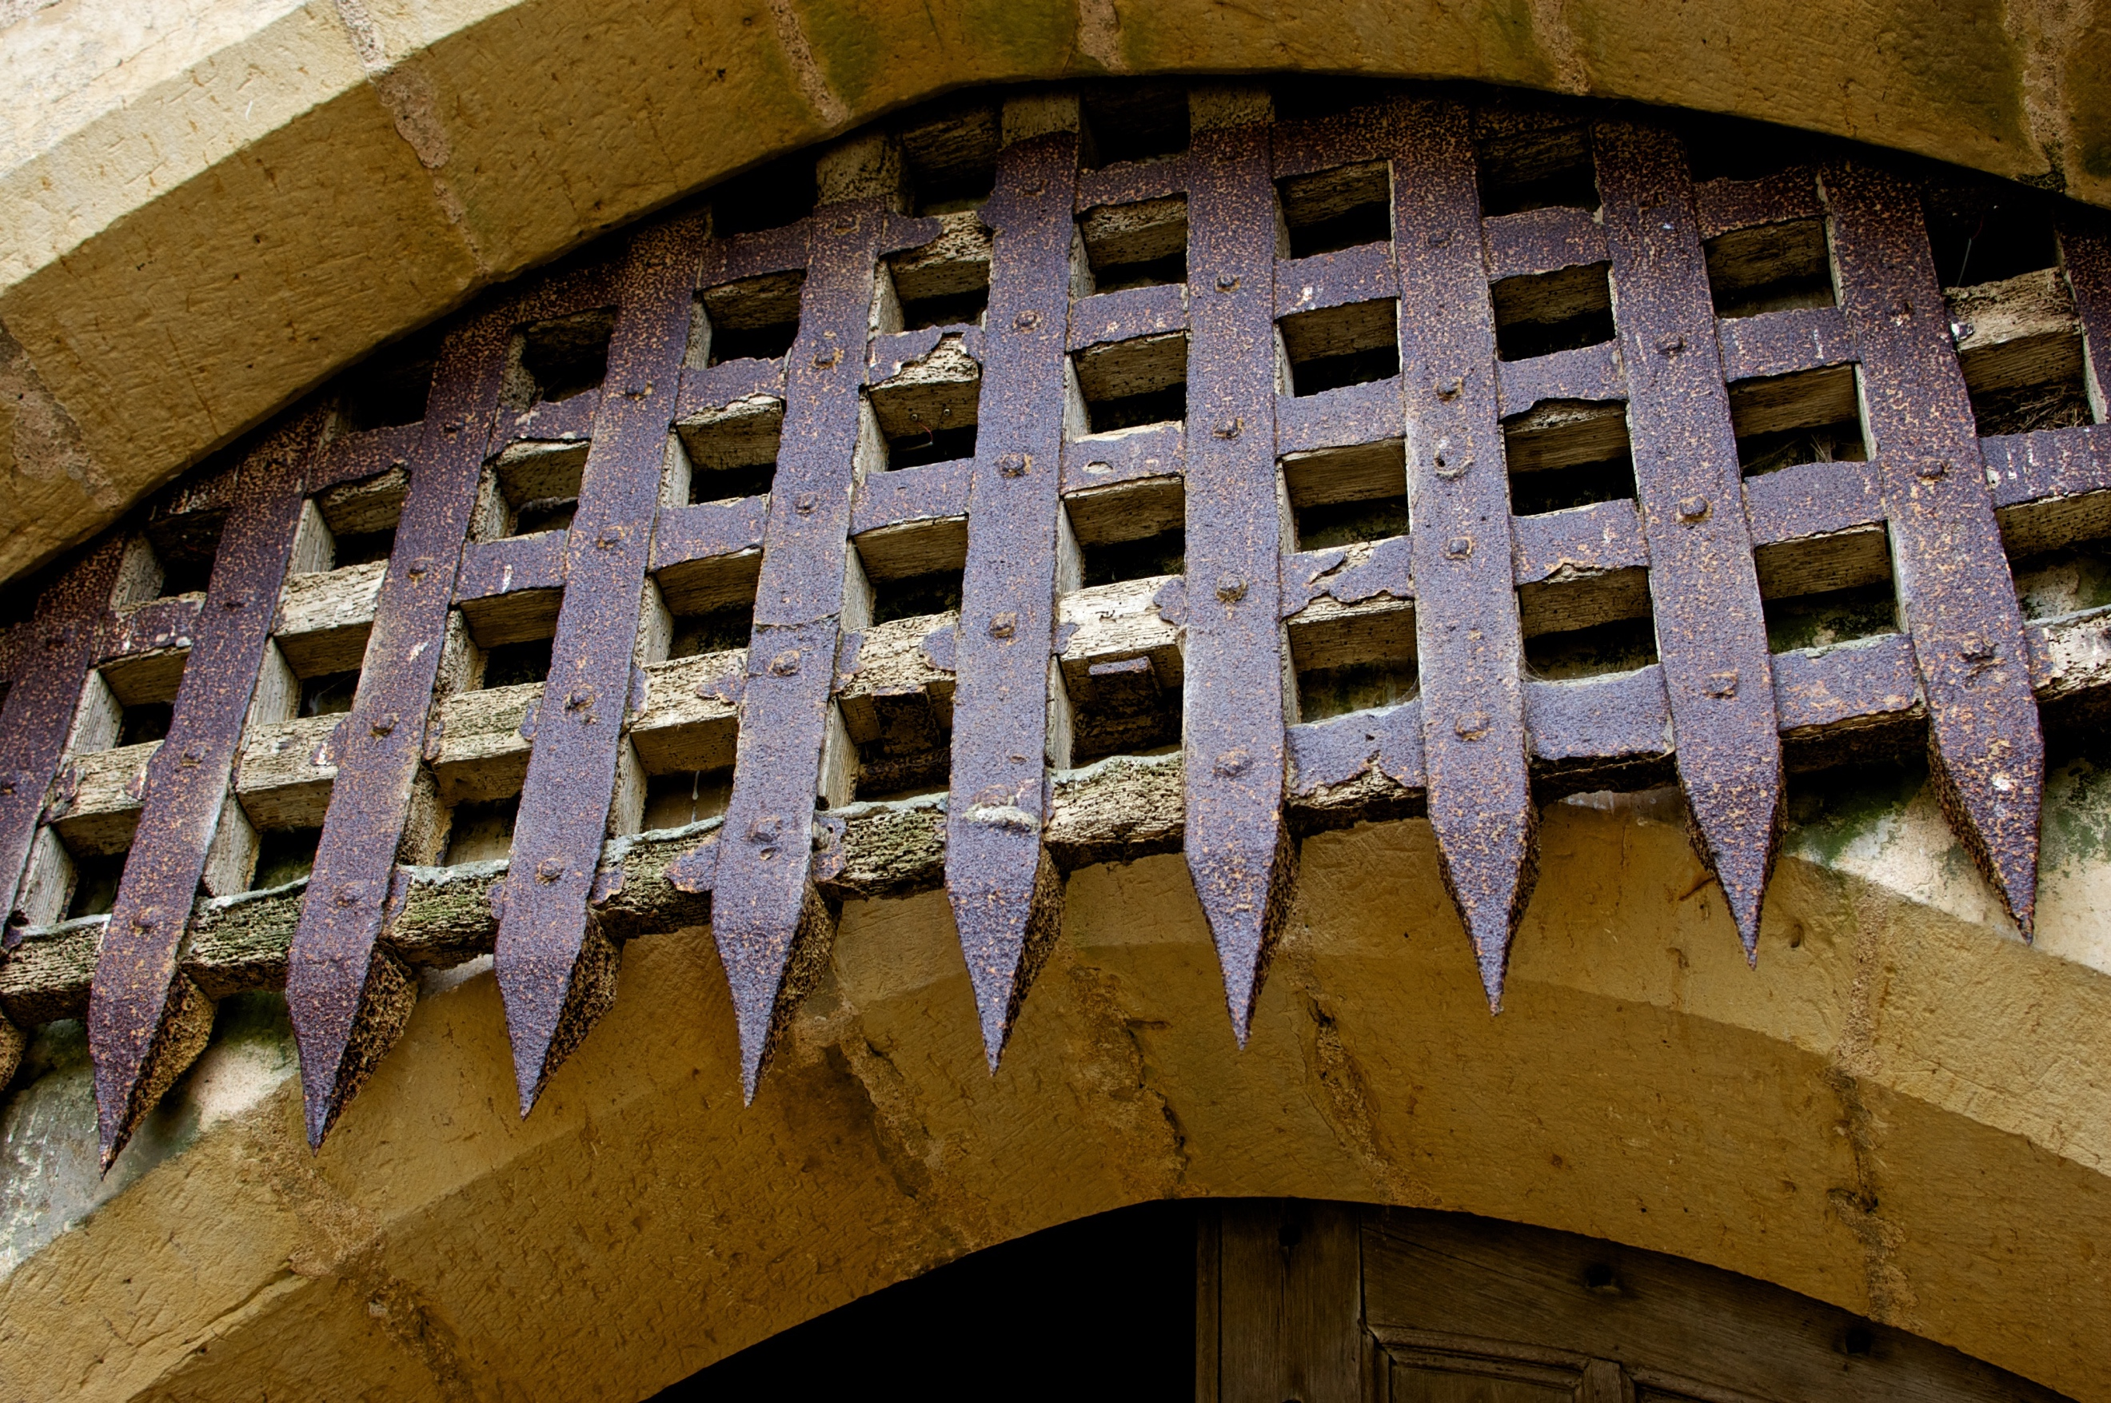  Portcullis | A (usually metal) spiked grate that lowered down in front of the castle’s gate.

Medieval Sieges – Key Features

Feature | Definition | Strengths/weaknesses
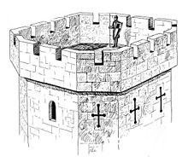  Towers | Taller sections attached to the walls that provided higher vantage points and often a large platform at the top.
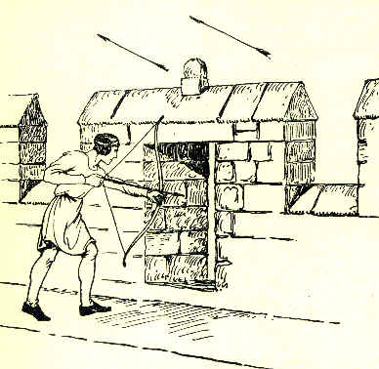  Battlements | The walkway that ran along the top of castle walls and towers to allow soldiers to guard the defences
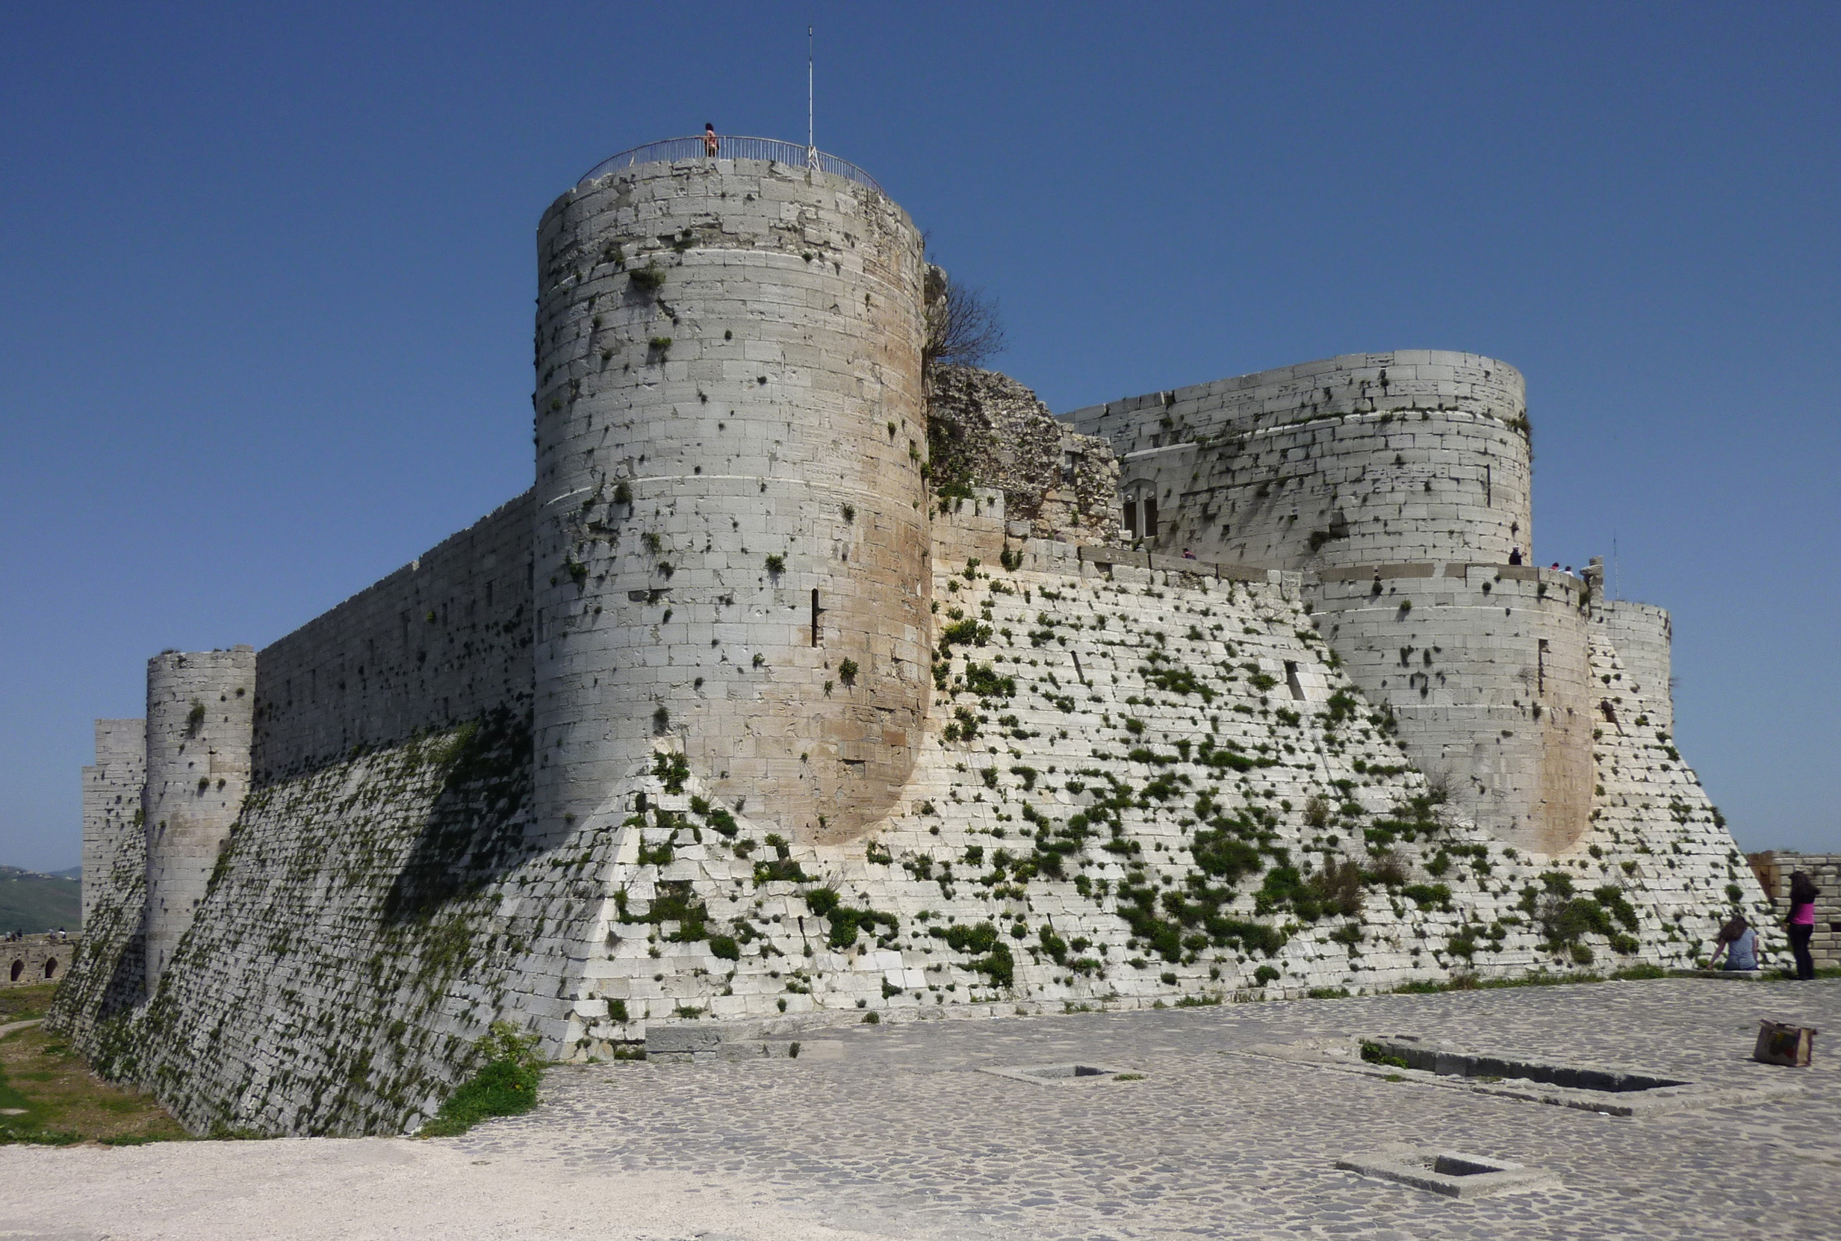  Talus | A slope that ran along the outside of the outer wall, often deliberately made in a rough, jagged manner.
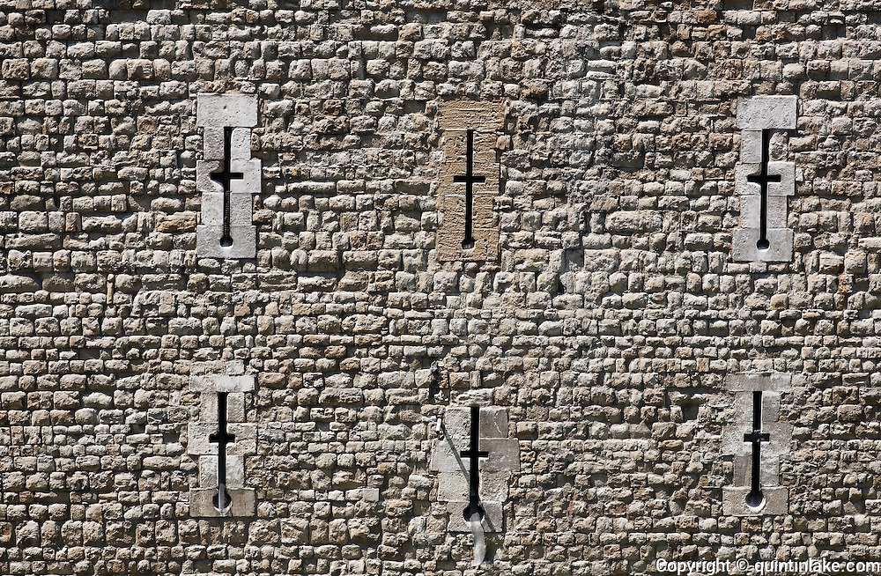  Arrow Slits | Narrow holes in the walls of towers and other defences to allow archers to shoot at attackers from within.

Medieval Sieges – Key Features

Feature | Definition | Strengths/weaknesses
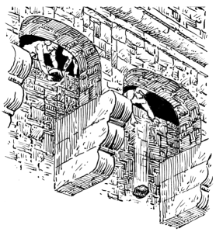  Murder Holes | Holes overlooking the ground below a wall or gate that allowed defenders to drop nasty surprises on the attackers.
Storeroom | A dry area in a castle where food, firewood and animal fodder could be kept dry. Some food was preserved through curing.
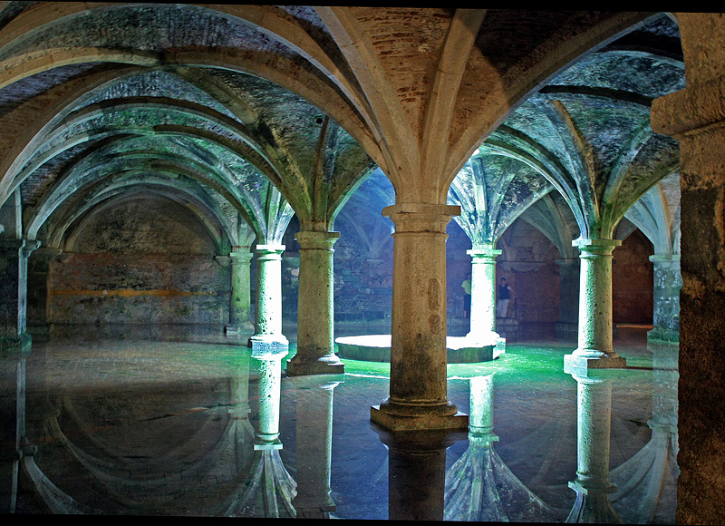  Cistern | An area in a castle, often a tank, but sometimes a room, that stored water. | 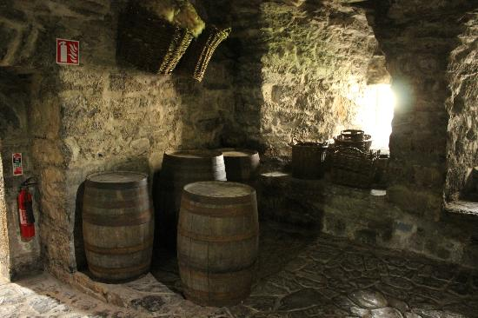
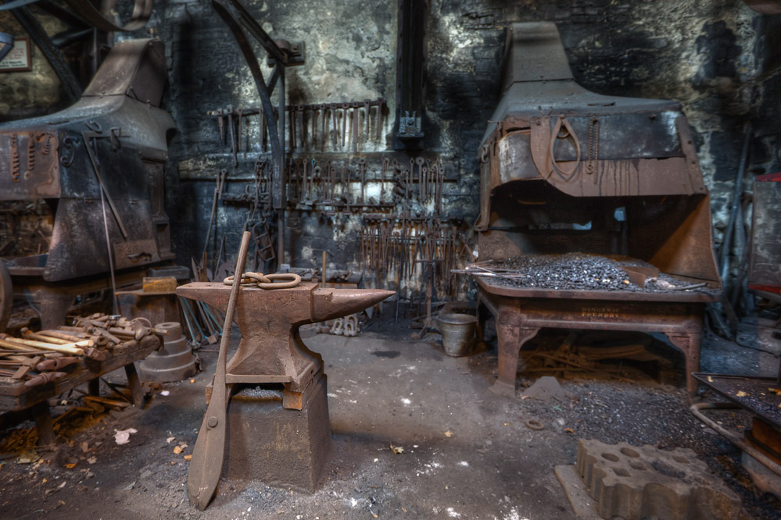  Smithy | A place where metal tools, weapons and armour were made and repaired, as well as essential metal parts of the castle itself

Medieval Sieges – Key Features

Feature | Definition | Strengths/weaknesses
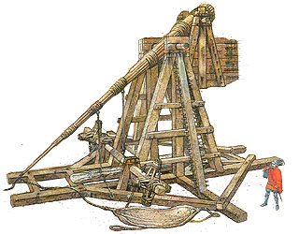  Trebuchet | A long-range catapult that flung projectiles out of a sling. The counterweight is raised using winches.
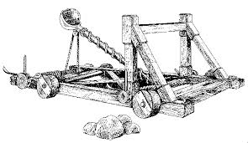  Mangonel | A catapult that fired projectiles out of a bowl-shaped bucket up to 1300 feet.
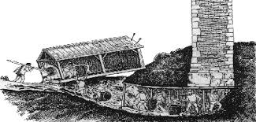  Undermining | The act of digging a tunnel, supported by wood, beneath a castle wall. The wooden beams could be burnt to collapse the wall.
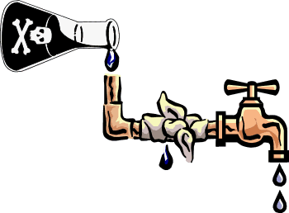  Poison | Sabotaging a water supply that flowed into a castle with the use of rotting corpses or excrement.

Medieval Sieges – Key Features

Feature | Definition | Strengths/weaknesses
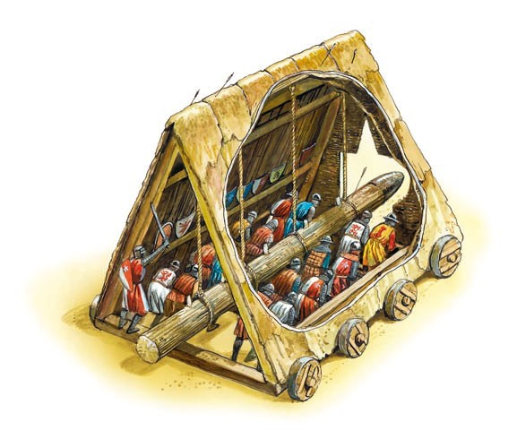  Battering Ram | A large log or similar object swung by hand or on chains to smash through gates or even walls.
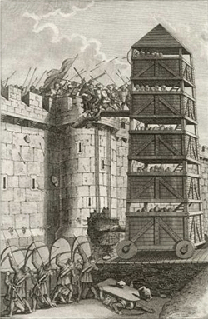  Belfry | A tower, either constructed at a wall or built on wheels to allow attacker to get onto the battlements via a drawbridge.
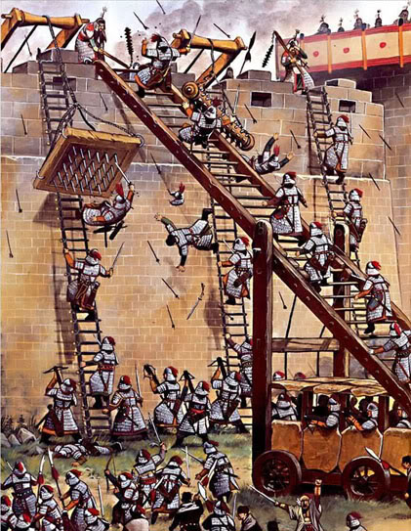  Ladder | Wooden rungs or steps raised against the walls to allow soldiers to climb onto the battlements.
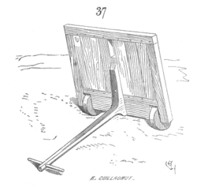  Mantlet | A protective wooden board move into position to provide attacking archers with some cover.

