**Amines & Amino acids &   
Polymers & DNA**

**Revision PPQ Answers**

51 marks

**Q1.**

(a)     (i)

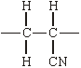

*(Ignore n or brackets, but trailing bonds are essential)*

**1**

(ii)     Addition or radical

**1**

(b)     (i)      2-aminobutanoic (acid)

**1**

(ii)

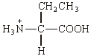

**1**

(c)     (i)      C3H4O2

**1**

(ii)



**1**

(1,4-)butan(e)dioic (acid)

*(allow succinic, but not dibutanoic nor butanedicarboxylic acid)*

**1**

(iii)     Can be hydrolysed / can react with acid or base or water /  
can react with nucleophiles

**1**

**[8]**

**Q2.**

(a)     (i)      H+ or proton acceptor **(1)**CH3NH2 + H2O () CH3+NH3 (+) OH– **(1)**

(ii)     CH3NH3Cl or HCl **(1)**

*Or any ammonium compound or strong acid  
name or formula*

(iii)     extra OH– reacts with   
or reaction / equilibrium moves to left  
or ratio salt / base remains almost constant **(1)**

*Any 2*

**5**

(b)     lone pair (on N accepts H+) **(1)**CH3 increases electron density (on N)  
       donates / pushes electrons  
       has positive inductive effect **(1)**

**2**

(c)     nucleophilic substitution **(1)  
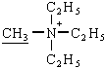 (1)**

**2**

**[9]**

**Q3.**

(a)     (i)

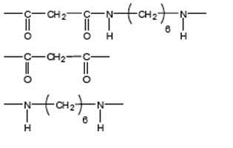

Allow –CONH- or - COHN -

*Mark two halves separately*

*lose 1 each for missing trailing bonds at one or both ends or error in peptide link or either or both of H or OH on ends*

**1**

*Not allow –(C6H12)–*

*Ignore n*

**1**

(ii)     **M1** in polyamides - H bonding

**1**

**M2** in polyalkenes - van der Waals forces

*Penalise forces between atoms or van der Waals bonds*

**1**

**M3** Stronger forces (of attraction) in polyamides  
Or H bonding is stronger  
(must be a comparison of correct forces to score M3)

*Do not award if refer to stronger bonds*

**1**

(b)     (i)      (nucleophilic) addition elimination

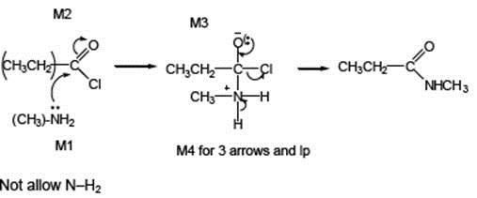

*Minus sign on NH2 loses* ***M1***

**1**

*M2 not allowed independent of* ***M1****, but allow* ***M1*** *for correct attack on C+*

*+ rather than + on C=O loses* ***M2***

*If Cl lost with C=O breaking, max 1 for* ***M1***

***M3*** *for correct structure with charges but*

*lp on O is part of* ***M4***

*only allow* ***M4*** *after correct/ very close M3*

*For M4, ignore NH3 removing H+ but lose*

***M4*** *for Cl removing H+ in mechanism,*

*but ignore HCl as a product*

**4**

(ii)     N-methylpropanamide

*Not N-methylpropaneamide*

**1**

(c)

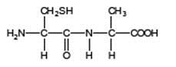

*Allow –CONH– or –COHN–*

**1**

(d)     (i)      2-amino-3-hydroxypropanoic acid

**1**

(ii)

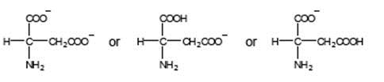

Must be salts of aspartic acid

*allow –CO2–*

*allow NH2–*

**1**

(iii)     Penalise use of aspartic acid once in d(iii) and d(iv)

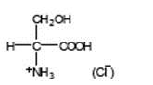

*allow –CO2H*

*allow +NH3–*

*don’t penalize position of + on NH3*

**1**

(iv)    Penalise use of aspartic acid once in d(iii) and d(iv)

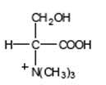**(Br–)**

*allow –CO2–*

*must show C-N bond*

*don’t penalize position of + on N(CH3)3*

**1**

**[16]**

**Q4.**

(a)     (i)      hexane-1,6-diamine or 1,6-diaminohexane **(allow ammine)**or 1,6 hexan(e)diamine **(1)**

(ii)     

*Allow –CONH–*

**2**

(b)     (i)      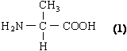

(ii)     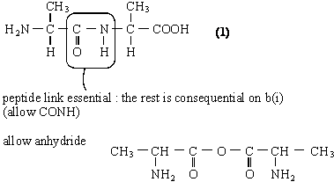

**2**

(c)     (i)      quaternary ammonium bromide salt **(1)**

*(not ion, not compound)*

*Allow quarternery*

(ii)     *Reagent*: CH3Br or bromomethane **(1)**

*penalise CH3Cl but allow excess for any halomethane*

*Condition*: excess (CH3Br) **(1)**

(iii)     nucleophilic substitution **(1)**

**4**

**[8]**

**Q5.**

(a)     2-deoxyribose

**1**

(b)     Base A

*If Base B stated, allow 1 mark only for response including hydrogen bonding*

**1**

Top N–H forms hydrogen bonds to lone pair on O of guanine

**1**

The lone pair of electrons on N bonds to H–N of guanine

**1**

A lone pair of electrons on O bonds to lower H–N of guanine

*Allow all 4 marks for a correct diagram showing the hydrogen bonding*

*Students could also answer this question using labels on the diagram*

**1**

(c)     Allow either of the nitrogen atoms with a lone pair NOT involved in bonding to cytosine

**1**

(d)     Use in very small amounts / target the application to the tumour

**1**

**[7]**

**Q6.**

C

**[1]**

**Q7.**

C

**[1]**

**Q8.**

B

**[1]**