**Iliad Book 7**

*Add the names of the characters that fit in this diagram of the plot. There are two red herrings!*

Wants to accept the challenge

These two gods debate how to settle the war.

This one suggests a champion to fight

Instead this one is chosen by lot

It’s agreed the winner will return the dead body for burial

VS

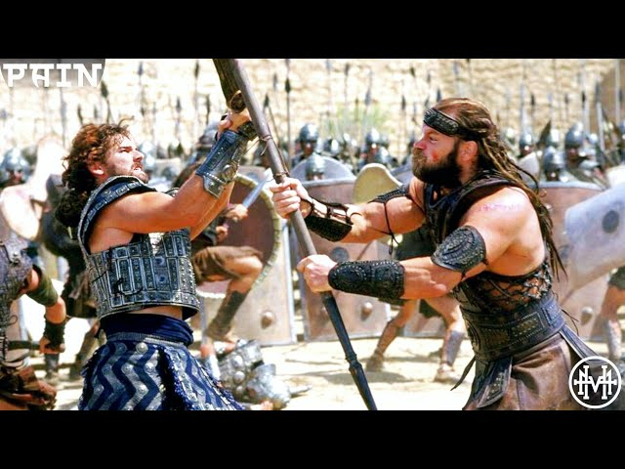

It’s a draw, and they exchange gifts

Paris’ offer is rejected by this one

This god orders the Achaean defences be destroyed

Zeus Hector Diomedes

Menelaus Aphrodite Athena

Ajax Apollo Pandarus