

**Higher IGCSE (9 – 1) Revision Pack**

**Circle Theorems**

**Part 2**

**Name --------------------------------**

**Questions**

**Q1.**

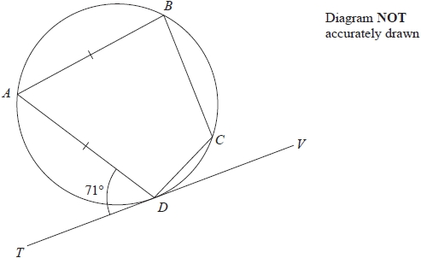

*A*, *B*, *C* and *D* are points on a circle.   
TDV is the tangent to the circle at *D*.

*AB* = *AD*  
Angle *ADT* = 71°

Work out the size of angle *BCD*.   
Give a reason for each stage of your working.

........................................................... °

**(Total for question = 5 marks)**

**Q2.**

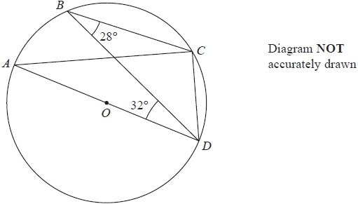

*A*, *B*, *C* and *D* are points on a circle, centre *O*.   
*AOD* is a diameter of the circle.

Angle *CBD* = 28°   
Angle *BDA* = 32°

Find the size of angle *BDC*.   
Give a reason for each stage of your working.

........................................................... °

**(Total for question = 4 marks)**

**Q3.**

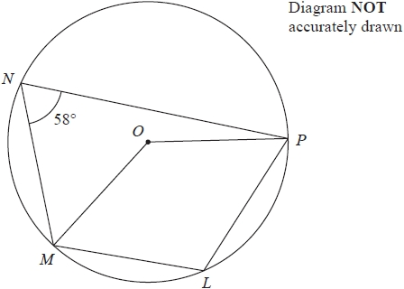

*L*, *M*, *N* and *P* are points on a circle, centre *O*

Angle *MNP* = 58°

(a)  (i)  Find the size of angle *MLP*

........................................................... °

(ii)  Give a reason for your answer.

.............................................................................................................................................

.............................................................................................................................................

**(2)**

(b)  Find the size of the reflex angle *MOP*

........................................................... °

**(2)**

**(Total for question = 4 marks)**

**Q4.**

The sides of triangle *PQR* are tangents to a circle.  
The tangents touch the circle at the points *S*, *T* and *U*.  
*QS* = 6 cm. *PS* = 7 cm.

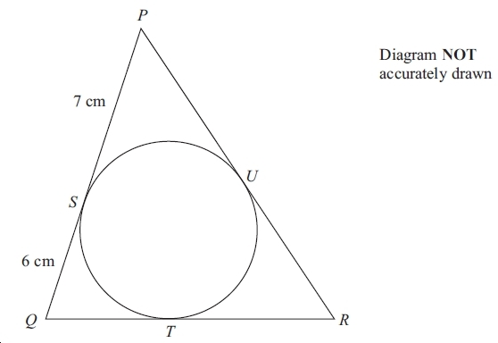

(a) (i) Write down the length of *QT*.

...............................cm

(ii) Give a reason for your answer.

      ..............................................................................................................................................

**(2)**

The perimeter of triangle *PQR* is 42 cm.

(b) Calculate the size of angle *PQR*.  
Give your answer correct to 1 decimal place.

..............................................°

**(4)**

**(Total for question = 6 marks)**

**Q5.**

*P*, *Q*, *R*, *S* and *T* are points on a circle with centre *O*.

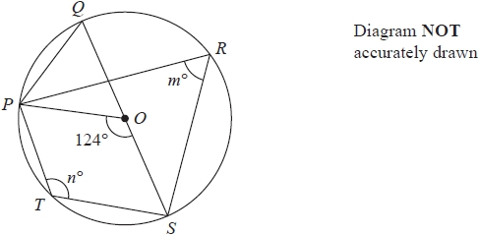

*QOS* is a diameter of the circle.

angle *POS* = 124°            angle *PRS* = *m*°            angle *PTS* = *n*°

(a)  Find the value of

(i)  *m*

...........................................................

(ii)  *n*

...........................................................

**(2)**

(b)  Find the size of angle *QPO*.

...........................................................°

**(1)**

**(Total for question = 3 marks)**

**Q6.**

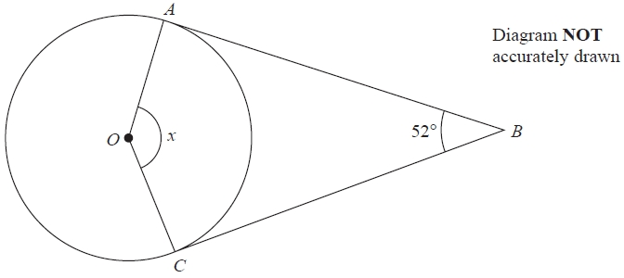

*A* and *C* are points on a circle, centre *O*.   
*AB* and *CB* are tangents to the circle.   
Angle *ABC* = 52°

Work out the size of angle *x*.   
Give a reason for each stage of your working.

*x* = ........................................................... °

**(Total for question = 4 marks)**

**Q7.**

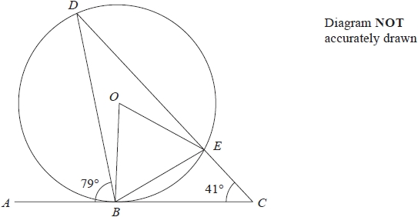

*B*, *D* and *E* are points on a circle, centre *O*.   
*ABC* is a tangent to the circle.   
*DEC* is a straight line.   
Angle *ABD* = 79° and angle *ECB* = 41°

(a)  Write down the size of angle *BED*.

........................................................... °

**(1)**

(b)  Work out the size of angle *BOE*.

........................................................... °

**(2)**

**(Total for question = 3 marks)**

**Q8.**

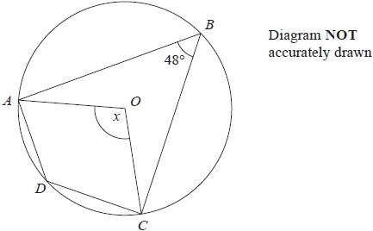

*A*, *B*, *C* and *D* are points on a circle with centre *O*.   
Angle *ABC* = 48°

(a) (i)  Calculate the size of angle *x*.

........................................................... °

(ii)  Give a reason for your answer.

.............................................................................................................................................

.............................................................................................................................................

**(2)**

(b) (i)  Calculate the size of angle *ADC*.

........................................................... °

(ii)  Give a reason for your answer.

.............................................................................................................................................

.............................................................................................................................................

**(2)**

**(Total for question = 4 marks)**

**Q9.**

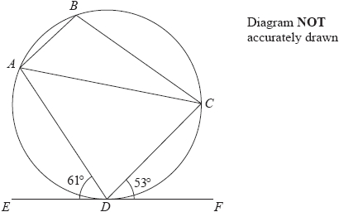

*A*, *B*, *C* and *D* are points on a circle.   
*EDF* is the tangent to the circle at *D*.

Angle *ADE* = 61° and angle *CDF* = 53°

(a)  (i)  Write down the size of angle *ACD*.

........................................................... °

(ii)  Give a reason for your answer.

.............................................................................................................................................

**(2)**

(b)  Work out the size of angle *ABC*.

........................................................... °

**(2)**

**(Total for question = 4 marks)**

**Q10.**

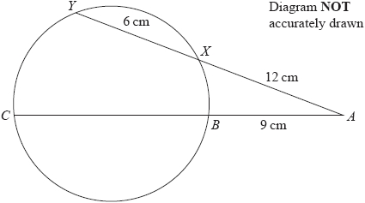

The points *B*, *C*, *Y* and *X* lie on a circle.   
*AXY* and *ABC* are straight lines.   
*AX* = 12 cm      *XY* = 6 cm      *AB* = 9 cm

Calculate the length of *BC*.

........................................................... cm

**(Total for question = 3 marks)**

**Q11.**

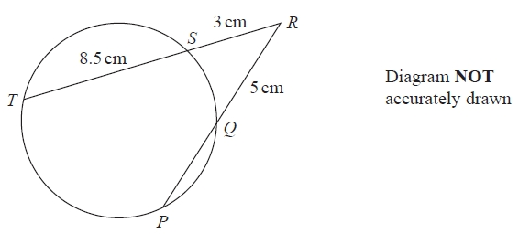

*P*, *Q*, *S* and *T* are points on a circle.   
*TSR* and *PQR* are straight lines.

Work out the length of *PQ*.

........................................................... cm

**(Total for question = 3 marks)**

**Q12.**

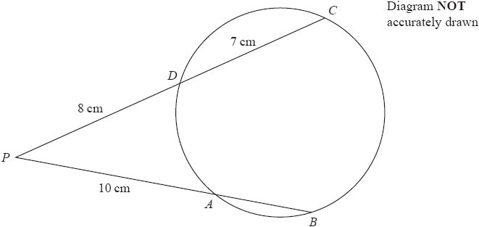

*A*, *B*, *C* and *D* are points on a circle.

*PAB* and *PDC* are straight lines.   
*PA* = 10 cm, *PD* = 8 cm and *DC* = 7 cm.

Calculate the length of *AB*.

........................................................... cm

**(Total for question = 3 marks)**

**Q13.**

*PTR* and *QTS* are chords of a circle.

PT = 3 cm.   
*ST* = 10 cm.   
*RT* = 15 cm.   
*QT* = *x* cm.

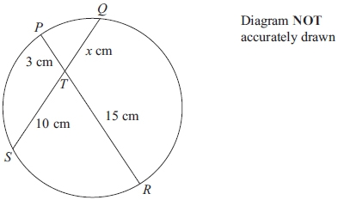

Calculate the value of *x*.

*x* = ...........................................................

**(Total for question = 2 marks)**

**Q14.**

*P*, *Q* and *R* are points on a circle, centre *O*.   
*TRV* is the tangent to the circle at *R*.

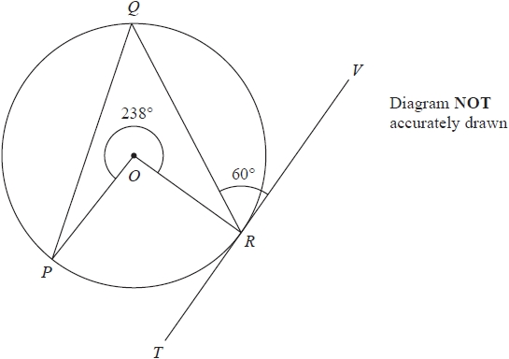

Reflex angle *POR* = 238°   
Angle *QRV* = 60°

Calculate the size of angle *OPQ*.   
Give a reason for each stage of your working.

........................................................... °

**(Total for question = 4 marks)**

**Q15.**

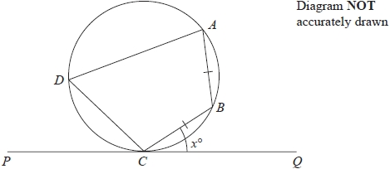

*A*, *B*, *C* and *D* are points on a circle.   
*PCQ* is a tangent to the circle.   
*AB* = *CB*.

Angle *BCQ* = *x*°

Prove that angle *CDA* = 2*x*°   
Give reasons for each stage in your working.

**(Total for question = 5 marks)**