3.6.2 Analysing HR data

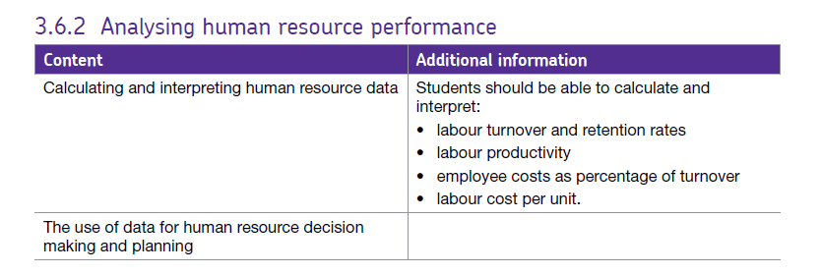

This booklet looks at the techniques used to analyse workforce performance such as calculating labour productivity and labour cost per unit. This might provide managers with crucial information needed for decision making. Before managers take decisions to improve the performance of the workforce, it is important to analyse the current position. This enables mangers to make more informed, effective decisons.

There is a range of data available for managers to assess the performance of employees and we will look at these in turn:

# http://s3-eu-west-1.amazonaws.com/tutor2u-media/subjects/business/diagrams/labour-productivity-formula.jpg?mtime=20150313144620Labour productivity

Labour productivity measures the output per employee over a period of time.

Labour productivity is the most basic indicator of employee performance since it has implications for a business’s costs and therefore pricing.

An increase in labour productivity means that employees are producing more output over a period of time. This in turn means that a business is able to **increase profit margins** or **reduce prices**.

Labour productivity depends upon a number of factors such as:

* The number and quality of capital equipment
* The degree of motivation of employees
* The nature of the product and the type of production techniques used
* The skills of the workforce
* Capacity utilisation – in times of high capacity utlisation, the business will provide incentives such as overtime for labour to work harder and so labour productivity will increase. When economic activity falls, orders fall, businesses may hold on to their employees initially instead of making them redundant straight away and as a result, productivity will fall

However, when observing data which applies to the entire UK economy, one must remember that not all business sectors in the UK will be experiencing the same trend in productivity. Some sectors may be doing better or worse than this. A business with low labour productivity might still be competitive if **wage rates** are low. This is because labour costs typically account for about two thirds of the costs of production.

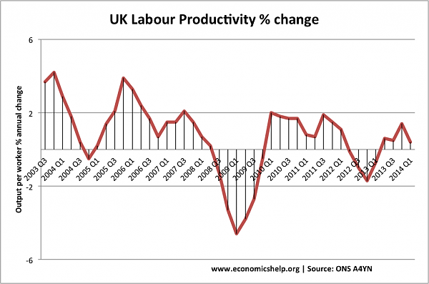When looking at labour productivity for one business, an increase in labour productivity may not necessarily be beneficial as labour productivity for competitors may have risen at a faster rate.

## Unit labour costs

There is a negative correlation between labour productivity and unit labour costs. As labour productivity increases, it will lead to a reduction in average unit labour costs since costs will be divided amongst a greater output.

Unit labour costs are based on *total* labour costs including *non-wage employment costs* such as a business’s National Insurance and pension contributions. Unit labour costs are calculated as:

**Total Labour Costs**

**Total Units of Output**

If a business manufactures 12,000 TV sets in a month with £900,000 total labour costs, then the unit labour costs for the TV sets is £900,000 / 12,000 = £75.

Unit labour costs represent the amount of money needed to pay employees to make one unit of output. Since there is a negative relationship between unit labour costs and productivity, an employer may be willing to increase wage rates if productivity has increased.

**Factors to consider when interpreting unit labour costs**

Lower labour unit costs are preferred, especially if they are below competitors. It is wise to observe labour unit costs *over time* since short term factors can have an impact on unit labour costs. For example, if some employees are engaged in off the job training, other colleagues may be paid overtime to cover their work and this will increase unit labour costs. Labour costs are only one cost to consider. If average unit labour costs fall while other costs increase, then the business will not be price competitive regardless.

**Strategies to increase labour productivity and reduce labour costs per unit**

* Recruitment and selection of suitably skilled and trained employees.
* Provision of training to enhance skills of existing employees.
* Appropriate pay and non-financial benefits to improve motivation and effort.
* Improved working practices which result in greater involvement of employees.
* Improved technology and capital equipment.

**Specific ways to reduce labour costs per unit include:**

* Negotiating pay reductions in order to retain staff. In this way, labour unit costs were cut without having to lose staff.
* Replacing workers with machines. As technology improves, more and more tasks can be done efficiently by machine.
* Outsourcing production to other firms.
* Budgeting employee costs as a percentage of revenue. This is good if the business supplies a *service*, labour represents a high proportion of the costs but the employees do not produce a physical output. This measure is often used by Premier League football clubs who generate revenue from supporters as well as TV deals with Sky and BT Sport.

## Influences of employee costs as a proportion of revenue

Higher levels of labour productivity will result in more products made and therefore sold. This of course will increase revenue. An increase in **wage rates** or **salaries** will increase employee costs. If sales revenue does not increase in the same proportion, then employee costs as a proportion of revenue will increase. Non-wage employment costs such as an expensive company pension scheme can drive up labour costs without necessarily increasing revenue.

Low capacity utilisation results in labour not being used efficiently to produce output. Low capacity utilisation is generally caused by low demand for the product and therefore employee costs as a proportion of revenue will rise.

## Labour turnover

Labour turnover is the number of people leaving a business over a period of time (usually a year). It is calculated as:

http://www.s-cool.co.uk/assets/learn_its/alevel/business-studies-as--a2-level/people-in-the-workplace/human-resource-management-hrm/image1.jpg

Because there are staff entering and leaving the business throughout the year, the business will usually use the *average* number of staff employed during the year rather than the *total* number of staff employed. For example, if the average number of staff employed last year was 250 and the number of employees who left the business during the year was 10, the labour turnover would be:

(10 / 250) X 100 = 4%

If the number of people leaving the company increases in the year while the average number of employees stays the same, then the rate of labour turnover will increase. If the number of employees leaving over a given period falls yet the average number of employees stays the same, then the rate of labour turnover will fall. If the number of employees leaving stays the same but the average number of workers employed rises or falls, then the rate of labour turnover will rise or fall respectively.

## Retention rate

This is calculated as follows:

**Number of employees with one or more years’ service 100**

**Overall workforce numbers**

For example, if the overall workforce comprised 250 workers and of these 100 had worked for the firm for more than one year, the retention rate would be:

(100/250) X 100 = 40%

If the number of employees with one or more years’ service rises while the overall workforce numbers remain the same, the retention rates will increase.

Both labour turnover and retention rates provide an organisation with data that can be used for human resource decision making and planning. If labour turnover is high and retention rates are low, this is likely to be reflected in problems elsewhere in the organisation. The types of problems created by high labour turnover and low retention rates are as follows:

# Problems associated with high labour turnover and low retention rates

High recruitment and selection costs to replace staff who leave. These include the administrative and management costs incurred in advertising positions, conducting interviews etc. Such costs are likely to be higher for senior management and professionals.

High induction and training costs to ensure that new employees quickly become familiar with the practices of the business and learn the necessary skills to carry out their job effectively. This process can take a great deal of time, especially if the job requires specialised skills.

A need to redesign jobs because in some industries where labour turnover is a particular problem, jobs have to be redesigned to keep them as simple as possible so it’s easier to replace the staff.

Reduced productivity due to the disruption caused by skilled staff leaving and new, usually untrained, staff joining the business. Low morale amongst existing staff as a result of the constant change of work colleagues.

## Typical cause of high labour turnover and low retention rates

In general, labour turnover and retention rates indicate how content the workforce is. If labour turnover is increasing and retention rates are decreasing, it could be a general sign of worker unrest and dissatisfaction. Causes include:

* Ineffective leadership and management techniques
* Poor communication
* Wages and salaries are lower than those being paid by other similar firms
* Poor selection and recruitment procedures
* Boring and unchallenging jobs which lack career development opportunities
* Poor working conditions and unpopular working practices
* Low morale and motivation
* If the economy is improving, there may be more attractive employment opportunities elsewhere

## Improving labour turnover and low retention rates

**Monitoring and benchmarking:** Many firms are either not proactive in dealing with labour turnover or unaware of its costs and implications. A monitoring system that includes knowing how labour turnover in a firm compares with the industry average, tracking trends in employee turnover over time, and identifying areas, departments and roles in a firm where labour turnover is particularly high or retention rates are particularly low, might be useful.

**Recruitment and selection:** The amount of money spent on ensuring that recruitment and selection procedures are effective will be more than recouped by the savings made from the lower labour turnover later on.

**Exit interviews:** These are useful to identify problem areas in an organisation and any characteristics which may be common to leavers who have not been with the firm for long. Issues to discuss include the job itself, supervision and management, pay and conditions of work and training and career prospects.

**Induction and training:** High quality induction training to make new employees feel part of the firm is as important as any other form of training.

**Reducing turnover of long-** **term employees:** Employees who have been with the firm for a long time, accumulate a huge amount of work specific human capital i.e. knowledge and skills relating directly to the business. If these employees leave, their knowledge and skills will disappear, so it is vital for the business to try and retain them. This may mean that the business has to ensure some kind of career progression and they must examine their remuneration to ensure it is not out of line with that provided by other businesses offering similar jobs.

# Data and human resource planning

The human resource plan is used to access the current and future capacity of a business’s workforce and sets out the actions necessary to meet the business’s future human resource needs. Human resource planning is one of the core activities of human resource management and entails a number of stages.

The human resource plan must contribute to the achievement of the business’s overall corporate objectives then take a strategic view of employees. This might include looking at how technology might complement or replace workers.

Those planning human resources will then need to make a judgement about the size and type of workforce the organisation will require over the future years.

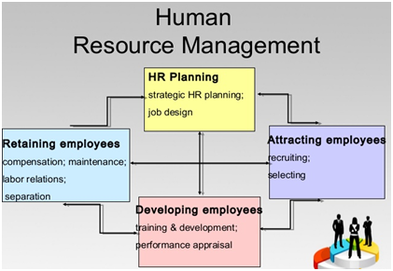The desired future workforce is then compared with that available at the time of planning.

Once this has been done, the business can then decide upon the policies required e.g. recruitment, training, redeployment and redundancy. This is needed so that the business can convert its existing workforce in to the future desired one.

A business’s human resource plan will require managers to draw on a range of data and this will include:

**Information on the business’s current workforce**

This will include:

* The number of employees that the business currently has and their skills.
* Data relating to labour productivity for the existing workforce.
* Current and forecast labour costs including unit labour costs.
* The age profile of employees, which will help the business to forecast future changes due to retirement etc.
* The business’s overall corporate objectives.

**Information from outside the business**

This will include:

* The expected rate of unemployment for workers with the skills required by the business.
* Forecast wage rates for potential employees.
* Expected demand for products supplied by the business.
* Likely prices at which the business can expect to sell its products.
* Availability and cost of technology which could be used in production.
* Economic forecasts and trends.