

**Marking Scheme**

**Direct and Inverse Proportion**

**Q1.**

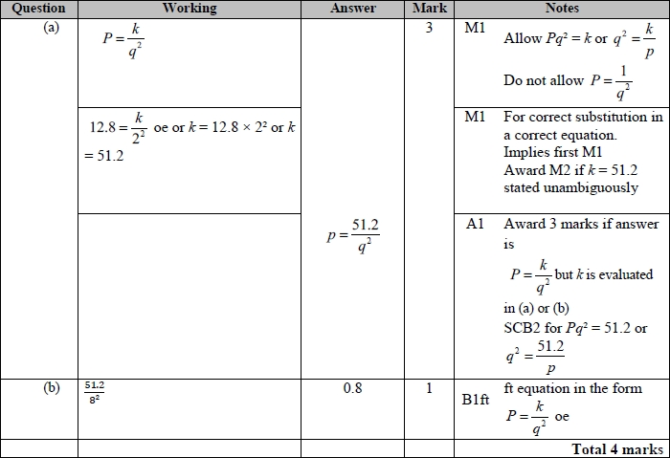

**Q2.**

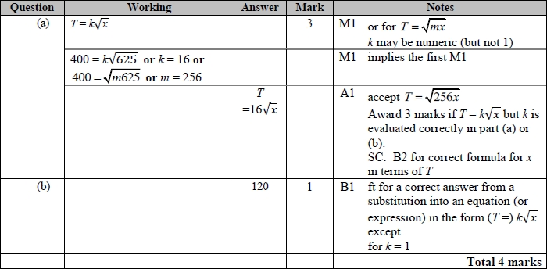

**Q3.**

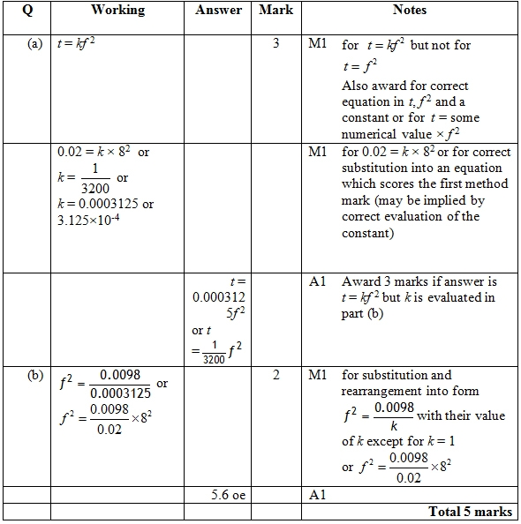

**Q4.**

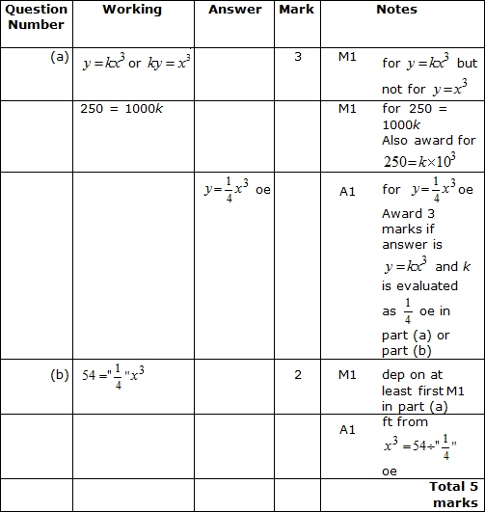

**Q5.**

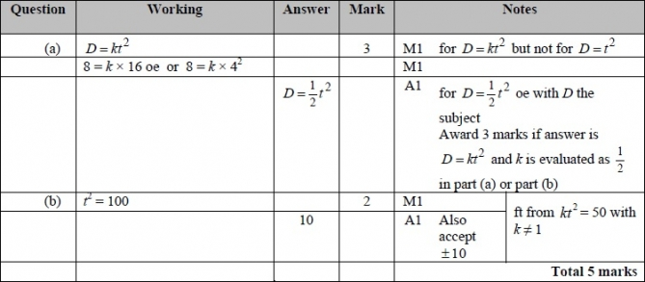

**Q6.**

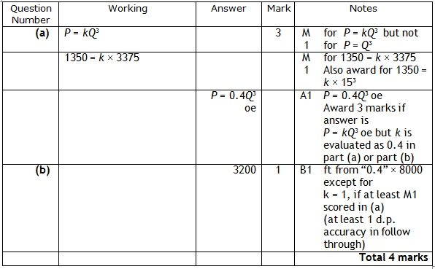

**Q7.**

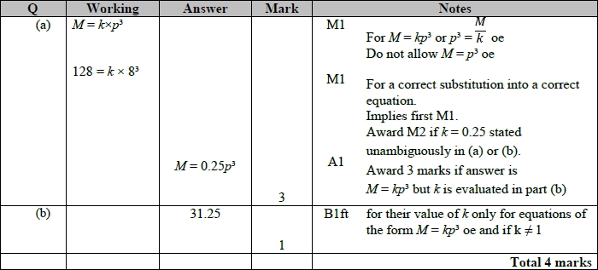

**Q8.**

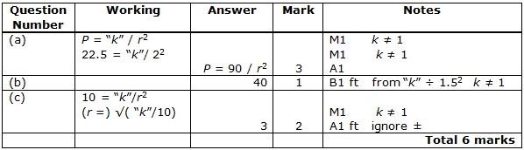

**Q9.**

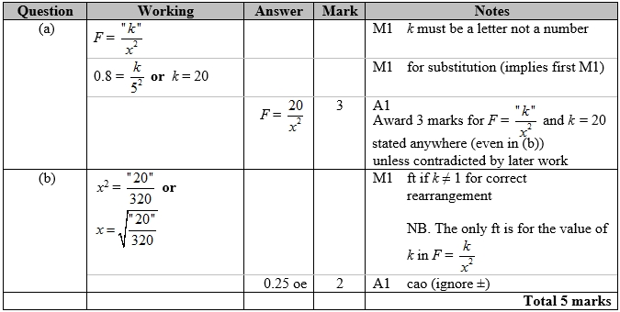

**Q10.**

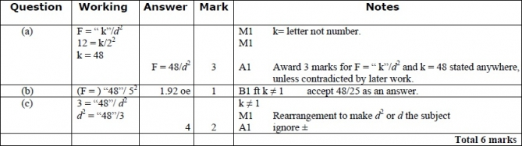

**Q11.**

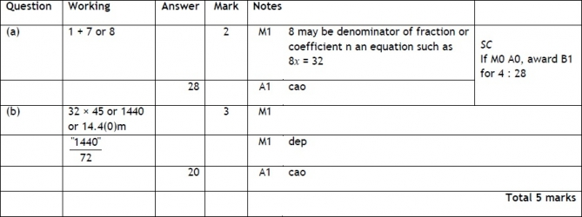

**Q12.**

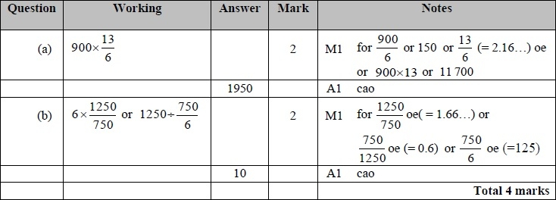

**Q13.**

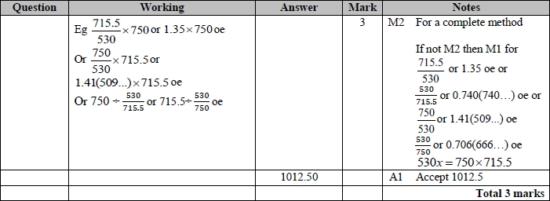

**Q14.**

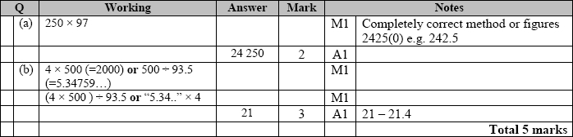

**Q15.**

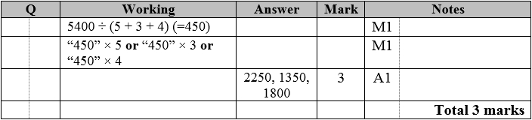

**Q16.**

The correct answer, unless clearly obtained by an incorrect method, should be taken to imply a correct method.

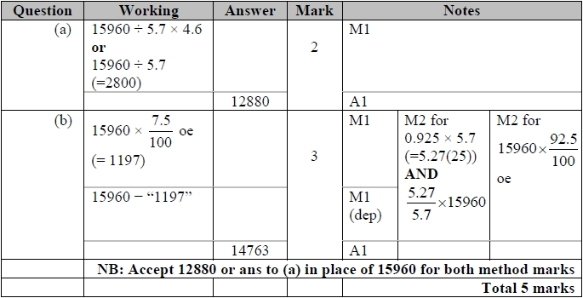

**Q17.**

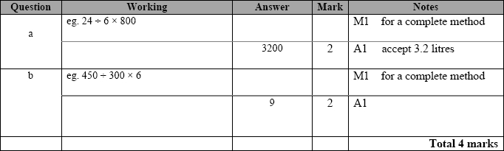

**Q18.**

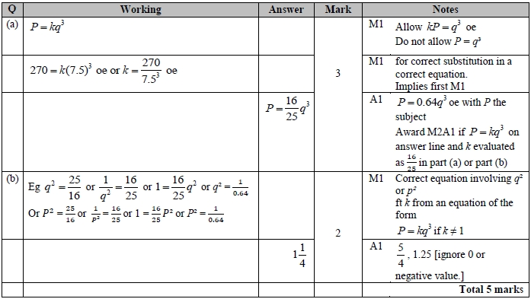

**Q19.**

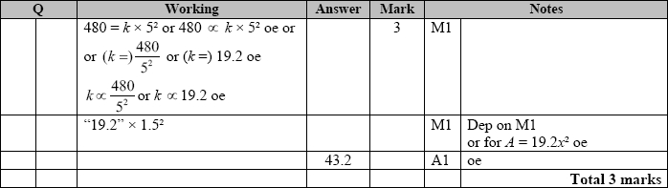

**Q20.**

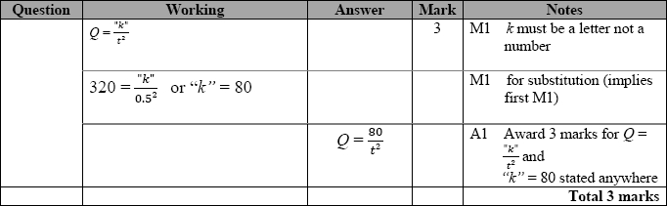

**Q21.**

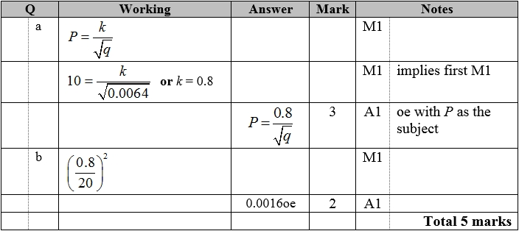

**Q22.**

The correct answer, unless clearly obtained by an incorrect method, should be taken to imply a correct method.

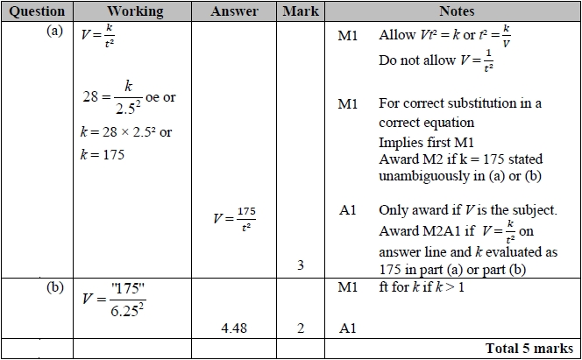

**Q23.**

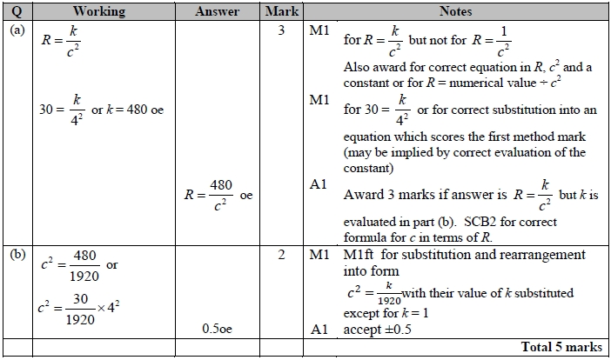

**Q24.**

The correct answer, unless clearly obtained by an incorrect method, should be taken to imply a correct method.

