

**IGCSE (9 – 1) Revision Pack**

**Expressions, Equations and Formulae**

**Name --------------------------------**

**Questions**

**Q1.**

(a)  Simplify  6*x* + 8*x* – 3*x*

...........................................................

**(1)**

(b)  Simplify  4*e* × 5*f*

...........................................................

**(1)**

(c)  Solve  8*p* = 24

*p* = ...........................................................

**(1)**

(d)  Solve  *k* – 4 = 13

*k* = ...........................................................

**(1)**

(e)  Simplify  10*t* + 4*d* – 3*t* + 2*d*

...........................................................

**(2)**

**(Total for question = 6 marks)**

**Q2.**

(a)  Simplify  *y*5 × *y*9

...........................................................

**(1)**

(b)  Simplify  (2*m*3)4

...........................................................

**(2)**

(c)  Solve  5(*x* + 3) = 3*x* – 4

Show clear algebraic working.

*x* = ...........................................................

**(3)**

(d)  (i)  Factorise  *x*2 + 2*x* – 24

...........................................................

**(2)**

(ii)  Hence, solve  *x*2 + 2*x* – 24 = 0

...........................................................

**(1)**

**(Total for question = 9 marks)**

**Q3.**

(a)  Simplify 4*m* + 2*m* – *m*

**(1)**

(b)  Simplify 5*p* × 7

**(1)**

(c)  Solve 8*g* = 40

*g* =

**(1)**

(d)  Solve 19 – *k* = 4

*k* =

**(1)**

**(Total for question = 4 marks)**

**Q4.**

(a)  Simplify  6*e* × 2*f*

...........................................................

**(1)**

(b)  Simplify  5*m* + 7*k* − 2*m* + *k*

...........................................................

**(2)**

(c)  Solve  5*y* + 3 = 14

*y* = ...........................................................

**(2)**

**(Total for question = 5 marks)**

**Q5.**

(a)  Simplify 6*m* − 2*k* + 5*m* − *k*

...........................................................

**(2)**

*P* = 2*a* + 3*b*

(b)  Work out the value of *P* when *a* = 5 and *b* = 8

*P* = ...........................................................

**(2)**

*P* = 2*a* + 3*b*

(c)  Work out the value of *a* when *P* = 16 and *b* = 20

*a* = ...........................................................

**(3)**

**(Total for question = 7 marks)**

**Q6.**

(a)  Expand and simplify (*m* − 8)(*m* + 5)

...........................................................

**(2)**

(b)  Factorise fully 5*y* + 20*y*2

...........................................................

**(2)**

(c)  Simplify (*p*2 + 3)0

...........................................................

**(1)**



(d)  Solve

Show clear algebraic working.

*x* = ...........................................................

**(4)**

**(Total for question = 9 marks)**

**Q7.**

Simon has *x* sweets.   
Yuen has 2 more sweets than Simon.   
Giulia has 3 times as many sweets as Yuen.

Simon, Yuen and Giulia have a total of *T* sweets.

(a)  Write down a formula for *T* in terms of *x*.

Give your formula in its simplest form.

...........................................................

**(3)**

(b)  Make *g* the subject of the formula  *r* = 4*g* + 7

...........................................................

**(2)**

(c)  Solve  6*y* – 3 = 2*y* + 8

Show clear algebraic working.

*y* = ...........................................................

**(3)**

**(Total for question = 8 marks)**

**Q8.**

(a)  Expand *x*(5 – *x*)

...........................................................

**(1)**

(b)  Factorise 3*y* – 21

...........................................................

**(1)**

(c)  Make p the subject of the formula *f* = 3*p* – *d*

...........................................................

**(2)**

Sergio buys *m* boxes of seeds and *n* packets of seeds.

Each box contains 10 seeds.   
Each packet contains 6 seeds.

The total number of seeds that Sergio buys is *T*.

(d)  Write down a formula for *T* in terms of *m* and *n*.

...........................................................

**(3)**

**(Total for question = 7 marks)**

**Q9.**

**Write your answers in the spaces provided.**

**You must write down all the stages in your working.**

(a)  Expand and simplify (*e* + 3)(*e* – 5)

**(2)**

(b)  Solve



Show clear algebraic working.

*y* =

**(3)**

(c)  Solve *x*2 + 3*x* – 18 = 0

Show your working clearly.

**(3)**

**(Total for question = 8 marks)**

**Q10.**

*P* = 2*g* + 3*h*

(a)  Work out the value of *P* when *g* = 7 and *h* = −4

...........................................................

**(2)**

(b)  Simplify   *e*9 ÷ *e*5

...........................................................

**(1)**

(c)   Simplify   (*y*2)8

...........................................................

**(1)**

(d)  Expand and simplify   (*x* + 9)(*x* – 2)

...........................................................

**(2)**

(e)  Factorise fully   16*c*4*p*2 + 20*cp*3

...........................................................

**(2)**

**(Total for question = 8 marks)**

**Q11.**

(a)  Solve 5*m* + 7 = 24

*m* =

**(2)**

(b)  Make *t* the subject of



**(2)**

(c)  Simplify *p*8 ÷ *p*3

**(1)**

(d)  Simplify *n*0

**(1)**

(e)  Simplify (3*x*2*y*5)3

**(2)**

**(Total for question = 8 marks)**

**Q12.**

(a) Simplify *c*4 × *c*3

...........................................................

**(1)**



(b) = *y*6

Find the value of *n*.

*n* = ...........................................................

**(2)**

**(Total for question is 3 marks)**

**Q13.**

Here is a number machine.



(a)  Work out the output when the input is –2

...........................................................

**(1)**

(b)  Work out the input when the output is 24

...........................................................

**(2)**

**(Total for question = 3 marks)**

**Q14.**

(a) Simplify 3*c*2 + 5*c*2 − *c*2

...........................................................

**(1)**

(b) Simplify 4*x* − 3*y* + 5*x* − 2*y*

...........................................................

**(2)**

**(Total for question = 5 marks)**

**Q15.**

(a) Simplify *m* + *m* + *m* − *m* + *m* + *m* − *m*

............................................................

**(1)**

(b) Simplify 5*x* − 3*y* + 4*x* − 2*y*

............................................................

**(2)**

**(Total for question = 3 marks)**

**Q16.**

(a)   Simplify 8*d* × 7*d*

...........................................................

**(1)**

(b)   Expand 4(3*e* – 5)

...........................................................

**(1)**

(c)   Factorise *f*2 – 2*f*

...........................................................

**(2)**

(d)   *H* = *g*3 + 6*g*  
Work out the value of *H* when *g* = 2

*H* = ...........................................................

**(2)**

**(Total for Question is 6 marks)**

**Q17.**

(a)  Simplify 8*e* + 2*f* − 11*e* + 3*f*

...........................................................

**(2)**

(b)  Expand 2*y*(3*y* − 7)

...........................................................

**(2)**

**(Total for question = 4 marks)**

**Q18.**

(a) Simplify

(i) *a* × 5 × *b* × *c*

...........................................................

(ii) *q*5 + *q*5 + *q*5

...........................................................

(iii) 7*m* + 6*n* − 2*m* − 9*n*

...........................................................

**(4)**

(b) Factorise *t*2 − 10*t*

...........................................................

**(2)**

**(Total for question = 6 marks)**

**Q19.**

(a)   Simplify 2*a* – 5*b* + 3*a* – 4*b* + *a*

...........................................................

**(2)**

(b)   Factorise 7*dg* – 9*de*

...........................................................

**(2)**

(c)   Expand and simplify (*x* + 2)(*x* + 5)

...........................................................

**(2)**

**(Total for Question is 6 marks)**

**Q20.**

(a) Simplify

(i) *t* + *t* + *t*

............................................................

(ii) *b* × 5 × *a*

............................................................

**(2)**

(b) Solve

(i) 8*x* − 3 = 9

*x* = ............................................................

(ii) 7*y* − 6 = 2*y* + 8

Show clear algebraic working.

*y* = ............................................................

**(5)**

(c) Expand and simplify

(*x* − 6)(*x* + 9)

............................................................

**(2)**

**(Total for question = 7 marks)**

**Q21.**

(a) Simplify

(i) *b* × 3 × *e*

...........................................................

(ii) *p*3 + *p*3 + *p*3 + *p*3

...........................................................

(iii) 6*g* − 4*h* + 2*g* − 3*h*

...........................................................

**(4)**

(b) Solve = 15



*x* = ...........................................................

**(1)**

(c) Factorise 5*a* − 3*a*2

...........................................................

**(2)**

(d) Expand

(i) 2(4 − 3*w*)

...........................................................

(ii) *y*2 (*y* + 10)

...........................................................

**(3)**

**(Total for question is 10 marks)**

**Q22.**

(a)   Simplify

(i)   *m + m + m + m + m*

...........................................................

(ii)   *p × h × 7*

...........................................................

**(2)**

(b)   Solve 8*g* = 24

*g* = ...........................................................

**(1)**

(c)   Solve *f* + 9 = 23

*f* = ...........................................................

**(1)**

**(Total for Question is 4 marks)**

**Q23.**

(a)  Simplify  9*x*2 + 2*x*2 – 5*x*2

...........................................................

**(1)**

*e* = 2*f* – 5*g*

(b)  Find the value of  *e*  when  *f* = 12  and  *g* = 3

*e* = ...........................................................

**(2)**

*e* = 2*f* – 5*g*

(c)  Find the value of *f* when  *e* = 8  and  *g* = –6

*f* = ...........................................................

**(3)**

**(Total for question = 6 marks)**

**Q24.**

(a)   Simplify 4*x* + 3*x*

...........................................................

**(1)**

(b)   Simplify 5 × 3*y*

...........................................................

**(1)**

*f* = 5*p* − 4*v*

(c) (i) *p* = −4, *v* = 3

Work out the value of *f*.

*f* = ...........................................................

(ii) *f* = −22, *v* = −5

Work out the value of *p*.

*p* = ...........................................................

**(5)**

**(Total for Question is 7 marks)**

**Q25.**

Here is a number machine.



Complete the table.

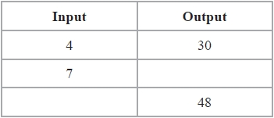

**(Total for question = 2 marks)**

**Q26.**

There are 6 batteries in a small packet of batteries.   
There are 9 batteries in a large packet of batteries.

Chow buys *m* small packets of batteries and *g* large packets of batteries.

The total number of batteries Chow buys is *T*.

Write down a formula, in terms of *m* and *g*, for *T*.

...........................................................

**(Total for question = 3 marks)**

**Q27.**

The diagram shows a right-angled triangle and a rectangle.

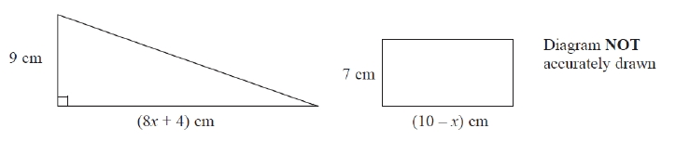

The area of the triangle is twice the area of the rectangle.

(i)  Write down an equation for *x*.

.............................................................................................................................................

(ii)  Find the area of the rectangle.

Show clear algebraic working.

........................................................... cm2

**(Total for question = 7 marks)**

**Q28.**

This formula can be used to work out the cost, in Riyals, of hiring a car in Qatar for   
a number of days.



(a) Daisha hired a car for 12 days.   
Work out the cost.

.......................................................... Riyals

**(1)**

(b) Yusuf hired a car.   
The cost was 765 Riyals.  
Work out the number of days for which Yusuf hired the car.

..........................................................

**(2)**

(c) *C* Riyals is the cost of hiring a car for *n* days.   
Write down a formula for *C* in terms of *n*.

..........................................................

**(2)**

(d) As a special offer, the cost of hiring a car for a month is 1800 Riyals.   
Awad wants to hire a car for a number of days.  
He works out that 1800 Riyals is less than the cost of hiring the car at  
85 Riyals for each day.

Work out the smallest number of days for which Awad wants to hire a car.

..........................................................

**(2)**

**(Total for question = 7 marks)**

**Q29.**

(a)  Find the value of  25 – 4 *g* when *g* = –3

...........................................................

**(2)**

(b)  Expand and simplify  *x*(2*x* + 1) + 3(*x* – 2) + 7

...........................................................

**(3)**

**(Total for question = 5 marks)**

**Q30.**

(a)  Expand   6(4 – 3*y*)

...........................................................

**(1)**

(b)  Factorise   *e*2 + 4*e*

...........................................................

**(1)**

(c)  Solve   7*x* + 8 = 2*x* – 3   
       Show clear algebraic working.

*x* = ...........................................................

**(3)**

(d)  Expand and simplify   ( *y* + 10)( *y* – 2)

...........................................................

**(2)**

**(Total for question = 7 marks)**

**Q31.**

Expand and simplify

(i) 5(2*x* + 1) − 3(3*x* − 1)

...........................................................

(ii) (*y* + 5)(*y* − 7)

...........................................................

**(Total for question = 4 marks)**

**Q32.**

(a) Expand and simplify 3(2*x* − 5) − 4(*x* + 3)

      ..............................................................................................................................................

**(2)**

(b) Expand and simplify (*y* + 7)(*y* + 2)

      ..............................................................................................................................................

**(2)**

**(Total for question = 4 marks)**

**Q33.**

(a)  Expand and simplify 3(2*c* − 5) − 2(*c* − 4)

...........................................................

**(2)**

(b)  Simplify (4*e*3)2

...........................................................

**(2)**

(c)  Expand and simplify (*a* + 5)(*a* − 1)

...........................................................

**(2)**

**(Total for question = 6 marks)**

**Q34.**

(a)  Expand and simplify    (*x* + 7)(*x* − 3)

...........................................................

**(2)**

(b)  Solve    5*p* − 9 = 3*p*

*p* = ...........................................................

**(2)**

(c)  Simplify    *y*7 × *y*4

...........................................................

**(1)**

(d)  Simplify    *h*12 ÷ *h*4

...........................................................

**(1)**

**(Total for question = 6 marks)**

**Q35.**

(a)  Factorise fully    6*y*2 + 15*y*

...........................................................

**(2)**

(b)  Expand and simplify    (*m* + 9)(*m* – 5)

...........................................................

**(2)**



(c)  Make *t* the subject of

...........................................................

**(2)**



(d)  Solve

Show clear algebraic working.

*x* = ...........................................................

**(3)**

**(Total for question = 9 marks)**

**Q36.**

(a)  Factorise    *t*2 + 6*t*

...........................................................

**(2)**

(b)  Solve    7*x* − 5 = 5*x* − 4

Show clear algebraic working.

*x* = ...........................................................

**(3)**

(c)  Expand and simplify fully    4(2*y* + 3) + 2(*y* − 6)

...........................................................

**(2)**

**(Total for Question is 7 marks)**

**Q37.**

(a)  Factorise    10*a* + 25

...........................................................

**(1)**

(b)  Factorise    7*w*2 − 4*w*

...........................................................

**(1)**

(c)  Expand *p*2(*p* − 5 )

...........................................................

**(2)**

(d)  Expand and simplify    (*x* − 3)(*x* + 7)

...........................................................

**(2)**

**(Total for question = 6 marks)**

**Q38.**

(a) Factorise *w*2 − 9*w*

............................................................

**(2)**

(b) Solve 5*x* − 1 = 2*x* − 7

*x* = ............................................................

**(3)**

(c) Expand and simplify (*y* − 7)(*y* + 3)

............................................................

**(2)**

**(Total for question = 7 marks)**

**Q39.**

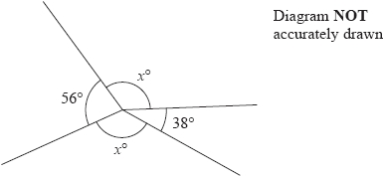

Work out the value of *x*.

...........................................................

**(Total for question = 3 marks)**

**Q40.**

The diagram shows a parallelogram *ABCD*.

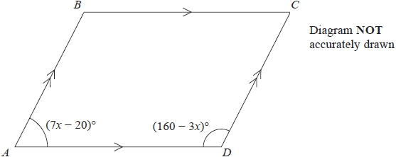

Angle *BAD* = (7*x* – 20)°   
Angle *ADC* = (160 – 3*x*)°

Work out the value of *x*.   
Show clear algebraic working.

*x* = ...........................................................

**(Total for question = 3 marks)**

**Q41.**

The diagram shows a parallelogram *ABCD*.   
In the diagram, all the angles are in degrees.

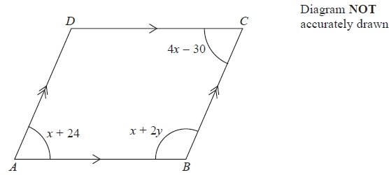

(a)   Work out the value of *x* and the value of *y*.

*x* = ...........................................................

*y* = ...........................................................

**(4)**

(b)   Find the size of angle *BAD*.

........................................................... °

**(1)**

**(Total for Question is 5 marks)**

**Q42.**



(a)  Simplify

...........................................................

**(1)**



(b)  Write as a single power of 7

...........................................................

**(2)**

**(Total for question = 3 marks)**

**Q43.**

Here is a square.

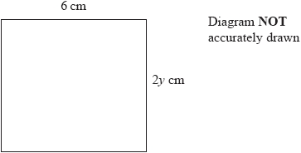

(a)  Find the value of *y*.

*y* = ...........................................................

**(1)**

Here is a rectangle.

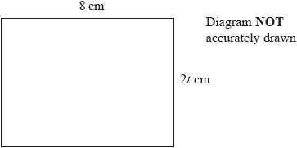

The rectangle has an area of 80 cm2

(b)  Find the value of *t*.

*t* = ...........................................................

**(2)**

**(Total for question = 3 marks)**

**Q44.**

Calvin has 8 identical rectangular tiles and 4 identical square tiles.   
He arranges the tiles to fit exactly round the edge of a rectangle, as shown in the diagram below.

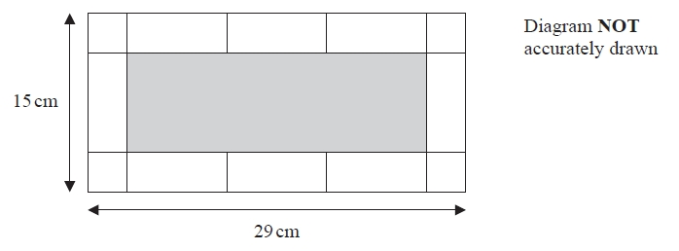

Work out the area of one of Calvin's rectangular tiles.

........................................................... cm2

**(Total for question = 5 marks)**

**Q45.**

Simplify      2*e*2*f* × 5*e*3*f*

...........................................................

**(Total for question = 2 marks)**

**Q46.**

(a)  Simplify     *e* + *e* + *e* + *e*

...........................................................

**(1)**

(b)  Simplify     4*c*2 + 3*c*2 − 5*c*2

...........................................................

**(1)**

(c)  Simplify     7*a* + 5*b* − 2*a* − 9*b*

...........................................................

**(2)**

(d)  Simplify     7*p* × 2*q*

...........................................................

**(1)**

(e)  Simplify     *x*7 × *x*2

...........................................................

**(1)**

(f)  Simplify     *y*9 ÷ *y*3

...........................................................

**(1)**

**(Total for question = 7 marks)**

**Q47.**

(a)  Simplify      *k* × *k* × *k* × *k* × *k*

...........................................................

**(1)**

(b)  Expand      2(7*t* − 3)

...........................................................

**(1)**

(c)  Expand and simplify fully

(i)  4(2*y* + 6) − 3(2*y* − 7)

...........................................................

(ii)  (*x* − 6)(*x* − 4)

...........................................................

**(4)**

(d)  Simplify fully



...........................................................

**(2)**

**(Total for Question is 8 marks)**

**Q48.**

(a)  Simplify     7 × *e* × 2 × *d*

...........................................................

**(1)**

(b)  Simplify     *m*5 × *m*2

...........................................................

**(1)**

(c)  Simplify     *c*11 ÷ *c*3

...........................................................

**(1)**

(d)  Simplify     (*a*5)3

...........................................................

**(1)**

(e)  Expand and simplify     4(2*x* + 3) + 2(*x* + 5)

...........................................................

**(2)**

**(Total for question = 6 marks)**

**Q49.**

(a)  Simplify

(i)  *t*3 + *t*3 + *t*3 + *t*3

...........................................................

(ii)  10*x* – 4*y* – 2*x* – *y*

...........................................................

(iii)  *e* × *e* × 7

...........................................................

**(4)**

(b)  Factorise *g*2 + 4*g*

...........................................................

**(2)**

**(Total for question = 6 marks)**

**Q50.**

(a)  Simplify    4*x* + 9*x* – 5*x*

...........................................................

**(1)**

(b)  Simplify    6*m* × 4*p*

...........................................................

**(1)**

(c)  Solve    8*t* = 40

*t* =...........................................................

**(1)**

**(Total for question = 3 mark)**

**Q51.**

(a)  Simplify    *x*2 + *x*2 + *x*2

...........................................................

**(1)**

(b)  Simplify    4*e* + 2*f* − 6*e* + 7*f*

...........................................................

**(2)**

(c)  Simplify    2 × *a* × 4 × *b*

...........................................................

**(1)**

(d)  Solve    = 12



*w* = ...........................................................

**(1)**

(e)  Solve    5*y* + 2 = 14

*y* = ...........................................................

**(2)**

**(Total for question = 7 marks)**

**Q52.**

(a)  Simplify  6*e* + 8*f* – 2*e* + 3*f*

...........................................................

**(2)**

(b)  Solve  7*x* + 11 = 14

*x* = ...........................................................

**(2)**

(c)  Expand  3(4*p* + 5)

...........................................................

**(1)**

(d)  Factorise  6*r* + 14

...........................................................

**(1)**

**(Total for question = 6 marks)**

**Q53.**

(a)  Solve    2*x* – 3 = 18

*x* = ...........................................................

**(2)**

(b)  Simplify fully    4*y* + 12 – 2*y* + 4

...........................................................

**(2)**

(c)  Simplify    (*t*5)3

...........................................................

**(1)**

(d)  Simplify    3*e*7*f* × 4*e*2*f*

...........................................................

**(2)**

(e)  Solve the inequality    2*q* ≥ 31 – 3*q*

...........................................................

**(2)**

–2 ≤ *n* < 3

*n* is an integer

(f)  Write down all the possible values of *n*.

........................................................................................

**(2)**

**(Total for question = 11 marks)**

**Q54.**

Pierre wants to convert some money between two currencies.  
 This graph can be used to convert between Euros (€) and Canadian dollars (C$).

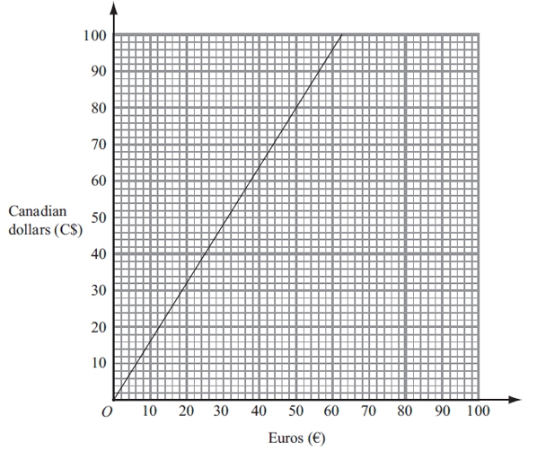

(a) Use the graph to convert

(i) 50 Euros (€) to Canadian dollars (C$),

C$...........................................................

(ii) 60 Canadian dollars (C$) to Euros (€).

€...........................................................

**(2)**

Pierre now decides to use this rule to convert Euros to Canadian dollars.



(b) Use this rule to convert 175 Euros to Canadian dollars.

C$...........................................................

**(2)**

**(Total for question = 4 marks)**

**Q55.**

This rule can be used to work out the total cost in dollars ($) of hiring a car.



Alex hired a car for 6 days.

(a)  Use the rule to work out the total cost.

$..........................................................

**(2)**

Suresh hired a car.   
The total cost was $410

(b)  Use the rule to work out the number of days he hired the car.

..........................................................

**(2)**

**(Total for question = 4 marks)**

**Q56.**

(a)  Simplify *k6* × *k3*

...........................................................

**(1)**

(b)  Simplify 5*y* × 4*y2*

...........................................................

**(2)**

**(Total for question = 3 marks)**

**Q57.**

Here is a number machine.



(a)  Find the output when the input is 30

...........................................................

**(1)**

(b)  Find the output when the input is −8

...........................................................

**(1)**

(c)  Find the input when the output is 10

...........................................................

**(1)**

The input is *x*  
The output is *y*

(d)  Write down a formula for *y* in terms of *x*.

...........................................................

**(2)**

**(Total for question = 5 marks)**

**Q58.**

This rule can be used to work out the fare, in dirhams, for a taxi journey in Dubai.

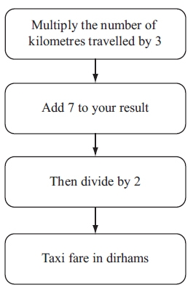

(a) Paulo travelled 9 kilometres.   
Work out his fare.

............................................................ dirhams

**(2)**

(b) Janine's fare was 26 dirhams.   
Work out his fare.

............................................................

**(2)**

(c) Find a formula for the fare, *C* dirhams, for a taxi journey of *d* kilometres.

............................................................

**(3)**

**(Total for question = 7 marks)**

**Q59.**

This rule can be used to work out the cost of a taxi ride.



(a)  Work out the cost of a taxi ride of 3 kilometres.

........................................................... euros

**(2)**

Jenny has a taxi ride.   
The cost is 26.10 euros.

(b)  Work out the number of kilometres of the taxi ride.

........................................................... kilometres

**(3)**

**(Total for question = 5 marks)**

**Q60.**

*M* = 2*t*2 − 7*t*

(a)  Work out the value of *M* when *t* = −3

*M* = ...........................................................

**(2)**

(b)  Solve    4(*x* + 3) = 9*x* − 10

Show clear algebraic working.

*x* = ...........................................................

**(3)**

*y* is an integer.   
−2 < *y* ≤ 3

(c)  Write down all the possible values of *y*.

...........................................................

**(2)**

**(Total for question = 7 marks)**

**End of questions**