**Principles of homeostasis**

**You should be able to define and use each of the following keywords:**

Endocrine system

Histamine

Homeostasis

Hormone

Local chemical mediator

Negative feedback

Paracrine system

Positive feedback

Prostaglandin

**Complete the sentences using the words in bold:**

**arterioles blood blood glucose cellular fluctuations glands histamines internal long-lasting negative osmosis paracrine permeability pH positive prostaglandins proteins secreted target organs temperature tissue water potential**

Homeostasis is the maintenance of a constant __________ environment, such as the volume, chemical make-up and temperature of the ________ and __________ fluid. There are continuous ______________ but they occur around a set point: homeostasis is the ability to return to that set point thus maintaining equilibrium. There are numerous reasons why this is important, including:

* Enzymes and other ___________ are sensitive to changes in ___ and _______________. Controlling blood CO2 levels and temperature ensures enzymes are able to act at their optimum rate.
* ________ ____________ of blood and tissue fluid should be kept constant to ensure cells do not burst or shrink due to ____________. Maintaining a constant _________ __________ concentration ensures that the water potential of the blood remains the same.

Homeostasis normally involves ___________ feedback. This occurs when feedback results in the corrective measures returning a condition to the set point when it increases above or decreases below that value. These include control of blood glucose, temperature and blood CO2 levels.

Some, few, homeostatic mechanisms involve ___________ feedback. This occurs when a change in conditions results in a further change away from the set point. Examples include during an action potential, the action of oestrogen on LH concentration and during hyperthermia.

Homeostasis can involve either the nervous system or endocrine system. The endocrine system comprises a series of __________ that secrete chemical messengers (hormones) and the __________ __________that have complementary receptors and so are able to detect and respond to these hormones. Hormones are effective in small quantities, yet have widespread (since they are carried in the blood) and ______-________ effects.

Nervous and hormonal forms of communication are only useful at coordinating the activities of the whole organism. At the __________ level they are complimented by local chemical mediators as part of the ____________ system. These are ____________ by individual cells and affect other cells in the immediate vicinity. A common example of this type of coordination is the inflammation of certain tissues when they are damaged or exposed to foreign agents. Two examples of chemical mediators are:

1. __________: stored in white blood cells and are secreted due to the presence of antigens. They causes dilation of blood vessels, increased ____________ of capillaries and therefore swelling the infected area.
2. _______________: found in cell membranes and cause dilation of small ____________. They are released due to injuries and increase the permeability of capillaries. They also affect blood pressure and neurotransmitters. In doing so they relieve pain.

**Answer the questions**

1. Draw sketch graphs to show a typical negative feedback response and a typical positive feedback response. [4]

|  |  |
| --- | --- |
| Negative feedback | Positive feedback |

1. Complete the table. [12]

|  |  |  |  |
| --- | --- | --- | --- |
|  | **Nervous system** | **Paracrine system** | **Endocrine system** |
| **Method of travel** |  |  |  |
| **Speed** |  |  |  |
| **Received by** |  |  |  |
| **Useful duration** |  |  |  |

**Answer the exam questions**

**Q1.**          Different substances are involved in coordinating responses in animals.

(a)     Hormones are different from local chemical mediators such as histamine in the cells they affect.

(i)      Describe how hormones are different in the cells they affect.

.............................................................................................................

.............................................................................................................

**(1)**

(ii)     Describe how hormones and local chemical mediators reach the cells they affect.

.............................................................................................................

.............................................................................................................

.............................................................................................................

.............................................................................................................

.............................................................................................................

**(2)**

(b)     Synapses are unidirectional. Explain how acetylcholine contributes to a synapse being unidirectional.

......................................................................................................................

......................................................................................................................

......................................................................................................................

......................................................................................................................

......................................................................................................................

**(2)**

(c)     Cells in the stomach wall release gastric juice after a meal. The graph shows how the volumes of gastric juice produced by nervous stimulation and by hormonal stimulation change after a meal.

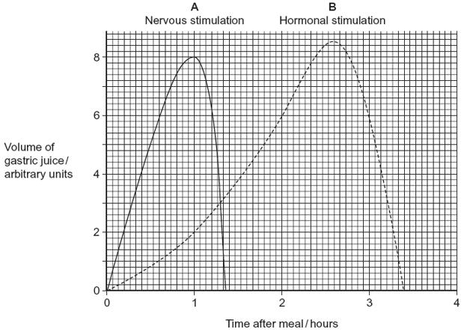

(i)      Describe the evidence from the graph that curve **A** represents the volume of gastric juice produced by nervous stimulation.

.............................................................................................................

.............................................................................................................

.............................................................................................................

.............................................................................................................

**(2)**

(ii)     Complete the table to show the percentage of gastric juice produced by nervous stimulation at the times shown.

|  |  |  |  |
| --- | --- | --- | --- |
|  | **Time after meal / hours** | | |
|  | **1** | **2** | **3** |
| Percentage of gastric juice produced by nervous stimulation |  |  |  |
|  |  |  |  |

**(1)**

**(Total 8 marks)**

**M1.**          (a)     (i)      Hormones have widespread effect / affect different organs / affect  
different parts of the body / affect distant organs / only affect cells with right receptor;

*Assume “they” refers to hormones.*

**1**

(ii)     1. Hormones in blood;

2. Local chemical mediators spread by diffusion / spread directly;

*1. May be awarded where candidates refer to both as “they”.*

**2**

(b)     1. (Acetylcholine) released from/in presynaptic side;

2. Diffusion from higher concentration/to lower concentration;

3. Receptors in postsynaptic (side) / binds on postsynaptic (side);

*2. Mark for diffusion only awarded in context of unidirectional movement.*

**2 max**

(c)     (i)      1. Rapid response;

2. Short duration;

*Specific wording is not important. It is the principles that matter here.*

*Points may be made by referring to figures.*

**2**

(ii)

|  |  |  |  |
| --- | --- | --- | --- |
|  | 1 | 2 | 3 |
| Percentage | 80 | 0 | 0 |

*Ignore % sign.*

**1**

**[8]**