

**Higher IGCSE (9 – 1)**

**Marking Scheme**

**Bearing 2**

**Mark Scheme**

Q1.

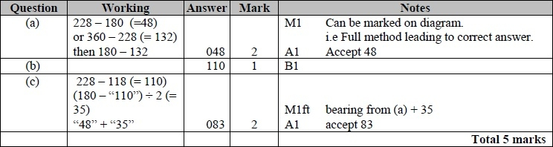

**Q2.**

The correct answer, unless clearly obtained by an incorrect method, should be taken to imply a correct method.

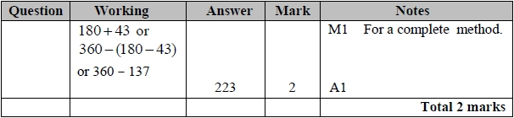

**Q3.**

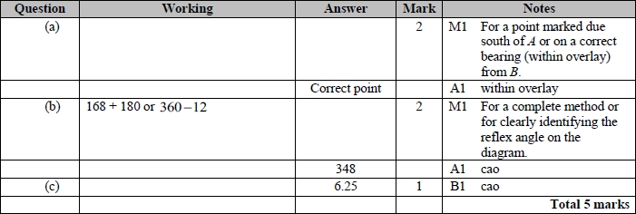

**Q4.**

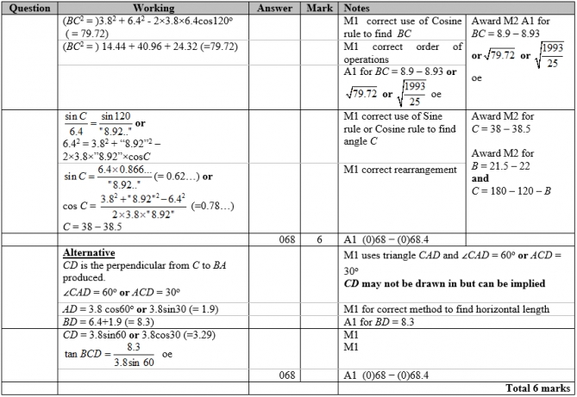

**Q5.**

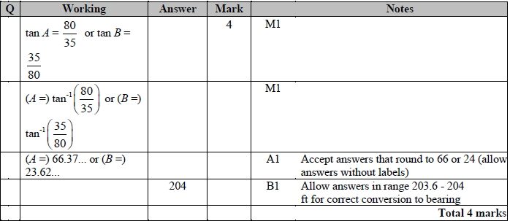

**Q6.**

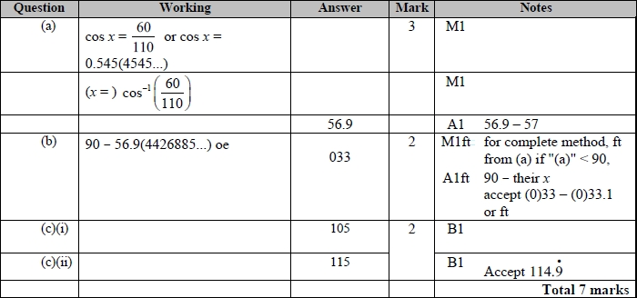

**Q7.**

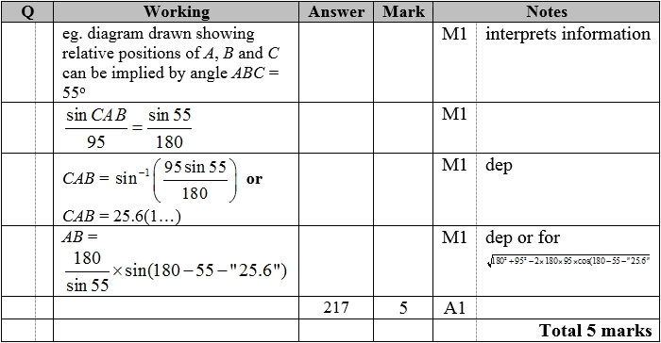

**Mark Scheme for extra 4 questions**

Q1.

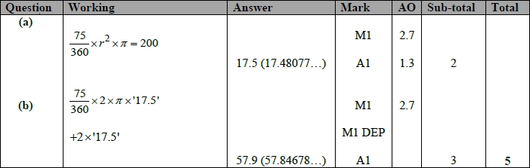

**Q2.**

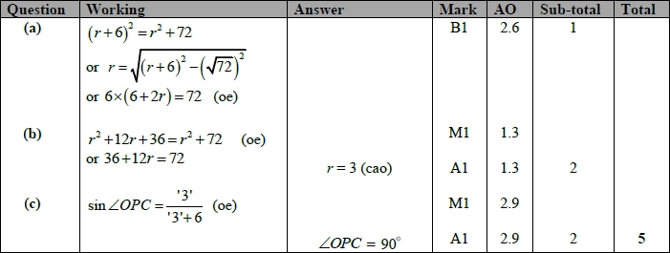

**Q3.**

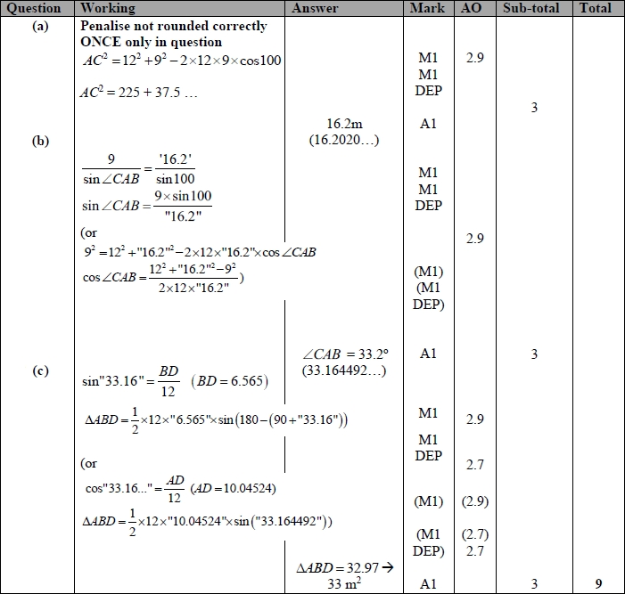

**Q4.** 