**3.3.10 Aromatic chemistry**

**AS Link:**

**3.3.1 – Introduction to organic chemistry (nomenclature & reaction mechanisms)**

**3.3.2 – Alkenes**

Arenes are **cyclical** **unsaturated** molecules **based on benzene**, **C6H6** – this is the simplest one. They can have functional groups replacing the hydrogen atoms attached to the ring. **Benzene** is a colourless **liquid** at **room temperature** and is **non-polar** so it’s **immiscible** with **water**. It causes cancer so is classified as a **carcinogen**.

These compounds were first isolated from sweet-smelling oils (balsam) hence the name **aromatic**, they have a characteristic odour.

***Starter: 5.2 – Industrially important molecules***

**Bonding and structure**

***Molymods: Benzene & cyclohexane***

Structure

Although benzene is unsaturated it is **very stable**, it has a **planar hexagonal** ring structure with single hydrogens bonded to each carbon. All bond lengths between carbon atoms are of **equal length** with identical **bond angles** (120oC).It has a special type of **bonding**.

The bonding and structure was a puzzle for a long time because:

* Although it is unsaturated it doesn’t undergo addition very easily
* All carbon atoms are equivalent, implying that the carbon-carbon bonds are the same.

***The most important dream in history? Kekulé’s discovery – Oxford p85***

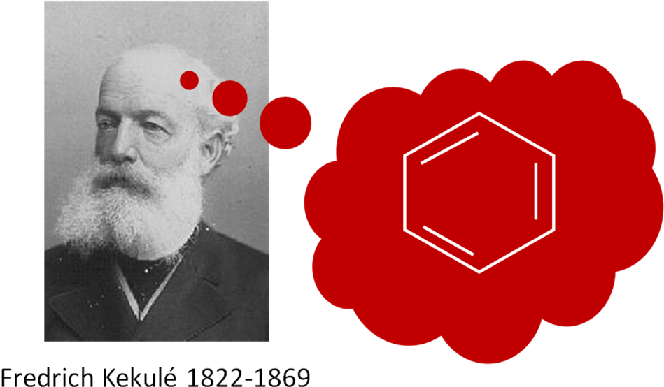

He suggested a cyclical arrangement with alternating single and double bonds

***Task: Systematic name?*** cyclohexa-1,3,5-triene

**This model presented these problems:**

1. A cyclical triene should undergo addition reactions (e.g. with bromine water) but benzene rarely does.
2. The hexagonal ring would not by symmetrical due to double C=C bonds being shorter than single C-C bonds but all bonds are the same length (half-way between C-C and C=C length).
3. If alternating single and double bonds exist then two isomeric forms should form but they do not.



**Kekulé** latersuggested a solution; he proposed benzene consisted of structures in rapid **equilibrium**.

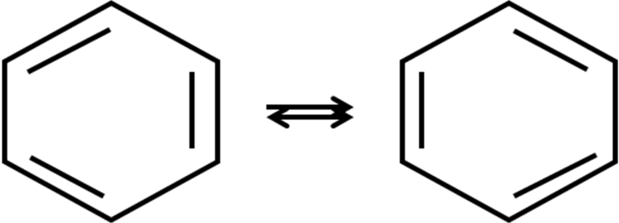

Later he developed the idea of a **resonance** **hybrid,** a sort of average of the two alternative structures.

|  |  |
| --- | --- |
|  |  |

An analogy is that the 2 alternating forms are like a unicorn and a dragon – neither exist but the real structure is somewhere in between, more like a rhino!

**X-ray diffraction provides evidence** for this by showing:

* **Planar** **hexagonal** cyclical – so they can pack together giving higher m.p. & b.p.
* **Bond angle** 120o – 6 carbons bonded to 2 other carbons and 1 hydrogen
* **C-C bonds all same length** and intermediate between single and double bonds.

This can be explained by the idea that some of the **electrons** are **delocalised;** they are spread over the 6 carbon atoms.

Bonding

Each carbon atom has **4 electrons** and **3 covalent bonds**: one to hydrogen and 2 to carbon. The **fourth electron** is in a **p-orbital** and there are 6 of these in total, which **overlap** becoming delocalised. They form a **region of high electron density** above and below the ring, called the **π system**.

|  |  |  |  |  |
| --- | --- | --- | --- | --- |
|  |  |  |  |  |
| 6 single bonds | overlapping *pi* orbitals | another possibility | delocalised *pi* orbital system | alternative drawing |

***Demo: Model***

This model explains **benzene’s properties and stability**.

**Delocalisation stability**

**AS Link:**

**3.1.4 – Energetics (enthalpy change)**

Benzene is far **more stable** than the theoretical compound cyclohexa-1,3,5-triene would be. This is shown by looking at the **thermochemical data** for the **enthalpy change** of **hydrogenation**.

**Cyclohexene** has one double bond, the enthalpy change following **hydrogenation** **to** **cyclohexane** can be determined experimentally.

Experimental C6H10(l) + H2(g) → C6H12(l)

cyclohexene cyclohexane

|  |  |  |  |  |
| --- | --- | --- | --- | --- |
|  | + H2 | → |  | ∆Hθhydrogenation = - 120 kJ mol-1 |

So enthalpy of hydrogenation for a ring with alternating double would be **expected to be three times this value**.

Predicted C6H6(l) + 3H2(g) → C6H12(l)

cyclohexa-1,3,5-triene cyclohexane

If benzene had 3 double bonds then it’s enthalpy of hydrogenation would be as follows:

|  |  |  |  |  |
| --- | --- | --- | --- | --- |
|  | + 3H2 | → |  | 3 x ∆Hθhydrogenation (cyclohexene) = 3 x 120 kJ mol-1  ∆Hθhydrogenation = - 360 kJ mol-1 |

However, **experimental** **data** for **benzene** gives this value of hydrogenation.

ExperimentalC6H6(l) + 3H2(g) → C6H12(l)

benzene cyclohexane

|  |  |  |  |  |
| --- | --- | --- | --- | --- |
|  | + 3H2 | → |  | ∆Hθhydrogenation = -208 kJ mol-1 |

This value shows a **smaller energy change than predicted** which **supports** the **new** **model** providing **evidence for** the **stability** of benzene. In reactions energy is first put in to break bonds then released when new bonds are made, a **smaller enthalpy change value** shows more energy was put in to break the bonds than released. This **indicates a more stable molecule**, which reacts less easily.

This indicated that **benzene is 152 kJ mol-1 more stable** than the theoretical compound cyclohexa-1,3,5-triene and it’s thought to be **due to the delocalisation of the electrons**. In a delocalised ring the electron density is shared over more atoms, lowering the energy of the molecule and so it becomes more stable.

Putting these values on an enthalpy diagram

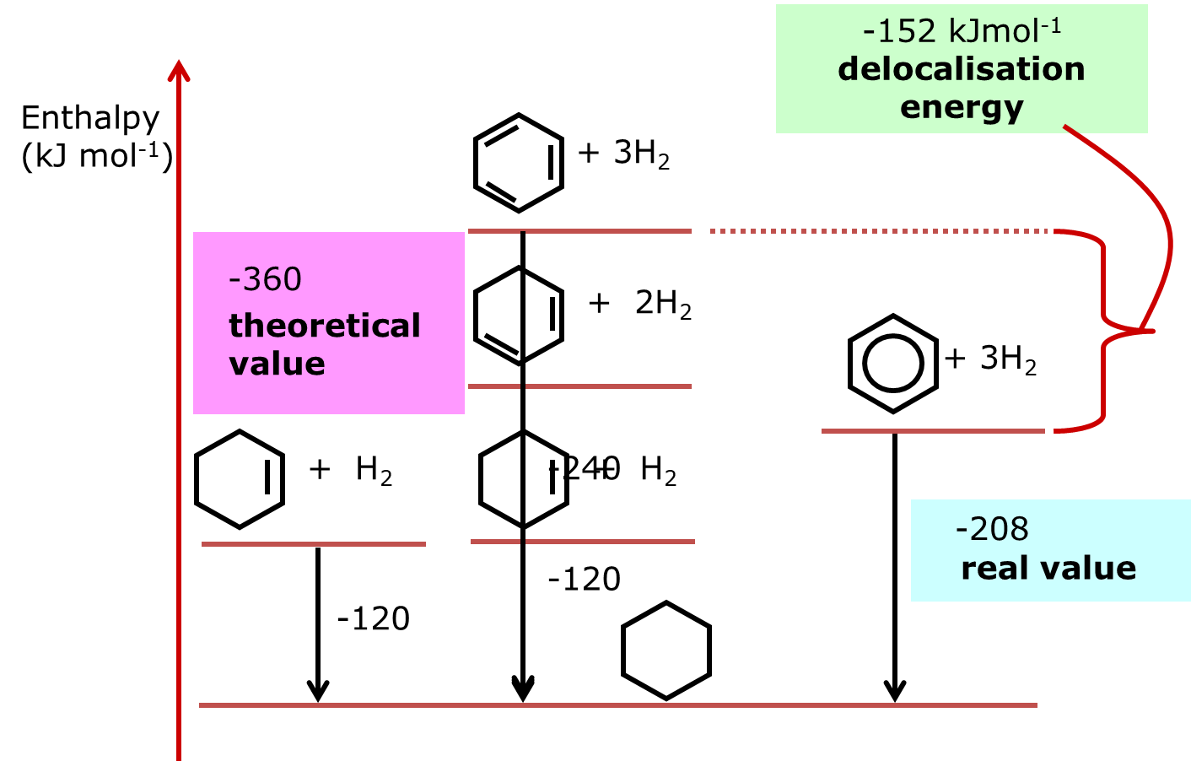

**theoretical – actual value for benzene = stability gained by delocalised electrons**

∆Hθhydrogenation values: **360 – 208 = 152 kJ mol-1**

This is often called the **delocalisation energy** or **resonance energy**.

***Starter: 5.3 – Structure of benzene***

***Sheet: Structure & bonding in benzene***

***Application: CGP204 PQ1***

**Naming aromatic compounds**

**Substituted arenes** are named as **derivatives of benzene**, this forms the root and appears as a **suffix -benzene**. However, there are still lots of non-systematic names used.

**Examples**

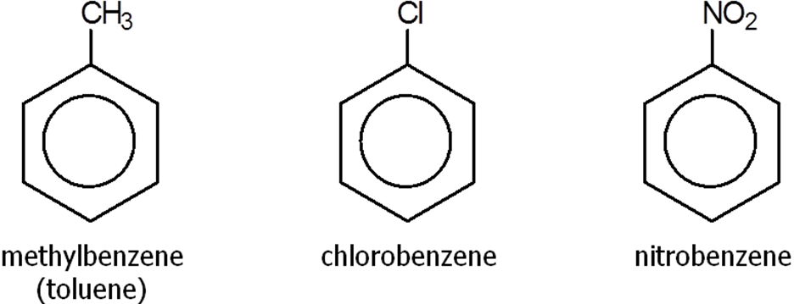

**Multiple substituents** are numbered to give the lowest numbers if they are all the same.

If there are different groups show the numbers before the name of the group

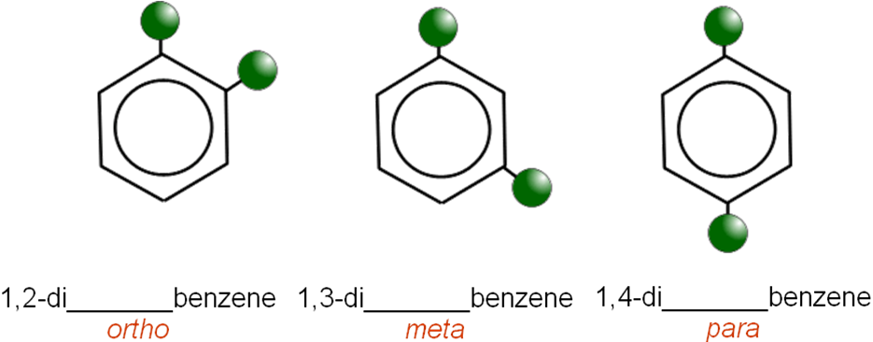

If there are **more than one different** functional groups then start numbering from the one that is first alphabetically.

**Examples**

|  |  |
| --- | --- |
|  |  |
| 1-bromo-3-methylbenzene | 1-methyl-2-nitrobenzene |

**In some cases the benzene ring** can be regarded as a **substituent** on another molecule so the prefix **phenyl-** or **phen-** is used. The **suffix** comes **from other functional groups** on the benzene ring.

**Examples**

|  |  |  |  |
| --- | --- | --- | --- |
|  |  |  |  |
| phenol | phenylamine | phenylethene | N-phenylethanamide |
|  | Common name: aniline |  | N- is used to show that nitrogen is bonded to a carbon |

There are some that are named differently and have to **be learnt**.

|  |  |
| --- | --- |
|  |  |
| benzenecarboxylic acid | methyl benzenecarboxylate |
| Common name: benzoic acid  Carboxylic acid always attached to 1st carbon | Common name: methyl benzoate |

***Sheet: Naming aromatic compounds***

***Starter: 5.1 – Naming aromatic compounds***

***Application: CGP205 PQ1***

***Fact recall: CGP205 Q1-2***

**Reactions of aromatics**

**Combustion**

Arenes are unsatruted molecules so incomplete combustion occurs giving a **smoky flame** due to a **high carbon:hydrogen ratio**. The unburnt carbon gives rise to **soot**.

**Electrophilic substitution**

Although **benzene** is **unsaturated** it does not react like an alkene, which easily undergoes addition reactions with electrophiles. Benzene **doesn’t undergo addition reactions** because these would cause the benzene ring to be changes and **lose its delocalised** **stability**. For addition reaction to occur they would require an extra input of delocalisation energy to destroy the aromatic ring system.

The high electron density on benzene **attracts electrophiles**. Rather than been added **substitution** for a hydrogen atom occurs which **leaves the aromatic ring unchanged**. This type of reaction **maintains** the **stability** of the **delocalised** **electrons**.

There are 2 types of electrophilic substitution reactions that will be looked at:

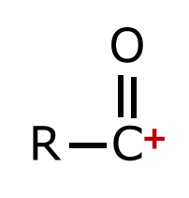

* Nitration (substituting for –NO2 group)

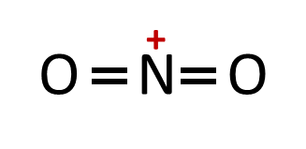

* Friedel-Crafts acylation (substituting for –COR an acyl group)

**Mechanism for electrophilic substitution**

After addition the carbon has 4 single bonds so is tetrahedral in shape until the hydrogen is eliminated

When **drawing** this mechanism it’s very important to be **precise**. Arrow clearly **from delocalised ring**. In the **cation intermediate** the delocalised electrons is between **carbon-2 and carbon-6 only**. Arrow must point **towards the positive charge**.

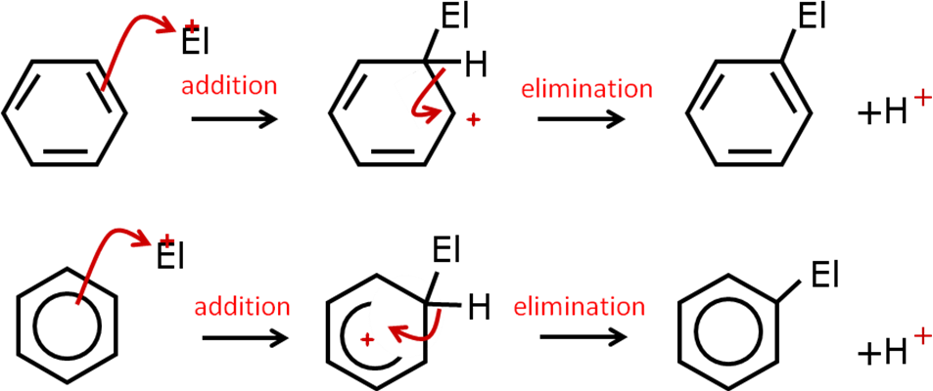

The **delocalised** system has a **high electron density** which **attracts electrophiles** and at the same time the **electrons are attracted** from the pi-bond **towards the electrophile**, **El+**.

A **bond** forms **between** the **electrophile** and a **carbon** atom, but it must use electrons from the delocalised ring, **destroying the aromatic system**. An **electron** is **lost** so a **positive ion** is **formed**.

To **get the aromatic stability** **back** the **cationic** **intermediate loses a hydrogen ion**, and the **bonded pair of electrons restores the delocalised ring** so the H+ is substituted by the electrophile El+.

***Sheet: Describe electrophilic substitution***

This same mechanism occurs in nitration and Friedel-Crafts acylation reactions.

Nitration

In this electrophilic substitution **a hydrogen atom is substitution for NO2**, other functional groups are unchanged.

The **electrophile** is the **nitryl cation** (or **nitronium ion**), **+NO2** which is produced by the **protonation** of **concentrated nitric acid** by a stronger acid, usually **concentrated sulphuric acid**. The **protonated nitric acid**, H2NO3+ then **loses** a molecule of **water** to give the nitronium ion. In the reaction mixture H2SO4 is a stronger acid than HNO3 so it donates a proton to HNO3 (which acts as a Brønsted-Lowry base in this reaction).

Formation of electrophile: HNO3  + H2SO4 → **+NO2** + HSO4- + H2O

**H2SO4 is regenerated** at the end so it’s a **catalyst**

The formation of the electrophile happens at the same time; as soon as it has been formed nitration can occur.

|  |  |  |
| --- | --- | --- |
| Nitronium ion: |  | Positive charge is on the nitrogen |

**Nitration summary**

Electrophile: +NO2 (nitryl cation)

Reaction to produce electrophile: HNO3 + H2SO4 → **+NO2** + HSO4- + H2O

Reaction to reform catalyst: H+ + HSO-4 → H2SO4

Reactants: benzene + conc. nitric acid

N.B. If exam question asks for the reagents of this reaction state both **conc. HNO3 & conc. H2SO4**

# Conditions: warm + conc. sulphuric acid (catalyst)

Product: nitrobenzene

Equation: C6H6 + HNO3 → C6H5NO2 + H2O

# Mechanism: Consists of addition step then elimination of H+

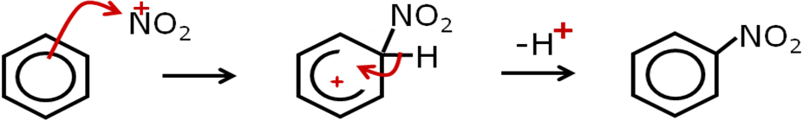

***Sheet: Nitration reaction summary***

***Task: Write the overall equation for this nitration reaction, name the reactant & product and give the mechanism***

C6H5CH3 + HNO3 → C6H4CH3NO2 + H2O

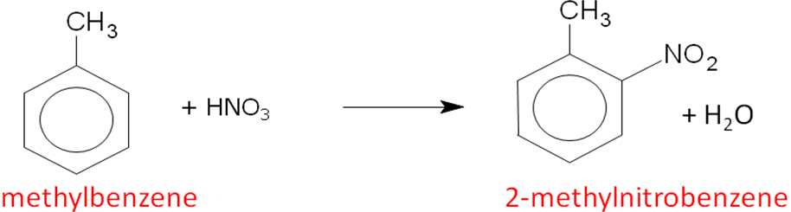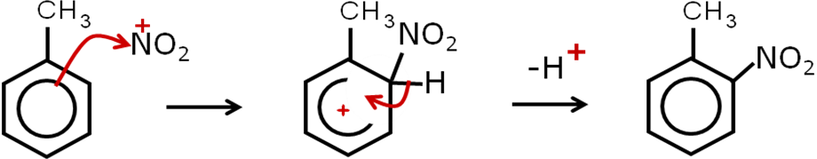

**Uses of nitration reactions**

Nitration is an important step in the production of these chemicals:

1. The **nitro group** can be **reduced** to an **amine** so aromatic nitro compounds are **precursors for aromatic amines**, which are useful intermediates in organic synthesis. Amines are used to make **dyes** and **pharmaceuticals**.

|  |  |
| --- | --- |
|  | **Reduction** of the nitro group to the amine occurs by:   * Catalytic hydrogenation e.g. Ni + H2 * Metal/acid e.g. Sn + HCl |

1. **Nitro compounds decompose violently** (with the rapid formation of heat and gas) when they are heated, so they are used as **explosives**. TNT or trinitrotoluene (C6H5(NO2)3CH3) is produced by the nitration of methylbenzene.

***Task: Draw and give the systematic name for TNT?*** ***Hint: methyl group is at position 1***



1-methyl-2,4,6-trinitrobenzene

Friedel-Crafts acylation

Charles Friedel and James Crafts developed acylation reactions with benzene. Many useful compounds contain benzene rings and Friedel-Crafts reactions are **important electrophilic substitution** reactions because they **lead to carbon-carbon bond** formation with the **addition of an acyl group** (-C(=O)-R) to the benzene ring.

**Benzene** is heated, in a non-aqueous solvent under reflux, with an **acyl chloride** to give a **phenylketone** and HCl. **Aluminium chloride** is used as a **catalyst**.



One an acyl group has been added the side chain can be modified to further to produce useful products. The **acyl chloride provides the RCO group** of the ketone. It initially reacts with AlCl3 to form AlCl4- and the **electrophile** **RCO+** (acylium ion). The **aluminium atom only has 3 electrons** in the outer main level so it **readily accepts** a **lone pair** from the **chlorine** of the **acyl chloride**. As the lone pair of electrons are pulled away the polarisation of the acyl chloride increases and a carbocation forms. This is a much **stronger electrophile** which is **able** to **react** with **benzene**.

Forming the electrophile: RCOCl + AlCl3 → **RCO+** + AlCl4-

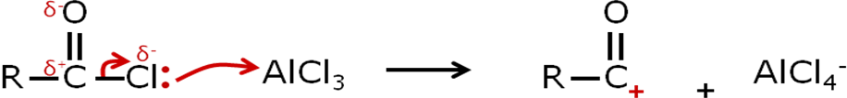

The **acylium ion** is a **good electrophile** so the delocalised electrons from the benzene ring attacks the electrophile to form the substitution products. **AlCl3 is reformed** by a reaction with a hydrogen ion that was eliminated from the benzene ring. Therefore it acts as a **catalyst**.

**Friedel-Crafts summary**

Electrophile: RC+O (acylium cation)

Reaction to produce electrophile: RCOCl + AlCl3 → RC+O + AlCl4-

Re-forming catalyst: AlCl4- + H+ → **AlCl3** + HCl

Reactant: benzene + acyl chloride

Acid anhydride can be uses and often preferred as it produces a weak acid, ethanoic acid – another useful product.

Acyl chloride produces HCl which is more hazardous.

Conditions: anhydrous + reflux + AlCl3 (catalyst)

Product: aromatic ketone

Equation: C6H6 + RCOCl → C6H5COR + HCl

C6H6 + (RCO)2O →C6H5COR + RCOOH

Example: C6H6 + CH3COCl →C6H5COCH3 + HCl

ethanoyl chloride phenylethanone



# Mechanism: electrophilic substitution (addition of electrophile then elimination of H+)

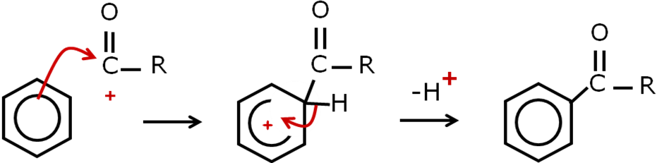

***Sheet: Friedel-Crafts reaction summary***

***Starter: 5.4 – Electrophilic substitution***

**Friedel-Crafts and acylation**

|  |  |
| --- | --- |
| Don’t get Friedel-Crafts acylation mixed up with acylation:  **Friedel-Crafts acylation: the hydrogen on the benzene is substituted**  **Acylation: the hydrogen on the nucleophile is eliminated** |  |

|  |  |
| --- | --- |
| Acylation | Friedel-Crafts acylation |
|  |  |
| Mechanism:Nucleophilic addition-elimination | Mechanism:  Electrophilic substitution |

|  |  |
| --- | --- |
| A classic question to test this: |  |

***Task: Animate general mechanism for electrophilic substitution***

***Sheet: Exam questions – Aromatic chemistry***

***Application: CGP208 PQ1-2***

***Fact recall: CGP208 Q1-3***

***Exam questions: Oxford p179-181 Q1-9***