

**Higher IGCSE (9 – 1) Revision Pack**

**Graphs Part 2**

**Name --------------------------------**

**Questions**

**Q1.**

By completing the square, find the coordinates of the turning point of the curve with equation *y* = *x*2 + 10*x* + 18   
You must show all your working.

( ................ , ................ )

**(Total for question = 3 marks)**

**Q2.**

(a)  Write 2*x*2 + 16*x* + 35 in the form *a*(*x* + *b*)2 + *c* where *a*, *b*, and *c* are integers.

...........................................................

**(3)**

(b)  Hence, or otherwise, write down the coordinates of the turning point of the graph   
       of *y* = 2*x*2 + 16*x* + 35

...........................................................

**(1)**

**(Total for question = 4 marks)**

**Q3.**

The expression *x2* – 8*x* + 21 can be written in the form (*x* – *a*)2 + *b* for all values of *x*.

(a) Find the value of *a* and the value of *b*.

*a* = . . . . . . . . . . . . . . . . . . . . . .

*b* = . . . . . . . . . . . . . . . . . . . . . .

**(3)**

The equation of a curve is *y* = f(*x*) where f(*x*) = *x*2 – 8*x* + 21

The diagram shows part of a sketch of the graph of *y* = f(*x*).

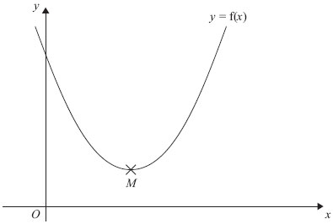

The minimum point of the curve is *M*.

(b) Write down the coordinates of *M*.

      ..............................................................................................................................................

**(1)**

**(Total for Question is 4 marks)**

**Q4.**

(a) Complete the table of values for *y* = 2*x*2 – 1

|  |  |  |  |  |  |
| --- | --- | --- | --- | --- | --- |
| *x* | -2 | -1 | 0 | 1 | 2 |
| *y* | 7 |  |  | 1 |  |

**(2)**

(b) On the grid below, draw the graph of *y* = 2*x*2 – 1 for values of *x* from *x* = –2 to *x* = 2

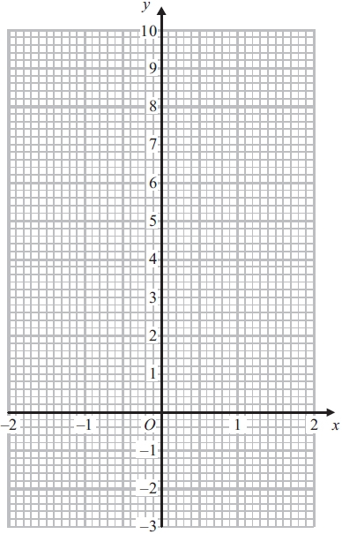

**(2)**

(c) Use your graph to write down estimates of the solutions of the equation 2*x*2 – 1 = 0

      ..............................................................................................................................................

**(2)**

**(Total for Question is 6 marks)**

**Q5.**

Here is the graph of  *y* = *x*2 – 2*x* – 4

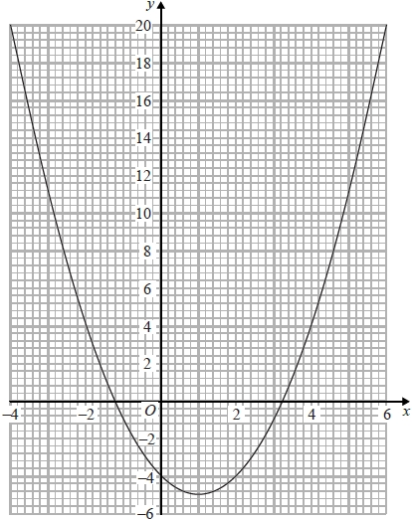

(a)  Write down estimates for the roots of  *x*2 – 2*x* – 4 = 0

...........................................................

**(2)**

(b)  Write down the coordinates of the turning point of  *y* = *x*2 – 2*x* – 4

( ................ , ................ )

**(1)**

**(Total for question = 3 marks)**

**Q6.**

The graph of *y* = f(*x*) is shown on each of the grids.

(a) On this grid, sketch the graph of *y* = f(*x* – 3)

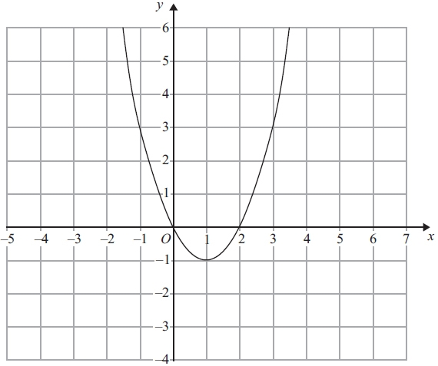

**(2)**

(b) On this grid, sketch the graph of *y* = 2f(*x*)

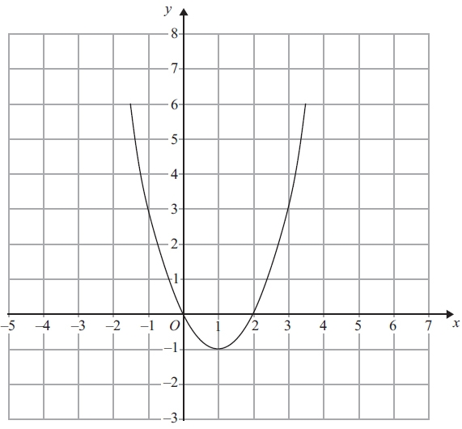

**(2)**

**(Total for Question is 4 marks)**

**Q7.**

The graph of *y* = f(*x*) is drawn on the grid.

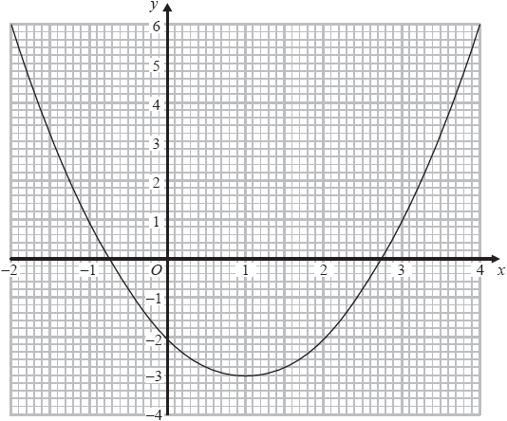

(a)   Write down the coordinates of the turning point of the graph.

( ................ , ................ )

**(1)**

(b)   Write down estimates for the roots of f(*x*) = 0

...........................................................

**(1)**

(c)   Use the graph to find an estimate for f(1.5)

...........................................................

**(1)**

**(Total for question = 3 marks)**

**Q8.**

The graph of *y* = f(*x*) is drawn on the grid.

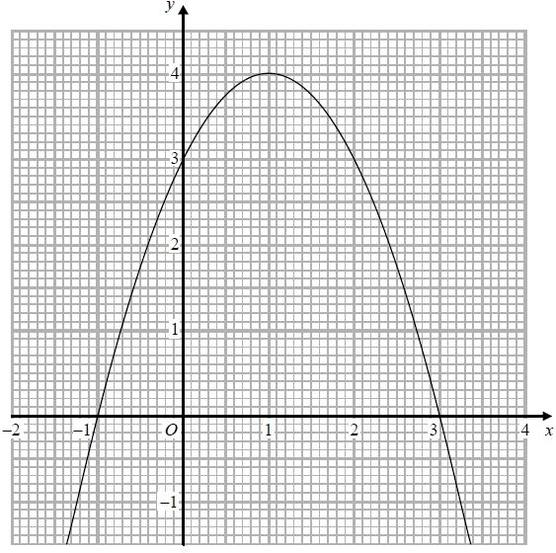

(a)  Write down the coordinates of the turning point of the graph.

(..........................., ...........................)

**(1)**

(b)  Write down the roots of f(*x*) = 2

...........................................................

**(1)**

(c)  Write down the value of f(0.5)

...........................................................

**(1)**

**(Total for question = 3 marks)**

**Q9.**

Sketch the graph of *y* = tan *x*° for 0 ≤ *x* ≤ 360

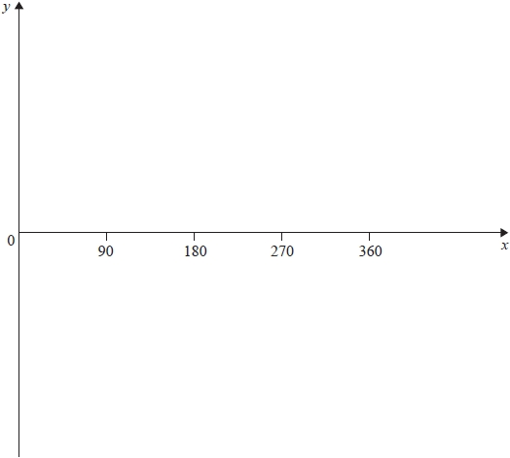

**(Total for question = 2 marks)**

**Q10.**

The diagram shows a sketch of the graph of *y* = cos *x*°

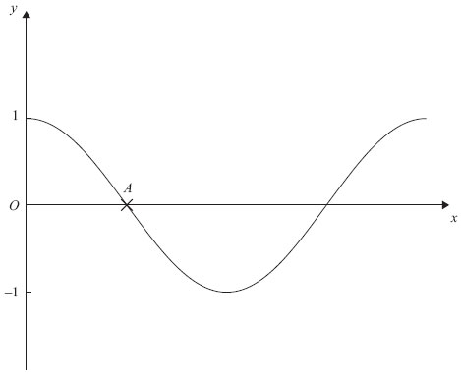

(a) Write down the coordinates of the point *A.*

      ..............................................................................................................................................

**(1)**

(b) On the same diagram, draw a sketch of the graph of *y* = 2 cos *x*°

**(1)**

**(Total for Question is 2 marks)**

**Q11.**

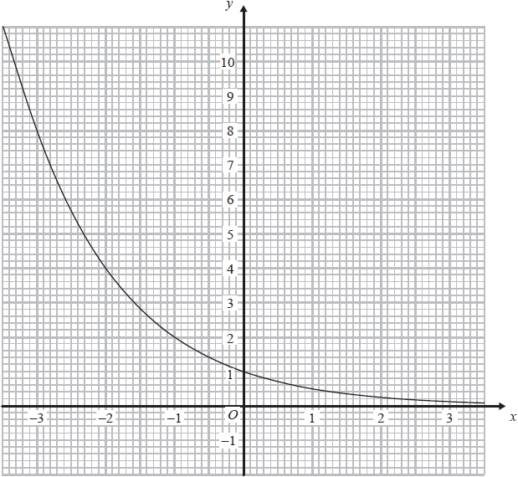

The graph of *y* = *kx*, where *k* is a positive constant, is shown above.

(a)  Find the value of *k*.

*k* = ...........................................................

**(2)**

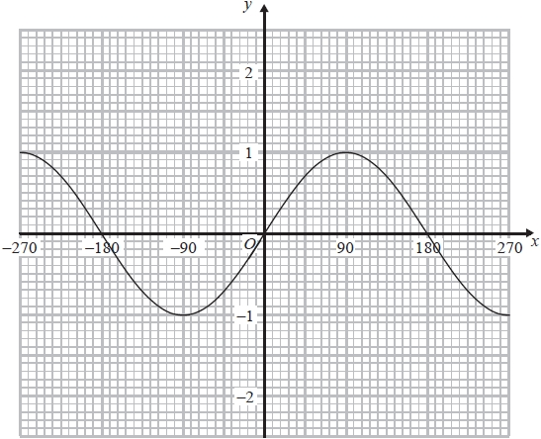

The graph of *y* = sin *x*° for values of *x* from –270 to +270 is shown above.

(b)  On the same axes, draw the graph of *y* = 1 – sin *x*° for values of *x* from –270 to +270

**(2)**

**(Total for question = 4 marks)**

**Q12.**

The diagram shows part of a sketch of the curve *y* = sin *x*°.

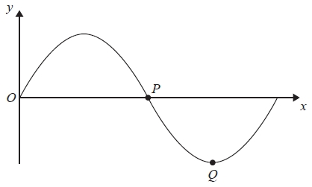

(a) Write down the coordinates of the point *P*.

(.............................. , ..............................)

**(1)**

(b) Write down the coordinates of the point *Q*.

(.............................. , ..............................)

**(1)**

Here is a sketch of the curve *y* = *a* cos *bx*° + *c*, 0 ≤ *x* ≤ 360

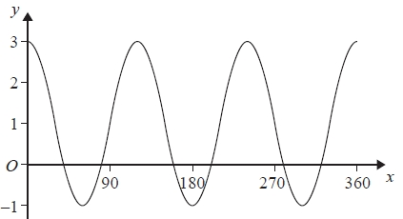

(c) Find the values of *a*, *b* and *c*.

*a* =...........................................................

*b* =...........................................................

*c* =...........................................................

**(3)**

**(Total for Question is 5 marks)**

**Q13.**

Here are some graphs.

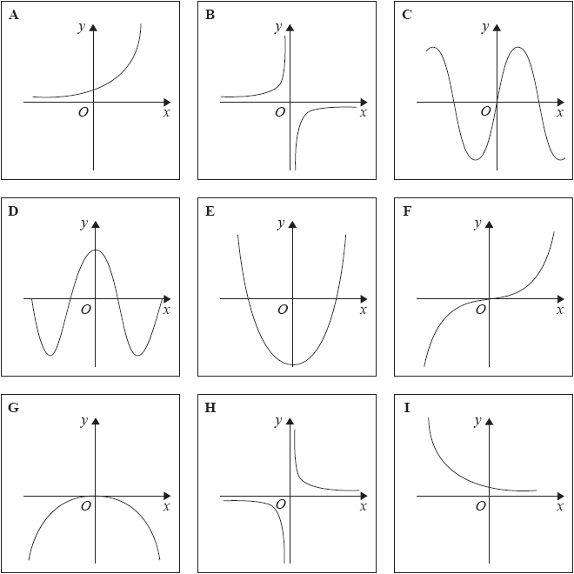

In the table below, match each equation with the letter of its graph.

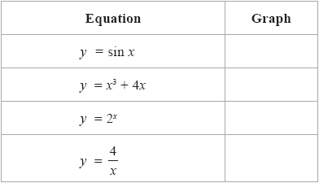

**(Total for question = 3 marks)**

**Q14.**

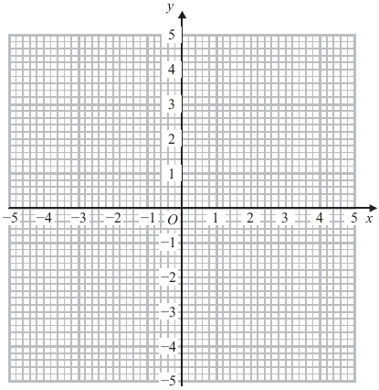

(a) On the grid, draw the graph of *x*2 + *y*2 = 4

**(2)**

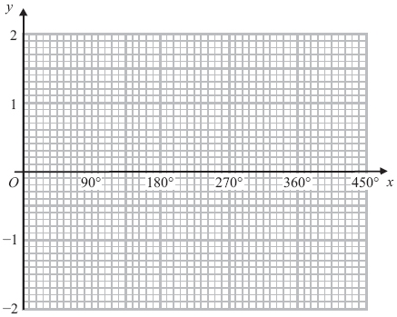

(b) On the grid, sketch the graph of *y* = cos *x* for 0° ≤ *x* ≤ 360°

**(2)**

**(Total for Question is 4 marks)**

**Q15.**

The graph of    *y* = f(*x*)    is shown on the grid.

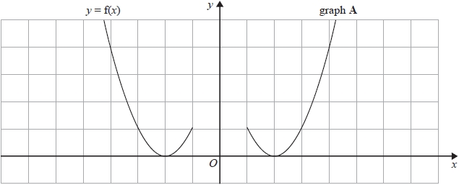

Graph **A** is a reflection of the graph of    *y* = f(*x*).

(a)  Write down the equation of graph **A**.

...........................................................

**(1)**

The graph of    *y* = g(*x*)    is shown on the grid.

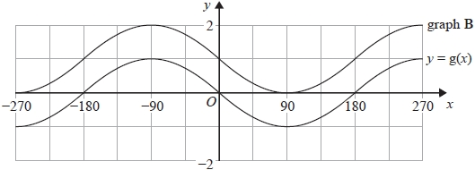

Graph **B** is a translation of    *y* = g(*x*).

(b)  Write down the equation of graph **B**.

...........................................................

**(1)**

The graph of    *y* = cos *x*°    is shown.

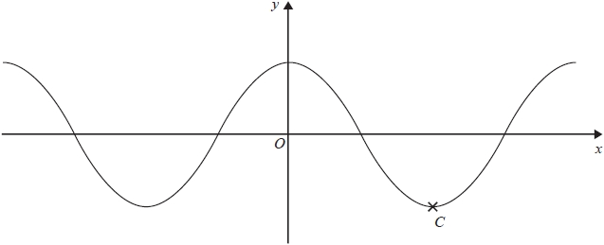

(c)  Write down the coordinates of the point marked *C*.

( ................ , ................ )

**(1)**

**(Total for question = 3 marks)**

**Q16.**

Here is a sketch of a curve.

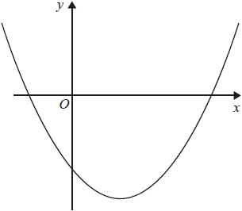

The equation of the curve is     *y* = *x*2 + *ax* + *b*     where *a* and *b* are integers.

The points (0, −5) and (5, 0) lie on the curve.

Find the coordinates of the turning point of the curve.

( ................ , ................ )

**(Total for question = 4 marks)**

**Q17.**

Given that *x*2 – 6*x* + 1 = (*x* – *a*)2 – *b* for all values of *x*,

(i)  find the value of *a* and the value of *b*.

*a* = ...........................................................

*b* = ...........................................................

**(2)**

(ii)  Hence write down the coordinates of the turning point on the graph of *y* = *x*2 – 6*x* + 1

( ................ , ................ )

**(1)**

**(Total for question = 3 marks)**

**Q18.**

The graph of *y* = f(*x*) is shown on the grid.

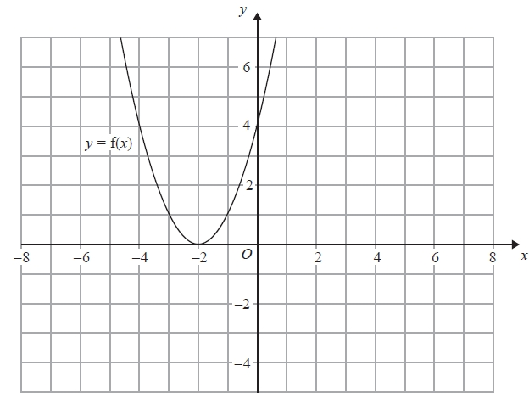

(a)  On the grid above, sketch the graph of *y* = f(*x* + 3)

**(2)**

The graph of *y* = g(*x*) is shown below.

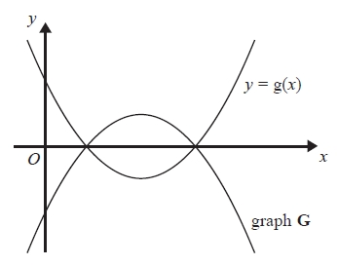

The graph **G** is the reflection of *y* = g(*x*) in the *x*-axis.

(b)  Write down an equation of graph **G**.

...........................................................

**(1)**

**(Total for question = 3 marks)**

**Q19.**

(a)  Sketch the graph of *y* = cos *x*º for 0  *x*  360

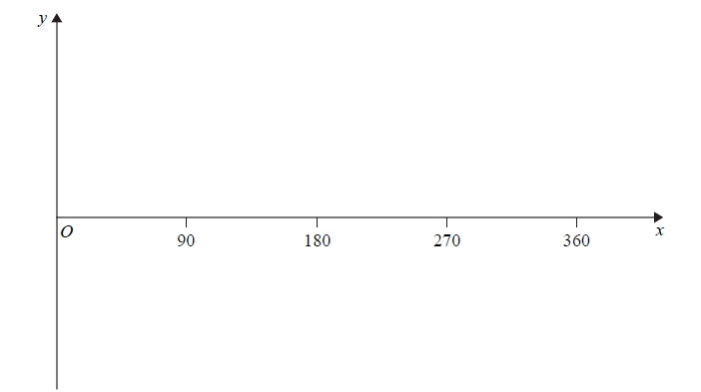

**(2)**

(b)  The graph of *y* = f(*x*) is shown on both grids below.

(i)  On this grid, draw the graph of *y* = 2f(*x*)

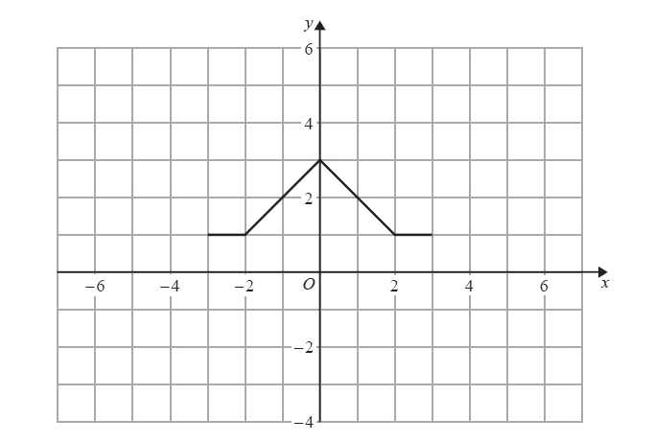

(ii)  On the grid below, draw the graph of *y* = f(*x* – 3)

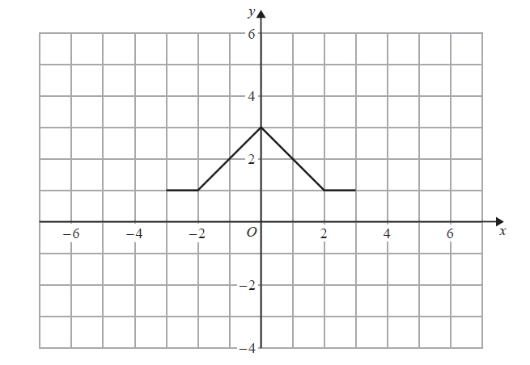

**(2)**

**(Total for question = 4 marks)**

**Q20.**

The graph of *y* = f(*x*) is shown on both grids below.

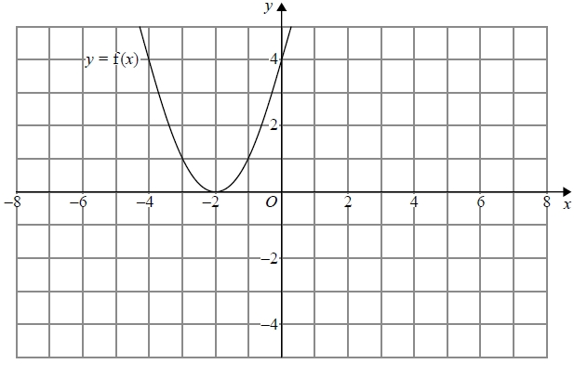

(a)  On the grid above, sketch the graph of *y* = f(−x)

**(1)**

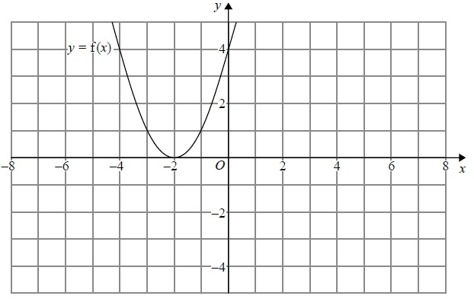

(b) On this grid, sketch the graph of *y* = −f(*x*) + 3

**(1)**

**(Total for question = 2 marks)**

**Q21.**

Here is the graph of *y* = sin *x*° for −180 ≤ *x* ≤ 180

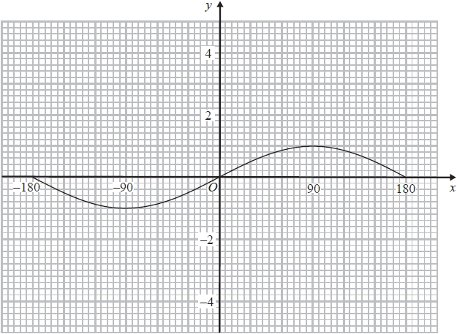

On the grid, sketch the graph of *y* = sin *x*° − 2 for −180 ≤ *x* ≤ 180

**(Total for question = 2 marks)**

**Q22.**

Here are four graphs.

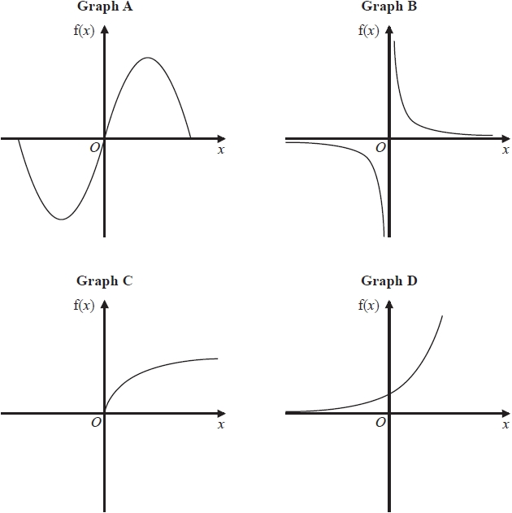

The graphs represent four different types of function f.

Match each description of the function in the table to the letter of its graph.

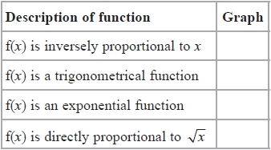

**(Total for question = 2 marks)**

**Q23.**

The table shows some values of *x* and *y* that satisfy the equation *y* = *a*cos*x*° + *b*

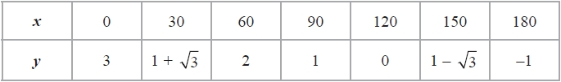

Find the value of *y* when *x* = 45

...........................................................

**(Total for question = 4 marks)**

**Q24.**

*y* = f(*x*)

The graph of *y* = f(*x*) is shown on the grid.

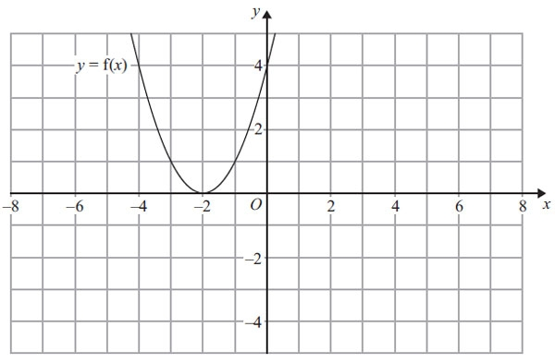

(a) On the grid above, sketch the graph of *y* = – f(*x*).

**(2)**

The graph of *y* = f(*x*) is shown on the grid.

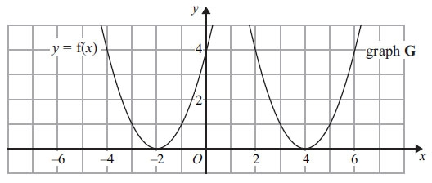

The graph **G** is a translation of the graph of *y* = f(*x*).

(b) Write down the equation of graph **G**.

      ..............................................................................................................................................

**(2)**

**(Total for Question is 3 marks)**

**Q25.**

Here is the graph of *y* = sin *x*° for –180 ≤ *x* ≤ 180

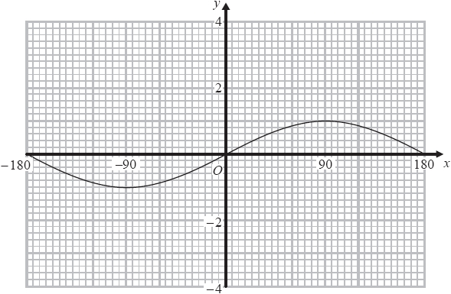

(a)  On the grid above, sketch the graph of *y* = sin *x*° + 2 for –180 ≤ *x* ≤ 180

**(2)**

Here is the graph of *y* = cos *x*° for –180 ≤ *x* ≤ 180

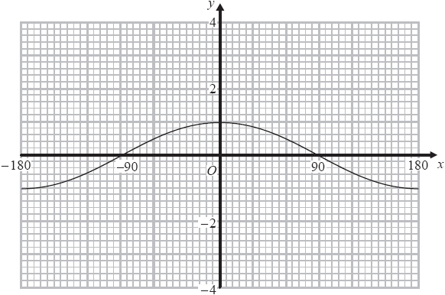

(b)  On the grid above, sketch the graph of *y* = –2 cos *x*° for –180 ≤ *x* ≤ 180

**(2)**

**(Total for question = 4 marks)**

**Q26.**

The graph of *y* = f(*x*) is shown on the grid below.

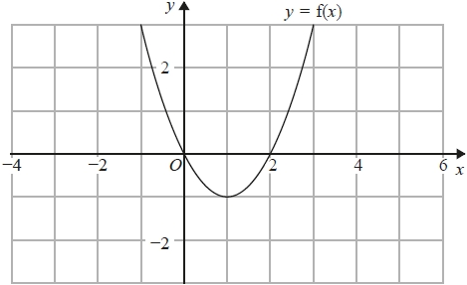

(a)  On the grid above, sketch the graph of *y* = f(*x* − 2)

**(1)**

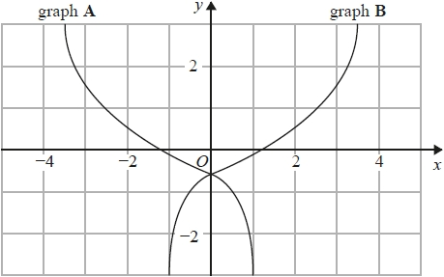

On the grid, graph **A** has been reflected to give graph **B**.

The equation of graph **A** is *y* = g(*x*)

(b)  Write down the equation of graph **B**.

...........................................................

**(1)**

**(Total for question = 2 marks)**

**Q27.**

The graph of the curve C with equation *y* = f(*x*) is transformed to give the graph of the curve S with equation *y* = f(−*x*) − 3

The point on C with coordinates (7, 2) is mapped to the point *Q* on S.

Find the coordinates of *Q*.

( ................ , ................ )

**(Total for question = 2 marks)**

**Q28.**

Here is a sketch of the curve   *y* = sin (*x* + *a*)° + *b*

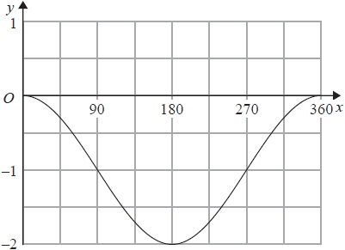

Given that 0 < *a* < 360   
find the value of *a* and the value of *b*.

*a* = ...........................................................

*b* = ...........................................................

**(Total for question = 2 marks)**

**Q29.**

The graph of *y* = f(*x*) is shown on the grid.

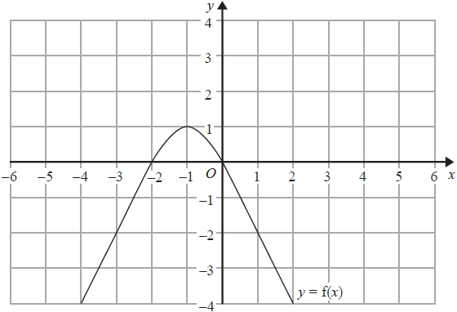

(a)  On the grid, sketch the graph of *y* = f(*x* − 1)

**(1)**

The graph of *y* = f(*x*) has a turning point at the point ( −1, 1)

(b)  Write down the coordinates of the turning point of the graph of *y* = f(–*x*) + 2

( ................ , ................ )

**(1)**

**(Total for question = 2 marks)**

**Q30.**

The graph of *y* = f(*x*) is transformed to give the graph of *y* = −f(*x* + 3)   
The point *A* on the graph of *y* = f(*x*) is mapped to the point *P* on the graph of *y* = −f(*x* + 3)

The coordinates of point *A* are (9, 1)   
Find the coordinates of point *P*.

(............................ , ............................)

**(Total for question is 2 marks)**

**End of questions**