**Key terms for Junior Maths Challenge**

**Consecutive** ‘Next door numbers’ eg 12 and 13 are consecutive whole numbers (which can be written algebraically as a and a+1)

**Integer** A whole number, positive or negative.

**Product** Multiply

**Sum** Add

**Difference** The difference between two numbers is the number you get when you subtract one from the other, ignoring the minus sign if you get a negative answer eg the difference between 11 and 14 is 3.

**Divisible** This word is used to describe when a whole number divides exactly into another, eg 27 is divisible by 9.

A few rules for divisibility:

|  |  |
| --- | --- |
| How can I tell if a number is divisible by… |  |
| 2 | Ends in 0, 2, 4, 6, 8 (even numbers) |
| 5 | End in 5, 0 |
| 10 | Ends in 0 |
| 3 | The sum of the digits is divisible by 3 (eg 243? Is divisible by 3 because 2 + 4 + 3 = 9 and 9 is divisible by 3) |
| 6 | Must be divisible by 2 and 3 (test using the rules above) |
| 4 | The last two digits must be divisible by 4 (eg 512? Is divisible by 4 because 12 is divisible by 4) |
| 9 | The sum of the digits is divisible by 9 |

**Factor** A number which divides exactly into another number eg 6 is a factor of 18.

**Highest Common** **Factor** When you have two numbers, this is the largest whole number which divides exactly into both of them eg 5 is the **HCF** of 15 and 10.

**Multiple** eg multiples of 3 are 3, 6, 9, 12, 15,…

**Lowest Common** **Multiple** When you have two numbers, this is the lowest number that is a multiple of both numbers eg the **LCM** for 12 and 18 is 36.

**Remainder**  What is ‘left over’ when a whole number is divided into another eg the remainder when dividing 22 by 5 is 2.

**Even numbers** Multiples of 2, will end in 0, 2, 4, 6 or 8

**Odd numbers** The numbers that are not even numbers!

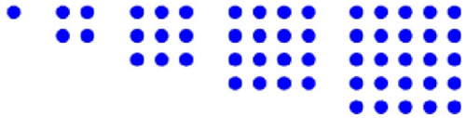

**Square numbers** 1, 4, 9, 16, 25, 36,…

(from 12, 22, 32, 42, 52 etc)

or imagine the number of dots in the squares

**Cube Number**s 1, 8, 27, 64, 125… (from 13, 23, 33, 43, 53,… ) or imagine the number of individual cubes in these cubes:

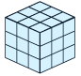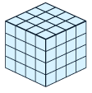

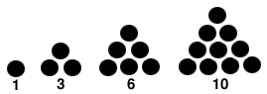**Triangle Numbers** 1, 3, 6, 10, 15, 21, 28, . . . (Start with 1 then you add 2, add 3, add 4 etc)

**Fibonacci numbers** 1, 1, 2, 3, 5, 8, 13, 21, 34,…. Each number is the previous two in the list added together.

**Prime Number** A number which has exactly 2 factors, 1 and itself eg 2, 3, 5, 7, 11, 13, 17, 19, 23, 29,…

**Prime factor** A prime number which divides exactly into your number eg 5 is a prime factor of 15 (and so is 3).

**Palindrome**  A number which reads the same if you reverse its digits, e.g. 23432.

**Mean** Add the numbers up and divide by how many there are eg the mean of 3, 5, 4 is (3+5+4)/3 = 12/3 = 4

**Polygon**  A shape with straight sides.

**Regular Polygon**  A shape with equal length straight sides and all interior angles equal eg a regular hexagon looks like this.