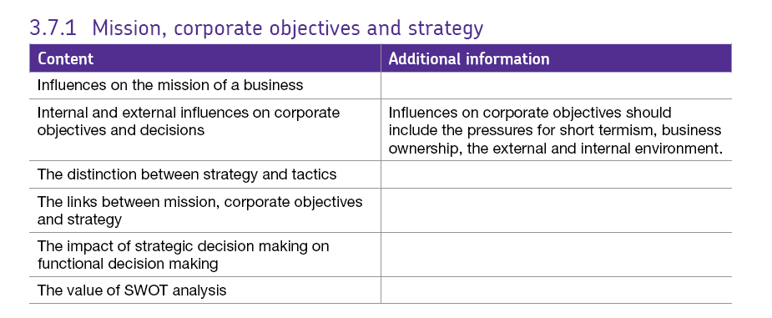3.7.1 Mission, corporate objectives and strategy.

What the organisation is attempting to achieve, and how this helps to determine its strategies – how it attempts to achieve its aims.

# Mission statements

A statement of what the firm is trying to achieve and a strategic view and where they are going.

Mission statements often include statements regarding;

* Corporate values
* Non-financial objectives
* Benefits of the business to the community
* How consumers are to be satisfied.

Mission statements can be reviewed and re-written if the firm’s circumstances change e.g. if there is a merger.

An effective mission statement:

* Differentiates the business from its competitors
* Defines the markets or business in which the business wants to operate
* Is relevant to all major stakeholders - not just shareholders and managers
* Excites, inspires, motivates & guides – particularly important for employees

Mission statements are often criticised because they are:

* Not always supported by actions of the business
* Often too vague and general or merely statements of the obvious
* Viewed as a public relations exercise
* Sometimes regarded cynically by employees
* Not supported wholeheartedly by senior management

# Corporate aims

These are the long-term plans of the business which are based upon the mission statement; they are intended to give the firm an overall sense of direction. e.g. profitable sustainable growth,

# Corporate objectives

The corporate objectives are smaller targets within the corporate aims. Corporate objectives are those that **relate to the business as a whole**. They are usually set by the top management of the business and they provide the focus for setting more detailed objectives for the main functional activities of the business.

Corporate objectives tend to focus on the desired performance and results of the business. It is important that corporate objectives cover a range of key areas where the business wants to achieve results rather than focusing on a single objective.

Each department (function) of the business then sets its objectives to feed into the overall corporate objectives of the firm. For example, if the aim was growth then an objective might be to increase sales in certain market segments or of specific product lines.

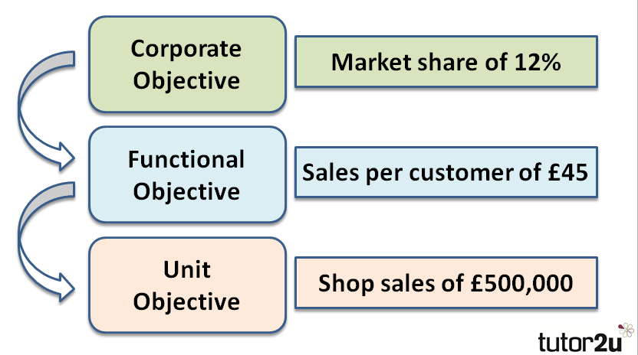

Objectives are usually SMART

## Strategic decisions:

These types of decision **affect the long term goals of the firm** and its general direction, they are often high risk e.g. diversifying into a new range of products with unknown outcomes.

## Tactical decisions:

These are short / medium term decisions which have a predictable element to their outcome. E.g. if labour turnover is rising we should use a worker questionnaire to ask staff what the issues are.

## Strategies and tactics.

Strategy is what a firm uses to help it to achieve its goals and ambitions. The strategies a firm chooses are often based upon a SWOT analysis and often corporate strategies require heavy investment in both time and resources.

Effective strategy requires planning, and planning requires regular review. The development of strategy requires:

**Effective strategies** have the following elements

* Clear purpose
* Vision of the end goal
* Customer and client details e.g. location and needs
* Commitment to success
* Timescale
* Flexibility
* Suitability

## Decision‑making to achieve objectives.

There are many different ways to think about making decisions but they will be influenced by available resources – not just financial but also time and people / skills needed and maybe ethics and social responsibility.

Some people like to go on a ‘hunch’ or their gut feeling while others will prefer to be scientific. Firms need to consider what information they have and what they need in order to interpret it to choose the best course of action.

## Types of strategy.

Strategies are classified according to their duration and their objective:

|  |  |  |
| --- | --- | --- |
| **Strategy** | **Duration** | **Objective** |
| Operational | Short term, day to day | Designed to improve efficiency in the day-to-day business of the firm e.g. achieving economies of scale, TQM, staff motivation & training. |
| Generic | Medium term | aka Business level strategy, designed to gain **competitive advantage** over other firms. E.g. cost leadership (ALDI), differentiation (Apple), consolidation (Marks and Spencer), new product development (Samsung or Apple) etc. |
| Corporate | Long term | Used to give the firm a direction, something to aim for. These plans include ideas on internal development e.g. restructuring, growth, work with other companies e.g. joint ventures etc. |
| Global | Long term | Benefits of a well-designed global strategy include: Efficiency – benefitting from economies of scale Reputation and brand image – tend to be stronger for global brands e.g. Coca-Cola, Levis, Google |
| Multi-domestic | Long-term | Having different products in different countries, decisions are made at local level regarding the needs of the domestic customers. |

Strategic development is achieved through:

**Internal development** – increasing sales and profit through organic growth – retaining profit and then re-investing it.

**External development** – takeovers, mergers and acquisitions - a good option for international development e.g. Tesco fresh and easy e.g. of not being successful.

**Synergy**: - collaborating with other firms through alliances and joint ventures.

# SWOT Analysis

SWOT analysis is a method for analysing a business, its resources and its environment. SWOT is commonly used as part of strategic planning and looks at:

* Internal strengths
* Internal weaknesses
* Opportunities in the external environment
* Threats in the external environment

SWOT analysis aims to discover:

* What the business does better than the competition
* What competitors do better
* Whether it is making the most of the opportunities available
* How a business should respond to changes in its external environment

The result of the analysis is a matrix of positive and negative factors for management to address:

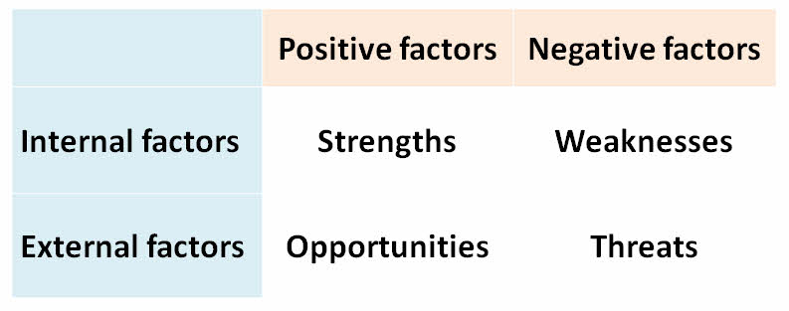

The key point to remember about SWOT is that:

***Strengths and weaknesses***

* Are internal to the business
* Relate to the present situation

***Opportunities and threats***

* Are external to the business
* Relate to changes in the environment which will impact the business

## Using SWOT analysis

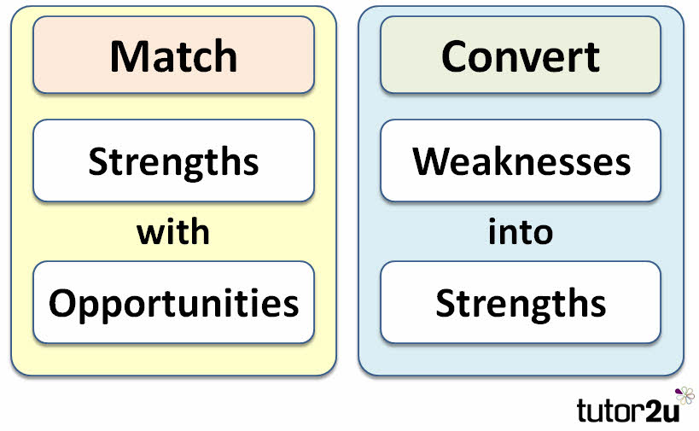

There is no point producing a SWOT analysis unless it is actioned! SWOT analysis should be more than a list - it is an analytical technique to support strategic decisions

Strategy should be devised around strengths and opportunities - the key words are **match and convert**:

A key challenge for any business is to convert weaknesses into strengths.

For example:

|  |  |
| --- | --- |
| Weakness | Possible Response |
| Outdated technology | Acquire competitor with leading technology |
| Skills gap | Invest in training & more effective recruitment |
| Overdependence on a single product | Diversify the product portfolio by entering new markets |
| Poor quality | Invest in quality assurance |
| High fixed costs | Examine potential for outsourcing or offshoring |

Don’t forget that for every perceived threat, the same change presents an opportunity for business.