**LOWER 5 NOTES**

**Gaseous exchange**

The lungs are in the upper part of the body (thorax), protected by the ribcage and separated from the lower part of the body (abdomen) by the diaphragm.

The breathing system takes air into and out of the body so that oxygen from the air can diffuse into the bloodstream and carbon dioxide can diffuse out of the bloodstream into the air.

To make air move into the lungs the ribcage moves out and up and the diaphragm becomes flatter. These changes are reversed to make air move out of the lungs. The movement of air into and out of the lungs is known as ventilation.

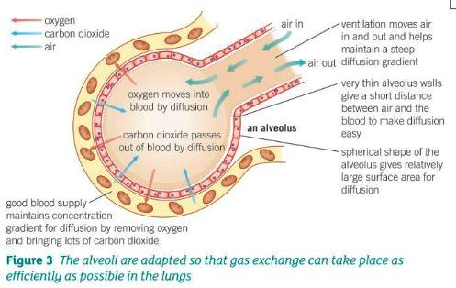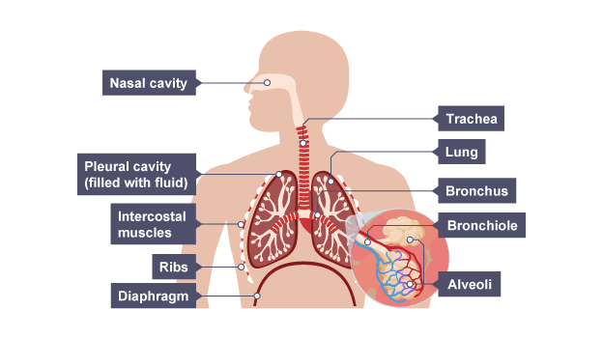

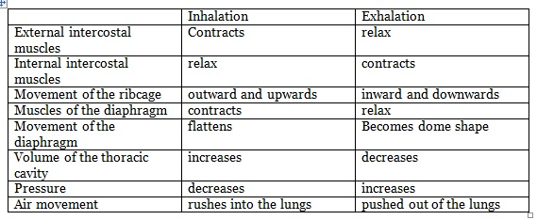**Inhalation and exhalation**

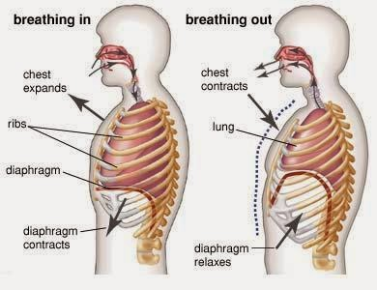

**The heart and blood vessels**

The heart is an organ that pumps blood around the body in a double circulatory system. Much of the wall of the heart is made from muscle tissue.

There are four main chambers (left and right atria and ventricles) of the heart. Blood enters the atria of the heart. The atria contract and force blood into the ventricles. The ventricles contract and force blood out of the heart.

The right ventricle pumps blood to the lungs where gas exchange takes place. The left ventricle pumps blood around the rest of the body.

Valves in the heart ensure that blood flows in the correct direction. Blood flows from the heart to the organs through arteries and returns through veins. There are two separate circulation systems, one for the lungs and one for all other organs of the body. The natural resting heart rate is controlled by a group of cells located in the right atrium that act as a pacemaker. Artificial pacemakers are electrical devices used to correct irregularities in the heart rate.

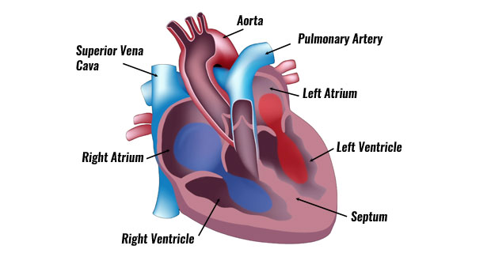

**Pacemaker**

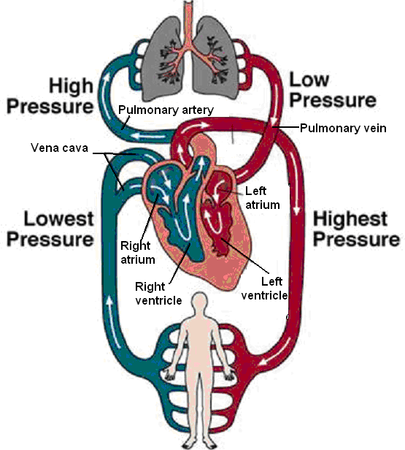

The body contains three different types of blood vessel:

* arteries
* veins
* capillaries

Arteries have thick walls containing muscle and elastic fibres. Veins have thinner walls and often have valves to prevent back-flow of blood.

If arteries begin to narrow and restrict blood flow stents are used to keep them open.

In the organs, blood flows through very narrow, thin-walled blood vessels called capillaries. Substances needed by the cells in body tissues pass out of the blood, and substances produced by the cells pass into the blood, through the walls of the capillaries.

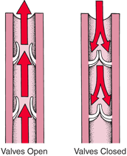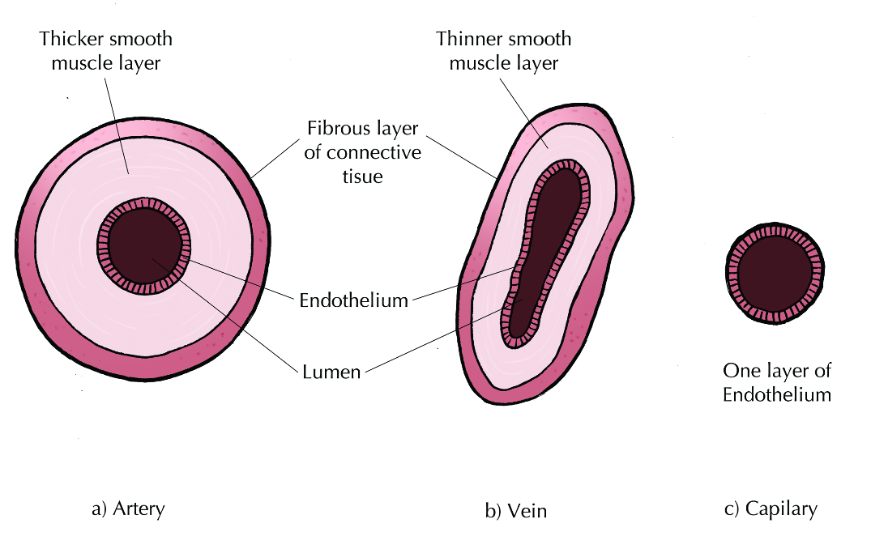

**The blood**

Blood is a tissue and consists of a fluid called plasma in which red blood cells, white blood cells, and platelets are suspended.

Blood plasma transports:

* carbon dioxide from the organs to the lungs
* soluble products of digestion from the small intestine to other organs
* urea from the liver to the kidneys.

Red blood cells transport oxygen from the lungs to the organs. Red blood cells have no nucleus.

They are packed with a red pigment called haemoglobin. In the lungs haemoglobin combines with oxygen to form oxyhaemoglobin.

In other organs oxyhaemoglobin splits up into haemoglobin and oxygen.

White blood cells have a nucleus. They form part of the body’s defence system against microorganisms.

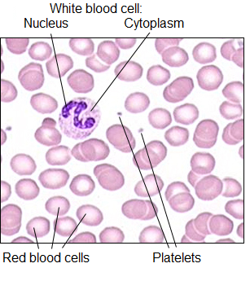Platelets are small fragments of cells. They have no nucleus. Platelets help blood to clot at the site of a wound.

**Coronary heart disease: a non-communicable disease**

There are advantages and disadvantages of treating cardiovascular diseases by drugs, mechanical devices or transplant.

In coronary heart disease layers of fatty material build up inside the coronary arteries, narrowing them. This reduces the flow of blood through the coronary arteries, resulting in a lack of oxygen for the heart muscle.

* Stents are used to keep the coronary arteries open.
* Statins are widely used to reduce blood cholesterol levels which slow down the rate of fatty material deposit.

In some people heart valves may become faulty, preventing the valve from opening fully, or the heart valve might develop a leak.

* Faulty heart valves can be replaced using biological or mechanical valves. However, no artificial valve is a perfect substitute for the natural valve. The life of the valve is limited by corrosion and damage due to its repeated use.

In the case of heart failure a donor heart, or heart and lungs can be transplanted. Artificial hearts are occasionally used to keep patients alive whilst waiting for a heart transplant, or to allow the heart to rest as an aid to recovery.

**Stents**

In order to keep beating, the heart muscle has its own artery called the **coronary artery**, which supplies the heart with [*glucose*](http://www.bbc.co.uk/schools/gcsebitesize/science/triple_aqa/transport_systems/blood_system/revision/4/) and oxygen. For patients who have heart disease, arteries can become narrower due to the build-up of fatty deposits within the wall of the artery. This has the effect of narrowing the [*lumen*](http://www.bbc.co.uk/schools/gcsebitesize/science/triple_aqa/transport_systems/blood_system/revision/4/) of the artery, reducing the amount of oxygenated blood that can be supplied to the heart muscle.

**Stents** are metal grids which can be inserted into an artery to maintain blood flow by keeping the artery open.

To insert a stent, a [*catheter*](http://www.bbc.co.uk/schools/gcsebitesize/science/triple_aqa/transport_systems/blood_system/revision/4/) with a balloon attached to it is inserted into a blood vessel in the leg. The balloon has the metal stent on it. The catheter is directed to the coronary artery. When the narrowed section of artery is found, the balloon is inflated which causes the stent to expand, and it becomes lodged in the artery.

The stent then acts to keep the artery open so that the heart continues to receive enough oxygen to function effectively.

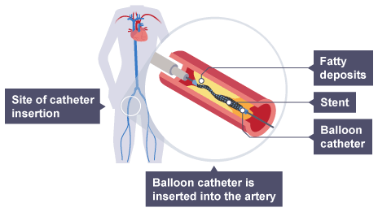

Stents are good alternatives to more risky operations, like [*by-pass surgery*](http://www.bbc.co.uk/schools/gcsebitesize/science/triple_aqa/transport_systems/blood_system/revision/4/), providing the patient’s heart disease is not too serious. However, fatty deposits may build up on the stent over time - meaning that blood flow to the heart muscle may be reduced again.

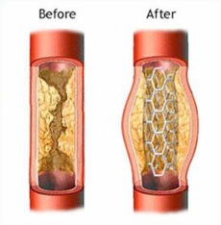

**Health issues**

There is a relationship between health and disease and the interactions between different types of disease.

Health is the state of physical and mental well-being.

Diseases, both communicable and non-communicable, are major causes of ill health. Other factors including diet, stress and life situations may have a profound effect on both physical and mental health.

* Defects in the immune system mean that an individual is more likely to suffer from infectious diseases.
* Viruses living in cells can be the trigger for cancers.
* Immune reactions initially caused by a pathogen can trigger allergies such as skin rashes and asthma.
* Severe physical ill health can lead to depression and other mental illness.

**The effect of lifestyle on some non-communicable diseases**

There is human and financial cost of these non-communicable diseases to an individual, a local community, a nation or globally

There is a huge effect of lifestyle factors including diet, alcohol and smoking on the incidence of non-communicable diseases at local, national and global levels.

Risk factors are linked to an increased rate of a disease.

They can be:

* aspects of a person’s lifestyle
* substances in the person’s body or environment

A causal mechanism has been proven for some risk factors, but not in others.

* The effects of diet, smoking and exercise on cardiovascular disease.
* Obesity as a risk factor for Type 2 diabetes.
* The effect of alcohol on the liver and brain function.
* The effect of smoking on lung disease and lung cancer.
* The effects of smoking and alcohol on unborn babies.
* Carcinogens, including ionising radiation, as risk factors in cancer.

Many diseases are caused by the interaction of a number of factors.

The principles of sampling can be applied to scientific data in terms of risk factors and it is possible to translate information between graphical and numerical forms; and extract and interpret information from charts, graphs and tables in terms of risk factors.

A scatter diagram can be used to identify a correlation between two variables in terms of risk factors.

**Cancer**

Cancer is caused as the result of changes in cells that lead to uncontrolled growth and division.

* Benign tumours are growths of abnormal cells which are contained in one area, usually within a membrane. They do not invade other parts of the body.
* Malignant tumour cells are cancers. They invade neighbouring tissues and spread to different parts of the body in the blood where they form secondary tumours.

Scientists have identified lifestyle risk factors for various types of cancer.

There are also genetic risk factors for some cancers.

**4.3 Infection and response**

Pathogens are microorganisms such as viruses and bacteria that cause infectious diseases in animals and plants. They depend on their host to provide the conditions and nutrients that they need to grow and reproduce. They frequently produce toxins that damage tissues and make us feel ill.

We can avoid diseases by reducing contact with them. The body uses barriers against pathogens. Once inside the body our immune system is triggered which is usually strong enough to destroy the pathogen and prevent disease.

When at risk from unusual or dangerous diseases our body’s natural system can be enhanced by the use of vaccination. Since the 1940s a range of antibiotics have been developed which have proved successful against a number of lethal diseases caused by bacteria. Unfortunately many groups of bacteria have now become resistant to these antibiotics. The race is now on to develop a new set of antibiotics.

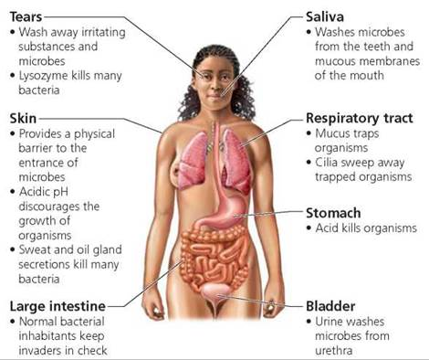**The body’s natural barriers to disease**

**4.3.1 Communicable diseases**

**Communicable (infectious) diseases**

The diseases caused by viruses, bacteria, protists and fungi are spread in animals and plants. However, the spread of diseases can be reduced or prevented.

Pathogens are microorganisms that cause infectious disease. Pathogens may be viruses, bacteria, protists or fungi. They may infect plants or animals and can be spread by direct contact, by water or by air.

Bacteria and viruses may reproduce rapidly inside the body. Bacteria may produce poisons (toxins) that damage tissues and make us feel ill. Viruses live and reproduce inside cells, causing cell damage.

**Viral diseases**

**Measles** is a viral disease showing symptoms of fever and a red skin rash. Measles is a serious illness that can be fatal if complications arise. For this reason most young children are vaccinated against measles. The measles virus is spread by inhalation of droplets from sneezes and coughs.

**HIV** initially causes a flu-like illness. Unless successfully controlled with antiretroviral drugs the virus attacks the body’s immune cells. Late stage HIV infection, or AIDS, occurs when the body’s immune system becomes so badly damaged it can no longer deal with other infections or cancers. HIV is spread by sexual contact or exchange of body fluids such as blood which occurs when drug users share needles.

**Tobacco mosaic virus (TMV)** is a widespread plant pathogen affecting many species of plants including tomatoes. It gives a distinctive ‘mosaic’ pattern of discolouration on the leaves which affects the growth of the plant due to lack of photosynthesis.

**Bacterial diseases**

**Salmonella** food poisoning is spread by bacteria ingested in food, or on food prepared in unhygienic conditions. In the UK, poultry are vaccinated against Salmonella to control the spread. Fever, abdominal cramps, vomiting and diarrhoea are caused by the bacteria and the toxins they secrete.

**Gonorrhoea** is a sexually transmitted disease (STD) with symptoms of a thick yellow or green discharge from the vagina or penis and pain on urinating. It is caused by a bacterium and was easily treated with the antibiotic penicillin until many resistant strains appeared. Gonorrhoea is spread by sexual contact. The spread can be controlled by treatment with antibiotics or the use of a barrier method of contraception such as a condom.

**Fungal diseases**

**Rose black spot** is a fungal disease where purple or black spots develop on leaves, which often turn yellow and drop early. It affects the growth of the plant as photosynthesis is reduced. It is spread in the environment by water or wind. Rose black spot can be treated by using fungicides and/or removing and destroying the affected leaves.

**Protist diseases**

The pathogens that cause malaria are protists. The malarial protist has a life cycle that includes the mosquito. **Malaria** causes recurrent episodes of fever and can be fatal. The spread of malaria is controlled by preventing the vectors, mosquitos, from breeding and by using mosquito nets to avoid being bitten.

**Human defence systems**

The non-specific defence systems of the human body against pathogens include:

* Skin is the first barrier.
* Trachea and lungs produce mucus that traps microorganisms.
* Blood clots seal the wound.
* The stomach secretes hydrochloric acid which kills microorganisms.
* Other protection:
* Ear wax
* Tears
* Nostril hairs
* 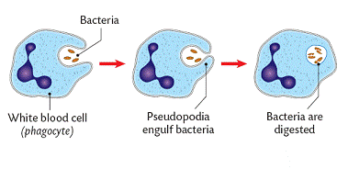Eyelashes

**Internal defences**

White blood cells help to defend against pathogens by:

* Ingesting pathogens
* Producing antibodies, which destroy particular bacteria or viruses
* Producing antitoxins, which counteract the toxins released by the pathogens.

**Vaccination**

Vaccination prevents illness in an individual and the spread of pathogens can be reduced by immunising a large proportion of the population.

Vaccination involves introducing small quantities of dead or inactive forms of a pathogen into the body to stimulate the white blood cells to produce antibodies. If the same pathogen re-enters the body the white blood cells respond quickly to produce the correct antibodies, preventing infection.

**Antibiotics and painkillers**

Antibiotics and other medicines can be used for treating disease.

Antibiotics, such as penicillin, are medicines that help to cure bacterial disease by killing infective bacteria inside the body. It is important that specific bacteria should be treated by specific antibiotics.

The use of antibiotics has greatly reduced deaths from infectious bacterial diseases. However, the emergence of strains resistant to antibiotics is of great concern. Doctor’s should only prescribe antibiotics when necessary – and not for viruses. It is important that if you are prescribed antibiotics you take the whole course. If you do this, you leave a few bacteria inside your body. These will reproduce, increasing the chance of some developing resistance.

Antibiotics cannot kill viral pathogens. It is difficult to develop drugs that kill viruses without also damaging the body’s tissues.

Painkillers and other medicines are used to treat the symptoms of disease but do not kill pathogens.

**Antibiotic Resistant Bacteria**

Many strains of bacteria, including MRSA, have developed resistance to antibiotics as a result of natural selection.

Mutations of pathogens produce new strains. Antibiotics and vaccinations may no longer be effective against a new resistant strain of the pathogen. The new strain will then spread rapidly because people are not immune to it and there is no effective treatment.

* Antibiotics kill individual pathogens of the non-resistant strain
* Individual resistant pathogens survive and reproduce, so the population of the resistant strain increases
* Now, antibiotics are no longer used to treat non-serious infections, such as mild throat infections, so that the rate of development of resistant strains is slowed down.

The development of antibiotic-resistant strains of bacteria necessitates the development of new antibiotics.

**Discovery and development of drugs**

The process of discovery and development of potential new medicines includes preclinical and clinical testing.

Traditionally drugs were extracted from plants and microorganisms.

* The heart drug digitalis originates from foxgloves.
* The painkiller aspirin originates from willow.
* Penicillin was discovered by Alexander Fleming from the Penicillium mould.

Most new drugs are synthesised by chemists in the pharmaceutical industry. However, the starting point may still be a chemical extracted from a plant.

New medical drugs have to be tested and trialled before being used to check that they are safe and effective.

New drugs are extensively tested for toxicity, efficacy and dose.

Preclinical testing is done in a laboratory using cells, tissues and live animals.

Clinical trials use healthy volunteers and patients.

* Very low doses of the drug are given at the start of the clinical trial.
* If the drug is found to be safe, further clinical trials are carried out to find the optimum dose for the drug.
* In double blind trials, some patients are given a placebo

**4.4 Bioenergetics**

Plants harness the Sun’s energy in photosynthesis in order to make food. This process liberates oxygen which has built up over millions of years in the Earth’s atmosphere.

Both animals and plants use this oxygen to oxidise food in a process called aerobic respiration which transfers the energy that the organism needs to perform its functions. Conversely, anaerobic respiration does not require oxygen to transfer energy. During vigorous exercise the human body is unable to supply the cells with sufficient oxygen and it switches to anaerobic respiration. This process will supply energy but also causes the build-up of lactic acid in muscles which causes fatigue.

**4.4.1 Photosynthesis**

**Photosynthetic reaction**

Photosynthesis is summarised by the equation:

Carbon dioxide + water + Light energy 🡪 glucose + oxygen

6CO2 + 6H2O + Light energy 🡪 C6H12O6 + 6 O2

During photosynthesis:

Light energy is absorbed by a green substance called chlorophyll, which is found in chloroplasts in some plant cells and algae. This energy is used by converting carbon dioxide (from the air) and water (from the soil) into sugar (glucose), Oxygen is released as a by-product.

Students should recognise the chemical symbols:

Photosynthesis as an endothermic reaction in which energy is transferred from the environment to the chloroplasts by light.

**Rate of photosynthesis**

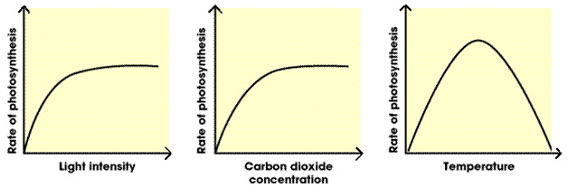The rate of photosynthesis may be limited by:

* shortage of light
* low temperature
* shortage of carbon dioxide.

Light, temperature and the availability of carbon dioxide interact and in practice any one of them may be the factor that limits photosynthesis.

**Uses of glucose from photosynthesis**

The glucose produced in photosynthesis may be:

* used for respiration
* converted into insoluble starch for storage
* used to produce fat or oil for storage
* used to produce cellulose, which strengthens the cell wall
* used to produce amino acids for protein synthesis.
* To produce proteins, plants also use nitrate ions that are absorbed from the soil.

**4.4.2 Respiration**

**Aerobic and anaerobic respiration**

Cellular respiration is an exothermic reaction which is continuously occurring in living cells.

The energy transferred supplies all the energy needed for living processes.

Respiration in cells can take place aerobically (using oxygen) or anaerobically (without oxygen), to transfer energy.

The processes of aerobic and anaerobic respiration can be compared with regard to the need for oxygen, the differing products and the relative amounts of energy transferred.

Organisms need energy for:

* chemical reactions to build larger molecules
* movement
* keeping warm.

Aerobic respiration is represented by the equation:

Glucose + oxygen 🡪 carbon dioxide + water (+ energy)

C6H12O6  + 6O2 🡪 6CO2 + 6H2O

Anaerobic respiration in muscles is represented by the equation:

Glucose 🡪 lactic acid

As the oxidation of glucose is incomplete in anaerobic respiration much less energy is transferred than in aerobic respiration.

Anaerobic respiration in plant and yeast cells is represented by the equation:

Glucose 🡪 ethanol + carbon dioxide

Anaerobic respiration in yeast cells is called fermentation and has economic importance in the manufacture of bread and alcoholic drinks.

**Response to exercise**

During exercise the human body reacts to the increased demand for energy.

The heart rate, breathing rate and breath volume increase during exercise to supply the muscles with more oxygenated blood.

If insufficient oxygen is supplied anaerobic respiration takes place in muscles. The incomplete oxidation of glucose causes a build-up of lactic acid and creates an oxygen debt. During long periods of vigorous activity muscles become fatigued and stop contracting efficiently.

Blood flowing through the muscles transports the lactic acid to the liver where it is converted back into glucose. Oxygen debt is the amount of extra oxygen the body needs after exercise to react with the accumulated lactic acid and remove it from the cells.

**Metabolism**

Sugars, amino acids, fatty acids and glycerol are important in the synthesis and breakdown of carbohydrates, proteins and lipids.

Metabolism is the sum of all the reactions in a cell or the body.

The energy transferred by respiration in cells is used by the organism for the continual enzyme controlled processes of metabolism that synthesise new molecules.

Metabolism includes:

* conversion of glucose to starch, glycogen and cellulose
* the formation of lipid molecules from a molecule of glycerol and three molecules of fatty acids
* the use of glucose and nitrate ions to form amino acids which in turn are used to synthesise proteins
* respiration
* breakdown of excess proteins to form urea for excretion.