GCSE Religious Studies



# Paper 2: Thematic Studies

# Religion and Life

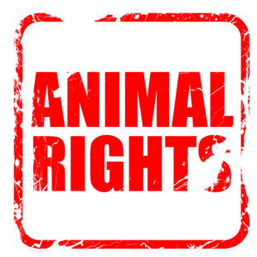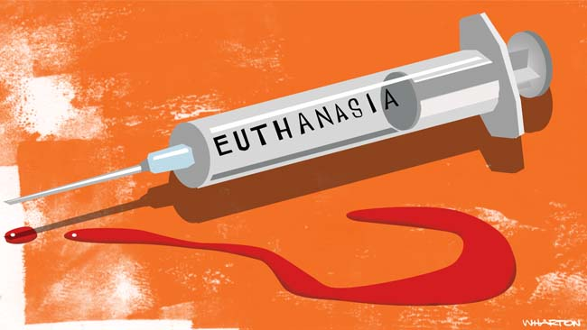

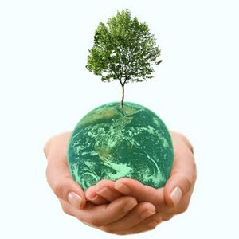

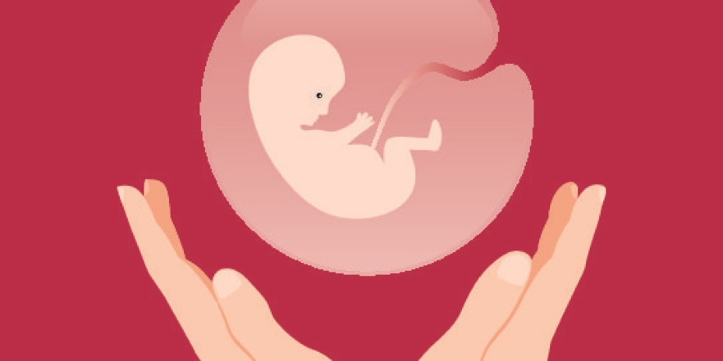

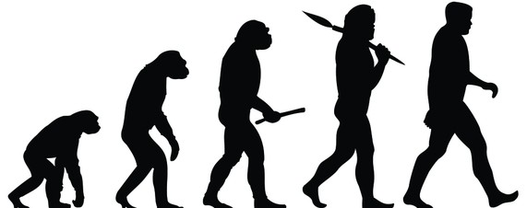

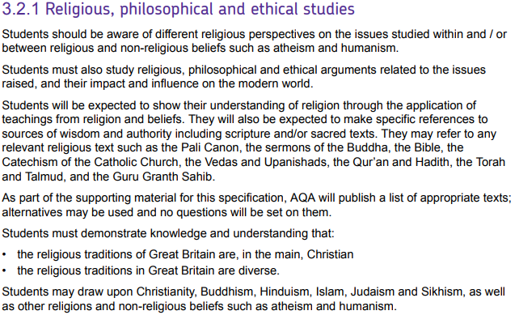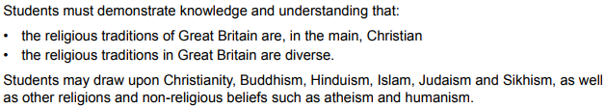

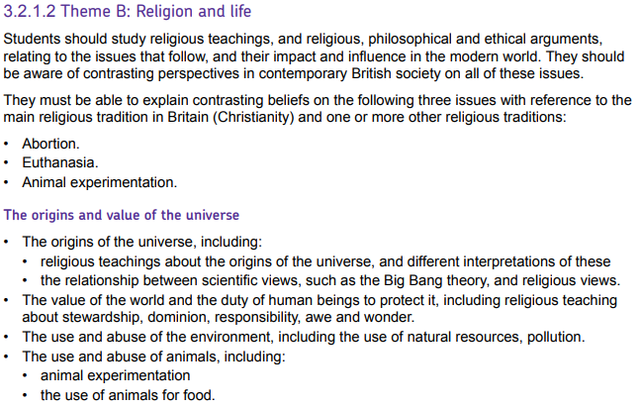

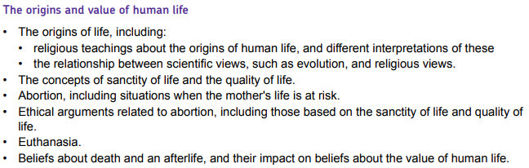



|  |  |
| --- | --- |
| **Key Term** | **Definition** |
| **Active euthanasia** | A painless death carried out by performing a deliberate action. |
| **Ahimsa** | Hindu principle of non-violence. |
| **Assisted suicide** | Providing a person with the means to kill themselves. |
| **Deforestation** | The cutting down of large amounts of forest, usually for business needs. |
| **Dominion** | Having power over something. |
| **Ensoulment** | The point at which the foetus receives a soul. |
| **Environment** | The natural world; the surroundings in which we live. |
| **Evolution** | The process by which living organisms are thought to have developed from earlier forms of life through natural selection. |
| **Euthanasia** | The painless killing of someone out of compassion. |
| **Natural resources** | Materials found in nature – such as oil and trees – that can be used by people. |
| **Non-renewable resources** | Things the earth provides that will eventually run out as there is a limited amount of them; e.g. oil, coal and gas. |
| **Non-voluntary euthanasia** | Ending someone’s life painlessly when they are unable to ask but you have good reason for thinking they would want you to do so |
| **Passive euthanasia** | Carried out when medical treatment or life support is deliberately withdrawn or when a severely ill person is not given treatment that would help them survive |
| **Pollution** | Making something dirty and/or contaminated, usually in reference to the environment. |
| **Quality of life** | The general well-being of a person, in relation to their health and happiness. |
| **Renewable energy** | Energy that comes from a source that does not run out, such as wind or the sun. |
| **Sanctity of life** | The belief that life is sacred. |
| **Stewardship** | The idea that humans have a duty to look after the environment on behalf of God. |
| **Sustainable development** | Building and progress that try to reduce the impact on the natural world for future generations. |
| **Universe** | All of time and space and its contents. |
| **Vegan** | A person who does not eat animals or food produced by animals e.g. eggs and dairy. |
| **Vegetarian** | A person who does not eat meat or fish |
| **Voluntary euthanasia** | Ending life painlessly when someone asks for death |

Origins of the Universe

The Genesis Account

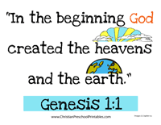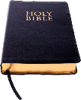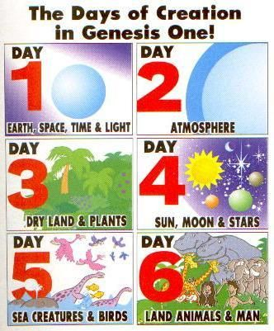The first chapter of the Bible, Genesis 1, tells a story about the creation of the world. It states that God created the world from nothing.

The rest of the chapter describes God creating the world in 6 days and then resting on the 7th. Some Christians take this story to be factually accurate. Christians who hold this belief are known as **creationists.**

----------------------------------------------------------------------------------------------------------------------------------------------

Scientific Explanation

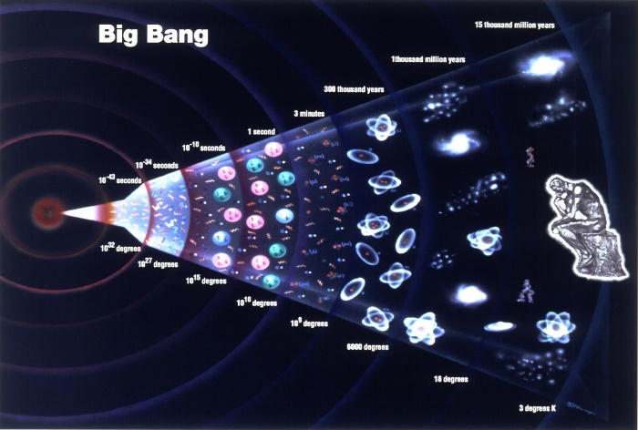The Big Bang theory is currently the leading **scientific** explanation for how they universe began. It suggests that the universe started with an incredibly small, hot, dense singularity which then exploded and expanded over the next 14 billion years. As the universe continued to expand and cool, the matter that has been flung in all directions became stars and formed galaxies.

Many argue that science has therefore proven the biblical account wrong:

|  |  |
| --- | --- |
| Creationist claim | Scientific claim |
| The universe is less than 10,000 years old. | The universe is over 14 billion years old and the Earth is 4.6 billion years old. |
| Aspects of the universe were created in separate acts by God. | The universe developed through expansion following the Big Bang. |

Some Christians have tried to reconcile the scientific and biblical accounts:

|  |  |
| --- | --- |
| **Day-Age Interpretation**  Many Christians believe that the word ‘day’ should be understood as meaning ‘period of time’. Christians who interpret the passage this way believe that science does not contradict the biblical narrative and in fact, Genesis is very accurate in describing the origin of the world. For example, the order of creation in Genesis is the same as the scientific view.  Arno Penzias, a Nobel Prize winning physicist said:  *“The best data we have [concerning the Big Bang] are exactly what I would have predicted, had I nothing to go on but the five books of Moses, the Psalms, and the Bible as a whole.”* | **Allegorical Interpretation**  Many other Christians believe that the Genesis account is not intended as a factual description of creation, but instead teaches **religious truths** such as:   * God is the **sole creator** and sustainer of the universe * The universe is **ordered**, not random * God created everything in the universe with a **purpose** * Humans are created in **God’s image** * Humans have a **responsibility** to care for the world God created.   Francis Collins, Head of the Human Genome Project wrote:  *“I see no conflict in what the Bible tells me about God and what science tells me about nature. I do not find the wording of Genesis 1 to suggest a scientific textbook but a powerful and poetic description of God's intentions in creating the universe.* *The mechanism of creation is left unspecified*” |

Notes:

 The Value of the World

Regardless of how one interprets the creation account in Genesis, Christians agree that the world is created by God and therefore has value. Christians regard the world as a priceless gift from God and loaned to humans because of his love.



Christians believe that God has given humans the privilege of living on the Earth but with the responsibility of looking after it and preventing it from being ruined. This special responsibility to protect and care for the Earth is known as **stewardship**.

“*The Lord God took the man and put him in the Garden of Eden to work it and take care of it.”* **Genesis 2:15**

In order to manage the earth, Christians teach that humans were given the power and authority to rule over the world and the things in it. This is known as having **dominion**:

A minority of Christians have interpreted ‘dominion’ as meaning that mankind can do whatever they want with the earth because they are in charge.

 *“Then God said, “Let us make man in our image, after our likeness. And let them have* ***dominion*** *over the fish of the sea and over the birds of the heavens and over the livestock and over all the earth and over every creeping thing that creeps on the earth.”* **Genesis 1:28**

The Genesis 1 creation story repeats several times *“and God saw that it was good.”* This indicates that creation has its own value in God’s eyes and does not merely exist for what humans can get out of it.

The Earth has also been created, not just for us, but for future generations and therefore many Christians believe we have a responsibility to encourage **sustainable development.**

Examples of abuse of the environment:

* Deforestation
* Overuse of fossil fuels (coal, natural gas and oil)
* Air pollution: Caused mainly by fumes from factories and vehicles, air pollution causes environmental problems such as global warming, climate change and acid rain. It also causes respiratory problems and lung cancer in humans.
* Land pollution: Caused by ineffective waste disposal. When chemicals enter the Earth, this can poison wildlife and contaminate the land resulting in less efficient farming.
* Water pollution: Caused by dumping waste into the sea and accidental contamination of the ocean e.g. oil spills. It can have a devastating effect on marine life.

**How** can Christians help preserve the planet?

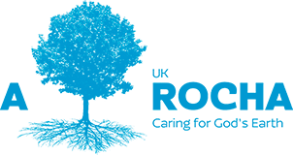

A Rocha UK is a Christian organisation that works with individuals and communities, encouraging them to think about their use of the environment and develop practical ways to care for people and the planet.

**Why** would Christians want to preserve the planet?

*“The Earth is the LORD’s and everything in it.”* **Psalm 24:1**

*“Every human act of irresponsibility towards the earth is an abomination.”* **Francis of Assisi**

Origins of human life

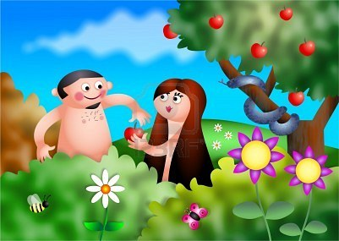Chapter 1 of Genesis describes human beings as being created by God on the sixth day in a special act of creation:

*“So God created mankind in his own image, in the image of God he created them; male and female he created them.”*

According to Genesis 2, Adam was formed by God from the soil and God breathed life into him. Later, God creates Eve as a helper for Adam. God creates Eve from one of Adam’s ribs while he is sleeping. The intention is that Adam and Eve will live in close relationship with God in the Garden of Eden.

Some Christians (creationists/fundamentalists) believe that this story is literally true and that the whole human race is descended from Adam and Eve.

-----------------------------------------------------------------------------------------------------------------------------------------------------------

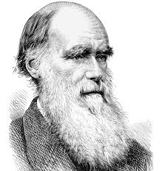

In 1859, Charles Darwin published *The Origin of Species by Means of Natural Selection.* In this work he proposed the theory of evolution which explains the complexity of life as a product of genetic mutation, adaptation and natural selection. Darwin’s theory suggested that all life evolved from single celled organisms over millions of years.

Biologists believe that the evidence of shared genetics among species, as well as fossil records showing the development of human beings over long periods of time, demonstrate the truth of evolution.

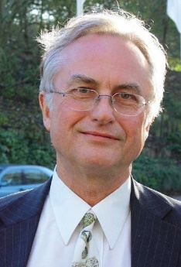Richard Dawkins writes:

*“My personal feeling is that understanding evolution led me to atheism.”*

Dawkins believes that evolution provides a better explanation of the origin of human life than the biblical account and renders a belief in a creator unnecessary. He argues that the evidence is overwhelming and cannot be denied, proving the Genesis story false.

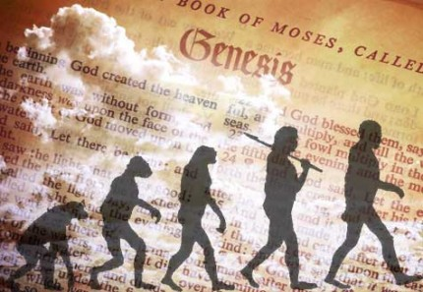Many Christians, such as Francis Collins, however do not take a literal interpretation of the Genesis account (see page 5) and therefore do not believe that biblical and scientific accounts of the origins of humanity to be in conflict. Christians who take this view often hold a position known as **theistic evolution**. On this view, God is a guiding force in the process of evolution; evolution is the method by which God creates human beings. According to this argument therefore, the Genesis story and evolution are compatible.

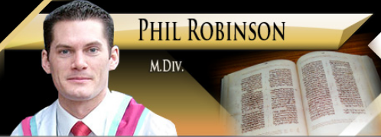Creationists/fundamentalists such as Phil Robinson however believe that any reinterpretation of Genesis to fit with modern science is to change the word of God and lose the true meaning of scripture:

*“Genesis 1 has to be one of the most straightforward narratives to read in the Bible. By reading the Genesis account of creation in a way that does not reflect what it is actually saying means that we will also have to read other passages in unnatural ways”*

The use and abuse of animals

Ways that humans use animals for their benefit

The value of animals

Image result for christianity*“And God said, Let us make man in our image, after our likeness: and let them have power over* [all animals].” (Genesis)

Image result for christianity*“A man is worth many [animals], but not one [animal] can die unnoticed in God's World.”* (Said by Jesus in Matthew’s Gospel)

Image result for christianity

*“A righteous man cares for the needs of his animal”* (Proverbs)

*“I look upon all creatures equally; none are less dear to me and none more dear. But those who worship me with love live in me, and I come to life in them.”* (Bhagavad Gita)

“*Nonviolence* [**ahimsa**]*... and mercy to all life forms are the goals of godly persons who are endowed with My nature.”* (Bhagavad Gita)

Should Christians eat meat?

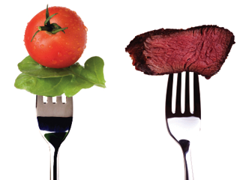In Genesis, God gives humans permission to eat meat:

*“Everything that lives and moves about will be food for you.”*

In Romans 14:2-3 though, it is clear that Christians have the choice to be meat-eaters, vegetarians or vegans and must not judge others.

*“The one who eats everything* [meat] *must not treat with contempt the one who does not, and the one who does not eat* [meat] *must not judge the one who does, for God has accepted them.”*

Animal Experimentation

|  |  |
| --- | --- |
| **Arguments FOR animal testing:** | **Arguments AGAINST animal testing:** |
|  |  |
| Religious (Christian) views (use scripture on p. 8) | Religious (Christian/Hindu) views (use scripture on p. 8) |

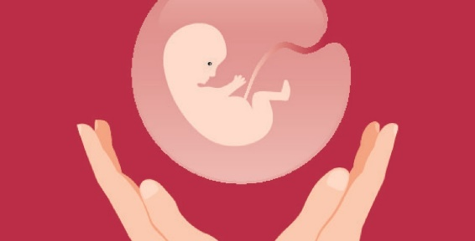Abortion

**Abortion** is the deliberate termination of a pregnancy.

In England, Scotland and Wales, abortion is legal if two doctors agree that one of the following conditions is met:

1. The pregnancy has not exceeded its 24th week and that the continuing the pregnancy would involve risk of injury to the physical or mental health of the pregnant woman or any existing children of her family.
2. The termination of the pregnancy is necessary to prevent grave permanent injury to the physical or mental health of the pregnant woman.
3. The continuance of the pregnancy would involve risk to the life of the pregnant woman.
4. There is a substantial risk that if the child were born it would suffer from such physical or mental abnormalities as to be seriously handicapped.

|  |  |
| --- | --- |
| **Pro-choice arguments (FOR abortion):** | **Pro-life arguments (AGAINST abortion):** |
|  |  |

Religious Attitudes to Abortion

Christians believe in the **sanctity of life.** This is the idea that human life is sacred and precious.

The **Catholic Church**, and many **evangelical Christians** believe that life begins at **conception.** This means that they believe an embryo or foetus to be an unborn child.



*“Before I formed you in the womb I knew you, before you were born I set you apart.”*

(Jeremiah 1:5)

Therefore, abortion is wrong since it is killing a human life.

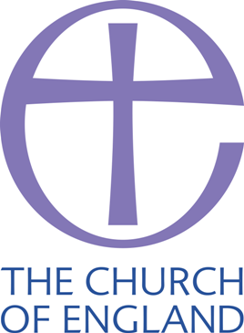The **Church of England** shares this opposition to abortion in most cases but believe that it might be acceptable in certain circumstances:

*“The Church of England combines strong opposition to abortion with a recognition that there can be – strictly limited – conditions under which it may be morally preferable to any available alternative.”* **CofE General Synod**

Circumstances in which the Church of England may permit an accept an abortion may include:

* When the life of the mother is at risk
* Where the child will suffer from a serious disability and survival will be for a very short period of time.

Some **liberal Christians** are more accepting of abortion and focus on being compassionate toward the mother of the unwanted child: “*In everything, do to others what you would have them do to you.”*

-----------------------------------------------------------------------------------

The Qur’an does not explicitly refer to abortion, but clearly shows that Muslims should value life.

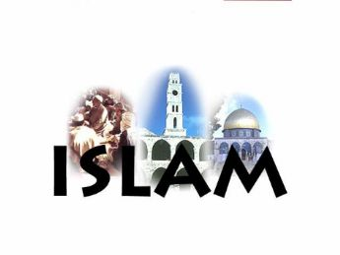Muslims believe that **ensoulment** does not occur at conception. Some believe that it happens at day 40 of the pregnancy, others believe 120. This means that, before this time, the mother’s life can be considered as more important since the foetus is only a potential life. Therefore, if the woman’s life will be harmed by continuing the pregnancy, an abortion may be accepted.

However, the Qur’an does appear to forbid abortions for financial reasons:

*“Do not kill your children for fear of poverty – we shall provide for them and for you – killing them is a great sin.”*

Euthanasia

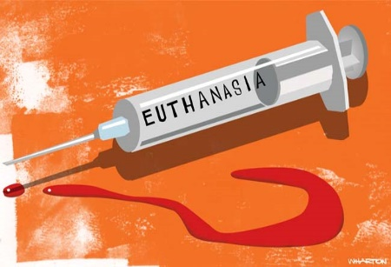The word **euthanasia** literally means ‘good death’. The intention is to compassionately end the life of someone who is in pain or has a poor quality of life.

There are many different forms of euthanasia (see key terms on page 2). All forms, as well as assisted suicide, are currently illegal in the UK and are considered either murder or manslaughter.

|  |  |
| --- | --- |
| **Arguments FOR euthanasia:** | **Arguments AGAINST euthanasia:** |
|  |  |

Religious Attitudes to Euthanasia

Many Christians, including Roman Catholics, believe that **euthanasia** is strictly forbidden. They would argue that taking a life is interfering with God’s plan and violates the 7th of the 10 Commandments: *“Thou shalt not murder”*. To decide when people die is to ‘play God’ and no human has the right to do this.

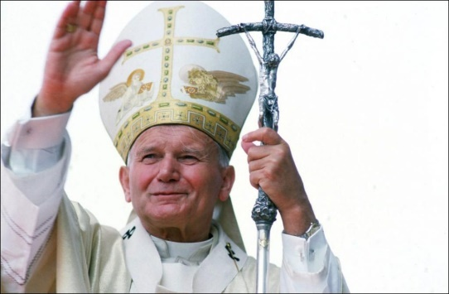*“Euthanasia is a grave violation of the law of God, since it is the deliberate and morally unacceptable killing of a human person.*

*…*

*True compassion leads to sharing another’s pain; it does not kill the person whose suffering we cannot bear.”*

Pope John Paul II

Some Christians do support euthanasia and believe that, in some circumstances, the most loving and compassionate thing to do is to end the life of the sufferer. They point to Jesus’ teaching to support this view:

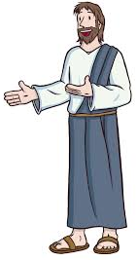

*“Blessed are the merciful”*

*“Do to others as you would have done to you.”*

-----------------------------------------------------------------------------------

Muslim Views

Euthanasia is strictly forbidden in Islam. Muslims believe in the sanctity of life; all life is a gift from God and therefore should be valued and looked after.

No person has the right to take away a life, only God decides when it will be ended. Only Allah knows why a person is suffering but since Allah is omnipotent, omniscient and omnibenevolent, there is a reason for human suffering and to end a life prematurely is to interfere with God’s plan.

The Qur’an says:

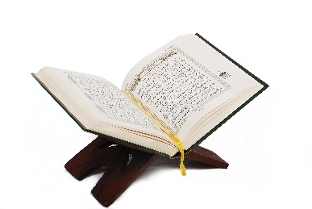*“Do not take life, which Allah has made sacred.”*

*“Do not kill each other, for Allah is merciful to you.”*

*“No soul may die, except with God’s permission at a predestined time.”*

Death and the Afterlife



Generally, atheists believe that at death one ceases to exist. However, some believe that we have evidence of life after death:

|  |  |
| --- | --- |
| **Evidence** | **Evaluation** |
|  |  |

Christian Beliefs

Christians believe that death is not the end. Following death, Christians believe that, ultimately, people will spend eternity in either heaven or hell.

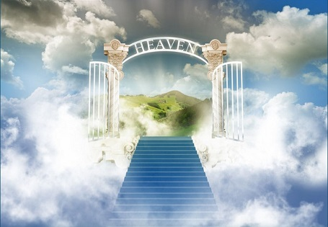Heaven

The Bible does not talk in huge detail about what heaven will be like. It does, however, make clear that heaven is a real place. Jesus says:

*“I am going there to prepare a* ***place*** *for you.”*

Ultimately, the Christian belief about heaven is that it is eternal life with God:

*“I desire to depart and be with Christ, which is better by far.”*

*“From heaven the Lord looks down and sees all mankind.”*

*“Everyone who believes in Him will not perish but have eternal life.”*

Hell

By contrast, Christians believe that Hell is eternal separation from God. There is disagreement about the nature of Hell, even consecutive Popes disagreed about it:

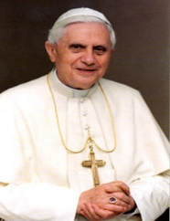

*“Hell really exists and is eternal, even if nobody talks about it much anymore. If sinners do not admit blame and promise to sin no more, they risked eternal damnation — the Inferno."*

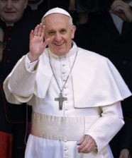

*“I do not believe in a literal hell where people suffer. This doctrine is incompatible with the infinite love of God. We see hell as a literary device; Hell is merely a metaphor for the isolated soul”*



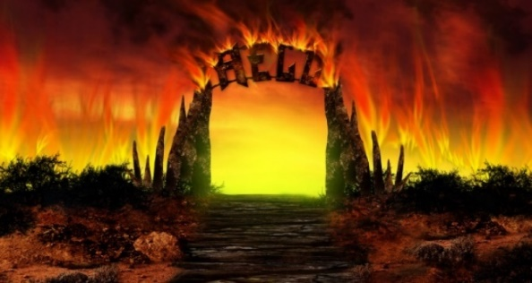 What does the Bible say about Hell?

*“And these will go away into eternal punishment, but the righteous into eternal life.”*

*“They will suffer the punishment of eternal destruction, away from the presence of the Lord and from the glory of his might.”*

*“And do not fear those who kill the body but cannot kill the soul. Rather fear him who can destroy both soul and body in hell.”*

Purgatory

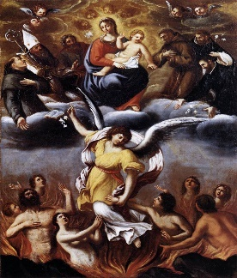Purgatory is a Catholic doctrine that does not appear in Protestant forms of Christianity. According to the Catechism of the Catholic Church (CCC), purgatory is a *“final purification”* which is afforded to *“all who die in God’s grace and friendship, but still imperfectly purified”* so that they might *“achieve the holiness necessary to enter the joy of heaven”.*

Essentially this means that purgatory is a sort of temporary purifying punishment for unconfessed, and therefore unforgiven, sins before entering heaven.

According to the Catholic Church, the purification is necessary because nothing unclean will enter the presence of God in heaven (*“Nothing unclean will ever enter heaven”*). Therefore, for those Christians whose sins have not been forgiven, a temporary period of purging is necessary in order to enjoy the presence and beauty of God that we were made for.

(See pages 24 – 26 in your Christian Beliefs and Teachings booklet for further information)

Possible exam questions

Question 1: (1 mark)

1) What term describes a religious theory about how the universe began?

1) What word means being gently and painlessly put to death?

1) What does the term ‘sanctity of life’ mean?

Question 2: (2 marks)

2) Give two examples of what religious believers might do to help to carry out the duty of stewardship.

2) Give two religious beliefs about pollution.

Question 3: (4 marks)

3) Explain two contrasting beliefs in contemporary British society about abortion.

3) Explain two similar religious beliefs about the use of animals for food.

3) Explain two religious teachings about the value of the world.

Question 4: 5 marks

**You must** refer to scripture or sacred writings in your answer.

4) Explain two religious beliefs about animal experimentation.

4) Explain two religious beliefs about the afterlife.

4) Explain two religious beliefs about the origins of humanity.

Question 5: (12 marks)

Evaluate the statement. In your answer you should:

• refer to Christian teaching

• give developed arguments to support this statement

• give developed arguments to support a different point of view

• reach a justified conclusion.

5) ‘It is not reasonable to believe in life after death.’

5) ‘Evolution proves that religious beliefs about the origins of life are wrong.’

5) ‘Abortion is murder.’