# Hofstede’s national cultures.

Hofstede defined organisational culture as an idea system which is largely shared between members of an organisation.

He carried out studies at IBM where he looked at the characteristics of working culture in different countries; the data can then be used to compare a workforce in one country against a workforce in a different country. Each country was scored between 1 – 120 for each characteristic, the higher the score the more the workers in that country exhibited a characteristic. The 6 characteristics are shown below.

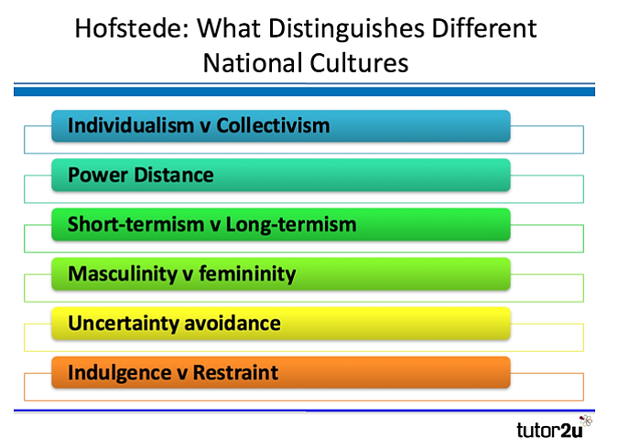

Hofstede found that cultural differences matter in business and affect how managers in one country will operate differently to those in another. Overall his findings suggest that greater business success can be achieved by adapting the leadership / management style to the characteristics of a particular country. Some of his findings are shown below.

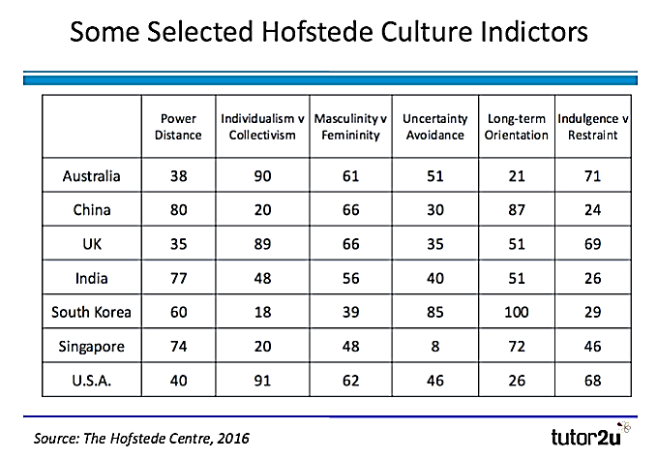

## Power distance -

The extent to which power is equally distributed in society and how widely society accepts this distribution. High PD culture is often related to strong leaders, highly autocratic cultures and would require a more autocratic style of leadership.

A low PD score indicates that the culture favours businesses where power is devolved – flatter structures

We can see from the table that **countries such as South Korea and China tend to favour more autocratic structures whereas the USA and Australia tend to favour more democratic or laissez-faire management.**

## Individualism –

Refers to how strong people’s ties are within the community. Countries with high scores tend to have workers who value their free time and have less interpersonal connection or value it less, workers value freedom and there is high expectation of reward. A low score here suggests a society where there are strong community bonds; work is often done for its intrinsic value so the need for specific financial rewards is less important. In these countries change often has to be introduced slowly as tradition is highly valued.

**Countries with low Individualism scores include –**

**Countries with high Individualism scores include –**

## Masculinity versus feminism –

This shows the extent to which society sticks to traditional male / female roles. A high score here suggests that men are generally seen as provider, assertive / authoritative and there are clear distinctions between male / female roles. A low scoring country is one in which men and women are more equal, there are many powerful / successful female roles, men are more sensitive and emotional and it’s more accepted for them to have caring roles. **The highest scoring country here is Japan and the lowest is Sweden.**

**Countries with low M v F scores include –**

**Countries with high M v F scores include –**

## Uncertainty avoidance index –

This refers to how anxious workers feel when they are in unknown situations. A high score here suggests that workers like structure and organisation and clear rules / chains of command. A low score suggests employees who don’t mind change and can cope easily when unusual events take place or if changes have to be completed quickly, business attitudes tend to be informal. **Belgium has a particularly high uncertainty avoidance score.**

**Countries with low uncertainty avoidance scores include –**

**Countries with high uncertainty avoidance scores include –**

## Long term orientation -

This refers to the value which society places on traditions and values.

In a country with a high score there is much greater emphasis on social obligations, family and community in general whereas in a county with a low score there is much greater promotion of equality, self-actualisation is important – fulfilling a person’s potential rather than focus on money and power. **USA and UK have low scores for long-term orientation.**

## Indulgence v restraint.

In countries with a low indulgence score freedom of speech and leisure are seen as less important whereas in those with a high indulgence score freedom to express yourself and use your free time however you want are seen as more important. **Countries with low indulgence scores include Eastern Europe, Asia and predominantly Muslim countries. Higher scores are seen in Australia, the Uk and the USA.**

# Applications of national cultures.

Some examples of cases where the Hofstede Model on national culture can be applied:  
  
**Leadership**

”Culture” can provide us with many answers about how and why people behave differently around the globe. One explanation is that people have very different views on "what is a good boss", or on ”how teams should be led”.

A major challenge in developing intercultural management competence is the fact that there is no "one way" to lead. This is especially relevant as all "new" and growing markets have something in common, they can be characterised as hierarchical cultures.  Many companies may realise that the leadership styles/guidelines they have been practicing might not be suitable for these cultures.

**Change Management**

The preparation and implementation of change is highly culturally sensitive. Often change is implemented incorrectly for the culture – ignoring behavioural issues such as resistance.  
**Customer services**

Many companies fail to gain maximum value from their customer service. High costs often offset the envisioned cost-savings, and culture is one of the most important reasons for failure when establishing customer service centres across geographical borders, both due to managing cultural differences, but also due to differences in customer cultures.  
  
**Marketing**

Because all aspects of consumer behaviour are culture-bound, there is an increased need to identify and understand this and its impact on global marketing and advertising. Hofstede's work can explain the differences in consumer behaviour across countries and can be a guide to increase efficiency in global marketing.

**Outsourcing**

Outsourcing is a very important strategic issue for most of the world's leading companies; however, it’s much more complex than just taking advantage of low wages in some emerging countries. Companies should not rush blindly into outsourcing, but need to plan it carefully. Managers are concerned with the coordination of resources (material, financial, and human) for the effective and efficient achievement of business objectives. However, what may be an effective and efficient way of coordination in one country may prove to be ineffective or inefficient in another.  
 **Recruitment**

For international organisations, recruiting the right people is of paramount importance. Coping with the complex international environment requires organisations to employ the people with the competences they need. HR and recruitment departments, therefore, develop profiles containing these desired competences.

Such profiles usually contain a listing of skills and character traits. Interestingly enough, however, organisations rarely consider the fact that the degree to which skills and traits are desirable differs from one country to another. The impact of management skills is culture-specific. Management techniques or leadership styles that work in one national culture do not necessarily work elsewhere.  
  
**Virtual Teams**

Working virtually is increasingly the norm, no matter which sector you work in. National culture has a big impact on this, because often a virtual team is also a cross-cultural team. Cultural diversity may manifest itself as differences in preference for and satisfaction with tasks, technology, outcomes, leadership style, decision-making process, relative contributions and communication practices of team members.