**3.1.8 Thermodynamics**

**AS Link:**

**3.1.4 – Energetics**

**3.1.1 – Atomic structure (ionisation energy)**

**Introduction**

Here’s a reminder of some definitions covered in energetics.

***Definition***:

**Enthalpy change** is the **heat change at constant** **pressure** under **standard conditions** (pressure 100 kPa and temperature 298 K).

Hess’s law is used to construct enthalpy cycles and energy level diagrams.

***Definition***: **Hess’s law** states that the enthalpy change of a reaction **depends only on the initial and final states of the reaction** and is **independent of the route** by which the reaction occurs.

Standard enthalpy change, ΔHθ

The size of any **enthalpy change** is **dependent on pressure, temperature** and **amount of substance**, so agreed **standard conditions** are used to **allow comparisons**.

***Definition***:

The **standard enthalpy change** for a reaction is the change in enthalpy when reactants in their **standard states** form products that are also in their **standard states**.

***Definition***:

The **standard state** of a substance at a given temperature is its **pure, most stable form** at 100 kPa.

* Standard amount is one mole
* Standard temperature is 298K (if no temperature is quoted assume 298K)

***Sheet: AS Enthalpy changes revision***

Ionic lattices

Ions form a **lattice with oppositely charged ions** next to each other, the ions are held by **electrostatic forces** which form **ionic bonds**.

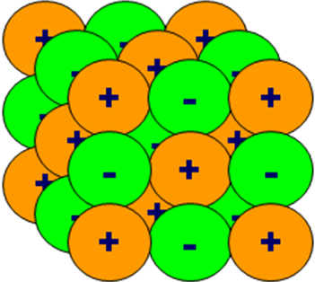

A simple model of **ionic bonding** is **electrons are transferred** from metal atoms to non-metal atoms, giving **positively charged metal ions** and **negatively charged non-metal ions** that all have a stable noble gas arrangement of electrons.

The **energy** it takes **to break** a bond **between two ions** is the **same** amount that is **given out** when the **bond forms**. This is called **the lattice enthalpy** and for each ionic substance there is a **specific value**, which shows the **strength of the ionic bond**.

**Example**

If **sodium** is placed in gas jar of **chlorine** gas an **exothermic reaction** occurs.

Na (s) + ½ Cl2 (g) → NaCl (s) Energy released so ΔHθ negative

***Show: Clip – NaCl formation***

Lattice enthalpy, ΔHθL

***Definition***:

The **lattice formation** **enthalpy** is the **standard enthalpy change** that accompanies the **formation of one mole** of a **solid ionic lattice** from its **gaseous ions**.

The **lattice dissociation** **enthalpy** is the **standard enthalpy change** that accompanies the **separation of one mole** of a **solid ionic lattice** into its **gaseous ions**.

These are **opposite processes** so they always have the **same amount of energy** associated with them, only the **sign will be different**.

|  |  |  |  |
| --- | --- | --- | --- |
| All ionic **crystals are energetically more favoured** than their separate gaseous ions, so **energy is required** to separate the ions in a lattice. **Enthalpy of lattice dissociation** is **endothermic**. | M+ (g) + X- (g) → MX (s) |  | ΔHθL = + |

|  |  |  |  |  |
| --- | --- | --- | --- | --- |
| In the opposite process of **lattice formation**, energy is released when the ions form a crystal lattice so it is **exothermic**. | MX (s) → M+ (g) + X- (g) |  | ΔHθL = - |  |

The **enthalpy of lattice formation** when an ionic crystal forms **can’t be determined experimentally** but an **enthalpy cycle** can be constructed and the **value** **calculated** by **combining** the **enthalpy values** of **other processes**.

It’s possible to break it down into several steps:

|  |  |
| --- | --- |
|  | Na(s) + 1/2Cl2(g)  Na(g) + Cl(g)  Na+(g) + e- + Cl(g)  Na+(g) + Cl-(g)  NaCl(s) |

**Standard enthalpy changes**

Each specific type of enthalpy change has its own **definition** which **must be learnt**.

* enthalpy of formation
* bond dissociation enthalpy
* enthalpy of atomisation
* ionisation enthalpy
* electron affinity
* enthalpy of hydration
* enthalpy of solution

***Sheet: Standard enthalpy change definitions***

Enthalpy of formation, ΔHθf

***Definition***:

The **standard** **enthalpy of formation** is the **enthalpy** change under **standard conditions** when **one mole** of a compound is **formed** from its elements with all reactants and products in their **standard states.**

A + B → AB exo

Standard enthalpy of formation of an **element is zero**.

Bond dissociation enthalpy, ΔHθdiss

***Definition***:

The **bond dissociation enthalpy** is the standard **molar enthalpy change** that accompanies the **breaking of a covalent bond** in a **gaseous** molecule to form **two gaseous free radicals**.

A free-radical is shown by write a **dot** alongside the odd-electron species. However, in **thermodynamic equations** which involve bond fission, it is **common to omit the dot**, since its presence is obvious.

***Definition***:

A **free radical** is a species that results from the **homolytic* fission of a covalent bond**. It contains an **unpaired electron**, since homolytic fission results in the splitting of the electron pair in a covalent bond, one electron going to each partner.

*Homolytic fission is the equal splitting of electrons in a covalent bond

X2 (g) → 2X (g) endo

AB4 (g) → AB3 (g) + B(g) endo

**Example**

Cl2 (g) → 2Cl (g) ΔHθdiss = +242 kJ mol-1

CH4 (g) → CH3 (g) + H (g) ΔHθdiss = +435 kJ mol-1

**One molecule of reactant is shown**; this differs from enthalpy of atomisation which is the formation of one mole of gaseous atoms.

Enthalpy of atomisation, ΔHθat

***Definition***:

The **enthalpy of atomisation** is the standard **molar enthalpy change** that accompanies the **formation of one mole** of **gaseous** **atoms** from the **elements** in standard form.

Solid element: X (s) → X (g) endo

This is the same as the standard enthalpy of sublimation (a solid changing state to a gas without forming a solid) of the solid, i.e. **ΔHθat = ΔHθsub**

Diatomic element: ½ X2 (g) → X (g) endo

This is the same as half the standard enthalpy of dissociation (breaking a covalent bond to form 2 free radicals) for a diatomic molecule, i.e. **ΔHθat = ½ ΔHθdiss**

If the molecule is **not in the gas phase** **it must become a gas before it is atomised**. If it’s a **liquid** it must undergo **vaporisation** (ΔHθvap) and if it’s a **solid** it must undergo **melting** (fusion, ΔHθfus) **followed by vaporisation**.

**Example**

Na (s) → Na (g) ΔHθat = +107 kJ mol-1

½ Cl2 (g) → Cl (g) ½ (+242) kJ mol-1 = 121 kJ mol-1

N.B. One mole atoms formed not one mole molecules

Ionisation enthalpy, ΔHθi

First ionisation energy of an element is the enthalpy change for the process

***Definition***:

The **ionisation** **enthalpy** is the standard **molar enthalpy change** for the **removal of one electron** from a species in the **gas phase** to form a **positive ion and an electron**, both also in the gas phase.

X(g) → X+(g) + e- endo

X+(g) → X2+(g) + e- endo

There may be **successive ionisation processes** depending on the charge of the cation. The state symbol (g) can be assumed for the electron so it is often omitted.

**Example**

Na(g) → Na (g) + e- ΔHθi = +496 kJ mol-1 1st ionisation enthalpy

Mg(g) → Mg+(g) + e- ΔHθi = +734 kJ mol-1 1st ionisation enthalpy

Mg+(g) → Mg2+(g) + e- ΔHθi = +1451 kJ mol-1 2nd ionisation enthalpy

Electron affinity, ΔHθea

***Definition***:

**Electron affinity** is the standard **enthalpy change** when an **electron is added** to an isolated **atom in the gas phase**.

X(g) + e- → X-(g) exo

X-(g) + e- → X2-(g) endo

**Example**

O(g) + e- → O-(g) ΔHθi = -142 kJ mol-1 1st electron affinity

O-(g) + e- → O2-(g) ΔHθi = +844 kJ mol-1 2nd electron affinity

There may be **successive electron affinity processes** depending on the charge of the anion. This process is for **single atoms** not molecules, so it has to **undergo atomisation** first before it accepts an electron.

**Example**

Cl (g) + e- (g) → Cl- (g) ΔHθea = -364 kJ mol-1

A chlorine atom in gas phase has a **strong affinity** for an electron to form a gaseous chloride ion with a release of energy.

***Fact recall: CGP22 Q1-6***

***Starter: 10.1 - Important definitions***

***Sheet: Sorting out enthalpy changes***

**Born-Haber cycles**

In 1918 two German scientists, Max Born and Fritz Haber met and discussed how an ionic compound is formed when a metal reacts with a non-metal. This resulted in the idea of a Born-Haber cycle.

Using Hess’s law allows **enthalpy cycles** to be constructed which consist of a **series of different enthalpy changes**. Starting at any point and ending up at the same point then the **sum of all the values must equal zero**. The **enthalpy of an unknown step can be determined** providing the values of all the other steps are known.

∑ΔHcycle = 0

Enthalpy change of lattice formation: Elements to compounds

|  |  |
| --- | --- |
| **Ionic compounds** form when a metal reacts with a non-metal with the formation of a **lattice** of **oppositely charged ions** held by **electrostatic forces**. This is called **enthalpy of formation, ΔHθf.**  M (s) + ½ X2 (g) → MX (s) exo |  |

It’s possible to break the **formation of an ionic lattice into these steps**:

1. **Elements** in their standard states
2. **Atomisation** - gaseous atoms form - endothermic
3. **Ionisation** – metal atom gives up electron to become a cation - endothermic
4. **Electron affinity** – non-metal atom gains an electron to become an anion - exothermic
5. **Lattice formation** - oppositely charged ions coming together to form a solid ionic lattice – exothermic

Hess’s law states that the **total enthalpy change for a reaction is the same** whichever route is taken, so long as the **initial and final conditions are the same** a **Born-Haber cycle** can be constructed for any ionic compound.

|  |  |
| --- | --- |
|  | **enthalpy of formation  (route 1)**  **=**  **sum of all other enthalpy values**  **(route 2)** |

Applying Hess’s law the **sum of the 5 steps is equal to the enthalpy of lattice formation** of NaCl.

So ΔHθf = +ΔHθat + ΔHθat + ΔHθi + ΔHθea + ΔHθL

And **ΔHθL** = -ΔHθat - ΔHθat - ΔHθi - ΔHθea **+ ΔHθf**

How to draw a Born-Haber cycle

* Use a rough scale (e.g. 1 line = 100kJ mol-1) to give a rough plan
* Remember:
  + Endothermic (positive enthalpy) changes go up
  + Exothermic (negative enthalpy) changes go down
* Order:
  + Elements (zero enthalpy – middle of paper)
  + Atomisation of metal & non-metal (positive – draw up)
  + Ionisation of metal (positive – draw up)
  + Electron affinity of non-metal (negative – draw down)
  + Formation of compound from elements (negative – draw down)
  + Lattice formation of compound from ions (negative – draw down)

**Example**

Enthalpy of formation of NaCl can be by the following equation:

Na (s) + ½ Cl2 (g) → NaCl (s) ΔHθf = - 411 kJ mol-1

And split into the following steps:

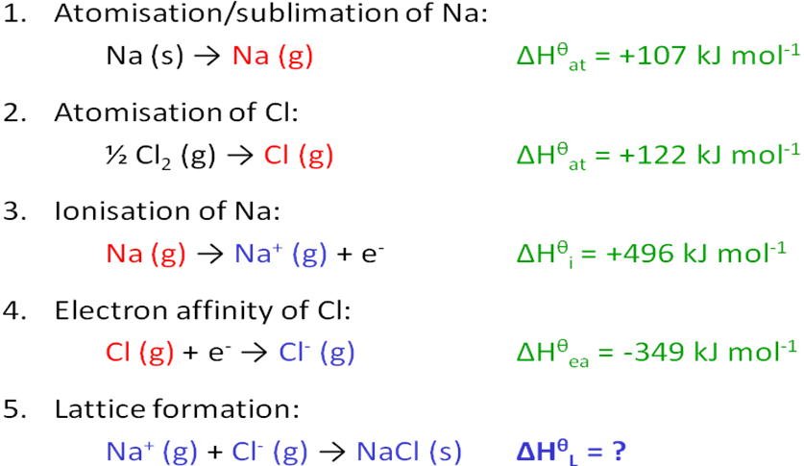

Applying Hess’s law:

ΔHθf = +ΔHθat + ΔHθat + ΔHθi + ΔHθea + ΔHθL

**ΔHθL** = -ΔHθat - ΔHθat - ΔHθi - ΔHθea **+ ΔHθf**

**ΔHθL (NaCl)** = - 107 - 122 – 496 - (-349) + (-411) = **-787 kJ mol-1**

Representing this as a Born-Haber cycle – elements to compound:

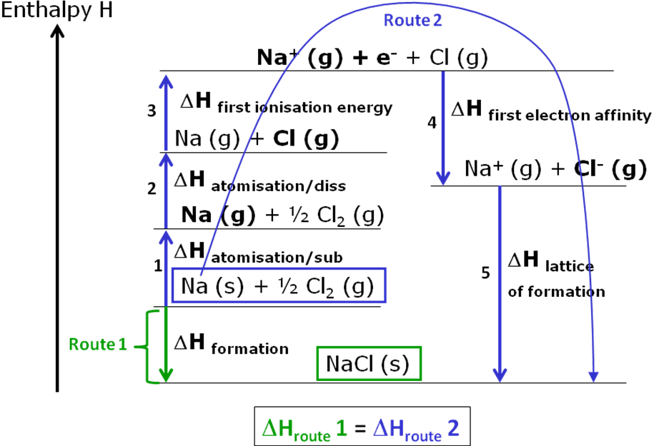

With the energy values shown:

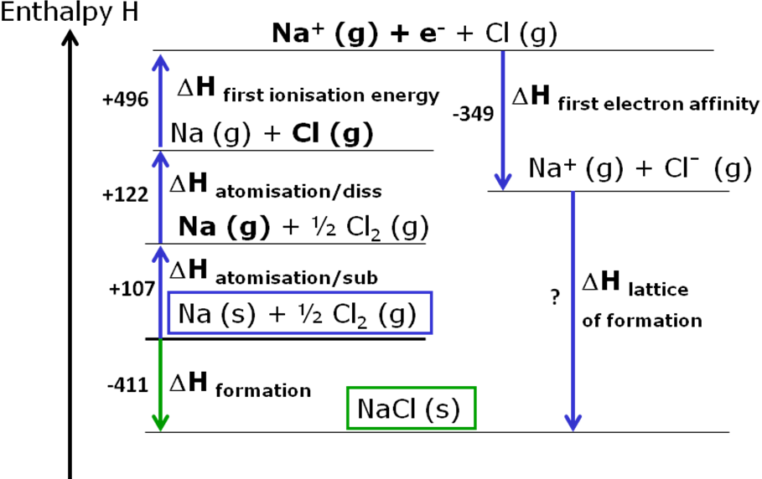

Applying Hess’s law:

ΔHθf = +ΔHθat + ΔHθat + ΔHθi + ΔHθea + ΔHθL

**ΔHθL** = -ΔHθat - ΔHθat - ΔHθi - ΔHθea **+ ΔHθf**

**ΔHθL (NaCl)** = - 107 - 122 – 496 - (-349) + (-411) = **-787 kJ mol-1**

***Task: Construct Born-Haber cycle for NaCl (interactive word document)***

**Example**

The enthalpy of formation of magnesium chloride is -642 kJ mol-1. Calculate the lattice enthalpy of formation.

|  |  |
| --- | --- |
| Atomisation enthalpy - magnesium | 148 kJ mol-1 |
| Atomisation enthalpy - chlorine | 122 kJ mol-1 |
| First ionisation energy - magnesium | 738 kJ mol-1 |
| Second ionisation energy - magnesium | 1451 kJ mol-1 |
| Electron affinity - chlorine | -349 kJ mol-1 |

Method

Construct Born-Haber cycle with first and second ionisation steps for magnesium chloride.

Answer

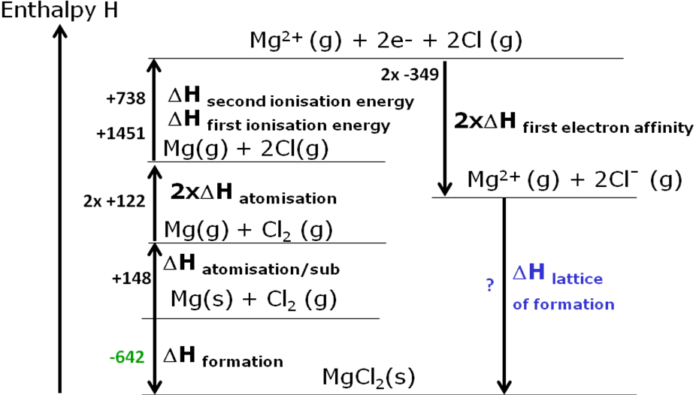

ΔHθL = - ΔHθat/sub – 2ΔHθat - ΔHθi - ΔHθi - 2ΔHθea + ΔHθf

ΔH θL = -148 – (2x122) – 738 – 1451 – (2x-349) + (-642) = **– 2525kJmol-1**

**Example**

The enthalpy of formation of sodium bromide is -360 kJ mol-1. Calculate the lattice enthalpy of formation.

|  |  |
| --- | --- |
| Atomisation enthalpy - sodium | 107 kJ mol-1 |
| Atomisation enthalpy - bromine | 194 kJ mol-1 |
| Enthalpy of vaporisation - bromine | 30 kJ mol-1 |
| First ionisation energy - sodium | 496 kJ mol-1 |
| Electron affinity - bromine | -342 kJ mol-1 |

Method

Construct cycle with extra vaporisation step because bromine is liquid.

Comment

Equation to form bromine gas involves only half a mole of bromine.

Answer

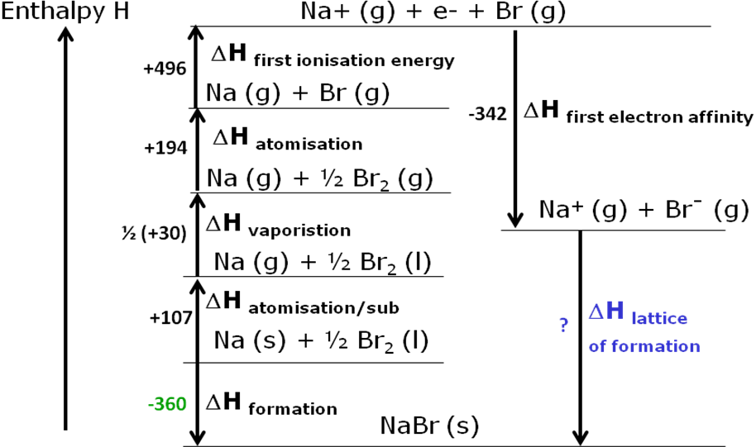

ΔHθL = - ΔHθat - ½ ΔHθvap - ΔHθat - ΔHθi - ΔHθea + ΔHθf

ΔH θL = -107 – (1/2 x 30) – 194 – 496 – (-342) + (-360) = **– 830kJmol-1**

***Sheet: Born-Haber cycles***

***Sheet: Born-Haber cycles – Stretch & challenge***

**Applications of lattice enthalpy**

Trends in lattice formation enthalpy

The lattice formation enthalpies of some simple ionic compounds are shown.

M+ (g) + X- (g) → MX (s)

|  |  |  |  |  |  |  |  |
| --- | --- | --- | --- | --- | --- | --- | --- |
|  | **Larger anion** | | | | |  | ***Task: What trend do you notice?*** |
| Larger  cation | **M+X-** | **F-** | **Cl-** | **Br-** | **I-** |  | The larger the ion, the smaller the lattice enthalpy. |
| **Li+** | -1031 | -848 | -803 | -759 |  |
| **Na+** | -918 | -788 | -742 | -705 |  | ***Can you explain it?*** |
| **K+** | -817 | -711 | -679 | --651 |  | Because opposite charges can’t approach each other as closely when the ions are large. Weaker electrostatic forces exist between the ions so less energy is released when the lattice is formed. |
| **Rb+** | -783 | -685 | -656 | -628 |  |
| **Cs+** | -747 | -661 | -635 | -613 |  |

*Table 1 Oxford p9*

Lattice enthalpy also **increases with the size of the charge** because ions with a **double charge** will **give out** approximately **four times as much energy** when they form.

Comparing compounds with double the charge:

|  |  |  |  |  |  |  |  |  |  |
| --- | --- | --- | --- | --- | --- | --- | --- | --- | --- |
| **Larger cation** | **Larger anion** | | | | |  | **Larger anion** | | |
|  | **M+X-** | **F-** | **Cl-** | **Br-** | **I-** |  | **M2+X2-** | **O2-** | **S2-** |
| **Li+** | -1031 | -848 | -803 | -759 |  | **Be2+** | -4443 | -3832 |
| **Na+** | -918 | -788 | -742 | -705 |  | **Mg2+** | -3791 | -3299 |
| **K+** | -817 | -711 | -679 | --651 |  | **Ca2+** | -3401 | -3013 |
| **Rb+** | -783 | -685 | -656 | -628 |  | **Sr2+** | -3223 | -2848 |
| **Cs+** | -747 | -661 | -635 | -613 |  | **Ba2+** | -3054 | -2725 |

*Table 1 Oxford p9 Table 2 Oxford p9*

**Comparing** the two data tables shows that **ions of approximately similar sizes**, that are formed from elements in the same group of the periodic table e.g. Na+ and Mg2+ or F- and O2-. It shows the **lattice enthalpy increases with the size of the charge**; this is because **ions** with **double** **the charge** the **electrostatic attraction** is **stronger** so **more energy** is **released** when the **lattice** is **formed**.

Lattice enthalpy and bonding

It’s possible to **calculate** the **energy** required to **convert one mole of salt ions in the solid phase into the gas phase**.

|  |  |
| --- | --- |
| MX (s) → M+ (g) + X- (g) ΔHθL (enthalpy of dissociation) |  |
| The calculation is based on the **perfect ionic model** which **assumes**:   * all **ions** are **spherical** * **only ionic forces** hold the ions together in a crystal * the **charge** of the ions is **evenly distributed** around them |

This enables a **theoretical** value for the **enthalpy of lattice dissociation** of an ionic compound to be calculated.

A comparison of **lattice dissociation enthalpy** can then be made between:

* An **experimentally-based** value (found using a Born-Haber cycle)
* A **theoretically-based** value (assuming a purely ionic model of a lattice)

If the **experimental** and **theoretical** lattice enthalpy **values** for a compound **agree** then there are **only ionic** characteristics, if they are **different** then the compound has **some** **covalent** bonding characteristics. Agreement needs only to be close, not exact since approximations are used in making the calculations.

**Comparing the alkali metal halides**

|  |  |  |  |  |  |  |  |  |
| --- | --- | --- | --- | --- | --- | --- | --- | --- |
| **ΔHL / kJ mol-1** | | | | | | | | |
|  | **F** | | **Cl** | | **Br** | | **I** | |
| **BH** | **IM** | **BH** | **IM** | **BH** | **IM** | **BH** | **IM** |
| **Li** | 1022 | 1004 | 846 | 833 | 800 | 787 | 744 | 728 |
| **Na** | 902 | 891 | 771 | 766 | 753 | 752 | 684 | 686 |
| **K** | 801 | 795 | 701 | 690 | 670 | 665 | 629 | 632 |

*BH = Born-Haber (experiment) IM = Ionic model (theoretical)*

There is a **very good agreement** between the values; the average discrepancy is about   
8 kJ mol-1, which is a 1-2% difference. Therefore, it can be concluded that these **simple alkali halide ionic crystals behave as expected for systems consisting of oppositely-charged discrete ions interacting exclusively through electrostatic attractions and repulsions,** i.e.they **only have ionic bonds**. The **ionic model works perfectly**. So the alkali metal halides are soluble in water.

**Comparing the silver halides**

|  |  |  |  |  |  |  |  |  |
| --- | --- | --- | --- | --- | --- | --- | --- | --- |
| **ΔHL / kJ mol-1** | | | | | | | | |
|  | **F** | | **Cl** | | **Br** | | **I** | |
| **BH** | **IM** | **BH** | **IM** | **BH** | **IM** | **BH** | **IM** |
| **Ag** | 955 | 870 | 905 | 770 | 890 | 758 | 876 | 736 |
| **Difference** | 85 | | 135 | | 132 | | 140 | |

*BH = Born-Haber (experiment) IM = Ionic model (theoretical)*

***Task: Calculate difference between the Born-Haber calculations and ionic model values and comment on the values***

* Less agreement, the average discrepancy is ~120 kJ mol-1, the **experimental** lattice enthalpy is about 13-14% **greater** than the **theoretical** ionic model calculation.

Some **other factor** must be having an **effect**. The simple ionic model doesn’t take into account any **degree of covalent bonding between the ions;** this **adds stability** to the solid structure. This **additional bonding** would **require an additional input of energy**.

* The **difference increases** from **fluoride to iodide** because the **iodide ion is larger** so there is **more dissociation** of the **electrons** towards the silver ion.
* The **increase in lattice enthalpy** may account for their **lack of solubility** in water.

**Polarisation and bonding**

Where the **lattice formation enthalpy** determined by **experimental** values **agrees** with the **theoretical** value this **confirms the ionic model is correct** for that compound.

When the values **don’t agree** this shows there is **some degree of covalent** bonding.

If the **cation** is relatively **small** with a **high positive charge** it can **distort** the **electron cloud** from the **anion towards itself**, particularly if the anion is large (so the electrons are far from the nucleus). This leads to a degree of **polarisation** and **electron sharing**.

|  |  |
| --- | --- |
|  | **The factors increasing polarisation are:**   * Cation – small size, high nuclear charge – attract electrons i.e. polarise other atoms * Anion – large size, high charge – give electrons i.e. are polarised by other atoms   ***Fact recall: CGP26 Q1-3*** |

**Enthalpy of solution**

***Demo: Dissolving NaCl (exothermic) & KNO3 (endothermic)***

Enthalpy of solution, ΔHθsol

***Definition***:

The **enthalpy of solution** is the **standard enthalpy change** that occurs when **one mole** of an **ionic solid dissolves** in enough water to ensure that the dissolved ions are **well separated** and do not interact with each other.

MX(s) → M+ (aq) + X- (aq)

***YouTube video clip***: <https://www.youtube.com/watch?v=9aYLonML69w>

|  |  |  |  |
| --- | --- | --- | --- |
| **soild ionic lattice** | **aqueous ionic solution** | **hydrated cation** | **hydrated anion** |
|  |  |  |  |

**Example**

NaCl (s) + aq →Na+ (aq) + Cl- (aq) ΔHθsol = +17 kJ mol-1

Ionic solids will **dissolve well** in **polar solvents**. The **ionic lattice must be broken up**, which requires an **input of energy** called the **lattice enthalpy**. The solvent clusters around the ions so that the **negative polar ends** of the **solvent** **surround** the **positive ions** and the **positive polar** **ends surround** the **negative ions**. When the solvent is **water** this is called **hydration**. **Weak bonds** form **between** the **positive ions** and the **partial negative charges** on the **oxygen** of the water molecules and between the **negative ions** and the **partial positive charge** of the **hydrogen** atoms.

**The process of dissolving an ionic compound in water is split into 3 steps:**

* Break the ionic lattice giving gaseous ions – **lattice dissociation enthalpy**  
    
  MX (s) → M+ (g) + X- (g) ΔHθL = +ve
* Hydrating cations – **enthalpy of hydration**  
    
  M+ (g) + aq → M+ (aq) ΔHθhyd = -ve

∆Hθ sol

* Hydrating anions – **enthalpy of hydration**  
    
  X- (g) + aq → X- (aq) ΔHθhyd = -ve

**Enthalpies of solution can be calculated** from these values and is often a **very small positive or negative value**. The **bigger the ion** (small charge to size ratio) the **weaker the attraction** between the water molecules and the ion so **less energy is produced** when the **solution forms**.

Enthalpy of hydration, ΔHθhyd

***Definition***:

The **enthalpy of hydration** is the **standard enthalpy change** for when water molecules surround one mole of **gaseous ions** forming one **mole of aqueous ions**.

water

X± (g) X± (aq) or X± (g) + aq →X± (aq) exo

X± (g) indicates both a gaseous cation X+ (g) and anion X- (g) and X± (aq) the hydrated species in solution.

Since **water is polar** the **positive ions** of the ionic compoundwill be **attracted** to the **Oδ-** and the **negative ions** will be **attracted** to the **Hδ+** with a **release of energy**. One mole of gaseous atoms dissolves in sufficient water to give an **infinitely dilute solution**. A solid compound will need to **undergo atomisation** first, then **ionisation/electron affinity** before hydration.

**Example**

Na+ (g) + aq → Na+ (aq) ΔHθhyd = -406 kJ mol-1

Cl- (g) + aq → Cl- (aq) ΔHθhyd = -363 kJ mol-1

Calculating enthalpy of solution

There are different methods that can be used:

* **Enthalpy diagrams**
* **Enthalpy** **cycle**
* **Equations**

|  |  |
| --- | --- |
| **Enthalpy diagram** | **Enthalpy cycle** |
|  |  |
|  |  |
| **Equations** | |
|  | |
| For all three methods the following is true: **ΔHroute 1 = ΔHroute 2**  So **ΔHθsol = ΔHθL (MX) + ΔHθhyd (M+) + ΔHθhyd (X-)** | |

**Example – GCP29**

Calculate the enthalpy of solution for sodium chloride using the enthalpies of hydration and lattice enthalpy.

|  |  |
| --- | --- |
| Enthalpy diagram | Answer |
|  | ΔHθsol = ΔHθL (NaCl) + ΔHθhyd (Na+) + ΔHθhyd (Cl-)  ΔHθsol = + 787 + (-406) + (-364) = **+ 17 kJmol-1** |

|  |  |
| --- | --- |
| Enthalpy cycle | Answer |
|  | ΔHθsol = ΔHθL (NaCl) + ΔHθhyd (Na+) + ΔHθhyd (Cl-)  ΔHθsol = + 787 + (-406) + (-364) = **+ 17 kJmol-1** |

|  |  |
| --- | --- |
| Equations |  |
|  | |

|  |  |
| --- | --- |
| ***Starter: 10.3 - Enthalpy of solution***  ***Sheet: Enthalpies of solution***  ***Application: CGP29 PQ1-2***  ***Fact recall: CGP29 Q1*** | ***Optional practicals:***   * ***Hess’s law 1*** * ***Hess’s law 2*** |

**Spontaneous change**

***Definition***:

A **spontaneous change** is one that has a natural tendency to occur without being driven by any external influences.

Spontaneous changes are all around us:

* **Air escapes** out a bike tyre when value is opened – physical effort is needed to put air into it
* **Hot coffee cools** when left – heat energy is needed to heat it up
* **Ice cream melts** on a hot day – electrical energy of the freezer is needed to freeze it
* **Iron rusts** in damp air – energy of a blast furnace is needed to turn it back into iron
* **Potassium nitrate** dissolves water – the solution becomes cold

Left to themselves some things happen spontaneously but others need energy. A **spontaneous change** is one which **occurs in one particular direction** but **not in reverse** (unless conditions are changed, e.g. temperature). It **doesn’t take into account the rate** of a reaction, they can be very slow (e.g. ice melting).

Enthalpy factor (kJ mol-1)

Many spontaneous reactions are **exothermic**; they lead to a **release of energy** as there is a change **from higher to lower enthalpy**; which is a **more stable state**. But some **endothermic reactions are also spontaneous**, so enthalpy doesn’t fully explain all spontaneous changes. Another factor is involved, called **entropy**.

Entropy **Units = J K-1 mol-1**

The additional **driving force** in spontaneous change is **entropy**, given the symbol **S**. It is the amount of **disorder**. It’s a measure of the **number of ways** that **particles** can be **arranged** **without changing the structure**.

***Entropy – Brian Cox***

***You Tube video clip:*** <https://www.youtube.com/watch?v=uQSoaiubuA0>

**Entropy & disorder**

Many processes that take place involve an **increase in disorder** e.g. solids melting, solids dissolving, reactions that give rise to an increase in the number of moles in the products. **Entropy will** always **increase** in these situations.

low entropy high entropy

more ordered more disordered

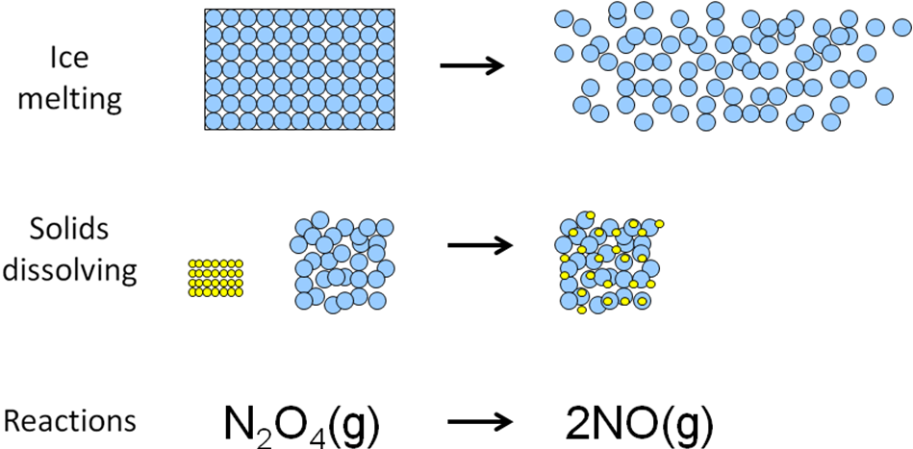

There is a **tendency in nature for randomness or disorder**, a pack of cards thrown in the air will land scattered on the floor rather than fall back in a neat pile.

***Demo: Cards thrown in air***

**Entropy** can be thought of in terms of **disorder**, an **increase** **in entropy** can be visualised as an **increase in disorder**.

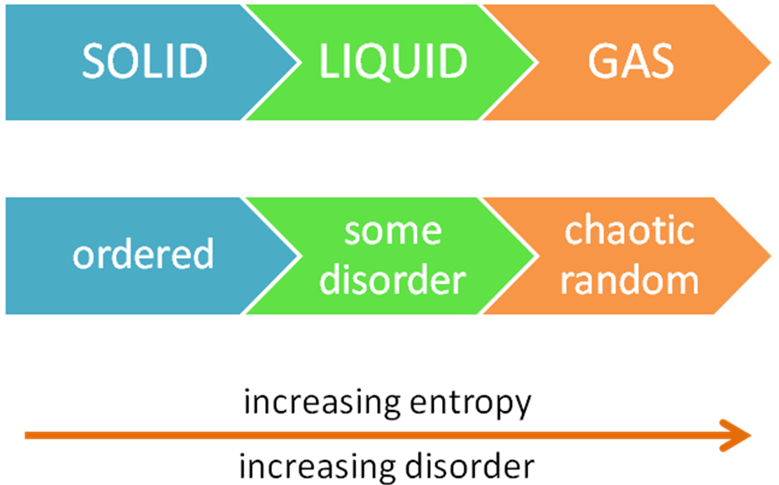

So **endothermic** reactions may be **spontaneous if they result in an increase in entropy**, if the **arrangement of the products is more disordered than the reactants** it will be spontaneous.

**Entropy & temperature**

A graph showing entropy change as temperature increases.

|  |  |
| --- | --- |
|  | Don’t confuse with: |

It shows:

* **Entropy** slowly **increases** with **increasing** **temperature**
* A **phase change** causes a **large increase in entropy**
* **Boiling** causes a **largest** **increase** in entropy

**Magnitude of entropy in different substances**

All substances have an **absolute entropy** value which is dependent on the form and state of the substance at 298K. For example, diamond and graphite, water and steam.

It shows how much the **energy of motion of the particles** within a substance **changes** **per** **Kelvin of temperature**.

|  |  |  |  |  |
| --- | --- | --- | --- | --- |
| **Sθ298/J K-1 mol-1** | |  | **Sθ298/J K-1 mol-1** | |
| diamond | 2.4 |  | He(g) | 126 |
| graphite | 5.7 |  | Ar(g) | 155 |
| NaCl(s) | 72 |  | O2(g) | 205 |
| NaHCO3(s) | 102 |  | CO(g) | 198 |
| SiO2(s) | 42 |  | CO2(g) | 214 |
| H2O(l) | 70 |  | H2O(g) | 189 |
| CH3OH(l) | 127 |  | CH3OH(g) | 240 |

It shows some general trends:

* All **absolute** **entropy** values are **positive** **N.B. ΔS can be negative**
* **Entropies** of **elements** in their standard states are **NOT zero**
* **Simple molecules** generally have **lower entropies** **than** more **complicated** ones
* **Entropy increases** with change of state from a **solid** **to** a **liquid** **to** a **gas.**

**Units for S**

Entropy values are generally quite **small** compared to enthalpy values so they are in terms of **joules** **per Kelvin per** **mole** rather than kilojoules. The SI system units are   
**J K-1 mol-1**.

So if ΔH is involved in entropy calculations must multiply by 10-3.

**Absolute entropy, Sθ**

Since entropy is linked to disorder and temperature, at **absolute zero** (0K) it’s reasonable to suggest that **all disorder will disappear** and all **substances will be perfectly ordered** and have **zero entropy**. It’s true for most substance, especially perfectly-ordered crystals.

This gives a starting point on a scale for entropy. So **at absolute zero entropy is zero**, and so substances can have an **absolute standard entropy value** (at 298K), from which **standard entropy changes can be calculated**.

With **enthalpy** it is only possible to consider the **standard** **enthalpy changes ΔHθ**, (i.e. only differences between enthalpy values) not an absolute enthalpy.

Entropy change in chemical reactions, ΔSθ

**Standard entropy changes** are calculated as the **difference** between the **entropy** of the **reactants** and the **products**. Absolute entropy values are listed in data tables.

**ΔSθ = ∑Sθ products - ∑Sθ reactants**

**Most reactions only occur if the entropy change is positive.**

**Example – CGP31**

Calculate the entropy change for the reaction of ammonia and hydrogen chloride under standard conditions.

Sθ NH3 = 192.3 Sθ HCl = 186.8 Sθ NH4Cl = 94.6

Method

Reaction: NH3(g) + HCl(g) → NH4Cl(s)

Answer

ΔSθ = ∑ΔSθ products - ∑ΔSθ reactants

= (94.6) – (192.3 + 186.8)

**= -284.5 J K-1 mol-1**

Comment

Entropy change is quite large and negative because 2 moles of reactants have produced one mole of product, so there is a decrease in disorder. Also the reactants are gases and the product is a solid.

*Task: Calculate the entropy change that accompanies the combustion of methane.*

Sθ CH4 = 186 Sθ O2 = 205 Sθ CO2 = 214 Sθ H2O= 69.9

Method

Reaction: CH4(g) + 2O2(g) → CO2(g) + 2H2O(l)

Answer

ΔSθ = ∑ΔSθ products - ∑ΔSθ reactants

= (214 + (2 x 69.9)) – (186 + (2 x 205))

**= -242.2 J K-1 mol-1**

Comment

Entropy change is quite large and negative because same number of moles of reactants and products, with 2 gases becoming a gas and a liquid so there is a decrease in disorder.

***Starter: 10.4 Entropy***

***Application: CGP32 PQ1-3***

***Fact recall: CGP32 Q1-2***

**Gibbs free energy change, ΔGθ**

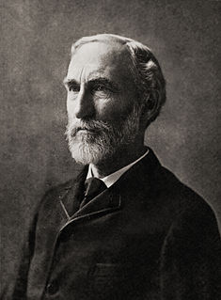

**ΔGθ = ∑Gθ products - ∑Gθ reactants**

Units: **kJ mol-1**

These factors govern the **feasibility** of a chemical reaction:

* Enthalpy (release of energy)
* Entropy (increase in disorder)
* Temperature

So **exothermic** reactions give a **release of energy** (ΔH = -ve) and **endothermic** reactions which lead to an **increase in entropy** (ΔS = +ve) **happen quite often**.

The conflicting demands of enthalpy and entropy are brought together in a quantity called **Gibbs free energy, G**. The **change in Gibbs free energy**, ΔG, is a measure used to **predict** whether a **reaction is** **feasible**. It takes into account the **changes in enthalpy** and **changes in entropy**.

If the **Gibbs free energies of the reactants and products are know** then the change in Gibbs free energy can be calculate using this equation.

Gibbs derived this equation to calculate the free energy change which **combines** the **entropy change** and the **enthalpy change**:

Since units are **kJ mol-1** must multiply ΔS by 10-3 to convert J to kJ

**ΔGθ = ΔHθ - TΔSθ**

If the **change in entropy** is **positive** and the reaction is exothermic (ΔH –ve) then the **change in Gibbs free energy** will be **more negative**. So the **greater** the **increase in entropy** and the **more exothermic** the **smaller** the value of **Gibbs free energy.** If **ΔG is negative (or zero)** then the reaction will be **feasible**, i.e. **it will occur**.

However the change in Gibbs free energy is **dependent on temperature**, so some reactions may be **feasible at one temperature but not at another**. An **endothermic** **reaction** can **become feasible** when **temperature is increased** and there is a large enough positive entropy change.

i.e. feasible

**ΔG≤ 0 for spontaneous change**

A very **negative** **ΔG** doesn’t always guarantee a reaction will happen. The reaction between hydrogen and oxygen at room temperature is classed as **spontaneous** because **ΔG is very negative**. So the reaction can go but it will not go unless a spark or flame is supplied; the **activation energy** **must be overcome before the reaction can occur**.

Spontaneous ≡ feasible

**Spontaneous and feasible** have the **same meaning in thermodynamics**, but be careful because spontaneous gives the meaning that it is inevitable, it must happen. In thermodynamics **spontaneity is the tendency for something to happen** it **does not mean it will actually happen**.

So the term **feasible is preferred** as it **implies that something is possible but not inevitable**.

Thermodynamics **doesn’t tell** you anything about the **speed** of the change. The **speed** of a feasible change can be very **slow**, e.g. a hot coffee cooling – it is **feasible because there is a decrease in free energy**. It only tells you about **whether a change can happen**.

So these questions must be asked in this order:

1. **Can it go?** (thermodynamics)
2. **How fast will it go?** (kinetics)

A chemical or physical change is:

* **feasible if ΔG ≤ 0**
* **unfeasible if ΔG ≥ 0**

ΔG marks a **break-point** where there will be **similar concentrations of reactants** and **products** present at **equilibrium**:

* **if ΔG < 0 – more products**
* **if ΔG > 0 – more reactants**

|  |  |
| --- | --- |
|  | The following is true when there is an equal concentration of reactants and products: |

Calculations involving, ΔGθ

Using standard enthalpy and standard entropy values the change in standard free-energy can be calculated and so the **feasibility determined**.

**ΔGθ = ΔHθ - TΔSθ**

**Example CGP33**

Calculate the free-energy change for the following reaction at 298K.

MgCO3 (s) → MgO(s) +CO2(g)

ΔHθ = +117 kJ mol-1

ΔSθ = +175 J K-1 mol-1

ΔGθ = ΔHθ - TΔSθ N.B units different: ΔHθ kJ mol-1 ΔSθ J K-1 mol-1

ΔGθ = +117 – (298 x 175 x 10-3)

**= +64.9 kJ mol-1**

Comment

ΔGθ is positive so the reaction isn’t feasible even though the entropy change is very large.

**Example**

Calculate the standard free-energy change for the combustion of graphite at 298K.

Reaction: C(s) + O2(g) → CO2(g)

ΔHθ = -394 kJ mol-1

ΔSθ = 3.3 J K-1 mol-1

Answer

ΔGθ = ΔHθ - TΔSθ

ΔGθ 298 = -394 – (298 x 3.3 x 10-3)

**= -395 kJ mol-1**

Comment

ΔGθ is negative therefore this reaction is feasible. The entropy change is very small therefore ΔGis approximately equivalent to ΔH and ΔGwill not vary much with temperature. This reaction is extremely slow and has a high activation energy.

***Task: Calculate the standard free-energy change for iron rusting at 298K***

***ΔHθ = -825 kJ mol-1 ΔSθ = -272 J K-1 mol-1***

|  |  |
| --- | --- |
| Reaction: 2Fe (s) + 3/2 O2 (g) → Fe2O3 (s)  Answer  ΔGθ = ΔHθ - TΔSθ  ΔGθ 298 = -825 – (298 x -272 x 10-3)  **= -744 kJ mol-1** | Comment  ΔG is very negative so the reaction is highly feasible and is favoured by low temperatures. The entropy change is negative because the disorder in the oxygen gas is lost when the solid is formed. ΔG is negative because the exothermic value of ΔH dominates. |

**Effect of temperature on feasibility**

The **feasibility temperature** gives the **breakeven point** at which the **concentration** of the **reactants** and **products** are **roughly equal**. So the **temperature** must be **above** the **feasibility temperature** in order **to produce** substantially **more product** than reactants. This **moves the equilibrium towards the product** side (Le Chatelier effect) and leads to an **increase in the rate** (kinetic effect). Both these will **make** the **process** **more** **viable**.

**Example CGP34**

Reaction1: ΔHθ = **+**10 kJ mol-1 ΔSθ = **+**10 J K-1 mol-1 N.B units

|  |  |
| --- | --- |
| At 300 K  ΔGθ = ΔHθ - TΔSθ  = 10 – (300 x 10 x 10-3)  = **+7 kJ mol-1** | At 1500 K  ΔGθ = ΔHθ - TΔSθ  = 10 – (1500 x 10 x 10-3)  = **-5 kJ mol-1** |
| Comment |  |
| ΔGθ is positive, so reaction is not feasible at this temperature. | ΔGθ is only negative at the higher temperature so the reaction is feasible at 1500 K. |

***Spreadsheet: Gibbs free-energy v temperature – effect* on ΔHθ & ΔSθ**

**The feasibility of reactions in different conditions can be summarised:**

* Exothermic (negative ΔH) and positive ΔS then ΔG always negative – feasible at any temperatures
* Exothermic (negative ΔH) and negative ΔS then ΔG only negative at low temperatures – feasible below a certain temperature
* Endothermic (negative ΔH) and positive ΔS then ΔG only negative at high temperatures – feasible above a certain temperature
* Endothermic (positive ΔH) and negative ΔS then ΔG always positive – not feasible at any temperatures (i.e. temperature has no effect).

**Summary table:**

|  |  |  |
| --- | --- | --- |
| ΔGθ = ΔHθ - TΔSθ | **ΔS positive** | **ΔS negative** |
| **ΔH negative (exothermic)** | All T | Low T |
| **ΔH positive (endothermic)** | High T | No T |

Calculating the temperature at which a reaction becomes feasible

**Feasibility** is **dependent** on **temperature**, so a reaction may not be feasible at one temperature but may be at another. The **temperature** at which **feasibility is just achieved** is the **temperature** at which there is **no spontaneous tendency** **for the reaction to go** in either direction, i.e. **it is at equilibrium**.

And **ΔG = 0**

Applying this to the equation ΔGθ = ΔHθ - TΔSθ

0 = ΔHθ - TΔSθ

Leads to ΔHθ = TΔSθ

N.B. Units are different:

ΔHθ = kJ mol-1

ΔSθ = J K-1 mol-1

So temperature is T= ΔHθ

ΔSθ

The **temperature of feasibility** can then be calculated.

**Example**

Calculate the temperature at which the thermal decomposition of sodium hydrogencarbonate becomes feasible.

ΔHθ = +130 kJ mol-1

ΔSθ = +335 J K-1 mol-1

Reaction: 2NaHCO3 (s) → Na2CO3 (s) + CO2 (g) + H2O (l)

Answer

T = ΔHθ

N.B. Convert ΔS to kJ by multiplying by 10-3

ΔSθ

T = 130 =  **388 K** in oC 388 – 273 = 115oC

335 x 10-3

Comment

The decomposition reaction is **feasible above 388K** and becomes **more feasible** as the **temperature is increased**. Below this temperature the reverse reaction (formation of sodium hydrogencarbonate) is feasible. The stoichiometry of the equation doesn’t affect the feasibly temperature because halving the chemical equation to give one mole NaHCO3 also halves ΔHand ΔS, so gives the same temperature.

***Task: Calculate the temperature at which the extraction of iron from iron ore becomes feasible.***

Reaction: 2Fe2O3 (s) + 3C (s) → 4Fe (s) + 3CO2 (g) ΔGθ = +302 kJ mol-1

So not feasible at 298K

ΔHθ = +467.9 kJ mol-1

ΔSθ = +558.1 J K-1 mol-1

Answer

T = ΔHθ

ΔSθ

T = 467.9 =  **838.4 K**

558.1 x 10-3

Comment: The reaction is **feasible above 838.4 K**

***Sheet: Entropy & free-energy calculations (Q1-9)***

Entropy of physical changes

Many physical changes involve an increase or decrease in order.

**Melting (fusion)**

|  |  |
| --- | --- |
|  | Ice melting at **constant temperature** (0OC) and **pressure** (100kPa) results in a **mixture** of **ice and water** with **no spontaneous tendency to solidify** (to a solid) **or melt** (to a liquid) **unless an external influence is involved**, the addition or removal of heat. |

This is an example of a **system at equilibrium** – it has **no tendency to spontaneously move in one direction or another**.



Since the **sign of ΔG determines the tendency of a system to change**, if there is **no tendency to change** then this must be true:

**A system at equilibrium, ΔG = 0**

So applying this to the equation ΔGθ = ΔHθ - TΔSθ

Gives 0 = ΔHθ - TΔSθ

Re-arranging ΔHθ = TΔSθ

To find the entropy change ΔSθ = ΔHθ

NB   
convert to J so ΔH x 103

T

**So the entropy change for melting is** ΔSθfus = ΔHθfus

Tfus

**Example**

Calculate the entropy change that accompanies the melting of ice. The enthalpy of fusion of ice is +6.0 kJ mol-1.

N.B. System is at equilibrium so ΔG = 0 and temperature is constant at 0OC or 273K

Change: H2O (s) ↔ H2O (l)

Answer

ΔSθfus = ΔHθfus

N.B. Remember ΔS so convert ΔH to J by multiplying by 103

Tθfus

ΔSθfus = 6.0 x 103 = **+22 J K-1 mol-1**

273

Comment

ΔS is positive so there is an increase in disorder when the solid melts.

**Boiling (vaporisation)**

|  |  |
| --- | --- |
|  | When water boils at **constant temperature** and **pressure** the mixture of **steam and water** has **no spontaneous tendency** either to **liquefy** or **vaporise** unless external influences are involved. |

This is again a **system at equilibrium** – it has **no tendency to spontaneously move in one direction or another** and **ΔG = 0.**

Applying this to the equation ΔGθ = ΔHθ - TΔSθ

**So the entropy change for boiling is** ΔSθvap = ΔHθvap

Tvap

***Task: Calculate the entropy change that accompanies the boiling of water.***

The enthalpy of vaporisation of ice is +44.0 kJ mol-1.

N.B. System at equilibrium so ΔG = 0 and temperature is constant so 100OC or 373K

Change: H2O (l) ↔ H2O (g)

Answer

ΔSθvap = ΔHθvap

Tvap

ΔSθfus = 44.0 x 103 = **+118 J K-1 mol-1**

373

Comment

The entropy change is much more positive that the value of melting. The increase in entropy is associated with the creation of one mole of disordered vapour molecules form one mole of relatively ordered liquid molecules.

Remember this graph:

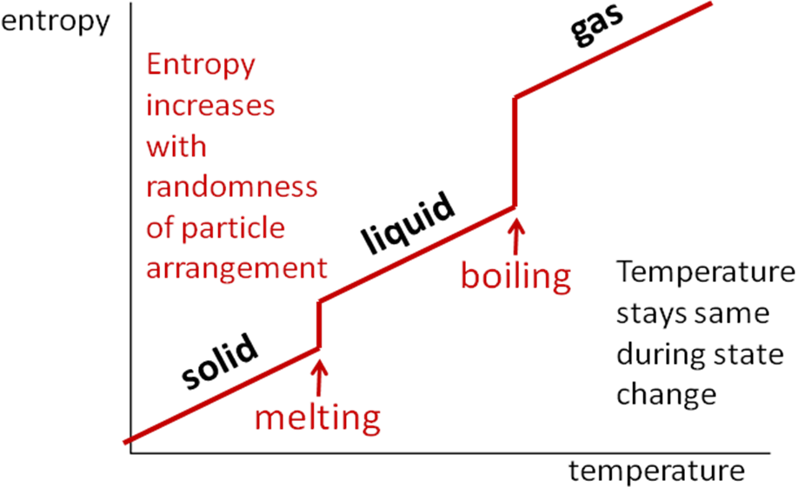

Summary:

The sign of ΔG determines the tendency of the system to change:

* ΔG negative - feasible
* ΔG positive – unfeasible
* ΔG zero – at equilibrium so no change

***Sheet: Entropy & free-energy calculations (Q10)***

***Prac: Finding ΔS & ΔH for the vaporisation of water***

Free-energy graphs

Graphs of **free-energy versus temperature** can be used to work out the **enthalpy** change and **entropy** change of a reaction. It is always a straight line so it can be described using this equation:

***y =* m*x* + c**

*y* and *x* are the axes

m is the gradient

c is the y-intercept

The gradient of a straight is equal to the change in the *y*-axis divided by the change in the *x*-axis:

m = Δ*y* / Δ*x*

Relating this to the free-energy equation ΔGθ = ΔHθ - TΔSθ, the following is true:

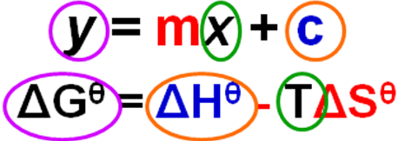

So it can be re-arranged into the same format:

**ΔGθ = (-ΔSθ x T) + ΔHθ**

ΔGθ is the *y*-axis

T is the *x*-axis

-ΔSθ is the gradient

ΔHθ is the *y*-intercept

**Example CGP35**

A graph showing the free-energy change (ΔGθ) versus temperature for a reaction is shown below. Use the graph to determine the enthalpy change and entropy change for this reaction.

|  |  |
| --- | --- |
|  | ΔGθ decreases as temperature increases  Gradient is negative |

Answer

The re-arranged equation ΔGθ = ΔHθ - TΔSθ into the form of the equation for a straight line

ΔGθ = (-ΔSθ x T) + ΔHθ

ΔHθ is the y-intercept (c) ΔHθ = **+40 kJ mol-1**

ΔSθ is the gradient (m)

To calculate the gradient (use Gibbs free-energy in **J** because entropy is J K-1 mol-1):

m = Δ*y* / Δ*x* = (-30 x 103 – 40 x 103) / (500 – 0)

= -70000 / 500

= -140

-ΔSθ = -140 ΔSθ = **+140 J K-1 mol-1**

***Task: Application CGP36 PQ3***

*(This example shows ΔGθ increases as temperature increases)*

***Application: CGP36 PQ1-2***

***Fact recall: CGP36 Q1-4***

***Sheet: A2 Thermodynamics questions***

***Sheet: A2 Gibbs free-energy questions***

***Exam questions: Oxford p22-23 Q1-4***