**3.3.15 - NMR Spectroscopy**

**AS link:**

**3.1.1 – Atomic structure (mass spec)**

**3.3.1 – Introduction to organic chemistry (nomenclature)**

**3.3.6 – Organic analysis (mass spec)**

The main techniques used to **determine the structure** of organic compounds are:

* Mass spectroscopy – covered in Topic 3.3.6
* Infra-red spectroscopy – covered in Topic 3.3.6
* Nuclear magnetic resonance, of which there are 2 types:
  + **1H NMR**
  + **13C NMR**

These techniques uses **different wavelength from the electromagnetic spectrum** and are often used in combination to determine the structure of an organic compound.

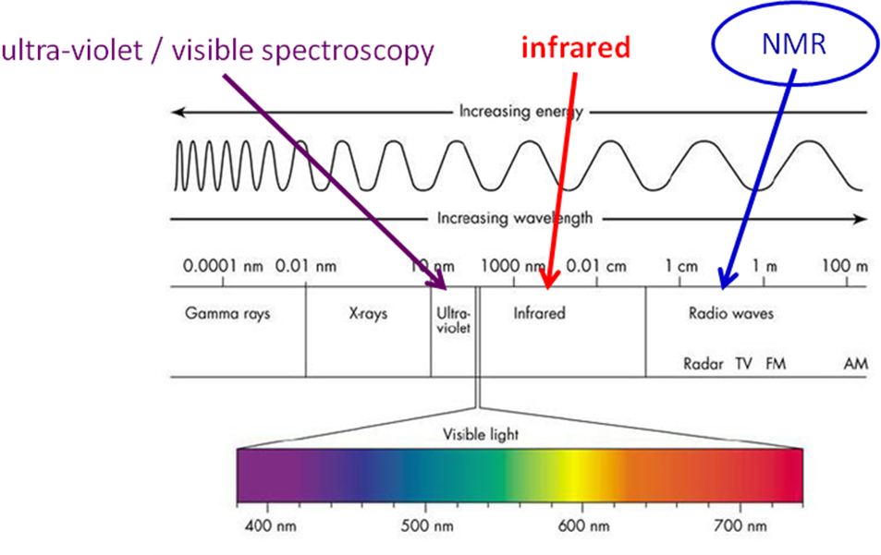

**Nuclear magnetic resonance spectroscopy**

Nuclear magnetic resonance (NMR) spectroscopy is a powerful tool in identifying the structure of organic molecules, even complex ones. It uses **radio waves to generate an energy change in the nuclei of atoms**. The same technique is used in MRI scanners to give a picture of the body.

Theory (not examined on)

**Nuclei** that have an **odd mass number**, such as **1H** (a proton) and **13C**, have a property called **nuclear spin** (as do electrons), which gives them a **magnetic field like a magnet**. Nuclei that possess an **even number** of both protons and neutrons such as 12C or 16O, **lack magnetic properties** and so **do not give rise to NMR signals**.

|  |  |  |
| --- | --- | --- |
| If bar magnets are placed in an external magnetic field they will **line up parallel to the external field** and will be in a **lower energy** state. |  | *Parallel to the field*  *Lower energy state* |
| It’s also possible that bar magnets could **line up anti-parallel to the field**, but hits orientation has a **higher energy state**, as the magnets are forced into a **position against the repulsion** of the external magnetic field. |  | *Anti-parallel to the field*  *Higher energy state* |
| The **stronger** the **external magnetic field** and the **stronger** the **bar magnets**, the **larger** the **energy gap** between the parallel and anti-parallel states. The energy difference is in the **radio waves** frequency. |  | |
| If a **magnetic field** is applied to an organic compound a similar thing happens to all the **nuclei with spin**, some nuclei will **line up in the same direction** (with the field) or in the **opposite direction** (against the field). There will be **more in the parallel state** with **lower** **energy**.  When the radiation stops the **nuclei relax** back to the **lower level**, **energy is released**. This is called **resonance**. |  | |

If electromagnetic **energy** (in the radio waves region) just **equal to the difference** between the two states is **supplied**, some **nuclei** will **absorb the frequency** and **‘flip’** between the parallel and anti-parallel positions.

|  |  |
| --- | --- |
|  | |
| The energy is supplied by a **radio frequency source**, after passing through the **sample** which is surrounded by an **electromagnet** a radio receiver **detects** the signal sending it to a computer to generate a **spectrum**. | |
|  |  |

The frequency needed to cause ‘flipping’ for a particular magnetic field is called the **resonance frequency** of the atomic nucleus. A **higher frequency** corresponds to a **larger** **energy gap** between the two states.

If the **magnetic field is kept constant** and the **radio frequency gradually increased**, **different** **nuclei** will come into **resonance** at **different frequencies** depending on the strength of their ‘atomic magnets’.

In **modern machines** a **pulse** of **radio waves** of a **range of frequencies** is used all at once and the **response** is analysed by a **computer technique** called ‘**Fourier transformation**’. So it’s often referred to as **FT-NMR**.

**Two techniques of NMR** are used which are particularly useful in organic chemistry as they provide **information** **about** the **hydrogen** and **carbon** **atoms** in a molecule.

* **1H NMR**
* **13C NMR**

**13C NMR**

Nuclear magnetic resonance only works if the nucleus has an odd mass number. **Carbon-12 has no nuclear spin** because it has an even number of particles in its nucleus. However **carbon-13** has an **odd number** of particles in its nucleus so it **does have spin**. But it **only accounts for 1% of all carbon atoms** consequently few molecules contain 13C atoms. Therefore, **13C NMR spectra** are **built up from a collection of molecules**, since an individual molecule is unlikely to contain more than one 13C atom

**Not all carbon-13 atoms** in a molecule **resonate** at exactly the **same magnetic field** strength. This is because the **carbon atoms** are in **different environments, they** are referred to as **non-equivalent**. The atoms in **different functional groups** **feel** the **magnetic field differently**.

The chemical shift

An NMR spectrophotometry produces a **graph** of **energy absorbed** (from the radio signal) **vertically** against a quantity called **chemical shift** (which relates to the resonance frequency) **horizontally**.

Chemical shift (symbol **δ**) is measured in part per million (**ppm**) on a scale that is set at **zero in relationship to the signal produced by a reference standard**. The standard used is a compound called **tetramethylsilane** (**TMS**), **Si(CH3)4**. It is used **in both13C and 1H NMR**. A **data table** is supplied giving the **chemical shift values** for 13C nuclei in different environments.

**Nuclear shielding in organic molecules**

Atoms are **surrounded** by **electrons** which **partly shield** them from the applied magnetic field; the **amount** of shielding **depends** on the **electron density** and **varies** from atom to atom **within a compound**.

|  |  |
| --- | --- |
| Shielded | De-shielded |
| * **nuclei** in atoms are **shielded** from the magnetic field **by the surrounding electrons** * atoms have a **greater electron density** * **adjacent** atoms or groups can **donate** electrons * **smaller magnetic field** will be felt by the nuclei * **resonate at a lower frequency** * up-field | * **nuclei** in atoms are **de-shielded** from the magnetic field * atoms have a **lower electron density** * **adjacent** atoms that are more **electronegative** will **withdraw** electrons away from the atom * **greater magnetic field** will be felt by the nuclei * **resonate at a higher frequency** * down-field |

**Factors that influence electron density** include:

* Bond polarity due to electronegative atoms
* Presence of electron-donating or electron-withdrawing groups.

This results in the nucleus being:

* **De-shielded** when the electron density is **reduced** giving a peak **downfield**
* **Shielded** when the electron density is **increased** giving a peak **upfield**

|  |  |  |  |
| --- | --- | --- | --- |
|  | * 13C has a δ scale 0-200ppm * 1H has a δ scale 0-10ppm * Scale goes right to left | | |
| The **TMS** is initially run with the sample to **calibrate** the spectrum and set the **zero peak**. All other absorptions are compared to the absorption from TMS and are downfield. | | |
| **TMS** is used because it:   * Gives a **single intense peak**   + Chemical shift TMS = 0ppm   + All other atoms are **less shielded**, so they are **downfield** * Gives a **signal** that is **upfield** (or high field on the far right) from almost all organic hydrogen and carbon resonance due to the **12 protons** and **4 carbons** being in the **same environment** and **highly shielded** * **Non-toxic** * **Inert** * **Low boiling point** so can be **easily removed**. | |  |

***Fact recall: CGP255 Q1***

13C NMR spectra

From the 13CNMR spectra it’s possible to determine the:

* **Number of non-equivalent** **carbon** atoms – different environments
* **Different types** **of** **carbon** atoms – saturated, unsaturated, aromatic or carbonyl carbon atoms

The 13C NMR spectra have these features:

* Each **non-equivalent carbon** gives rise to a **separate** **signal**
* The **size of signal is not relative to the number of equivalent C atoms** – however there is some relationship to the number of atoms and the size of the signal, a single peak derived from 2 equivalent carbon atoms will be larger than one derived from a single carbon atom
* The **chemical shift** (δ) is **measured relative to TMS** (comparing to the methyl group carbons)
* Sample is dissolved in an organic solvent
  + Deuterated (2H) solvents are usually used as in 1H NMR (see later), **13C shows a signal for any carbon atoms in the solvent**
* Typical range of chemical shifts is **0-220 ppm** – so peaks are less likely to overlap.

***Task: Identify the different carbon environments***

|  |  |  |  |  |
| --- | --- | --- | --- | --- |
| 1. Example   4 | |  | 1. 2 |  |
| 1. 3 |  | | 1. 5 |  |

**Example CGP256 - Ethanol**

|  |  |  |
| --- | --- | --- |
|  | shift (δ) | carbon |
| 18 | CH3 |
| 58 | CH2 |
|  | |

The carbon-13 NMR for ethanol has **only 2 peaks**, for **each carbon atom**. The carbon attached (**CH2**) to the **electronegative oxygen** has its **electrons drawn away** for it and so it is more **de-shielded**, feeling the magnetic field more, resonating at a higher frequency and appears **downfield**. The **CH3 is surrounded by more electrons** so is **more** **shielded** and its peak appears **upfield** with a **smaller chemical shift**.

**Example - Methyl ethanoate**

|  |  |
| --- | --- |
|  | * CH3 most shielded so appears upfield * COO most de-shielded due to 2 electronegative oxygen atoms so appears upfield * CH3 some de-shielding caused by electronegative oxygen so appears in the middle |

**Ethyl ethanoate**

|  |  |
| --- | --- |
|  | 1. CH3 shielded so appears upfield 2. COO is most de-shielded so appears downfield 3. CH2 some de-shielding caused by electronegative oxygen so appears in the middle 4. CH3 most shielded as furthest from the oxygen atoms so appears upfield |

***Task: Identify the number of peaks***

|  |  |
| --- | --- |
| 1. butane CH3CH2CH2CH3 2. 2-methylpropane CH3CH(CH3)CH3 3. butanal CH3CH2CH2CHO 4. butanone CH3COCH2CH3 5. pentan-2-one CH3COCH2CH2CH3 6. pentan-3-one CH3CH2COCH2CH3 7. cyclohexane C6H12 | 2  2  4  4  5  3  1  19 |

***Starter: 8.5 - 13C NMR spectroscopy***

Interpretation of 13C NMR spectra

To summarise how to interpret 13C NMR spectra:

* **Number of peaks** shows how many **different carbon environments** in a compound
* **Chemical shift** indicates what **type of environment** the carbons are in, shielded or de-shielded – refer to **data table** for values

Identifying isomers

13C NMR is **useful for identifying isomers** since the number of peaks relates to the carbons atoms in equivalent environments.

Looking at these 2 isomers, their 13C NMR spectra would give a different number of peaks.

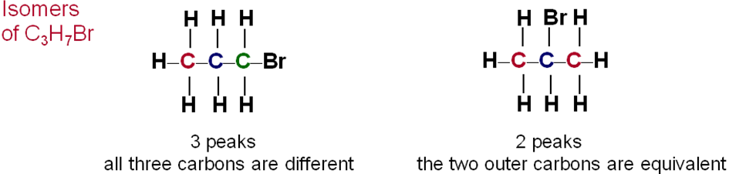

**Example: 2-methyl butane**

There are **four peaks** in the 13C NMR spectrum so there are **four chemically different carbon atoms** in the molecule.

|  |  |
| --- | --- |
|  | **Other isomers of C5H12** are shown below, they would give rise to a different number of peaks:  **pentane**  CH3CH2CH2CH2CH3 3 peaks    **2,2-dimethylpropane**  (CH3)4C 2 peaks |

***Task: Identify the isomers of C4H8O***

|  |  |  |
| --- | --- | --- |
|  |  |  |
| A. butanal  CH3CH2CH2CHO | B. butanone  CH3CH2C(CH3)O | C. 2-methylpropanal  CH(CH3)2CHO |

***Application: CGP259 PQ1-3***

***Sheet: 13C NMR***

**1H or Proton NMR**

1H NMR is also referred to as **proton NMR** because an H-1 atom only contains a proton. The 1H nucleus is being examined and since nearly all hydrogen atoms are 1H it is **easier to get an NMR spectrum for 1H than 13C**.

By definition the **chemical shift value for TMS is zero** and almost all proton NMR absorption are in the **range 0-10ppm**.

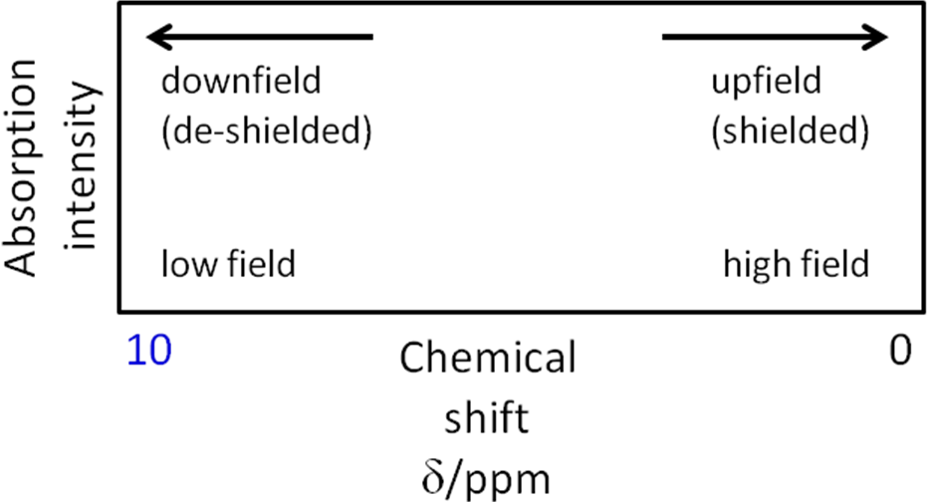

|  |  |
| --- | --- |
| As with carbon-13 NMR the reference standard **TMS** is initially run with the sample to **calibrate** the spectrum and set the **zero peak**.  **TMS** gives a **single intense peak** that is **upfield** due to the **12 equivalent** **protons** being **highly shielded**. |  |

The organic molecules are dissolved in a solvent but since most solvents contain H-1 atoms the sample is **dissolved in a 1H-free solvent** to avoid unwanted absorptions and produce a spectra that is easier to interpret.

**Typical solvents** used are:

Deuterium (**2H**) is used instead of 1H because it has an **even mass number** and so will not interfere with the NMR signals. Given the chemical symbol **D**.

* CCl4 tetrachloromethane (non-polar)
* CDCl3 (CHCl3) deuteriotrichloromethane (polar)
* D2O (H2O) deuterium oxide (polar)
* C6D6 (C6H6) perdeuterobenzene (non-polar)

Features of 1H NMR spectra

There are **4 important aspects** of 1H NMR spectra which provide information about chemical structure:

1. The **number of absorptions** (peaks on the spectrum) indicates how **many non-equivalent hydrogen atoms** are present in **different environments**.
2. The **intensity of the absorption** (area of peak) reveals **how many equivalent** **hydrogen atoms** are associated with each resonance peak.
3. The **positions of the absorptions** give indicates the **environment** of each equivalent of proton (shielded or de-shielded).
4. The **splitting of an absorption** (called **multiplicity**) into several peaks (this is caused by **spin-spin coupling**) provides information about **neighbouring hydrogen atoms**.
5. **Number of absorptions**

Each **hydrogen atom** has a **unique electronic environment** giving rise to a **characteristic resonance**; they will ‘feel’ the magnetic field differently because all **nuclei** are **shielded** from the external magnet **by** the **electrons** surrounding them. Nuclei with **more electrons** will be **better shielded**.

**Chemically equivalent protons** are all in the **same** **environment** and will therefore **absorb** at the **same frequency** resulting in **one** **signal**. Protons in a **different environment** will give **different signals**.

Hydrogen atoms only give a **small difference in frequency** so they are recorded as **parts per million** (ppm).

The different environments of the protons in an organic molecule are shown by looking at a **low resolution 1H NMR spectrum**. In this example **ethanol has 3 distinct peaks**.

|  |  |
| --- | --- |
|  | There are **3 kinds of non-equivalent protons** shown by the **3 different peaks**. |

These examples show hydrogen atoms in **different environments**:

|  |  |
| --- | --- |
|  |  |
|  |  |

***Sheet: 1H NMR – Task 1***

1. **Intensities of absorption**

The **ethanol** spectrum shows **3 peaks** of **different** **intensities**. For each peak, the **area** is **proportional to the number of equivalent hydrogen** atoms giving rise to the signal. So for ethanol the **ratio is 1:2:3** for the following hydrogens **OH:CH2:CH3**.

|  |  |
| --- | --- |
|  | The **area of the signal** is **proportional** to the **number** of **equivalent hydrogen** atoms it represents.  ***Sheet: 1H NMR – Task 2*** |

It’s the **area not the height that matters**. The following signals all have the **same area** and so represent the **same number of hydrogen atoms**:

|  |  |
| --- | --- |
|  | There are 4 signals here – each has the **same area**, although some show a number of peaks in a specific pattern (this is called **splitting** – see later). |

***Sheet: 1H NMR – Task 3***

There are a number of **ways to calculate the relative size** (area) of the signals.

One approach is to indicate the **relative intensity of the signals** from which the **simplest whole number ratio** can be calculated.

e.g. relative intensity = 1.2 : 1.2 : 1.8 = 2 : 2 : 3

relative intensity = 2.1 : 2.8 = 3 : 4

relative intensity = 1.5 : 0.5 : 2.0 = 3 : 1 : 4

relative intensity = 0.3 : 0.15 : 0.3 : 0.6 = 2 : 1 : 2 : 6

Sometimes an **‘integration trace’** is drawn on the spectrum. The **relative height** of these traces **gives the relative number of hydrogen atoms** represented by each signal.

14 mm

28 mm

42 mm

**14 : 28 : 42 = 1 : 2 : 3**

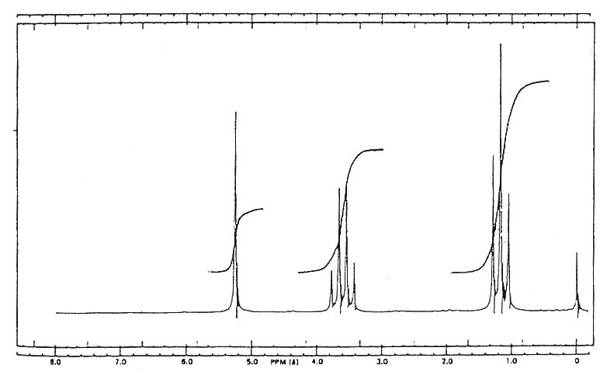

1. **Position of absorption**

The effect of **shielding** and **de-shielding** is expressed by the chemical **shift values** on the δ scale. The **δ values vary according to the structural environment**, so organic functional groups have characteristic chemical shifts. It **depends on what other atoms/groups are near the hydrogen**. The **closer** the hydrogen is to an **electronegative atom** (e.g. O, N), the **greater the shift**. Also, the **more electronegative atoms** that are near, the **greater the shift**.

For **ethanol**, the **hydroxyl hydrogen** atom is **de-shielded** because of the effect of the electron-withdrawing **electronegative oxygen** atom. However, the **CH2**and **CH3** groups are progressively **further away** from the oxygen and the electron density around the hydrogens increases. The **CH3** atoms are the **most** **highly** **shielded** and so **absorb** at the **higher field** (low δ).

|  |  |
| --- | --- |
|  | So the **position of absorptions** can be related to the **electronegativities of adjacent atoms** and the **electron-withdrawing** or **electron-donating** **effects** of functional groups. |

Multiple substituents have a cumulative effect.

For example:

* CH3Cl 3.05ppm
* CH2Cl2 5.30ppm
* CHCl3 7.27ppm

The **de-shielding influence** of electron-withdrawing substituents **decreases rapidly with distance**. **Delocalised electrons** in an **aromatic ring** exert a **strong de-shielding effect**, so **aromatic protons** appear at **low field** (high δ).

The **OH** groups in alcohols and **NH2** groups in amines exhibit relatively **broad NMR peaks**, their hydrogen atoms **absorb** over a **wide range of frequencies** due to **hydrogen bonding** and **sensitivity** to the **solvent** and to **moisture**.

***Sheet: 1H NMR – Task 4***

In the example below, it can be seen that the closer the hydrogen are to any oxygen atoms, the greater the chemical shift.



1. **Spin-spin coupling**

By using a **high-resolution NMR** spectrophotometer what previously appeared as a single peak is in fact **split into more complex patterns** called **multiplets**. This is known as **spin-spin coupling** or **spin-spin splitting**.

It happens because the **applied magnetic field** felt by any hydrogen is **affected by the magnetic field of the hydrogen atoms on the neighbouring carbon atoms**. Hydrogens that are **equivalent don’t** **cause** this **splitting**; only **non-equivalent nuclei** with **different chemical shifts** will cause splitting.

So the spin-spin splitting is **very useful** as it give **information about the neighbouring hydrogens**. It gives information on whether they are **non-equivalent** and, if they are, **how** **many** there are.

The **high-resolution** 1H NMR spectrum for **ethanol** reveals that the **three absorptions** are **not single peaks** but are split.

|  |  |
| --- | --- |
| * **CH3** is split into **3** peaks – a **triplet** * **CH2** is split into **4** peaks – a **quartet** * **OH** remains as **1** peak – a **singlet** |  |

The **adjacent CH3 splits** the **CH2** to form a **quartet**; this is due to the **resonance** of the **CH3 protons** **split** **by the CH2 protons**.

***The n+1 rule***

The **number of lines is equal to 1 plus the number of non-equivalent hydrogen atoms on the adjacent carbon atoms**, this is called the **n+1 rule**. For n hydrogens on an adjacent carbon atoms

***Definition***:

**n hydrogens** on a adjacent carbon atom will **split** a peak into **n+1 smaller peaks**.

So if there are **two hydrogens** on the **adjacent carbon**, this will **split** the NMR signal of particular hydrogen **into three peaks** in the **height ratio 1:2:1**. **Three** adjacent hydrogens will **split** the signal of a particular hydrogen **into four** peaks in the **height ratio 1:3:3:1**.

Looking at the **ethanol example**:

* **CH2** peak is **adjacent** to a **CH3** with **3** equivalent **hydrogens** so it is split into **3+1 = 4**
* **CH3** peak is **adjacent** to a **CH2** with **2** equivalent **hydrogens** so it is split into **2+1 = 3**
* **OH** peak **remains** a **singlet** as these hydrogens **rarely cause splitting,** this is because the weakly **acidic** **hydrogens** rapidly **exchange** between other ethanol and water molecules – they are **decoupled due to fast proton exchange**.

|  |  |  |  |  |
| --- | --- | --- | --- | --- |
| signal | singlet | doublet | triplet | quartet |
| appearance |  |  |  |  |
| number of lines | 1 | 2 | 3 | 4 |
| number of **neighbouring** non-equivalent H atoms | 0 | 1 | 2 | 3 |
| relative size |  | 1:1 | 1:2:1 | 1:3:3:1 |

Theory behind the peak splitting (*not part of specification*)

The multiplicity and relative intensities of the n+1 components can be obtained from Pascal’s triangle (not in specification).

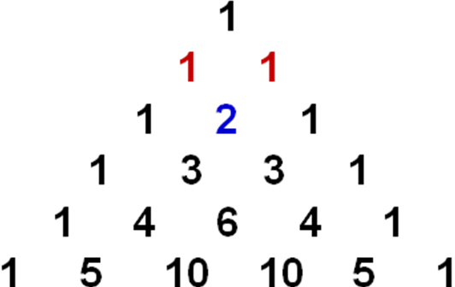

This can be explained by using this analogy.

|  |  |
| --- | --- |
| Imagine you had an opinion on something. If nobody influenced you, your opinion would be the same. However if another person had a view on the topic, they would either agree or disagree with you. Their ideas would either enhance what you thought or diminish it.  There would be **two possibilities of equal chance**. |  |
| If there were two people offering views they could either be both for it (1 possibility) , both against (1 possibility) or one could be in favour and the other against (2 possibilities).  There would be **three possibilities of relative chance 1:2:1** |  |

So this occurs:

|  |  |
| --- | --- |
| **0 adjacent H’s**  There is no effect |  |
| **1 adjacent H**  can be aligned either with or against the field  there are only two equally probable possibilities  the signal is split into 2 peaks of equal intensity |  |
| **2 adjacent H’s**  more possible combinations  get 3 peaks in the ratio 1 : 2 : 1 |  |
| **3 adjacent H’s**  even more possible combinations  get 4 peaks in the ratio 1 : 3 : 3 : 1 |  |

**Examples**

|  |  |  |  |  |  |  |
| --- | --- | --- | --- | --- | --- | --- |
| **Example 1 - butanone** |  | * 3 non-equivalent Hs:   CH3:CH2:CH3CO   * Giving 3 peaks:   CH3 most shielded/up field/low δ  CH2 most de-shielded/down field  CH3CO de-shielded/middle field   * Each split:   CH3 has 2 adjacent Hs 2+1 = 3  CH2 has 3 adjacent Hs 3+1 = 4  CH3CO no adjacent Hs = 1 | | | | |
|  | |  | | | | |
|  | | shift (δ) | assignment | relative intensity | coupling | coupled to |
|  | | 1.0 | CH3CH­2 | 3 | triplet | CH2 |
|  | | 2.0 | CH3CO | 3 | singlet |  |
|  | | 2.4 | CH­2 | 2 | quartet | CH3 |
|  | |  | | | | |

|  |  |  |  |  |  |  |
| --- | --- | --- | --- | --- | --- | --- |
| **Example 2 - butane** |  | * 2 non-equivalent Hs:   2 x CH3:2 x CH2   * Giving 2 peaks:   CH3 most shielded/up field/low δ  CH2 least shielded/down field/high δ   * Each split:   CH3 has 2 adjacent Hs 2+1 = 3  CH2 has 3 adjacent Hs 3+1 = 4 | | | | |
|  | |
| shift (δ) | assignment | relative intensity | coupling | coupled to |
| 1.3 | CH2 | 2 | quartet | CH3 |
| 0.8 | CH­3 | 3 | triplet | CH2 |
| **Note:**  The CH2 only couples to the CH­3 and not the other CH2 as the CH2 is equivalent. | | | | |

There are some **common signals** to look out for:

|  |  |  |  |
| --- | --- | --- | --- |
| Triplet & quartet | 3:2 | CH3 –CH2 –  (ethyl group) | * The triplet and quartet do not have to be next to each other in the spectrum. * The atom joined to the other side of the CH2 cannot have hydrogen atoms on or if it does they do not couple, e.g. OH group or an equivalent CH2 as in butane. |
| Triplet & triplet | 2:2 | – CH2 – CH2 – | * The two triplets do not have to be next to each other in the spectrum. * The two CH2 groups must be non-equivalent (otherwise they would produce one signal not two!). * The atoms joined either side of the CH2 groups can’t have any hydrogens on them. |
| Singlet | 3 | CH3 –  (methyl group) | * The atom joined to the CH3 can’t have any hydrogens on it. |

This example spectrum shows **all three of these common signals**.

|  |
| --- |
|  |
| 2  2  3  **3 singlet**  **CH3 –**  **3:2 triplet & quartet**  **CH3 – CH2  –**  **2:2 triplet & triplet**  **– CH2 – CH2  –**  2 |

***Sheet: 1H NMR – Task 5***

***Starter: 8.3 – 1H NMR spectra***

Interpretation of 1H NMR spectra

To summarise how to interpret 1H NMR spectra:

* **Number of peaks** shows how many **different hydrogen environments** in a compound.
* **Ratio of peak** **areas** shows the **relative number of hydrogens** in each environment.
* **Chemical shift** indicates what type of **environment the hydrogens** are in, shielded or de-shielded – refer to **data table** for values.
* **Split pattern** shows the **number of hydrogens on the adjacent atom** (usually carbon) – use the n+1 rule.

***Task: Which ketone?***

|  |  |
| --- | --- |
|  |  |
|  |
|  |

***Sheet: 1H NMR – Tasks 6 – 9***

***Task: 1H NMR – Work out the structure of each compound***

***Sheet: S&C – 1H NMR spectra***

***Application: CGP264 PQ1-2***

***Fact recall: CGP264 Q1-4***

**Using spectroscopy techniques together**

Spectroscopy techniques tend to be **used in conjunction** with each other, in order to find out information about a molecule.

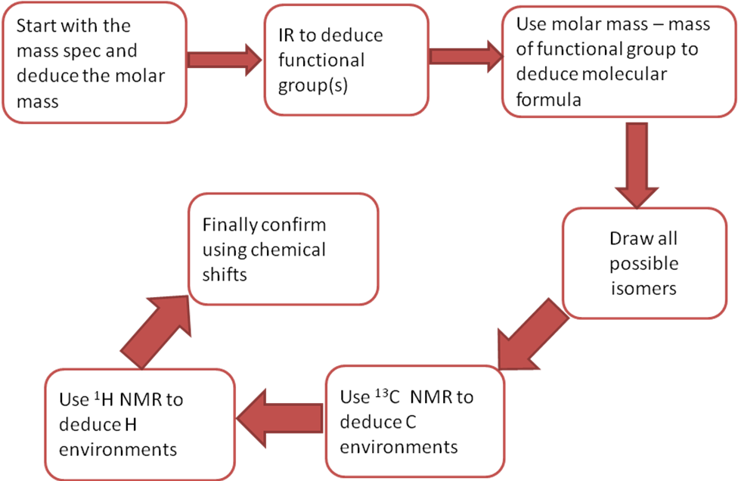

|  |  |  |
| --- | --- | --- |
| Mass spec | Start with the mass spec and deduce **molar mass** |  |
| Infra-red | Now use the IR to deduce the **functional groups** |  |
| 13C NMR | Work out number of C environments in each isomer and compare with 13C NMR, this also allows the H in the molecule to be deduced |  |
| 1H NMR | Now use 1H NMR  to confirm by looking at the number of H environments and using the splitting patterns to deduce the structure |  |

***Sheet: NMR spectroscopy questions***

***Exam questions: Oxford p236-237 Q1-2***