

**IGCSE (9 – 1) Revision Pack**

**Geometrical Reasoning**

**Name --------------------------------**

**Questions**

**Q1.**

The diagram shows a triangle.

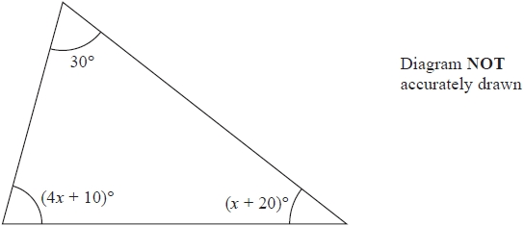

Work out the value of *x*.

*x* = ...........................................................

**(Total for question = 4 marks)**

**Q2.**

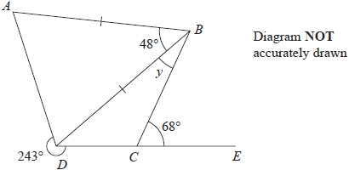

*ABD* is an isosceles triangle with *AB* = *DB*.   
*DCE* is a straight line.

Angle ABD = 48°   
Angle *BCE* = 68°   
Reflex angle *ADC* = 243°

Work out the size of the angle marked *y*.   
Give a reason for each stage in your working.

°

**(Total for question = 5 marks)**

**Q3.**

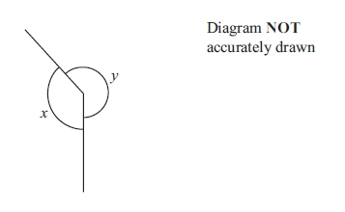

(a) Explain why the diagram is wrong for *x* = 135° and *y* = 245°

.............................................................................................................................................

.............................................................................................................................................

**(2)**

(b) Write down the mathematical name for

(i) an angle of 135°

...........................................................

(ii) an angle of 245°

...........................................................

**(2)**

**(Total for question is 4 marks)**

**Q4.**

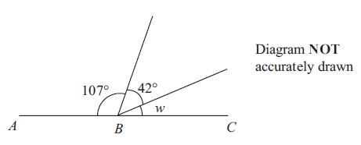

*ABC* is a straight line.

(a) (i)    Work out the size of angle *w*.

............................................................°

(ii)    Give a reason for your answer.

      ..............................................................................................................................................

      ..............................................................................................................................................

**(2)**

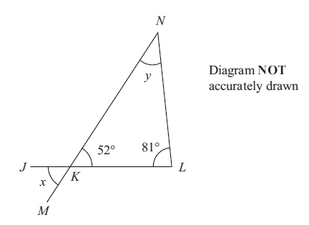

*JKL* and *MKN* are straight lines.

(b) (i)    Find the size of angle *x*.

............................................................°

(ii)    Find the size of angle *y*.

............................................................°

**(3)**

**(Total for question = 5 marks)**

**Q5.**

The diagram shows a shape made from a right-angled triangle and a semicircle.

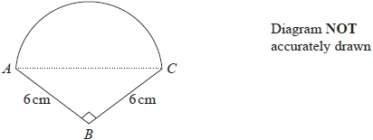

*AC* is the diameter of the semicircle.   
*BA* = *BC* = 6 cm   
Angle *ABC* = 90°

Work out the area of the shape.   
Give your answer correct to 1 decimal place.

........................................................... cm2

**(Total for question = 5 marks)**

**Q6.**

The diagram shows a shape.

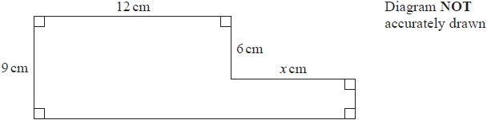

The shape has area 129 cm2

Work out the value of *x*.

*x* = ...........................................................

**(Total for question = 4 marks)**

**Q7.**

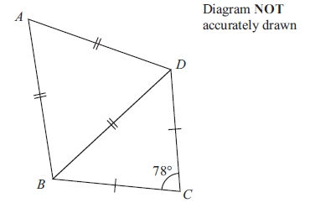

The diagram shows a quadrilateral *ABCD*.   
*AB* = *BD* = *AD*.   
*CB* = *CD*.   
Angle *BCD* = 78°

Work out the size of angle *ABC*.

........................................................... °

**(Total for question is 4 marks)**

**Q8.**

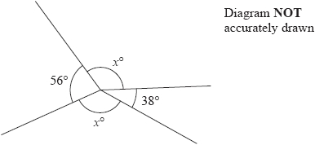

Work out the value of *x*.

...........................................................

**(Total for question = 3 marks)**

**Q9.**

The diagram shows a shape drawn on a centimetre grid.

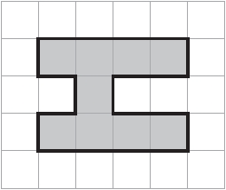

(a) (i)  Find the area of the shape.

........................................................... cm2

(ii)  Find the perimeter of the shape.

........................................................... cm

(iii)  On the grid, draw the line of symmetry of the shape.

**(3)**

Here is a different shape.

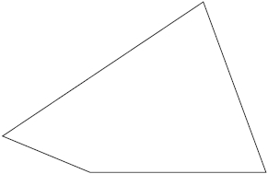

(b)  On this shape, mark an obtuse angle.   
        Label your angle *O*

**(1)**

**(Total for question = 4 marks)**

**Q10.**

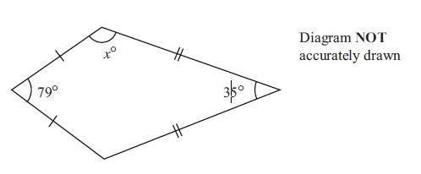

The diagram shows a kite.

Work out the value of *x*.

*x* =...........................................................

**(Total for question = 3 marks)**

**Q11.**

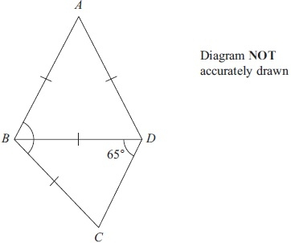

In triangle *ABD*, *AB* = *AD* = *BD*.  
 In triangle *BCD*, angle *BDC* = 65° and *BC* = *BD*.

Work out the size of angle *ABC*.

...........................................................°

**(Total for question = 4 marks)**

**Q12.**

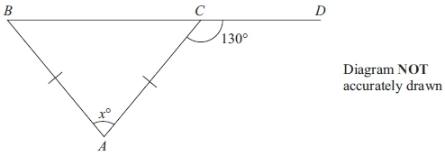

The diagram shows an isosceles triangle *ABC*.  
*AB* = *AC*.  
*BCD* is a straight line.  
 Angle *ACDM* = 130°

Work out the value of *x*.

*x* = ...........................................................

**(Total for question = 3 marks)**

**Q13.**

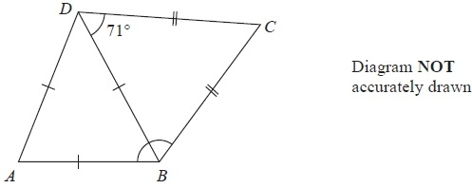

The diagram shows a quadrilateral *ABCD*.

*AB* = *BD* = *AD*.

*BC* = *DC*.

Angle *BDC* = 71°

Work out the size of angle *ABC*.

...........................................................°

**(Total for Question is 2 marks)**

**Q14.**

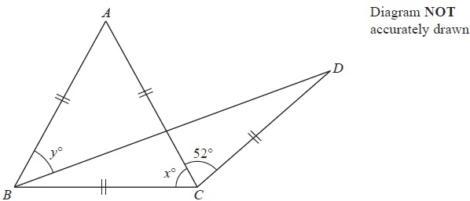

The diagram shows an equilateral triangle *ABC* and an isosceles triangle *BCD*.

*AB* = *AC* = *BC* = *CD*.

Angle *ACD* = 52°

Angle *ACB* = *x*°

(i)  Find the value of *x*.

*x* = ...........................................................

Angle *ABD* = *y*°

(ii)  Work out the value of *y*.

*y* = ...........................................................

**(Total for Question is 4 marks)**

**Q15.**

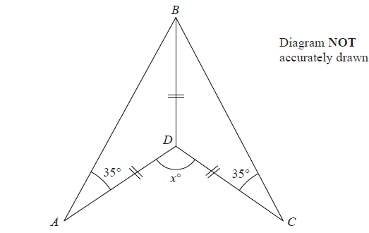

The diagram shows a quadrilateral *ABCD*.   
The quadrilateral *ABCD* is made from two identical isosceles triangles, *ABD* and *CBD*.   
*DA = DB = DC*.   
Angle *BAD* = Angle *BCD* = 35°   
Angle *ADC* = *x*°

Work out the value of *x*.

*x* = ...........................................................

**(1)**

**(Total for Question is 4 marks)**

**Q16.**

The diagram shows a quadrilateral.

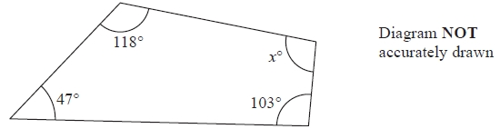

Work out the value of *x*.

*x* = ...........................................................  
**(Total for Question is 2 marks)**

**Q17.**

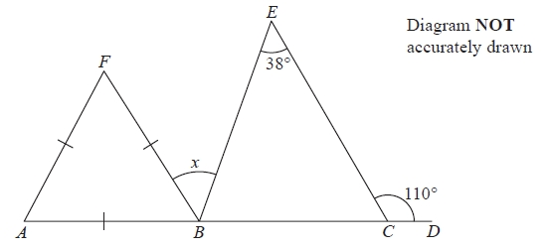

*ABCD* is a straight line.

Triangle *ABF* is equilateral.

Angle *ECD* = 110°

Angle *BEC* = 38°

Work out the size of angle *x*.

........................................................... °

**(Total for question = 3 marks)**

**Q18.**

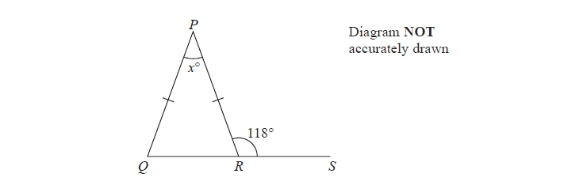

*PQR* is an isosceles triangle.   
*QRS* is a straight line.   
*PQ* = *PR*.   
Angle *PRS* = 118°

Work out the value of *x*.

*x* =...........................................................

**(Total for question = 3 marks)**

**Q19.**

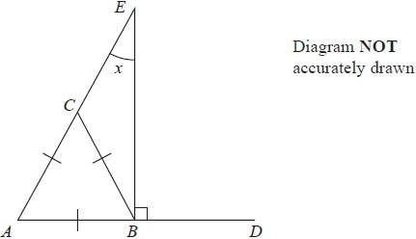

*ABC* is an equilateral triangle.   
*ABD* and *ACE* are straight lines.   
Angle *EBD* = 90°

Work out the size of angle *x*.

...........................................................°

**(Total for question = 3 marks)**

**Q20.**

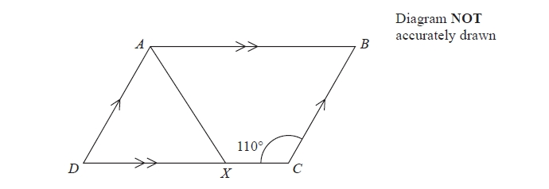

*ABCD* is a parallelogram.   
Angle *DCB* = 110°   
*X* is the point on *DC* such that *AX* bisects the angle *DAB*.

Calculate the size of angle *AXC*.

.......................................................... °

**(Total for question = 4 marks)**

**Q21.**

Here is a regular 10-sided polygon.

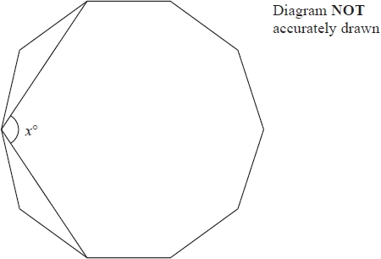

Work out the value of *x*.   
Show your working clearly.

*x* = ...........................................................

**(Total for question = 4 marks)**

**Q22.**

*ABE* is an isosceles triangle and *BCDE* is a square.

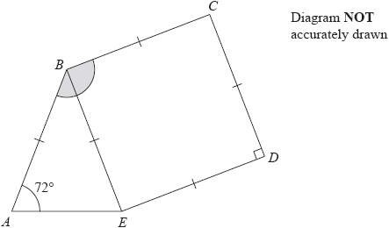

Angle *BAE* = 72°

Work out the size of angle *ABC*.

........................................................... °

**(Total for question = 3 marks)**

**Q23.**

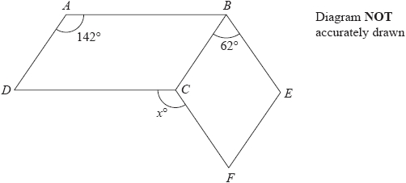

*ABCD* is a parallelogram.   
*BEFC* is a rhombus.

Angle *DAB* = 142°   
Angle *CBE* = 62°

Calculate the value of *x*.

*x* = ...........................................................

**(Total for question = 3 marks)**

**Q24.**

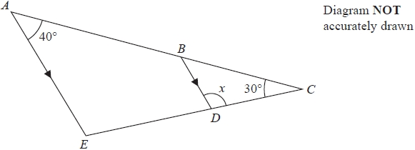

*ABC* and *EDC* are straight lines.   
*AE* is parallel to *BD*.   
Angle *EAC* = 40°   
Angle *ACE* = 30°

Work out the size of angle *x*.   
Give reasons for your answer.

*x* = ...........................................................°

**(Total for question = 3 marks)**

**Q25.**

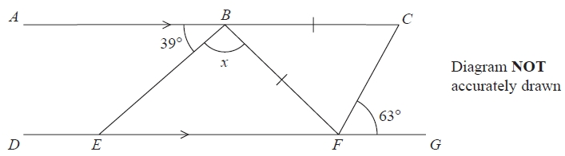

*ABC* is parallel to *DEFG*  
*BC* = *BF*  
Angle *ABE* = 39°   
Angle *CFG* = 63°

Work out the size of angle x.   
Give a reason for each stage in your working.

........................................................... °

**(Total for question = 5 marks)**

**Q26.**

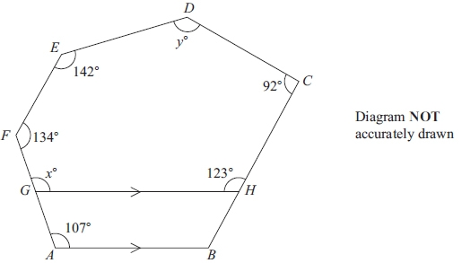

*ABCDEF* is a hexagon.  
*G* is a point on *AF*.  
*H* is a point on *BC*.  
*GH* is parallel to *AB*.

(a) Give a reason why *x* = 107

      ..............................................................................................................................................

**(1)**

(b) Work out the value of *y*.

*y* = ...........................................................

**(4)**

**(Total for question = 6 marks)**

**Q27.**

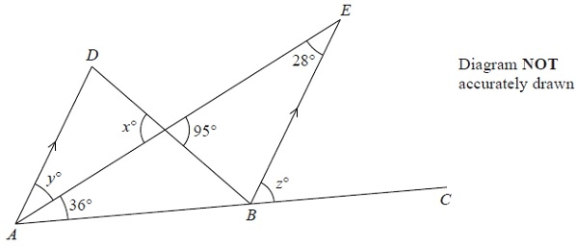

*ADB* and *AEB* are triangles.

*ABC* is a straight line.

*AD* is parallel to *BE*.

(a)  (i)  Find the value of *x*.

*x* = ...........................................................

(ii)  Give a reason for your answer.

.............................................................................................................................................

**(2)**

(b)  Find the value of *y*.

*y* = ...........................................................

**(1)**

(c)  Find the value of *z*.

*z* = ...........................................................

**(2)**

**(Total for Question is 5 marks)**

**Q28.**

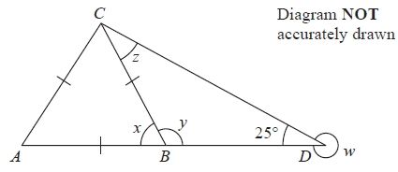

In the diagram, *ABD* is a straight line.   
*AB = BC = CA* and angle *BDC* = 25°

(a)   Work out the size of angle *w*.

........................................................... °

**(1)**

(b)   Write down the size of angle *x*.

........................................................... °

**(1)**

(c)   Work out the size of angle *y*.

........................................................... °

**(1)**

(d)   Work out the size of angle *z*.

........................................................... °

**(2)**

**(Total for Question is 5 marks)**

**Q29.**

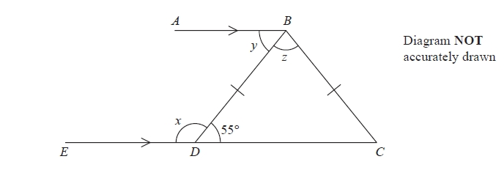

*AB* and *EDC* are parallel lines.   
*BD* = *BC*  
Angle *BDC* = 55°

(a)  (i)   Work out the size of angle *x*.

...........................................................°

(ii)  Give a reason for your answer.

.............................................................................................................................................

.............................................................................................................................................

**(2)**

(b) Find the size of angle *y*.

...........................................................°

**(1)**

(c) Work out the size of angle *z*.

...........................................................°

**(2)**

**(Total for question = 5 marks)**

**Q30.**

The scale drawing shows the positions of a ship, *S*, and a port, *P*.

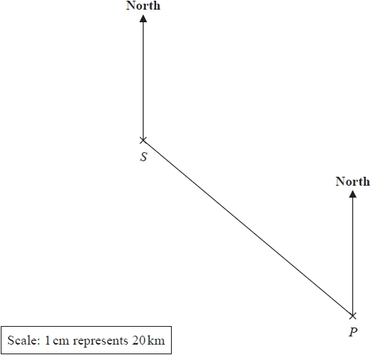

(a)  Find the bearing of *S* from *P*.

........................................................... °

**(1)**

The ship *S* now sails directly towards port *P*.   
The ship sails at an average speed of 24 km/h.

(b)  Work out how long it takes the ship to get to *P*.   
Give your answer correct to the nearest hour.

........................................................... hours

**(4)**

**(Total for question = 5 marks)**

**Q31.**

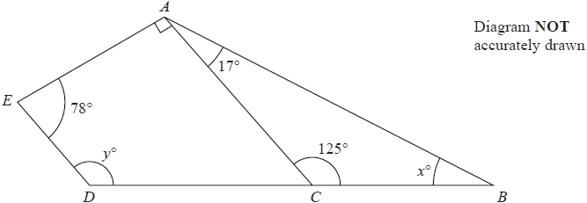

*ABDE* is a quadrilateral.   
*ABC* is a triangle.   
*DCB* is a straight line.

(a)  (i)  Work out the value of *x*.

*x* = ...........................................................

**(1)**

(ii)  Give a reason for your answer.

.............................................................................................................................................

**(1)**

(b)  Work out the value of *y*.   
Give a reason for each stage of your working.

*y* = ...........................................................

**(3)**

**(Total for question = 5 marks)**

**Q32.**

Each exterior angle of a regular polygon is 24°

Work out the number of sides of the polygon.

...........................................................

**(Total for question = 2 marks)**

**Q33.**

The diagram shows a shaded shape *ABCD* made from a semicircle *ABC* and a   
right-angled triangle *ACD*.

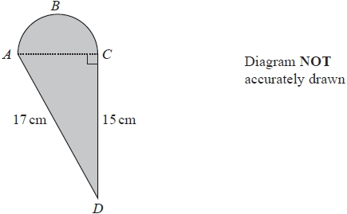

*AC* is the diameter of the semicircle *ABC*.

Work out the perimeter of the shaded shape.   
Give your answer correct to 3 significant figures.

........................................................... cm

**(Total for question = 5 marks)**

**Q34.**

A regular polygon has *n* sides.   
The size of each interior angle of the regular polygon is 140°

Work out the value of *n*.

*n* = ...........................................................

**(Total for question = 3 marks)**

**Q35.**

*A*, *B* and *C* are points on a circle, centre *O*.

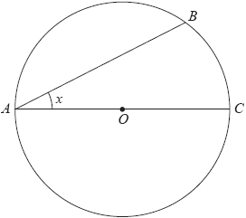

(a)  (i)  Write down the mathematical name for the line *OC*.

...........................................................

(ii)  Measure the size of the angle marked *x*.

........................................................... °

**(2)**

In the diagram, *ABCD* is a quadrilateral.

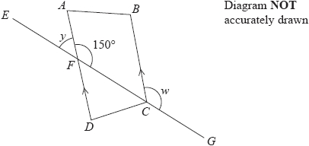

*DA* and *CB* are parallel lines.   
*AFD* and *EFCG* are straight lines.

(b)  (i)  Find the size of angle *y*.

*y* = ........................................................... °

(ii)  Give a reason for your answer.

.............................................................................................................................................

**(2)**

(c)  (i)  Find the size of angle *w*.

*w* = ........................................................... °

(ii)  Give a reason for your answer.

.............................................................................................................................................

**(2)**

**(Total for question = 6 marks)**

**Q36.**

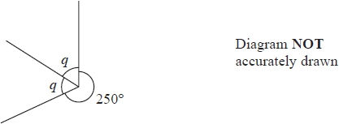

(a)  Work out the size of angle *q*.

...........................................................°

**(2)**

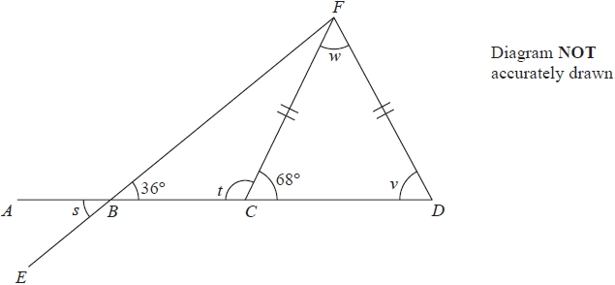

*ABCD* and *EBF* are straight lines.   
Angle *FBC* = 36° and angle *FCD* = 68°   
*FC* = *FD*

(b)  Write down the size of angle *s*.

...........................................................°

**(1)**

(c)  Work out the size of angle *t*.

...........................................................°

**(1)**

(d)  Explain why angle *v* = 68°

.............................................................................................................................................

.............................................................................................................................................

**(1)**

(e)  Work out the size of angle *w*.

...........................................................°

**(2)**

**(Total for question = 7 marks)**

**Q37.**

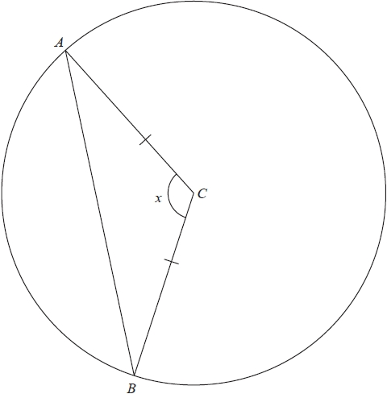

*A* and *B* are points on a circle, centre *C*.   
*AC* = *BC*.

(a)  (i)  Measure the size of angle *x*.

...........................................................°

(ii)  Write down the mathematical name for angle *x*.

...........................................................

**(2)**

(b)  Write down the mathematical name for triangle *ABC*.

...........................................................

**(1)**

**(Total for question = 3 marks)**

**Q38.**

The diagram shows a parallelogram *ABCD*.   
In the diagram, all the angles are in degrees.

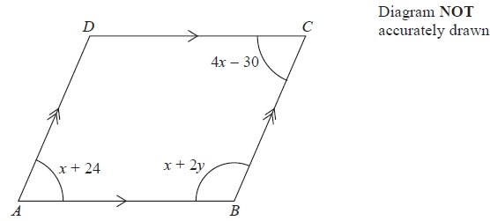

(a)   Work out the value of *x* and the value of *y*.

*x* = ...........................................................

*y* = ...........................................................

**(4)**

(b)   Find the size of angle *BAD*.

........................................................... °

**(1)**

**(Total for Question is 5 marks)**

**Q39.**

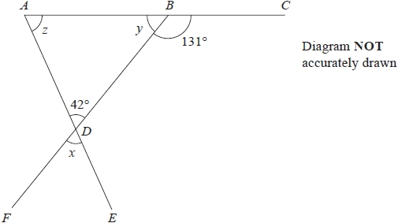

*ABC*, *BDF* and *ADE* are straight lines.

(a)  Write down the size of angle *x*.

........................................................... °

**(1)**

(b)  Work out the size of angle *y*.

........................................................... °

**(1)**

(c) (i)  Work out the size of angle *z*.

........................................................... °

(ii)  Give a reason for your answer.

.............................................................................................................................................

**(2)**

**(Total for question = 4 marks)**

**Q40.**

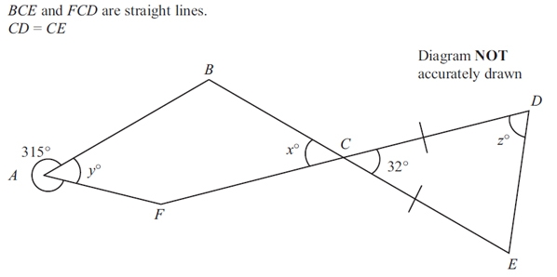

(a) (i) Find the value of *x*.

*x* = ...........................................................

(ii) Give a reason for your answer.

      ..............................................................................................................................................

**(2)**

(b) (i) Work out the value of *y*.

*y* = ...........................................................

(ii) Give a reason for your answer.

      ..............................................................................................................................................

**(2)**

(c) Work out the value of *z*.

*z* = ...........................................................

**(2)**

**(Total for question = 6 marks)**

**Mark Scheme**

Q1.

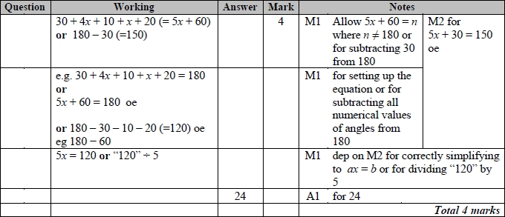

**Q2.**

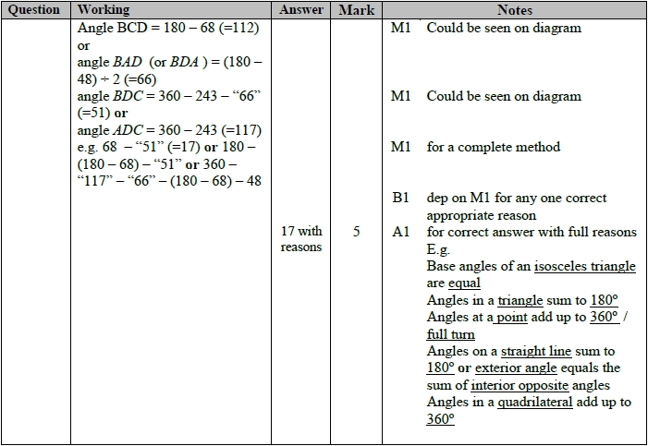

**Q3.**

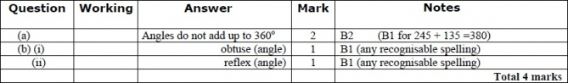

**Q4.**

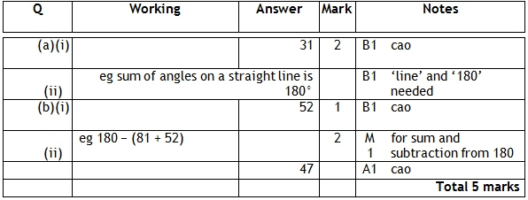

**Q5.**

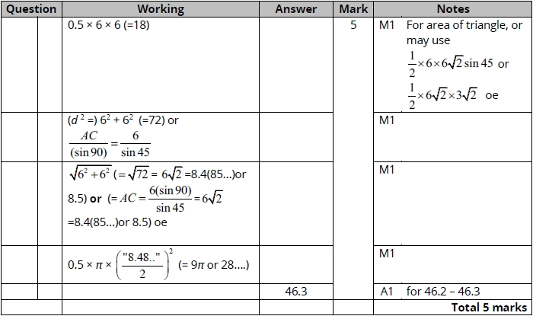

**Q6.**

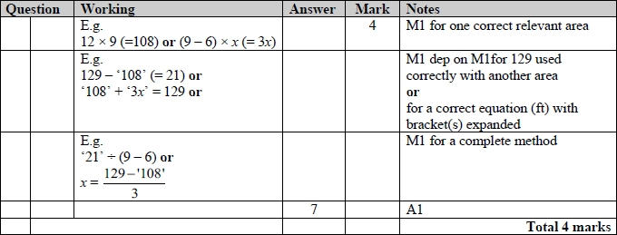

**Q7.**

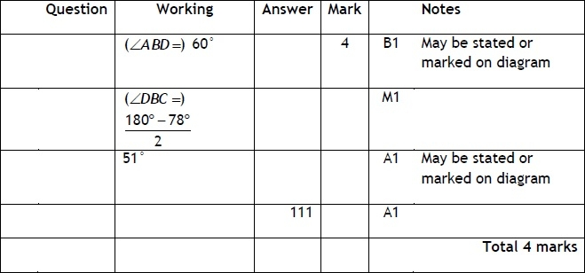

**Q8.**

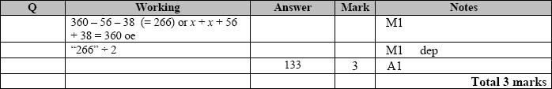

**Q9.**

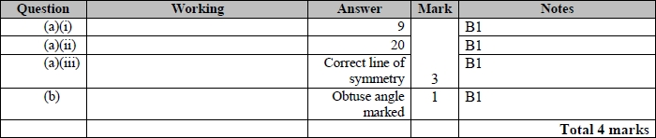

**Q10.**

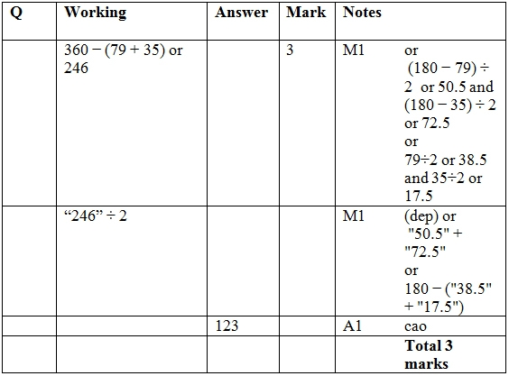

**Q11.**

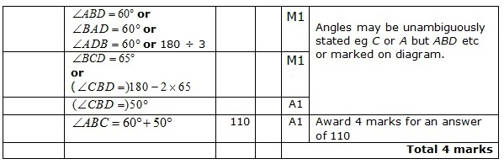

**Q12.**

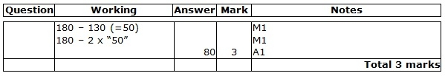

**Q13.**

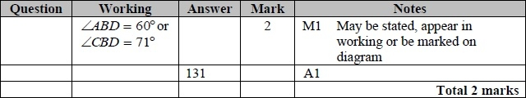

**Q14.**

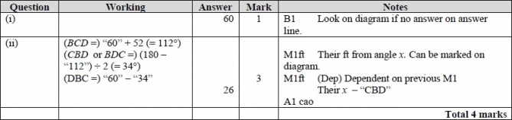

**Q15.**

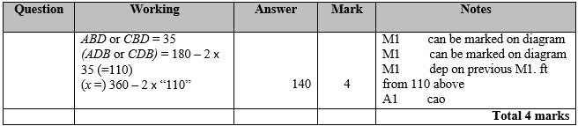

**Q16.**

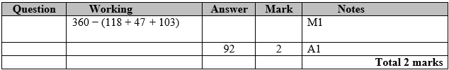

**Q17.**

For all questions, the correct answer, unless clearly obtained by an incorrect method, should be taken to imply a correct method.

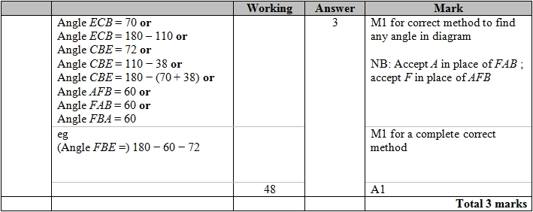

**Q18.**

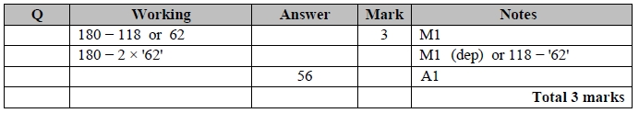

**Q19.**

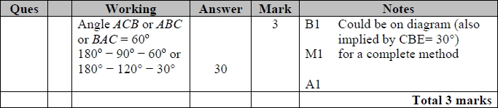

**Q20.**

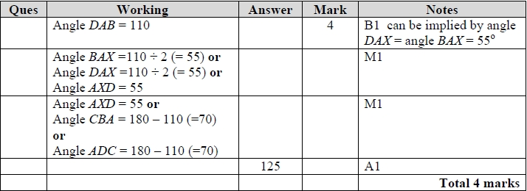

**Q21.**

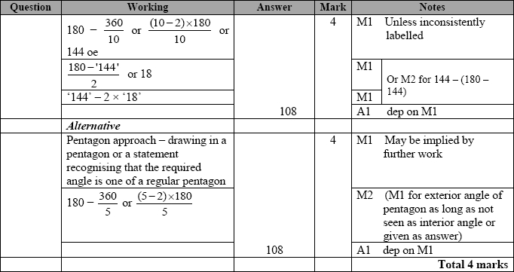

**Q22.**

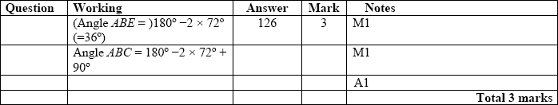

**Q23.** 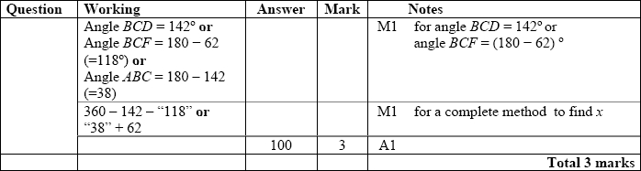

**Q24.**

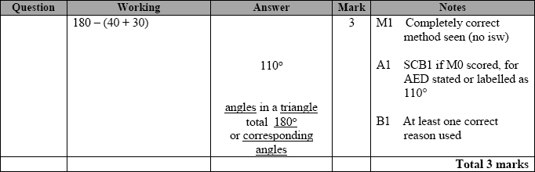

**Q25.**

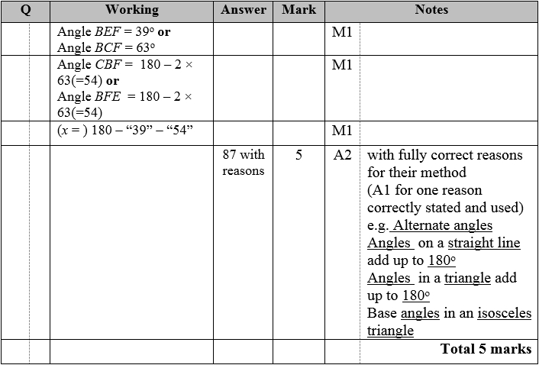

**Q26.**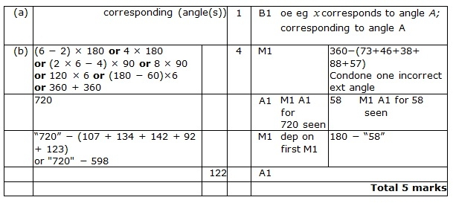

**Q27.**

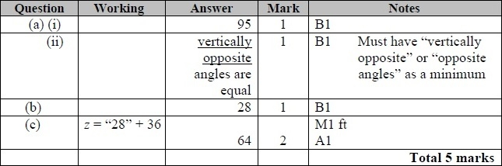

**Q28.**

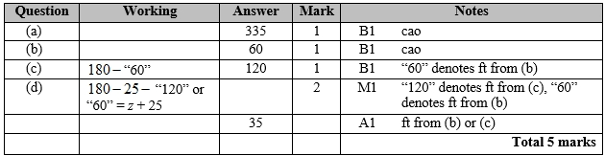

**Q29.**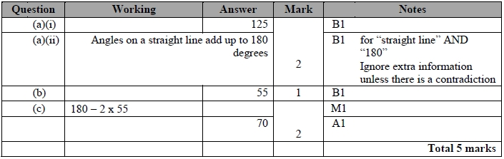

**Q30.**

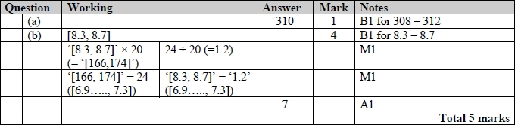

**Q31.**

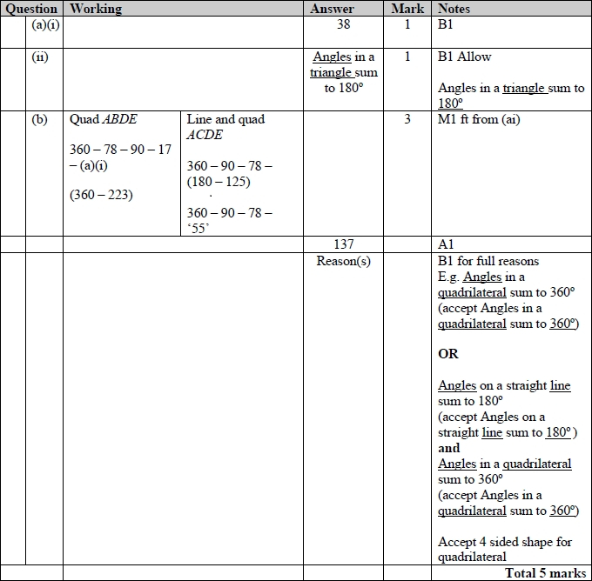

**Q32.**

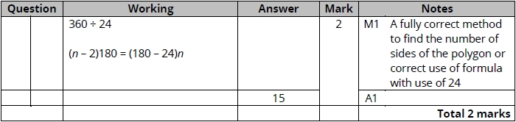

**Q33.**

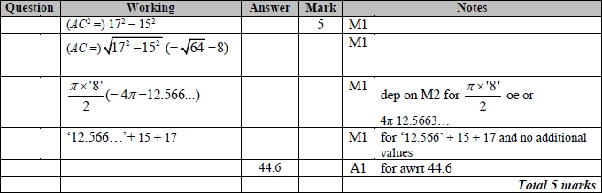

**Appendix 1**

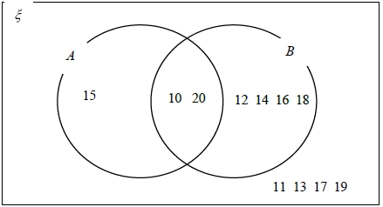

**Q34.**

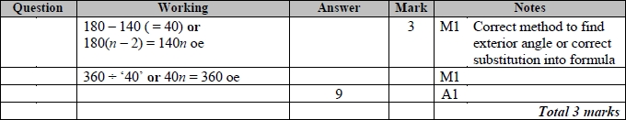

**Q35.**

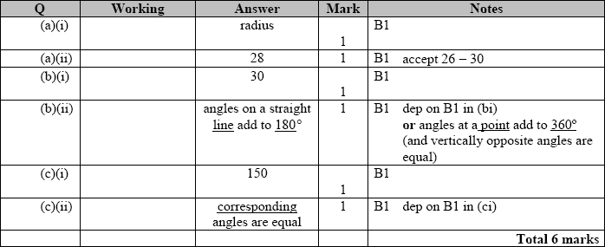

**Q36.**

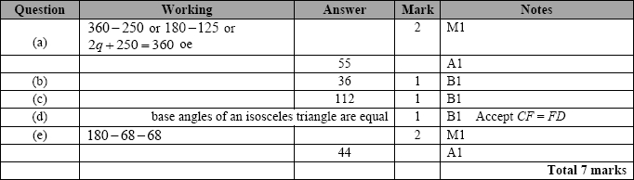

**Q37.**

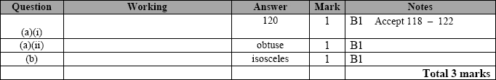

**Q38.**

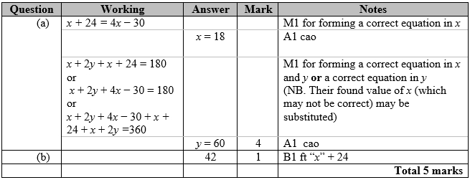

**Q39.**

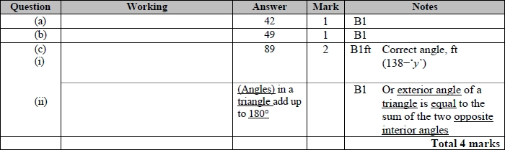

**Q40.**

