

**Marking Scheme**

**Straight Line Graphs and Equations**

Q1.

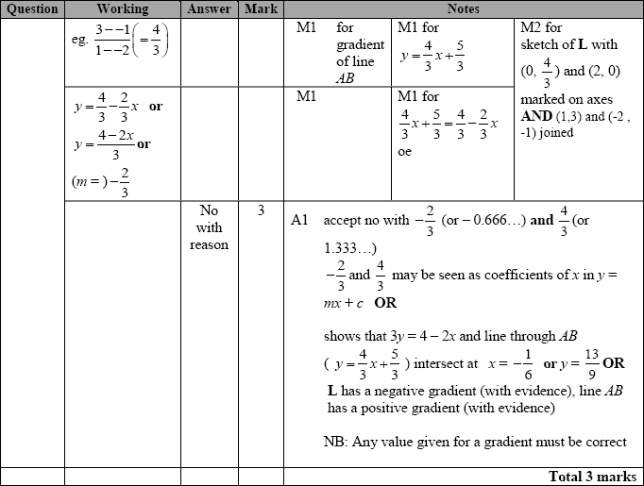

**Q2.**

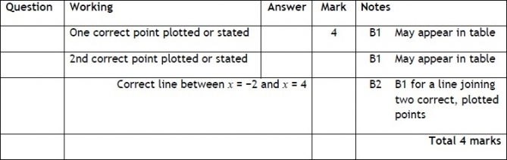

**Q3.**

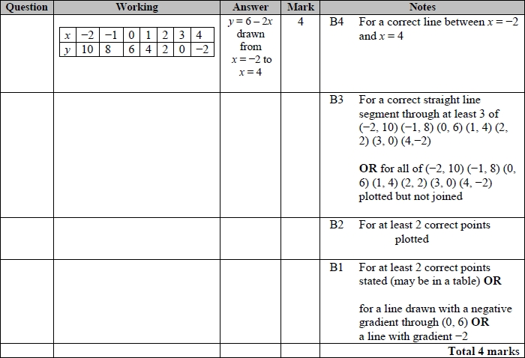

**Q4.**

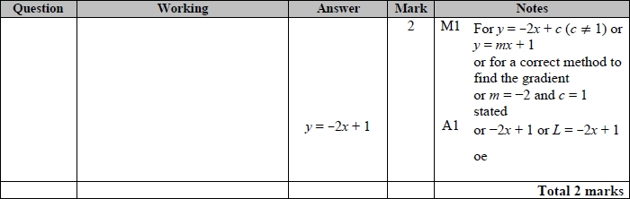

**Q5.**

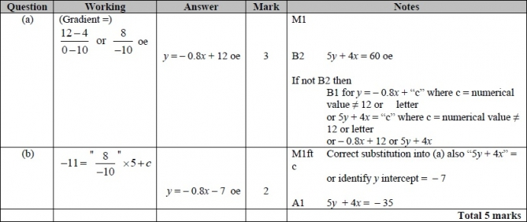

**Q6.**

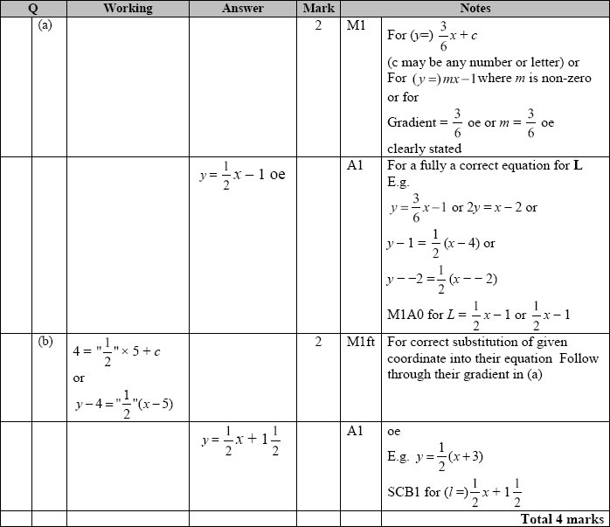

**Q7.**

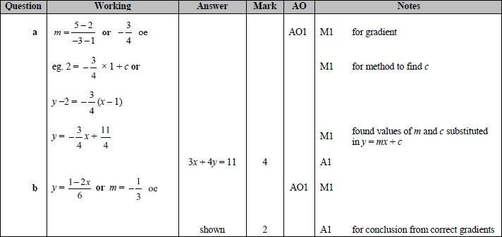

**Q8.**

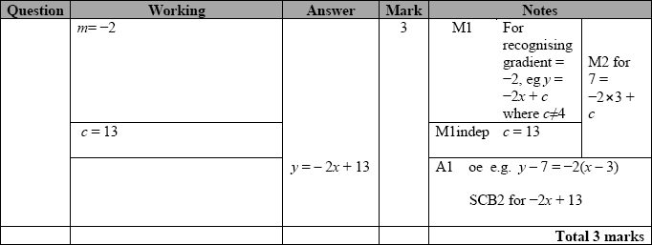

**Q9.**

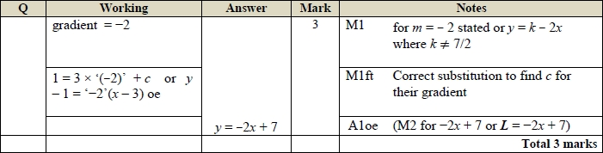

**Q10.**

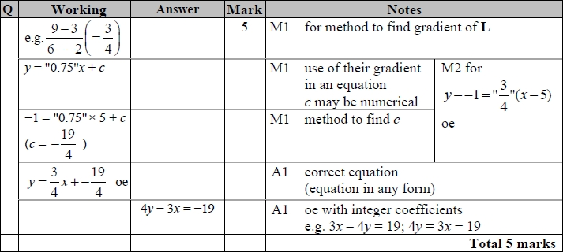

**Q11.**

The correct answer, unless clearly obtained by an incorrect method, should be taken to imply a correct method.

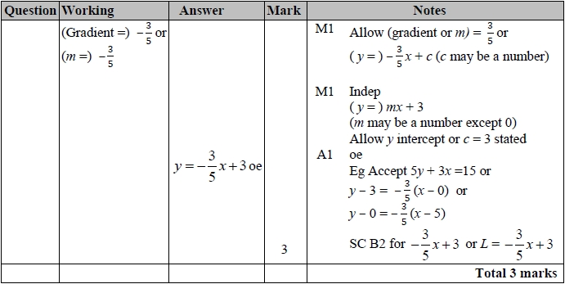

**Q12.**

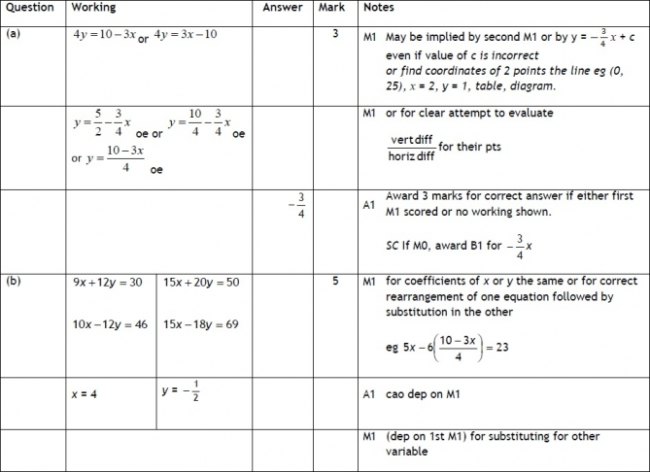

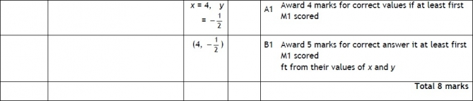

**Q13.**

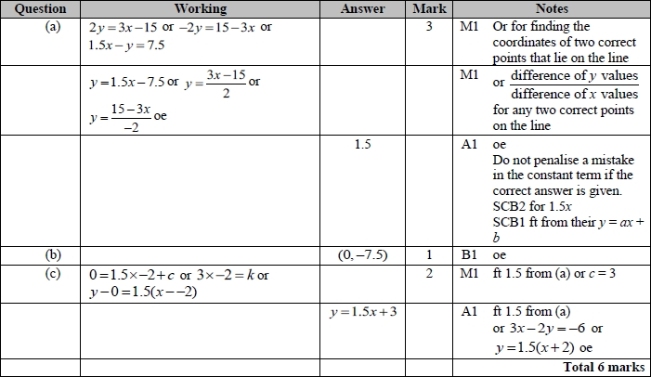

**Q14.**

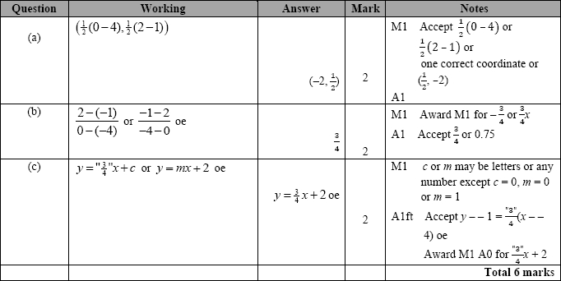

**Q15.**

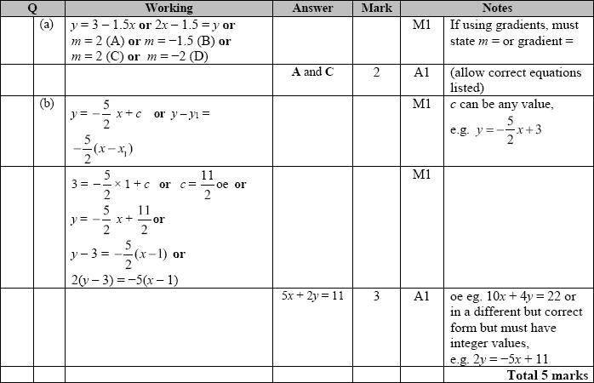

**Q16.**

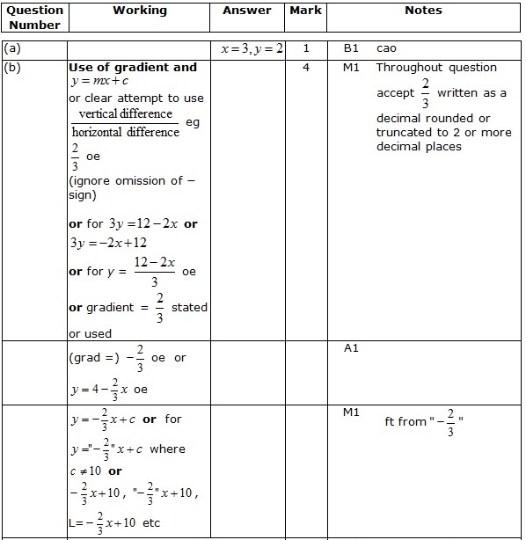  
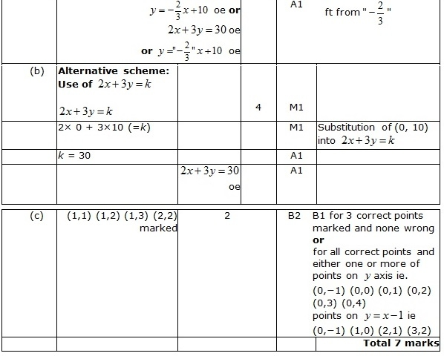

**Q17.**Apart from a, where the mark scheme states otherwise, the correct answer, unless clearly obtained by an incorrect method, should be taken to imply a correct method.

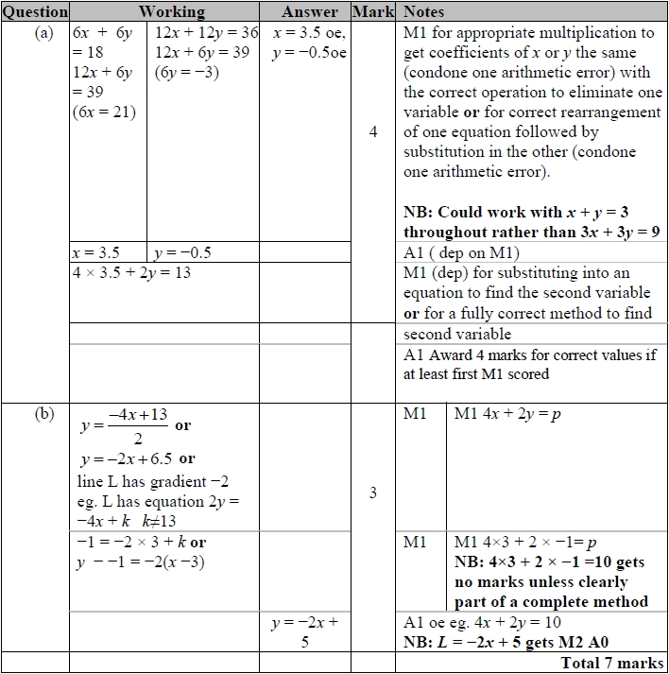

**Q18.**

 