**3.1.3 Bonding**

**Bond** between atoms involves the **outer electrons,** these are called the **valence electrons**. **Noble gases** have a **full** outer main level of electrons and are **very unreactive**. The **forces** that hold atoms together are **attractions between positive and negative charges**. Bonding involves **sharing or transferring** electrons to **achieve a more stable electron arrangement**. This is often a full outer main level, like noble gases.

***Definitions***:

Bonding – **force** **of attraction** between a positive and negatively charged particle

Particle – atom or ions

Structure – **arrangement** of particles

Property – the **behaviour** of the substance – **explained by the structure and bonding**

Lattice – **regular** **repeating** structure

Giant – **large**

Molecule – small group of **atoms covalently bonded**

**Types of chemical bonds:**

* Ionic
* Covalent
* Metallic

***Starter: 3.1.3 – Which type of chemical bond***

**Physical properties of materials:**

* *Melting and boiling points* – the temperature at which a state change occurs, these are determined by the **strength of the attraction** between the particles, the **stronger the bond** the **higher** the melting and boiling point.
  + Melting point & freezing point occur at the same temperature
  + Boiling point & condensing point occur at the same temperature
* *Electrical conductivity* – a substance will conduct electricity if it has **charged particles** that are **able to move** such as ions or delocalised electrons.
* *Solubility* – how soluble a substance is in a solvent **depends on the type of particles** that it contains and whether the solvent is able to overcome the forces of attraction between the particles to separate the particles in the substance.

**Ionic**

Bonding

Ionic bonds form between **metals** and **non-metals** atoms when there is a **transfer** of **electrons**. Ionic compounds have **strong electrostatic attractions** between **oppositely charged ions**. Ionic crystals are giant lattices of ions.

Structure

|  |  |
| --- | --- |
| * **positive ion** formed when **metal** atom **loses electron(s)** * **negative ion** formed when non-metal atom **gains electron(s)** * oppositely charged ions attracted by **electrostatic force** * attraction spreads throughout compound forming a **giant lattice** * ions with same charge repulsion – the giant lattice allows repulsive and attractive forces to balance. |  |

Dot & cross diagrams

**Example: Sodium chloride** Formula: NaCl

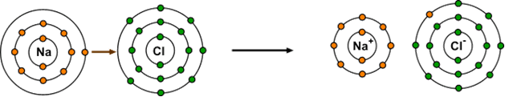

|  |  |  |  |  |
| --- | --- | --- | --- | --- |
| Atoms  Na  1s22s22p63s1  [Ne] 3s1 | Cl  1s22s22p63s23p5  [Ne] 3s23p5 | Na → Na+ + e-  Cl + e- → Cl- | Ions  Na+  1s22s22p6  [Ne] | Cl-  1s22s22p63s23p6  [Ar] |

***Starter: 3.1.2 - Ionic dot and cross***

Ionic charges from the periodic table

For **simple ions** their **charge** can be worked out from their **position on the periodic table**. Elements in the **same group** will have the **same charge** because they have the **same number of valence electrons**.

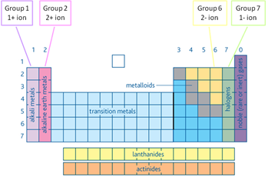

There are also ions made up of **groups of atoms**, these are called **compound ions** and the ionic formula of the common ones **must be learnt**.

|  |  |
| --- | --- |
| **Compound ion** | **Ionic formula** |
| Ammonium | NH4+ |
| Hydroxide | OH- |
| Nitrate | NO3- |
| Carbonate | CO32- |
| Sulphate | SO42- |

**Formula**

In ionic compounds the **positive charges balance** the **negative charges** exactly so the **overall charge is zero**. The **formula** shows the **simplest ratio of ions**.

**Example: Sodium chloride**

|  |  |
| --- | --- |
|  | ***Video: NaCl formation*** |

* Each Na+ surrounded by 6 Cl-
* Each Cl- surrounded by 6 Na+
* **6:6 co-ordination** – co-ordination number is 6
* **1:1 ratio**
* Formula is **NaCl.**

Properties

The **physical properties** of ionic compounds are determined by the type of bond and their structure.

|  |  |
| --- | --- |
| **Properties** | **Reasons** |
| *Melting point*  High  Solids at room temperature  ***Demo: Heating NaCl*** | Lattice of ions **held** by **strong electrostatic force**  **A lot of energy** is required **to overcome** the **forces**. |
| *Hardness/strength*  Hard but brittle    ***Demo: NaCl in pestle & mortar*** | Lattice of **alternating positive & negative ions.**  If **hit** an ionic crystal the ions **move** & produce **contact between ions of the same charge**, there is **repulsion** and so it **breaks.** |
| *Electrical conductivity*  Good conductor when molten or dissolved in water    ***Demo: Conductivity solid NaCl & solution*** | When **solid** the **ions** are **fixed** in position but when they are **liquid** or in a **solution** they are **free to move** and **carry** the **current** through the **movement of ions towards** the **electrode** of the **opposite charge**. |
| *Solubility*  Soluble in water (polar solvent)    ***Demo: NaCl dissolving*** | The **ionic lattice must be broken up**. The solvent molecules cluster around the ions so that the **negative polar ends** of the solvent **surround the positive ions** and the **positive polar** **ends surround the negative ions**. Then the ions are separated within the solution. |

***CGP72 PQ1-4***

***Fact recall: CGP72 Q1-6***

**Covalent**

Bonding

**Non-metal** atoms need to receive electrons to fill their outer shells, so covalent bonds formed when **orbitals**, each **containing one electron, overlap**. This forms a region in space where a **shared pair** **of electrons** can be found.

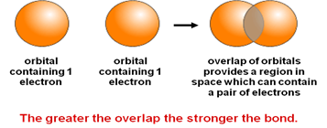

A covalent bond is a **pair of shared electrons**

**Electrostatic attraction** between **positive nucleus** and **shared electrons** - resists separation - forces are balanced when nuclei are a particular distance apart.

Structure of simple molecules

These are compounds made of **lots of individual molecules**. They are also called **molecular**. They have this structure:

* **Atoms within** molecules bonded **very** **strongly**
* Molecules not strongly bonded – held by **weak intermolecular forces**

|  |  |
| --- | --- |
| **+**  **+** |  |
|  |  |

* Covalent bonds are possible between the **same atoms** or **different** ones.
* **Single, double or triple** covalent bonds can exist between atoms.

Dot & cross and stick diagrams

**Examples: CGP73 - Single bonds**

* Hydrogen H2 H-H
* Water H2O un-bonded pair electron – 2 lone pair
* Ammonia NH3 un-bonded pair electron – 1 lone pair

|  |  |  |
| --- | --- | --- |
| Bonding - Tuition (shಥ)² |  |  |
|  |  |  |
|  |  |  |

**Examples: CGP73 - Double & triple bonds**

* Oxygen O2 double bond (2 pairs i.e. 4 electrons)
* Nitrogen N2 triple bond (3 pairs i.e. 6 electrons)

|  |  |  |
| --- | --- | --- |
| Bonding in oxygen. Two oxygen atoms each share two electrons |  |  |
| nitr |  |  |

***Starter: 3.1.1 - Covalent dot and cross***

The formulas of covalent molecules need to be learn.

***Activity: What covalent molecule am I?***

Co-ordinate bond or dative covalent bond

A single covalent bond consists of a pair of electrons shared between two atoms. In most each atom provides one of the electrons. But in some **one atom provides both of the electrons**. The **donor atom** must have a **lone pair of electrons** and the **receiving atom** does not have a fill outer shell of electrons, it is **electron-deficient**. Once the bond is formed it is **identical** to a covalent bond in strength and length.

***Definition***: Co-ordinate or dative bond – both electrons originate from same atom

This type of covalent bond is shown on a diagram with an **arrow**.

**Example: CGP75 – Ammonium ion**

The **ammonium ion** is formed by a **co-ordinate bond** between **ammonia** (which donates a pair of electrons) and a **hydrogen ion** (which is electron-deficient). The ammonium ion formed is covalently bonded but is a charged particle, **NH4+**.

|  |  |
| --- | --- |
| Description: NH4+g |  |

**Example: CGP76 – Hydronium ion**

The **hydronium ion** (**H3O+**) is formed when water reacts with a hydrogen ion. The **hydrogen ion receives** a **lone pair** of **electrons** **from the oxygen atom** on the water molecule, forming the **dative bond**.

|  |  |
| --- | --- |
| Formation of a coordinate covalent bond in the hydronium ion | 3D diagram showing the pyramidal structure of the hydroxonium ion |

***Task: Draw the stick diagram of ammonia bonding with boron trifluoride***

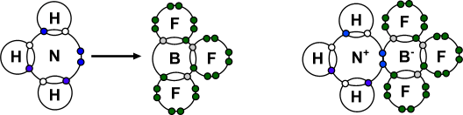

***Starter: 3.2.1 – Co-ordinate bonding***

***CGP76 PQ1***

***Fact recall: CGP76 Q1-3,6,7***

Properties

The sharing of electrons and the weak intermolecular forces give simple covalent molecules **different physical properties** to ionic compounds.

|  |  |
| --- | --- |
| **Properties** | **Reasons** |
| *Melting & boiling point*  Low  Liquids or gases at room temperature  ***Demo: Kettle boiling***  ***Analogy: Throw H2O molymods*** | **Weak forces** of attraction between molecules.  So **little energy** **needed** to move apart. |
| *Electrical conductivity*  Do not conduct electricity  ***Demo: Conductivity ethanol*** | **No free moving charged particles** – no free moving ions or electrons to carry the charge. Some covalent molecules form ions when dissolved in water and so will conduct in solution. |
| *Solubility*  Dissolve in water depending on how polarised the molecules are, many are insoluble in water but will dissolve in a non-polar solvent  ***Demo: Oil & ethanol in water*** | Due to polarisation of molecules intermolecular forces can form between the molecule and the solvent so it dissolves. |

***Activity: What covalent molecule am I?***Molecular crystals

Molecular crystals consist of **molecules** **held** in a regular array by one or more **intermolecular** **force**. **Covalent bonds** within the molecules **hold the atoms** but do not act between the molecules.

**Example - Iodine**

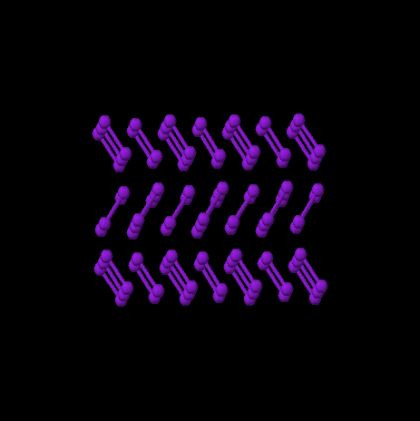

There is a **strong covalent bond** hold the **iodine atoms in pairs**. So it forms a **di-atomic** molecule with the formula **I2**. There are weak intermolecular forces (van der Waals’ forces) holding the molecules together as a solid.

|  |  |
| --- | --- |
| **Properties** | **Reasons** |
| *Melting & boiling point*  Low (114oC)  Iodine sublimes (solid to gas)  ***Demo: Heating iodine*** | **Weak forces** of attraction between molecules. So **little energy** **needed** to move apart. |
| *Hardness/strength*  Crystals soft and break easily  ***Demo: Iodine in pestle & mortar*** | **Weak forces** of attraction between molecules **easily broken.** |
| *Electrical conductivity*  Does not conduct electricity | **No free moving charged particles**. |
| *Solubility*  Insoluble in water | Non-polar molecule. Covalent **bonds too difficult to break** to separate the atoms. |

Structure of giant molecules

**Giant covalent structures** are a **type of crystal** structure. They are a **large network** of covalently bonded **non-metal atoms**, either the **same** atoms or **different** ones forming a **giant lattice**. They are can also be called **macromolecular**. The covalent bonds extend throughout the structure and so they have **typical properties of a giant structure** held by **strong bonds**.

**Examples: Diamond, Graphite & Fullerene**

Diamond, graphite and fullerenes form giant structures with **covalent bonds between every atom**. They all consist of pure **carbon** so are referred to as **allotropes** or **polymorphs**. They have **different properties** because their **atoms are arranged differently**.

**Diamond**

Structure:

Each carbon atom has 4 outer electrons and forms **4 single covalent bonds** with other carbons atoms. The electron bonding pairs repel each other giving a **tetrahedral** shape with bond angles of **109.5o**

|  |  |  |
| --- | --- | --- |
| http://www.morganrockhill.com/NewFiles/iDiamond_P.jpg |  |  |

|  |  |
| --- | --- |
| **Properties** | **Reasons** |
| *Melting point*  Very high (sublimes at 3642°C)  ***Analogy: Scaffolding*** | **A giant lattice structure.**  **All** **atoms** in held by strong **covalent bonds,** all bonds need to be broken to melt. |
| *Hardness/strength*  Very hard & strong | **Giant 3 dimensional lattice** of strong covalent bonds.  Useful as cutting tools. |
| *Electrical conductivity*  Non-conductor | Electrons are held in localised bonds so **no free moving charged particles**. |
| *Thermal conductivity*  Good | **Vibrations travel easily** through the stiff lattice. |
| *Solubility*  Insoluble in water | Covalent **bonds too strong to break** to separate the atoms. |

**Graphite**

Structure:

It consists of 2 types of bonds; strong covalent bonds and weaker forces. Each carbon atoms forms **3 single covalent** bonds to other carbon atoms and so forms a **trigonal planar** (flat) arrangement, with bond angle of **120o**. Each carbon atom has an **unbonded electron** in a p-orbital which merge at the above and below the plane of the rings giving rise to **delocalised** electrons. This produces a **2-dimentional** layer of linked **hexagons** of carbon atoms joined with strong covalent bonds, each **layer** of graphite is a **macromolecule.** The **layers** are **held** by weaker **intermolecular forces** (van der Waal’s).

|  |  |  |
| --- | --- | --- |
| http://z.about.com/d/geology/1/0/4/F/graphite.jpg |  |  |

|  |  |
| --- | --- |
| **Properties** | **Reasons** |
| *Melting point*  Very high (sublimes at 3642°C)  ***Demo: Red hot carbon*** | **Giant lattice structure.**  **All** **atoms** in each plane held by strong **covalent bonds,** all bonds need to be broken to melt.  Useful as electrodes in electrolysis – won’t melt. |
| *Hardness/strength*  Soft and flaky  ***Demo: Pencil/graphite on paper*** | **Weak intermolecular forces easily broken** so the layers slide off.  Useful as a dry lubricant. |
| *Electrical conductivity*  Conducts  ***Demo: Graphite conducting*** | **Delocalised electrons** free to **move** **along** **layers** (not at right angles).  Useful as electrodes in electrolysis. |
| *Density*  Low | The **layers** are quite **far apart**.  Useful for strong lightweight sports equipment. |
| *Solubility*  *Insoluble in water* | Covalent **bonds too strong to break** to separate the atoms. |

A new material called **graphene** consists of a single layer of hexagonally arranged carbon atoms; possible uses for it are as a super conductor.

**Other allotropes** (same element but a different structure)

|  |  |  |
| --- | --- | --- |
| A number of other forms of carbon have been discovered fairly recently. They have a closed cage structure either in the shape of a sphere or a tube. | http://upload.wikimedia.org/wikipedia/commons/thumb/4/41/C60a.png/170px-C60a.png |  |
|  | Buckminster fullerene: C60 | Nanotube |

***CGP76 PQ2***

***Fact recall: CGP76 Q4,5***

**Metallic**

Bonding

Metals are **elements** made up of atoms that can **easily** **lose** up to three **outer electrons**, leaving a **positive ion** (**cation**). They can’t transfer the electrons unless there is a non-metal atoms present. So the **outer main energy levels** of the atoms **merge**, resulting in the outer electrons no longer associated with one atom. The **electrons become delocalised** (sometimes referred to as a **‘sea** **of** **electrons’**) and the **metal atoms become positive** **ions**. The positive ions are **prevented from repelling** each other and are **held** together **by** the **electrostatic attraction** between cations and the delocalised electrons.

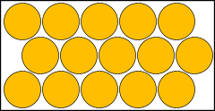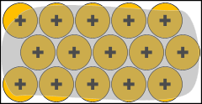

The **number of delocalised electrons** depends on the **number of electrons** been **lost** from each metal atom. The **formula of metals** is always the **element symbol**.

|  |  |
| --- | --- |
| **Magnesium**  **Mg** |  |

Structure

***Demo: Model metal structure & marbles***

***Demo: Displacement – copper wire & silver nitrate solution***

* Metallic bonding spreads throughout metal to form a **giant metallic lattice.**
* They have a **crystal structure.**
* The positive metals **ions embedded in** a sea of **delocalised electrons** creates an attraction of positive and negative particles **throughout the crystal**.
* The ions are **closely packed**; each has 6 neighbours in the plane; 3 above and 3 below.

**Strength of the metallic bond**

The **strength** of the metallic bond is dependent on **size of the atom, nuclear charge** andnumber of **outer electrons** donated to the electron cloud.

* The size of ion – with **smaller cations** the **delocalised electrons** are **closer** **to** the positive **nucleus** and the metallic bond strength **increases.**
* The charge of ion – the **greater the charge** of the cation, the **greater the number of delocalised electrons** and the **stronger the electrostatic attraction***.*

**Example: Lithium, sodium and magnesium**

Lithium and sodiumare soft metals that can be easily cut. Whereas magnesium cannot as it has a greater number of electrons with each atom donating 2 electrons to the delocalised electron cloud.

|  |  |
| --- | --- |
| Li & K | Mg |
| metal4 | metal3 |

***Rich question: Which metals have the highest and lowest melting points – sodium, potassium, magnesium – explain your reasoning?***

Properties

|  |  |  |
| --- | --- | --- |
| **Properties** | | **Reasons/structure** |
| *Melting point*  High  Solids | **A giant lattice structure.**  **Strong attraction** between **positive ions** and **delocalised electrons.**  The strength of the metallic bond affects the melting point. | |
| *Strength*  Strong  Alloys are stronger  ***Demo: Marbles*** | **Strong** electrostatic **forces throughout** the **metal lattice.**  Different size metal atoms stop ions sliding.  See above for differences in strength. | |
| *Ability to shape*  Malleable & ductile  ductile | Planes of **ions slide** over each other.  After it has changed shape each cation is still in the **same environment** as it was before so the **strength** of the metallic **bond** is **unaffected**. | |
| *Electrical conductivity*  Good – solid and liquid  metcond | Delocalised electrons are **free to move** **throughout the metal** and **carry the current**.  Electrons are attracted to the positive electrode (anode) and are replaced by those entering from the negative electrode (cathode). | |
| *Thermal conductivity*  Good | Delocalised electrons **pass on kinetic energy** to each other. | |
| *Solubility*  Insoluble in water but can dissolve in liquid metals | Metallic **bonds too difficult to break** to separate the atoms. | |
| *Metallic lustre*  Shiny | Delocalised electrons **reflect photons of light.** | |

***Video: Bonding***

***Starter: 3.1.4 – Bonding summary***

***Starter: 3.3 – Properties and bonding***

***Activity: Identify the structure?***

***Sheet: The nature of bonds***

***Sheet: The truth about structure & bonding***

***Sheet: So you think you understand bonding***

***CGP92 PQ1-3***

**Types of crystals**

***Demo: Sodium chloride, copper sulphate, copper wire & silver nitrate solution, metal, diamond, graphite, sulphur crystals, iodine***

**Crystals are solids**. The **strength** of the **forces** of **attraction** between the particles in the crystal **affects the physical properties** of the crystals. Crystals can be **classified** **according to the type of bonding** between the particles:

* Ionic
* Metallic
* Macromolecular
* Molecular

***Sheet: Crystal types***

***CGP95 PQ1-2***

***Fact recall: CGP76 Q1-3***

**Polarisation**

Polarisation of bonds occurs because of the nature of different atomic nuclei and their ability to attract electrons. In **ionic** compounds there is a **complete transfer** of electrons from one atom to another, the electrons are **not shared equally**. Even in **covalent** bonds the **electrons** shared may **not be evenly spread** between the atoms. One of the atoms may be **better at attracting** the electrons than the other, that atom is **more** **electronegative**. The electrons around an atom are considered as clouds of **electron density** and the term **electron density** is sometimes used to describe the distribution in a molecule.

Electronegativity

The ability to attract the electron density in a covalent bond is called **electronegativity**.

***Definition***: Electronegativity – ability of an atom to **attract bonding electrons** in a covalent bond

It is measured on the **Pauling** scale (0-4), the **higher** the number the **better** an atom is able to attract the bonding electrons.

Electronegativity depends on:

* **Nuclear charge**
* **Distance** between the nucleus and the outer electrons
* **Shielding** of the nuclear charge by electrons on the inner shells

|  |  |
| --- | --- |
| The **smaller** the atoms the **closer the nucleus** is to the shared **outer electrons** and the **greater** the **electronegativity**. | FG09_38 |

***Task: Identify which atoms which will have the greatest electronegativity***

|  |  |
| --- | --- |
| Description: FG10_02 | Top right-hand most electronegative.  Going up a group and across a period the electronegativity increases as the size of the atom decreases and nuclear charge increases. |

**Electronegativity increases:**

* up a group – atoms get smaller – less shielding
* across a period – nuclear charge increases – same shielding

|  |  |
| --- | --- |
|  | The most electronegative atoms are at the top right had side of periodic table with **nitrogen, chlorine, oxygen and fluorine being the most electronegative**. |

Polar covalent bonds

**Polarity** is a property of the bond and describes the **unequal sharing of electrons** between atoms that are covalently bonded. **Polarity** of a bond measured in **debye**.

Atoms with the **same or similar electronegativity** will attract the **electrons pair equally** towards themselves, so **will not have polar bonds**.

**Example: Hydrogen- hydrogen bond**

|  |  |
| --- | --- |
|  | Any element bonded to itself will be **non-polar** because the atoms have the **same electronegativity** |

**Example: Hydrogen-carbon bond**

|  |  |
| --- | --- |
|  | Carbon and hydrogen have **similar electronegativities** (C = 2.5, H = 2.1) so the bond is **non-polar**. |

Atoms **differing in electronegativity** will have an **uneven distribution** of the electron cloud, the shared electrons will be **displaced towards more electronegative atom**.

|  |  |
| --- | --- |
|  | This creates an electric ‘**dipole’** which is permanent and the **bond** is **polar**. The greater the difference in electronegativity the more polar the bond will be. |

This difference in electronegativity is shown on the atoms using a partial charge:

* **Less electronegative** atom is **slightly electron-deficient** δ+
* **More electronegative** has a slight **excess electron density** δ-

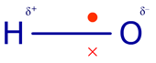

|  |  |
| --- | --- |
| Molecules with a **permanent dipole** are called **polar molecule;** it is also dependent on the overall **molecule shape**.  A **permanent dipole** is shown with an **arrow** like this, indicating the **direction** of the dipole. |  |

***Demo: Polarity water – comb***

***Prac: Intermolecular forces***

More complicated molecules may have **several polar bonds**. The **shape** of the molecule will **determine** if there is an overall **permanent dipole** in the molecule. If the bonds are arranged **symmetrically** the **dipoles** will **cancel** each other out and there will not be a permanent dipole and the molecule will be **non-polar**.

**Example: Carbon dioxide**

|  |  |
| --- | --- |
|  | The **polar bonds** are arranged **symmetrically** so the **dipoles cancel** each other out. |

**Example: Water**

|  |  |
| --- | --- |
|  | The **polar bonds** are arranged **asymmetrically** so the **dipoles** are in the **same direction** resulting ina **permanent dipole** and a **polar molecule.** |
| ***Video: Polarity water*** | <https://www.youtube.com/watch?v=8RSDK17lnUc> |

Atoms with the **greatest difference in electronegativity** are **100% ionic** because one **atom completely attracts** the **electron** to itself. Very polar bonds have some ionic properties. It’s also possible for some ionic compounds to have covalent properties.

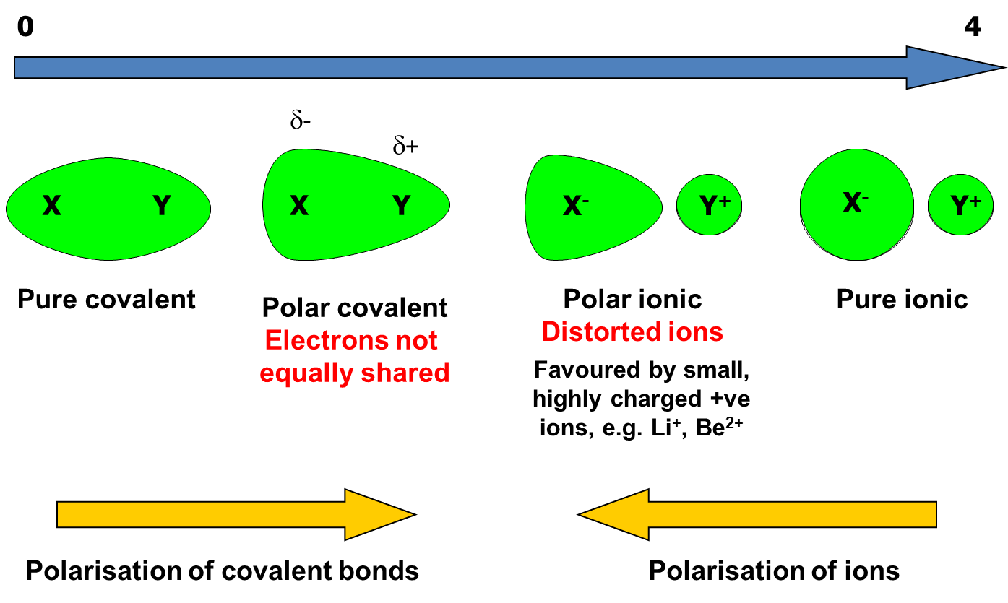

***Starter: 3.2.2 - Electronegativity and polarity***

***Sheet: Bond polarity***

***CGP85 PQ1-2***

***Fact recall: CGP85 Q1-3***

**Intermolecular forces**

**Atoms** in molecules and in giant structure are **held** together by **strong covalent bond, ionic or metallic bonds**. **Simple molecules** and **separate** **atoms** are **attracted** to each other by **weaker** forces called **intermolecular forces**. (‘inter’ means between)

3 types intermolecular forces, in **order of strength**:

* **van der Waals’** – between all atoms and molecules and are in addition to other forces

weakest

strongest

* **permanent dipole-dipole** – between polar molecules
* **hydrogen bonding** – between molecules containing hydrogen bonded to N, O or F

The relative strength of intermolecular forces

The strength of intermolecular forces is determined by these factors:

* **Type** of intermolecular force
  + General rule: van der Waals’ < dipole-dipole < hydrogen bonds
* **Size** of molecule (number of electrons)
* **Shape** of the molecule (branched chains)

The **strength** of the **intermolecular forces** determines the **melting** and **boiling point**. The **weaker** the intermolecular forces the **lower** the melting and boiling point.

However, **larger molecules** with only **van der Waals’ forces** between them **can have higher boiling points** than **smaller** **molecules** with **dipole-dipole forces** between them.

Van der Waals’ forces

All atoms and molecules are made up of **positive and negative charges** even though they are **neutral overall**. The **electron clouds** are always **moving** very quickly, so at any particular moment in time the electrons in an atom can be **more to one side** than the other. This gives the atom a **temporary dipole**. This **dipole** can then **attract** the electron cloud in **neighbouring atoms**, causing another temporary dipole. These **temporary dipole-induced dipole attractions** continue with all neighbouring atoms.

*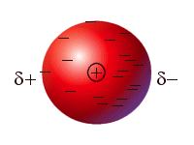*

They then produce **very weak electrostatic attractions** between the slightly positive and slightly negative regions of the atom or molecule. These are called **van der Waals’ forces** (after a Dutch scientist called Johannes van der Waals).

The magnitude of the electrostatic attraction depends on:

* **Size** of the atom or molecule, the **more electrons** there are in the electron cloud the **greater** the temporary **dipole** and the **stronger** the **van der Waals’ forces**
* **Shape** of the molecule (branched chained hydrocarbons have weaker van der Waals’ forces than straight chained as they are unable to pack so close).

**Example: Noble gases**

The Noble gases are mon-atomic atoms which are attracted to each other with van der Waals’ forces caused by temporary dipole-induced dipole attractions.

|  |  |
| --- | --- |
| FG12_16 | FG12_17 |

**Example CGP86: Iodine**

Iodine consists of di-atomic molecules, which are held together in a molecular crystal lattice by van der Waals’ forces.

|  |  |
| --- | --- |
|  |  |

***Task: Plot the following boiling points and explain the trends using your knowledge of van der Waals’ forces***

|  |  |
| --- | --- |
| **Noble gas** | **Boiling point / K** |
| Helium | 4 |
| Neon | 24 |
| Argon | 87 |
| Krypton | 120 |
| Xenon | 165 |

|  |  |
| --- | --- |
|  | The atoms get larger, with an increase in the number of electrons down the group. So, the strength of the van der Waals’ forces increases resulting in an increase in the boiling point. |

|  |  |
| --- | --- |
| **Alkane** | **Boiling point / K** |
| Methane | 111 |
| Ethane | 185 |
| Propane | 231 |
| Butane | 274 |
| Pentane | 309 |
| Hexane | 342 |

|  |  |
| --- | --- |
|  | The molecules get larger, with an increase in the number of electrons down the group. So, the strength of the van der Waals’ forces increases resulting in an increase in the boiling point.  Greater surface contact so more van der Waals’ forces between molecules. |

***Stella: Compare the boiling points of the branched alkanes to the straight chained alkanes and explain***

|  |  |  |  |  |  |  |
| --- | --- | --- | --- | --- | --- | --- |
| **Molecular formula** | **Alkane** | **Boiling point / K** | **Branched alkane** | **Boiling point / K** | **Branched alkane** | **Boiling point / K** |
| CH4 | Methane | 111 |  |  |  |  |
| C2H6 | Ethane | 185 |  |  |  |  |
| C3H8 | Propane | 231 |  |  |  |  |
| C4H10 | Butane | 274 | Methylpropane | 260 |  |  |
| C5H12 | Pentane | 309 | 2-Methylbutane | 300 | 2,2-Dimethylpropane | 282 |
| C6H14 | Hexane | 342 | 2-Methylpentane | 335 | 2,2-Dimethylbutane | 322 |

As the branching increased the molecules are unable to pack as closely together and so the strength of the van der Waals’ forces decreased resulting in lower boiling points.

Permanent dipole-dipole forces

These **act between molecules with permanent dipoles**, due to a **difference** in **electronegativity** between the atoms giving **polar covalent bonds**. There are **weak electrostatic forces** between the opposite partial charges on neighbouring molecules.

**Example: Hydrogen chloride**

HCl – chlorine is more electronegative than hydrogen so the electrons are pulled towards the chlorine and the molecule has a dipole. Hδ+ - Clδ-

Two molecules with dipoles will be attracted to each other: Hδ+ - Clδ- ......... Hδ+ - Clδ-

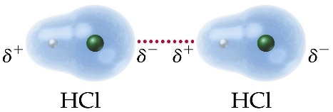

Hydrogen bonding

Hydrogen bonging is the **strongest type of intermolecular force** and is a special type of intermolecular force with some characteristics of dipole-dipole attraction.

It only happens when:

* **hydrogen** is covalently bonded to a **very** **electronegative atom** with a **lone pair of electrons**
* the **electronegative atoms** are **N, O or F**

**Hydrogen** will have a **strong positive partial charge** because attached to a **strongly electronegative** **N, O or F,** which will have a **strongly negative partial charge**. The electrons on the hydrogen atom are so strongly pulled towards the N, O or F atom that the **hydrogen** almost has an **unshielded proton**. Then a **dipole-dipole** attraction, called a **hydrogen bond** forms between the **lone pair** of electrons on the **N, O or F** atom and the **hydrogen atom** of a neighbouring molecule.

The **strength of the hydrogen bond increase when a more electronegative atom** is involved and **more hydrogen bonds** that can form.

**Example: Hydrogen fluoride**

|  |  |
| --- | --- |
| FG12_23 | FG12_23-05f |

**Example CGP89: Ammonia & water**

|  |  |
| --- | --- |
| **Ammonia NH3** | **Water H2O** |
|  |  |

**N.B.** You must be able to draw these accuratly.The **nucleus of the hydrogen** is always **in line** with the **lone pair of the electronegative** atom.

***Starter: 3.2.3 - Intermolecular forces***

***Activity: Intermolecular snap***

***Sheet: Hydrogen bonding questions***

Boiling point of hydrides

Hydrogen bonding has an **effect on the properties** of substances. They cause **higher melting and boiling points** for similar molecules due to the **extra energy needed** to break the hydrogen bonds. Although **hydrogen bonds** are **weak intermolecular forces** they are **strong enough to affect boiling** **points**, this can be seen in the hydrides compounds of elements of group 4, 5, 6 and 7.

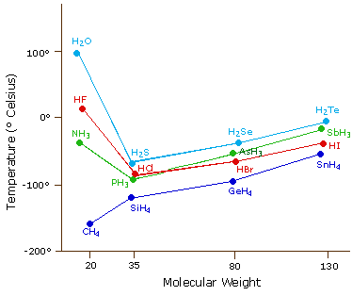

The boiling points of the **group 4 hydrides** (CH4, SiH4, GeH4, SnH4) show a **gradual increase** because the only forces acting between the molecules are **van der Waals’ forces** which **increase** with the number of **electrons**.

Looking at the trend in the hydrides of group 5 (NH3, PH3, AsH3, SbH3), 7 (HF, HCl, HBr, HI) and 6 (H2O, H2S, H2Se, H2Te) show that the **boiling points of water, hydrogen fluoride and ammonia** are all **higher** than those of the hydrides of the other elements in their groups. You would expect it to be lower, like with group 4 hydrides, if **only van der Waals’ forces** were acting upon them. They are higher because **hydrogen bonding** is present, which are **stronger intermolecular forces** and so **require more energy** to break. Only **nitrogen, oxygen and fluorine are electronegative enough** to make hydrogen bonding possible.

***Sheet: Forces between molecules***

***Rich question: Why is there no hydrogen bonding between molecules of HCl gas even though Cl is more electronegative than N yet NH3 has hydrogen bonding?***

The importance of hydrogen bonding

The **effect of hydrogen bonds in molecules can be significant**; they can be broken and re-formed under certain conditions, whereas covalent bonds are unaffected.

|  |  |  |  |
| --- | --- | --- | --- |
| **Ever thought why?** | | | |
| * Ice floats | * Ironing removes creases | * Straighteners remove curls | * Eggs go white when you cook them |
| http://t1.gstatic.com/images?q=tbn:ANd9GcQsJhpqinV5D_buLAW9y4NtF3hEKIlYs_HpxsqexoGpw5S-52gB9w | http://t0.gstatic.com/images?q=tbn:ANd9GcSeYphhMm-Hh16-t8VzJmo89UnL7iIAAHQhmwKQjDLuX5fm8gnF | **https://s3.amazonaws.com/luuux-original-files/bookmarklet_uploaded/Half_curly_Half_straight_gi.jpg** | http://t3.gstatic.com/images?q=tbn:ANd9GcS-7coUZTyK1qPd7KpUqacJ3eXfg6IiJrQL-RAwmRtHtC5d2OH2Zw |

**Structure and density of ice**

When substances change from **a gas to a liquid to a solid** their **density reduces**. This is does not happen when water changes from a liquid to a solid.

***Demo: Ice & olive oil cubes***

***Demo: Density of ice***

When **water** is in its **liquid** state the **hydrogen bonds break and reform** as the molecules move. When water **freezes** the molecules are no **longer moving** so the **hydrogen bonds hold molecules in fixed position**. The resulting 3 dimensional lattice structure is **like diamond**. Since hydrogen bonds are relatively long the **average distance** between molecules of water in the **solid state compare to the liquid state** is **longer** so they are **less packed together.** The water molecules in **ice** are **held further** **apart** than in water; so **occupy more space** and ice is **less dense than water**.

***Demo: Model ice v liquid water***

|  |  |  |
| --- | --- | --- |
|  |  | http://live.kerboodle.com/NT3/NTLS_RootRepository/ContentPackages/91/AQA_AS_CHEMISTRY_Batch_1_Final/product/chem_as_ch03_pg57_fig5.jpg |

***YouTube*** ***– difference in hydrogen bonding water & ice:*** <https://www.youtube.com/watch?app=desktop&v=UukRgqzk-KE>

This is significant because it means that ice forms on the surface of lakes and ponds allowing life to continue underneath. Six water molecules join together to form a hexagonal ring which gives rise to a tetrahedral structure, hence why snowflakes are all

6-sided.

|  |  |  |
| --- | --- | --- |
| A muskie lays under the ice Sunday, one of the thousands of dead fish visible under the frozen surface of Lake Owasso in Shoreview. (Pioneer Press: Chris | http://i276.photobucket.com/albums/kk19/Icemanofcharlotte/Fig2web.jpg | Image result for snowflake |

**Proteins**

**Proteins** are very **important biological molecules** that fulfil a variety of **important functions in living organism**. Their function is dependent on the having an **exact shape**. They are long chain molecules with lots of **C=O and N-H groups**, which can **form hydrogen bonds** between different sections of the protein to hold them in a fixed shape.

The fact that hydrogen bonds are **relatively weak** means that the **shape of the protein** **changes** if it **heated** or the **pH changes** so:

* The heat from straighteners or hair dryers disrupts the hydrogen bonds in hair proteins and it becomes straight.
* A hot iron breaks the hydrogen bonds in clothes fibres and then they reform when iron is removed leaving smooth clothes.
* Proteins become denatured when they are heated.

They form two main shapes: **helix** and **beta-pleated sheet**.

|  |  |
| --- | --- |
| **Helix** | **Beta-pleated sheet** |
| protein 2ndary | http://www.bio.miami.edu/tom/courses/protected/MCB6/ch03/3-05a.jpg |

**DNA**

|  |  |
| --- | --- |
| **DNA** (deoxyribonucleic acid) consists of a **double helix** , each strand is **held by hydrogen bonds**. When cells divide or replicates the **two strands split** into two separate helices by **breaking the hydrogen bonds**. The covalent bonds holding the atoms together don’t break so the separate strands can act as templates for the formation of a new helix. | FG12_22 |

***Activity: What are 'hydrogen bonds' and where are they found?***

***CGP91 PQ1-5***

***Fact recall: CGP91 Q1-5***

**Shapes of simple molecules and ions**

The **outer electrons** in molecules exist in **pairs** either shared in a **covalent bond** or unshared in **lone** **pairs** or **non-bonding pairs** in volumes of space called **charge** or **electron** **cloud**. An **electron cloud** is an **area** where there is a **high chance** of **finding** an **electron**, they are moving all the time. The **shape** of the **electron cloud** depends on whether the electrons are a **bonding** (more **sausage** shaped) or **non-bonding** pair (more **rounded** shaped).

|  |  |
| --- | --- |
| Bonding electron cloud | Non-bonding electron cloud |
|  |  |

***Models: Balloons***

**Example CGP77: Ammonia**

**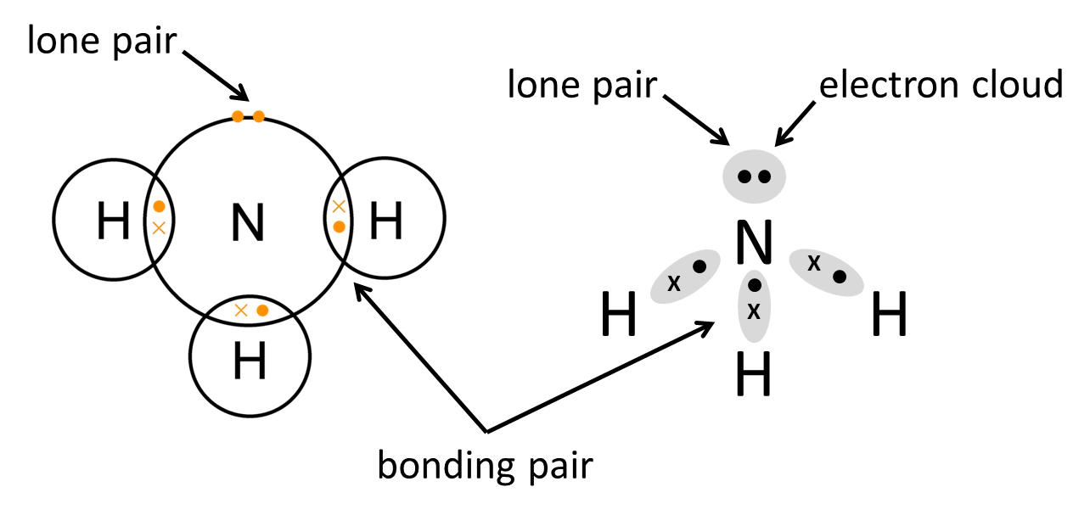**

The **shape** of a simple covalent molecule or ion **depends** on number of **pairs of electrons** in the **outer shell** of the **central atom** and can be predicted by using the following ideas:

* Electron pairs may be a **shared pair** forming a covalent bond or a **lone** **pair** (non-bonding)
* Each **pair of electrons** in the **valence shell** (outer shell) around an atom will **repel** all other electron pairs
* **Pairs of electrons** will take up positions around the central atom **as far apart** from each other **as possible** to **minimise repulsion.**

**Lone** **pairs** of electrons are **more compact** than bonding pairs of electrons because the electrons cloud is pulled towards the nuclei of the central atom. They therefore cause **greater repulsion** than bonding pairs of electrons and will **reduce the angle between bonds**.

**Learn this rule**: lone pair-lone pair repulsions are greater than lone pair-bonding pair repulsions which are greater than bonding pair-bonding pair repulsions.

**LP:LP > LP:BP > BP:BP**

This is called **valence shell electron pair repulsion theory (VSEPR).**

The **shape** of a molecule therefore **depends** on the **number** and **type** of **electron pairs** around the central atom.

***Models: Balloons & pipe cleaners***

**Standard shapes**

|  |  |  |  |
| --- | --- | --- | --- |
| Number of **bonding pairs** of electrons | Shape | Bond angle | Diagrams |
| 2 pairs | linear | 180O |  |
| 3 pairs | trigonal planar | 120O |
| 4 pairs | tetrahedral | 109.5O |
| 5 pairs | trigonal bipyramidal | 90O & 120O |
| 6 pairs | octahedral | 90O |

Drawing shapes of molecules

To show a **3-D shape on a 2-D page** is difficult and different types of lines are used:

* Straight line – in the plane of the paper
* Wedge line – pointing out in front of the paper
* Broken line – pointing away from the plane of the paper

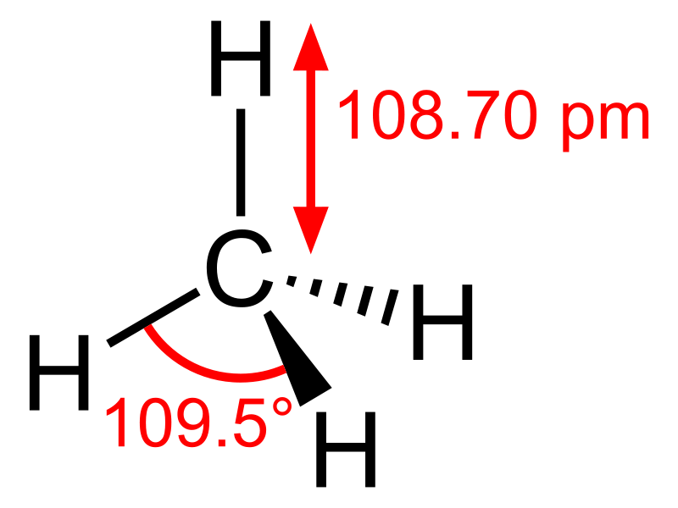

Working out **standard shapes**

To work out the shape of a molecule or ion you need to know how many bonding pairs and lone pairs of electrons there are around the central atom.

* Central atom – count outer electrons
* Bonding atoms – count electrons donated (i.e. 1 per bond)
* Total number of outer electrons
* Total number electron pairs (divide by 2)
* This gives shape and bond angle so electron repulsion is minimised
* Number of bonding electron pairs determines the shape.

***Demo: Molymods – beryllium chloride, boron trifluoride, methane, phosphorus pentachloride, sulphur hexafluoride***

The **shape is determined** by the number of **bonding pairs of electrons**. They want to **minimise repulsion** by being **as far apart** from each other **as possible**.

|  |  |  |  |  |  |
| --- | --- | --- | --- | --- | --- |
|  | **Beryllium chloride\*** | **Boron trifluoride** | **Methane** | **Phosphorus pentachloride** | **Sulphur hexafluoride** |
| **Examples** | BeCl2 | BF3 | CH4 | PCl5 | SF6 |
| **Central atom electrons** | 2 | 3 | 4 | 5 | 6 |
| **Bonding atoms electrons** | 2 | 3 | 4 | 5 | 6 |
| **Total electrons** | 4 | 6 | 8 | 10 | 12 |
| **Electron pairs** | **2** | **3** | **4** | **5** | **6** |
| **Shape** | **linear** | **trigonal planar** | **tetrahedral** | **trigonal bipyramidal** | **octahedral** |
| **Diagram** |  |  |  |  |  |
|  |  |  |  |  |
| **Bond angle** | **180 O** | **120 O** | **109.5 O** | **120 O**  **90 O** | **90 O** |

\*note: covalent in gas phase

This **shape** can be **modified** if **lone pairs** exist or molecule has a **charge**.

Working shapes of molecules with **lone pairs**

Look at the **shape** you would get **if all pairs were bonding** and **replace** one or more **bonding electrons with lone pairs**. Only **describe the shape the bonding pairs** make. There will be **greater repulsion** between any lone pairs and lone pairs-bonding pairs so the bond angles will be reduced.

Remember rule: **LP:LP > LP:BP > BP:BP**

**Lone pairs will distort the shape due to greater repulsion** and **change the bond angle,** every **lone pair will reduce the angle** by approximately **2o**.

The **shape describes** the arrangement of the **bonding pairs of electrons only**, not the lone pairs.

|  |  |  |  |  |
| --- | --- | --- | --- | --- |
|  | **Ammonia** |  | **Water** |  |
| **Examples** | NH3 | Write | H2O | Write |
| **Central atom electrons** | 5 | Electron pairs 4  Directs shape towards tetrahedral  But 1 lone pair & 3 bonding pairs  So shape is **triangular pyramid**  (shape of bonds)  Greater repulsion from lone pairs  So bonding angle is **107o** | 6 | Electron pairs 4  Directs shape towards tetrahedral  But 2 lone pairs & 2 bonding pairs  So shape is  **v-shape**  (shape of bonds)  Greater repulsion from lone pairs  So bonding angle is **105o** |
| **Bonding atoms electrons** | 3 | 2 |
| **Total electrons** | 8 | 8 |
| **Number electron pairs** | 4 | 4 |
| **Types of electron pairs** | **3 x BP**  **1 x LP** | **2 x BP**  **2 x LP** |
| **Order of repulsion** | LP:BP > BP:BP  Bond angle reduces  so bonding pairs closer | LP:LP > LP:BP >BP:BP  Bond angle reduces  so bonding pairs closer |
| **Shape** | **triangular pyramid**  (shape of bonds) | **v-shape or bent**  (shape of bonds) |
| **Diagram** |  |  |
| **Bond angle** | **107 O** | **105 O** |

Working shapes of molecules with **charges**

For **ionic molecules** the total **number of electrons depends** on the **charge**:

* **Positive** ion – **subtract** one electron
* **Negative** ion – **add** one electron

***Demo: Molymods – chlorine tetrafluoride ion***

|  |  |  |  |
| --- | --- | --- | --- |
|  | **Chlorine tetrafluoride ion** | **Boron tetrafluoride ion** | **Ammonium ion** |
| **Example** | ClF4- | BF4- | NH4+ |
| **Central atom electrons** | 7 | 3 | 5 |
| **Bonding atoms electrons** | 4 | 4 | 3 (co-ordinate bond) |
| **Total electrons** | 11  Look for charge  **negative so add 1**  Total = 12 | 7  add 1  Total = 8 | 8  Charge already taken care of with the co-ordinate bond |
| **Number electron pairs** | 6 | 4 | 4 |
| **Types of electron pairs** | **4 x BP**  **2 x LP** | **4 x BP** | **4 x BP** |
| **Shape** | **square planar**  (shape of bonds) | **tetrahedral** | **tetrahedral** |
| **Bond angle** | **90O** | **109.5O** | **109.5O** |
| **Diagram** |  |  |  |

Working shapes of molecules with **multiple bonds**

For molecules with **multiple bonds** each is treated as **if it were a single bond** in order to work out the shape, even though there is slightly ore repulsion between double bonds).

|  |  |  |
| --- | --- | --- |
|  | **Carbon dioxide** | **Sulphur dioxide** |
| **Example** | CO2 | SO2 |
| **Central atom electrons** | 4 | 6 |
| **Bonding atoms electrons** | 4 | 4 |
| **Total electrons** | 8  2 double bonds  so treat as single bonds  so half giving 4 | 10  2 double bonds  so treat as single bonds  so half giving 5 |
| **Number electron pairs** | **2** | **2** |
| **Types of electron pairs** | All bonding | 2 x BP  1 x LP |
| **Shape** | **linear** | **v-shape or bent** |
| **Bond angle** | **180O** | **118O** |
| **Diagram** |  |  |

***Starter: 3.2.4 - Shapes of molecules - whiteboard***

***Sheet: Shapes of molecules & ions***

***Sheet: G&T Shapes of molecules & ions***

***CGP83 PQ1-4***

***Fact recall: CGP77 Q1-3***

***Fact recall: CGP83 Q1-3***

**States of matter**

A key idea in science is that **matter**, everything with **mass**, is made of **particles**. These particles are in **motion**, they have **kinetic energy**. The three states of matter have different arrangements of particles with different amounts of kinetic energy. Moving from one state to another involves changes in energy.

***Task: Complete a table for the 3 states of matter***

***Demo: Sample of crystals, syringes, water in flask & beaker***

|  |  |  |  |
| --- | --- | --- | --- |
|  | **Solid** | **Liquid** | **Gas** |
| **Description of arrangement of particles** | Regular  Held by ionic, metallic, covalent, hydrogen bonds, dipole-dipole forces or van der Waals’ forces | Random | Random |
| ***Evidence*** | *Crystal shapes have straight edges*  *Solids definite shapes* | *None direct but a liquid changes shape to fill the bottom of the container* | *None direct but a gas will fill its container* |
| **Spacing** | Close | Close | Far apart |
| ***Evidence*** | *Solids not easily compressed*  *High density* | *Liquids not easily compressed*  *High density* | *Gases easily compressed*  *Low density* |
| **Movement** | Vibrating about a point | Rapid ‘jostling’  Too close to travel except at the surface | Rapid random movement |
| ***Evidence*** | *Diffusion is very slow*  *Solids expand when heated* | *Diffusion is slow*  *Liquids evaporate* | *Diffusion is rapid*  *Gases exert pressure* |
| **Particle diagram** |  | melting  point | boiling  point |

***Focus eLearning – Particle model:*** <https://www.focuselearning.co.uk/s/75kd57vceeyb>

***Video: Changing states of matter***

**Changing states**

**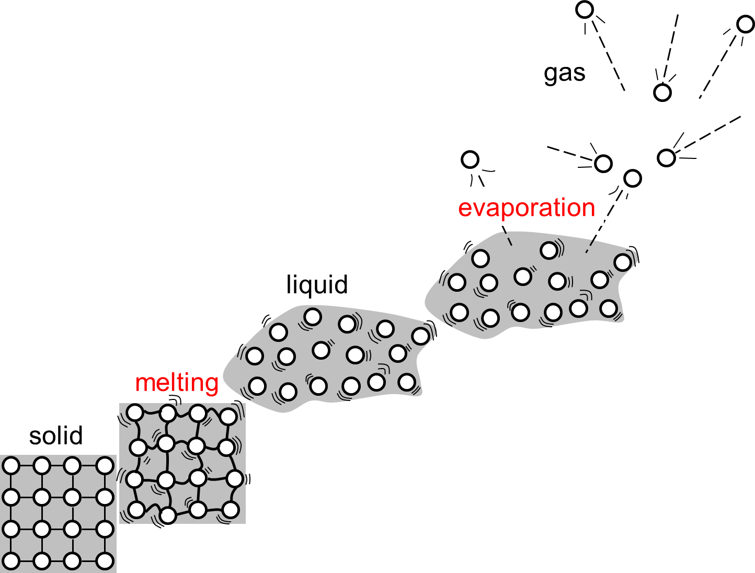**

***Focus eLearning – Changing states:*** <https://www.focuselearning.co.uk/s/ezdw1bq0gte>

**Energy changes on heating**

**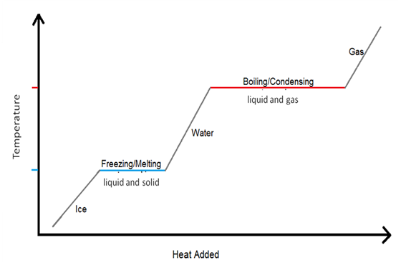**

* During a **change in state** the **temperature is constant** because energy is gained.
* Heat **energy is required to change** solid to liquid at its **melting point**. The energy is used to **loosen** the forces holding the particles and is called **enthalpy of fusion.**
* **More energy required** to change liquid to gas at its **boiling point**. The energy is used to **overcome** **the forces holding the particles** so the particles are **completely separated**. It’s called the **enthalpy of vaporisation.**

***Task: Re-arrange the changing states of matter***

***Sheet: PPQ 1-5***

***Homework: Oxford p71 EPQ1-5***