**A Brief History of the Microscope**

* Microscopy techniques have developed over time, increasing our understanding of cell subcellular structure
* The first **light microscopes** were developed in the 17th Century
* Scientists such as Anton van Leeuwenhoek and Robert Hooke are responsible for using microscopes to develop our first understanding of cells
* Light microscopes use **light and lenses** to form a magnified image of a specimen
* Over the centuries, the design of the light microscope has evolved, **increasing magnification and resolution** to enhance the detail of what can be visualised
* With a light microscope it is possible to see images of **cells and large subcellular structures** (like nuclei and vacuoles), although **stains** are often required to highlight certain parts of cells
* The first **electron microscopes** were developed in the first half of the 20th Century
  + Electron microscopes use **beams of electrons**, rather than light, to visualise specimens
  + The **wavelength** of an electron beam is much **smaller** than that of visible light, which gives electron microscopes a much **higher resolution and magnification**

**Electron Microscopes**

* An electron microscope has much higher **magnification and resolving power** than a light microscope
* They can therefore be used to study cells in much finer detail, enabling biologists to see and understand many more **subcellular structures** such as the **mitochondrion**
* They have also helped biologists develop a better understanding of the structure of the **nucleus and cell membrane**

**Magnification Calculations**

* Magnification is calculated using the following equation:

Magnification = Drawing size ÷ Actual size

* A better way to remember the equation is using an **equation triangle**:

[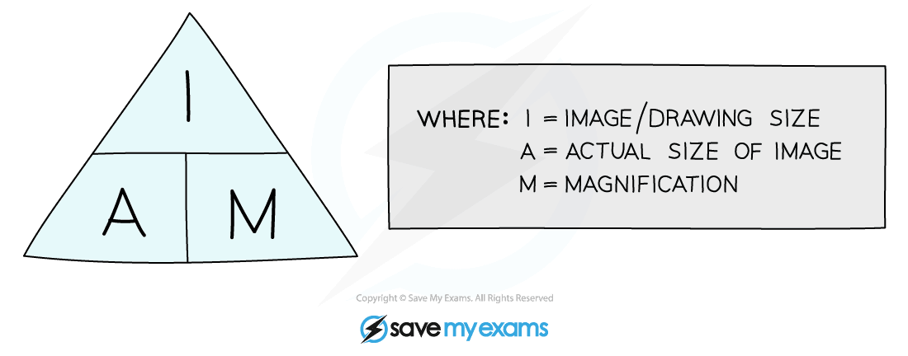](https://cdn.savemyexams.co.uk/wp-content/uploads/2020/01/Magnification-Equation.png)

***An equation triangle for calculating magnification***

* Rearranging the equation to find things other than the magnification becomes easy when you remember the triangle – **whatever you are trying to find, place your finger over it and whatever is left is what you do**, so:
  + Magnification = image size / actual size
  + Actual size = image size / magnification
  + Image size = magnification x actual size
* Remember magnification **does not have any units** and is just written as ‘X 10’ or ‘X 5000’

**Worked example**

An **image** of an animal cell is 30 mm in size and it has been **magnified** by a factor of X 3000. What is the **actual** size of the cell?

To find the **actual** size of the cell:

[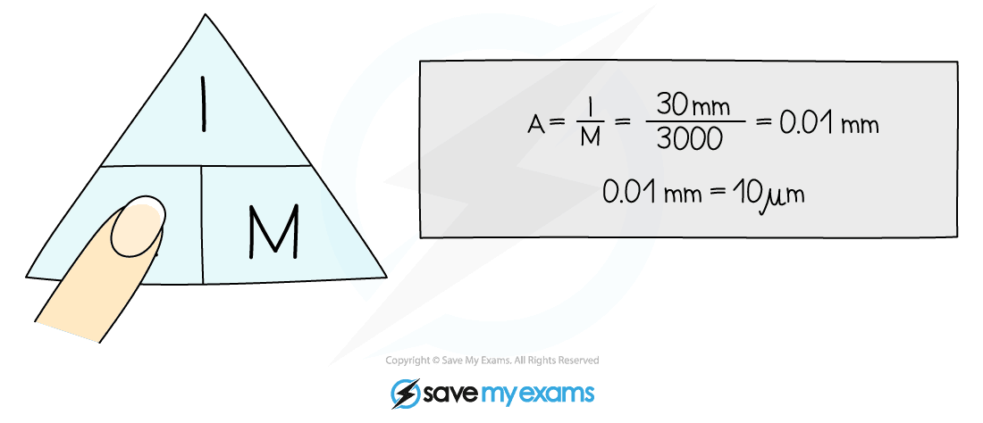](https://cdn.savemyexams.co.uk/wp-content/uploads/2020/01/Worked-Example-Using-Magnification-Equation.png)

***Worked example using the equation triangle for magnification***

**Exam Tip**

It is easy to make silly mistakes with magnification calculations. To ensure you do not lose marks in the exam:

* **Always look at the units** that have been given in the question – if you are asked to measure something, most often you will be expected to measure it in millimetres NOT in centimetres – double-check the question to see!
* **Learn the equation triangle** for magnification and always write it down when you are doing a calculation – examiners like to see this!

**Converting Units**

* You may be given a question in your Biology exam where the measurements for a magnification calculation have **different units.**You need to ensure that you **convert them both into the same unit** before proceeding with the calculation (usually to calculate the magnification)
* For example:

[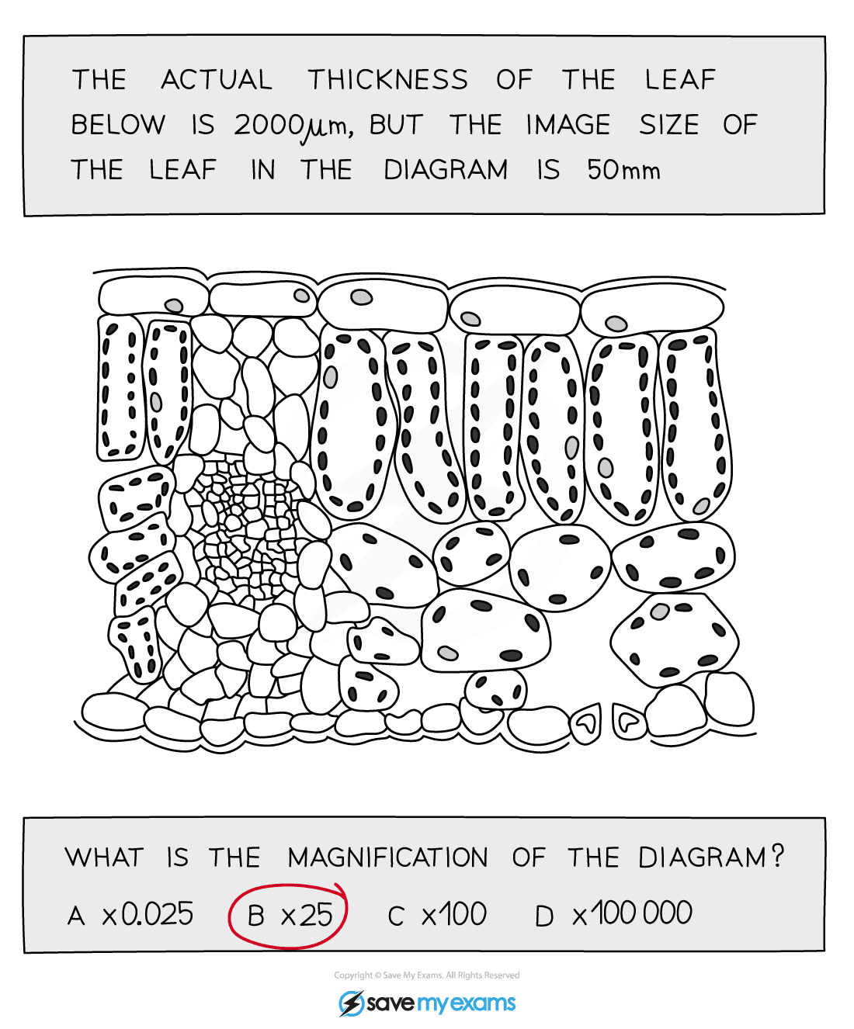](https://cdn.savemyexams.co.uk/wp-content/uploads/2020/01/Example-extended-magnification-question.png)

***Example of an extended magnification question***

* Remember that 1mm = 1000µm
* 2000 / 1000 = 2, so the actual thickness of the leaf is 2 mm and the drawing thickness is 50 mm
* Magnification = image size / actual size = 50 / 2 = 25
* So the magnification is x 25

**Exam Tip**

If you are given a question with **2 different units** in it, make sure you make a conversion so that **both** measurements have the **same** unit before doing your calculation. Also, watch out for the units you are given in the answer-prompt space.

Remember the following to help you convert between mm and µm:

[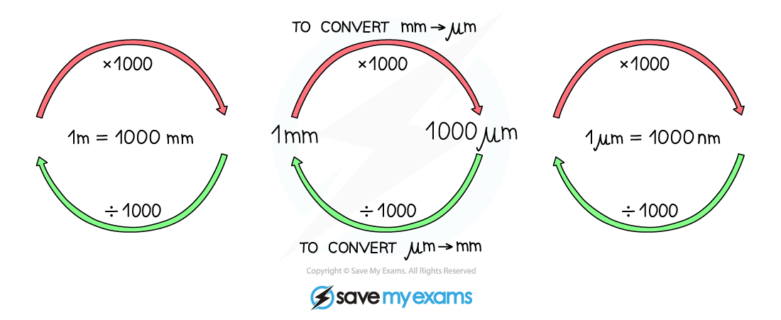](https://cdn.savemyexams.co.uk/wp-content/uploads/2020/06/1.1.1.-Converting-Units-AQA.png)

**REQUIRED PRACTICAL: Using a Light Microscope**

* Aim: To use a light microscope to observe, draw and label a selection of plant and animal cells, including a magnification scale
* You will:
  + Use a light microscope to make observations of biological specimens and produce labelled scientific drawings
  + Include a magnification scale

**Preparing a microscope slide**

* Specimens must be prepared on a microscope slide to be observed under a light microscope
* This must be done carefully to avoid damaging any biological specimen
* The most common specimens to observe under a light microscope are cheek cells (animal cells) and onion cells (plant cells)
* Stains are used to highlight structures within cells – methylene blue is used to stain cheek cells, iodine for onion cells

[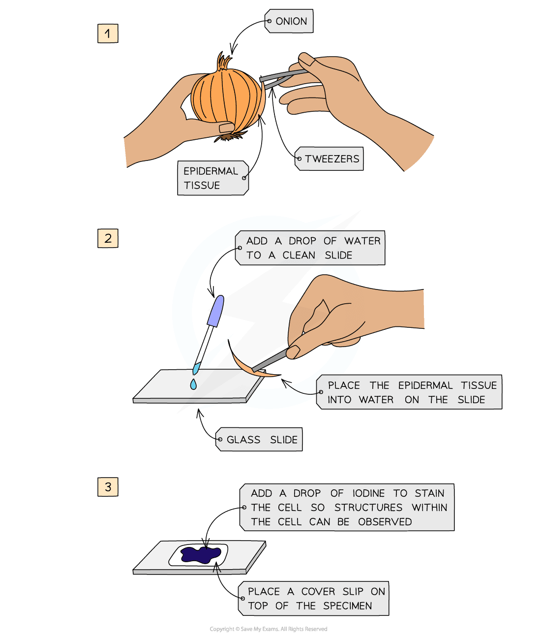](https://cdn.savemyexams.co.uk/wp-content/uploads/2020/08/Preparing-a-slide.png)

***Care must be taken to avoid smudging the glass slide or trapping air bubbles under the coverslip***

**Using a microscope**

* Understanding the main features of a light microscope is essential if you are to use it correctly
* Always hold the microscope by the arm when moving it around the lab, and always start your observation with the lowest-powered objective lens

[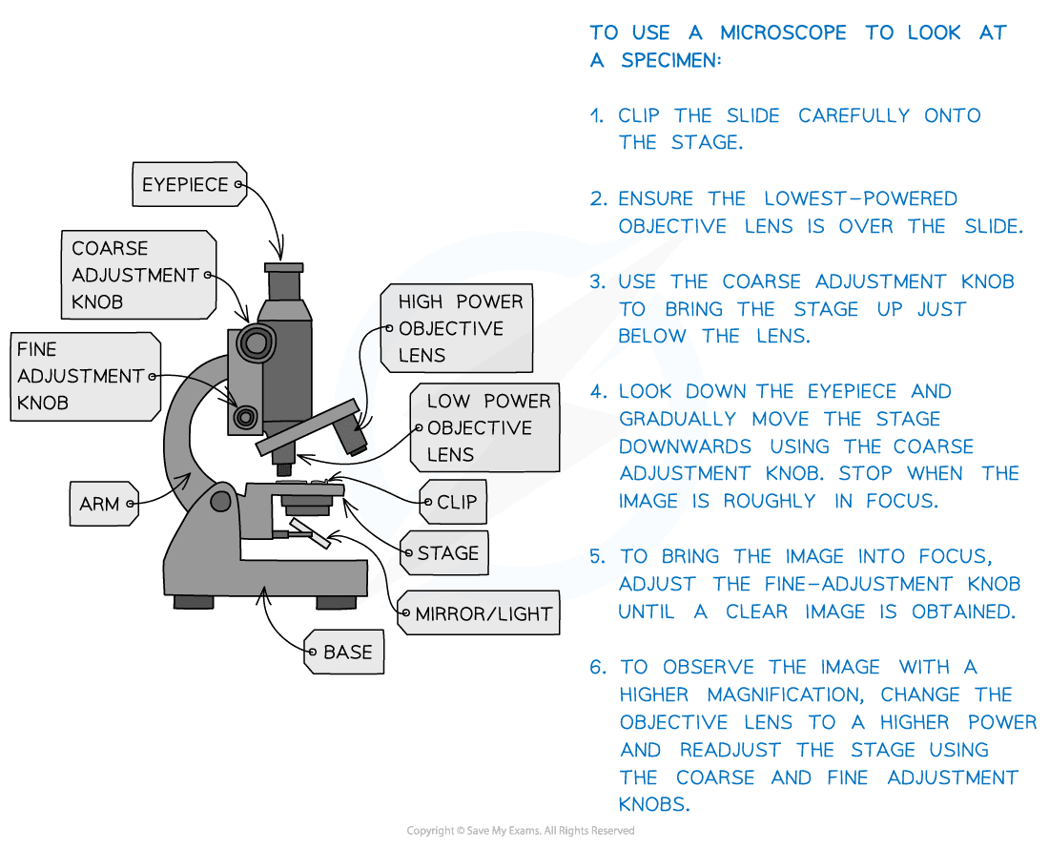](https://cdn.savemyexams.co.uk/wp-content/uploads/2020/08/RP-Microscopy_-Using-a-Microscope.png)

***Light microscopes have a lens in the eyepiece which is fixed and two or three objective lenses of different powers***

**Biological drawings**

* Producing biological drawings of what you see under the microscope is a key skill
* The key is not to try to be too artistic with your drawings – they are supposed to be scientific so make sure you follow the rules

[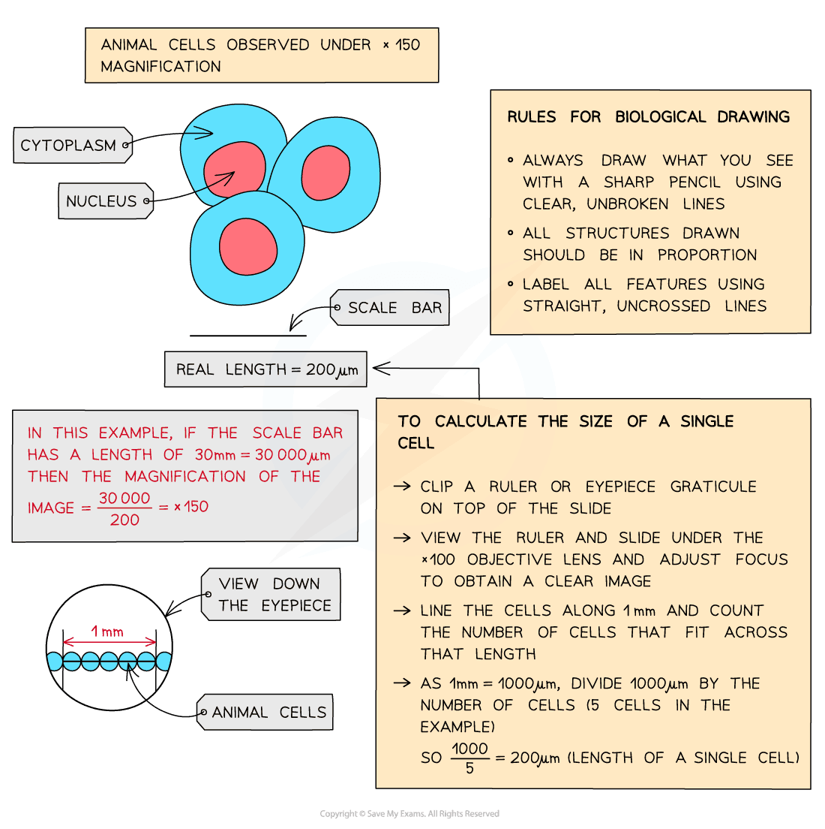](https://cdn.savemyexams.co.uk/wp-content/uploads/2020/08/Biological-Drawings.png)

***Biological drawings should be as large as possible – aim to take up at least half of the space available on the page with your drawings***