

**Higher IGCSE (9 – 1) Revision Pack**

**Bearings 2**

**Name --------------------------------**

**Questions**

**Q1.**

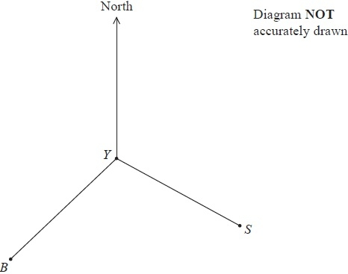

The diagram shows the positions of a yacht *Y*, a ship *S* and a beacon *B*.   
The bearing of *B* from *Y* is 228°

(a)  Find the bearing of *Y* from *B*.

...........................................................°

**(2)**

The bearing of *S* from *Y* is 118°

(b)  Find the size of the angle *BYS*.

...........................................................°

**(1)**

(c)  Given also that *BY* = *SY*, find the bearing of *S* from *B*.

...........................................................°

**(2)**

**(Total for Question is 5 marks)**

**Q2.**

The diagram shows two points *S* and *T*.   
The bearing of *T* from *S* is 043°

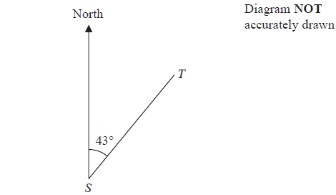

Work out the bearing of *S* from *T*.

...........................................................°

**(Total for question = 2 marks)**

**Q3.**

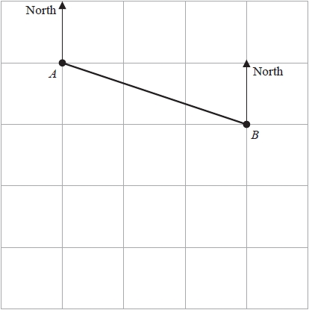

The diagram shows point *A* and point *B* on a map.   
The point *C* is due south of *A*  
The bearing of *C* from *B* is 235°

(a)  Mark the point *C* on the map.

**(2)**

The bearing of a point *D* from *B* is 168°

(b)  Find the bearing of *B* from *D*

........................................................... °

**(2)**

Gordon measures a length on the map as 6.3 cm correct to 1 decimal place.

(c)  Write down the lower bound for this length.

........................................................... cm

**(1)**

**(Total for question = 5 marks)**

**Q4.**

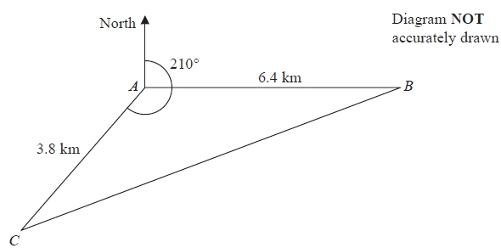

*A*, *B* and *C* are 3 villages.   
*B* is 6.4 km due east of *A*.   
*C* is 3.8 km from *A* on a bearing of 210°

Calculate the bearing of *B* from *C*.   
Give your answer correct to the nearest degree.   
Show your working clearly.

........................................................... °

**(Total for Question is 6 marks)**

**Q5.**

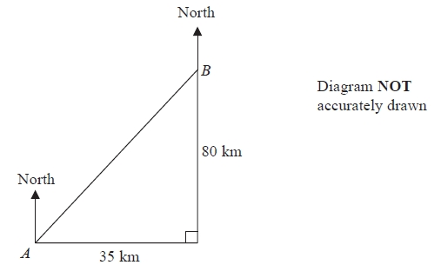

Town *B* is 35 km east and 80 km north of town *A*.

Work out the bearing of *A* from *B*.   
Give your answer correct to the nearest degree.

........................................................... °

**(Total for question = 4 marks)**

**Q6.**

The diagram shows the positions of two towns, *A* and *B*.

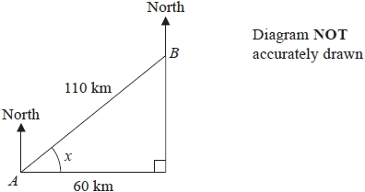

The distance from *A* to *B* is 110 km.   
*B* is 60 km east of *A*.

(a)  Work out the size of angle *x*.

Give your answer correct to 1 decimal place.

........................................................... °

**(3)**

(b)  Work out the bearing of *B* from *A*.

Give your answer correct to the nearest degree.

........................................................... °

**(2)**

The distance from *A* to *B* is 110 km correct to 2 significant figures.

(c) (i)  Write down the lower bound for the distance from *A* to *B*.

........................................................... km

(ii)  Write down the upper bound for the distance from *A* to *B*.

........................................................... km

**(2)**

**(Total for question = 7 marks)**

**Q7.**

*A*, *B* and *C* are three towns.

The bearing of *B* from *A* is 105°   
The bearing of *C* from *B* is 230°

The distance of *C* from *A* is 180 km.   
The distance of *C* from *B* is 95 km.

Calculate the distance of *B* from *A*.   
Give your answer correct to 3 significant figures.

........................................................... km

**(Total for question = 5 marks)**

Extra 4 questions for your enjoyment

**Q1.**

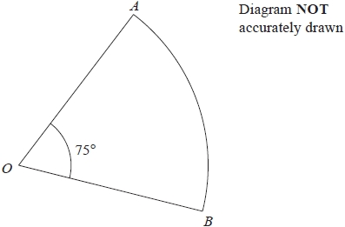

*AOB* is a sector of a circle, centre *O*, with ∠*AOB* = 75°   
The area of the sector is 200 cm2

Find, to 3 significant figures,

(a)   the radius, in cm, of the circle,

........................................................... cm

**(2)**

(b)   the length, in cm, of the perimeter of the sector.

........................................................... cm

**(3)**

**(Total for question = 5 marks)**

**Q2.**

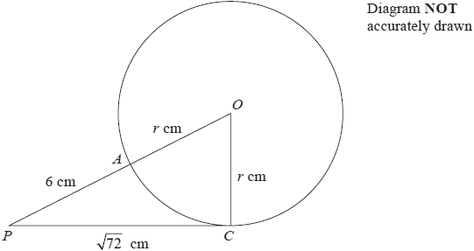

*A* and *C* are two points on the circumference of a circle centre *O* and radius *r* cm.

The point *P* is such that *PC* is a tangent to the circle and *PAO* is a straight line.

Given that *PC* =  cm and *PA* = 6 cm,

(a)   write down an equation in *r*,

...........................................................

**(1)**

(b)   find the value of *r*,

*r* = ...........................................................

**(2)**

(c)   find the size, in degrees to 3 significant figures, of ∠*OPC*.

........................................................... °

**(2)**

**(Total for question = 5 marks)**

**Q3.**

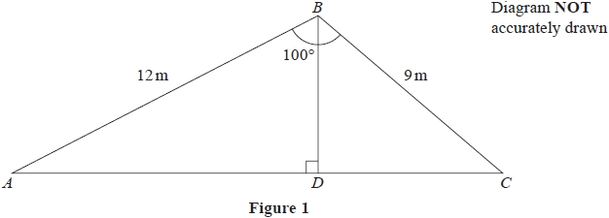

*A*, *B* and *C* are three points on horizontal ground such that *AB* = 12 m, *BC* = 9m and ∠*ABC* = 100° as shown in Figure 1.

Calculate to 3 significant figures,

(a)   the length, in m, of *AC*,

**(3)**

(b)   the size, in degrees, of ∠*CAB*.

**(3)**

*D* is the point on *AC* such that *BD* is perpendicular to *AC*.

(c)   Calculate the area, in m2 to 2 significant figures, of triangle *ABD*.

**(3)**

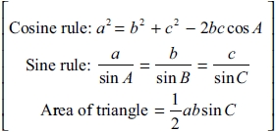

.............................................................................................................................................

.............................................................................................................................................

.............................................................................................................................................

.............................................................................................................................................

.............................................................................................................................................

.............................................................................................................................................

.............................................................................................................................................

.............................................................................................................................................

.............................................................................................................................................

.............................................................................................................................................

.............................................................................................................................................

.............................................................................................................................................

.............................................................................................................................................

.............................................................................................................................................

.............................................................................................................................................

.............................................................................................................................................

.............................................................................................................................................

.............................................................................................................................................

.............................................................................................................................................

.............................................................................................................................................

.............................................................................................................................................

.............................................................................................................................................

.............................................................................................................................................

.............................................................................................................................................

.............................................................................................................................................

.............................................................................................................................................

.............................................................................................................................................

.............................................................................................................................................

.............................................................................................................................................

.............................................................................................................................................

**(Total for question = 9 marks)**

**Q4.**

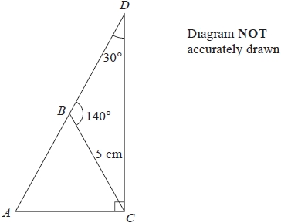

The diagram shows Δ*BDC* in which *BC* = 5 cm, ∠*BDC* = 30° and ∠*CBD* = 140°

(a)   Calculate the length, in cm to 3 significant figures, of *DC*.

........................................................... cm

**(3)**

The line *DB* is extended to the point *A* so that the line *AC* is perpendicular to *DC* as shown in the diagram.

(b)   Calculate the area, in cm2 to 3 significant figures, of Δ*ABC*.

........................................................... cm

**(4)**

**(Total for question = 7 marks)**