

**Higher IGCSE (9 – 1) Revision Pack**

**Statistical Measures**

**Questions 30 – 50**

**Name --------------------------------**

**Questions**

**Q30.**

The table gives information about the ages of all the 90 adults in a supermarket.

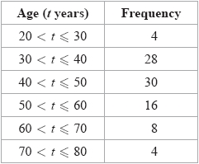

One of these 90 adults is picked at random.

(a)  Find the probability that this adult's age is more than 50 years.

...........................................................

**(2)**

(b)  Complete the cumulative frequency table for these 90 adults.

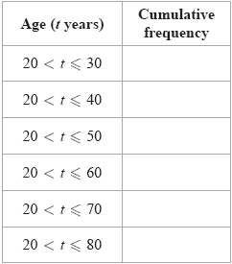

**(1)**

(c)  On the grid, draw a cumulative frequency graph for your table.

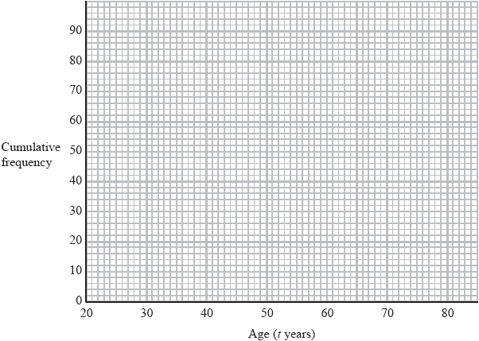

**(2)**

All of these adults with an age greater than 65 years receive a discount on their shopping bill.

(d)  Use your graph to find an estimate for the number of these adults who receive a discount.

...........................................................

**(2)**

**(Total for question = 7 marks)**

**Q31.**

Three positive whole numbers have a median of 7 and a mean of 5

Find the range of these three numbers.

...........................................................

**(Total for question is 3 marks)**

**Q32.**

Three integers have a mean of 7, a median of 5 and a range of 14

Find the three integers.

..............................    ..............................    ..............................

**(Total for question = 2 marks)**

**Q33.**

The cumulative frequency graph gives information about the lengths, in minutes, of  
 80 telephone calls.

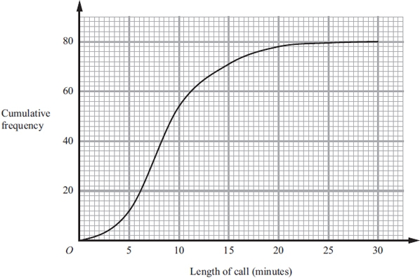

(a) Find an estimate for the number of calls which were longer than 15 minutes.

...........................................................

**(2)**

(b) Find an estimate for the interquartile range of the lengths of the 80 calls.

........................................................... minutes

**(2)**

**(Total for question = 4 marks)**

**Q34.**

The table shows information about the number of peas in each of 25 pods.

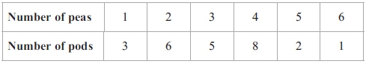

(a) Work out the mean number of peas in the 25 pods.

...........................................................

**(3)**

(b) Tariq puts the 25 pods in a bag.   
He takes at random one of the pods.

Find the probability that he takes a pod with 3 peas or a pod with 4 peas.

...........................................................

**(2)**

(c) Laila puts the 25 pods in a bag.   
She takes at random two pods without replacement.

Calculate the probability that

(i) there are 3 peas in each of the two pods she takes,

...........................................................

(ii) there is a total of 4 peas in the two pods she takes.

      ..............................................................................................................................................

**(5)**

**(Total for question = 10 marks)**

**Q35.**

The cumulative frequency graph gives information about the monthly rainfall, in millimetres, in the United Kingdom during 120 months in the years 2001 to 2010.

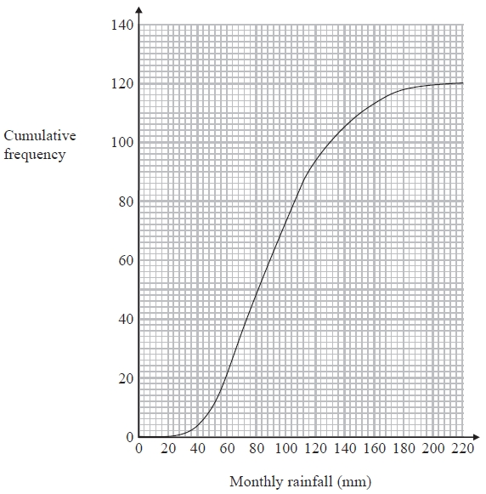

(a)   Use the graph to estimate the number of months for which rainfall was less than 50 mm.

...........................................................

**(1)**

(b)   Use the graph to find an estimate for the median monthly rainfall.

........................................................... mm

**(1)**

(c)   Use the graph to find an estimate for the interquartile range of the monthly rainfall.

........................................................... mm

**(2)**

**(Total for Question is 4 marks)**

**Q36.**

Ahmed, Beth and Cleo are three friends.

The mean age, in years, of Ahmed, Beth and Cleo is 21   
The mean age, in years, of Ahmed and Beth is 19

(a)  Work out Cleo's age.

........................................................... years

**(3)**

Ahmed is the youngest of the three friends.   
The median age, in years, of the three friends is 20

(b)  Find the range of their ages.

........................................................... years

**(3)**

**(Total for question = 6 marks)**

**Q37.**

The cumulative frequency graph gives information about the intelligence quotients (IQ) of a random sample of 100 adults.

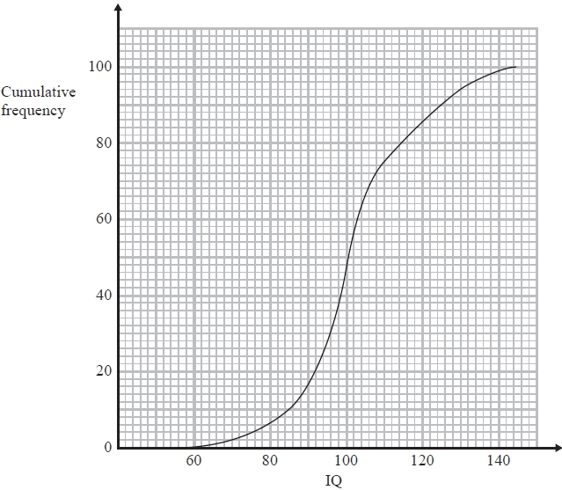

(a)  Use the cumulative frequency graph to find an estimate for the number of adults in the sample who   
       have an IQ between 85 and 115

...........................................................

**(2)**

(b)  Find an estimate for the upper quartile of the IQ of adults in the sample.

...........................................................

**(2)**

**(Total for question = 4 marks)**

**Q38.**

The table shows information about the number of letters in the first name of each of  
 50 people.

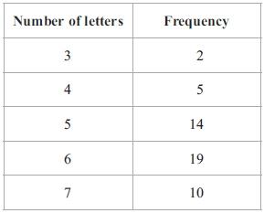

(i) Work out the mean number of letters in the first names of the 50 people.

...........................................................

(ii) One more person joins the 50 people.   
The mean number of letters in the first names of the 51 people is less than the mean  
number of letters in the first names of the 50 people.

Write down the greatest number of letters in the first name of the person who joins   
the group.

...........................................................

**(Total for question = 4 marks)**

**Q39.**

Freya keeps hens.   
The table shows information about the number of boxes of eggs she sold in each of 52 weeks.

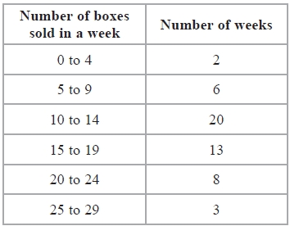

(a)   Write down the modal class.

...........................................................

**(1)**

(b)   Work out an estimate for the mean number of boxes of eggs that Freya sold each week. Give your answer correct to 3 significant figures.

...........................................................

**(4)**

Dan picks at random one of the 52 weeks.

(c)   Find the probability that in this week Freya sold at least 15 boxes of eggs.

...........................................................

**(2)**

**(Total for Question is 7 marks)**

**Q40.**

A group of students take a test.  
 The group consists of 12 boys and 8 girls.  
 The mean mark for the boys is 18  
 The mean mark for the girls is 16.5

Calculate the mean mark for the whole group.

...........................................................

**(Total for question = 4 marks)**

**Q41.**

The table shows information about the numbers of text messages sent by 40 teenagers  
 in one day.

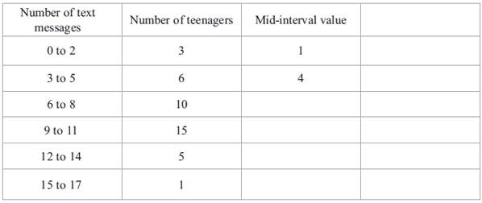

(a) Write down the modal class.

...........................................................

**(1)**

(b) (i) Work out an estimate for the mean number of texts sent by the 40 teenagers   
in one day.

...........................................................

(ii) Explain why your answer to part (b)(i) is an estimate.

.............................................................................................................................................

.............................................................................................................................................

**(5)**

**(Total for question is 6 marks)**

**Q42.**

A box contains 80 tea bags.



The table shows information about the weight of each tea bag.

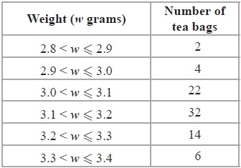

(a)  Work out the percentage of the 80 tea bags that weigh more than 3.1 grams.

........................................................... %

**(2)**

(b)  Work out an estimate for the total weight of the 80 tea bags.   
Use halfway values of 2.85 grams, 2.95 grams, ...

........................................................... grams

**(3)**

Here is a cumulative frequency graph for the weights of the 80 tea bags.

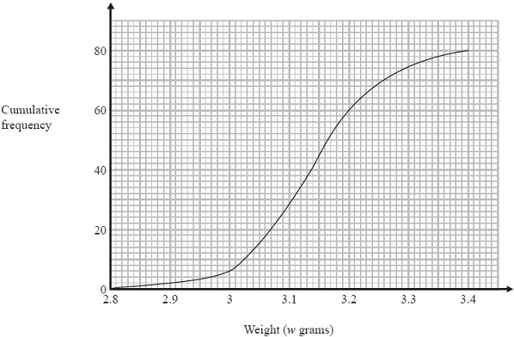

(c)  Use the graph to find an estimate for the number of tea bags which weighed more than 3.25 grams.

...........................................................

**(2)**

(d)  Use the graph to find an estimate for the interquartile range of the weights of the tea bags.

........................................................... grams

**(2)**

**(Total for Question is 9 marks)**

**Q43.**

Here is a list of numbers written in order of size.

3          6          *x*          *y*

The numbers

have a median of 8

have a mean of 11

Find the value of *x* and the value of *y*.

*x* = ...........................................................

*y* = ...........................................................

**(Total for question = 3 marks)**

**Q44.**

There are 30 apples in a box.   
The mean weight of these 30 apples is 120 grams.

There are 10 apples in a bag.   
The mean weight of these 10 apples is 95 grams.

Work out the mean weight of the 40 apples.

........................................................... grams

**(Total for question = 3 marks)**

**Q45.**

Ian plays 7 games of cricket.   
His mean score per game for these 7 games is 42 runs.

Ian is going to play one more game of cricket.   
He wants his mean score per game for the 8 games to be exactly 50 runs.

How many runs must he score in his 8th game?

...........................................................

**(Total for question = 3 marks)**

**Q46.**

Three positive whole numbers are all different.   
The numbers have a median of 8 and a mean of 6   
Find the three numbers.

...........................................................

**(Total for question = 2 marks)**

**Q47.**

Here are the points that Carmelo scored in his last 11 basketball games.

23        20        14        23        17        24        24        18        16        22        21

(a)   Find the interquartile range of these points.

...........................................................

**(3)**

Kobe also plays basketball.   
The median number of points Kobe has scored in his games is 18.5   
The interquartile range of these points is 10

(b)   Which of Carmelo or Kobe is the more consistent points scorer?   
Give a reason for your answer.

.............................................................................................................................................

.............................................................................................................................................

**(1)**

**(Total for Question is 4 marks)**

**Q48.**

Here are 8 cards.

There is a number on each of six cards.   
Two cards are blank.



Uzma wants the mean of the numbers on the 8 cards to be 4   
She wants the range of the numbers on the 8 cards to be 9

Find the numbers that she should write on the two blank cards.

..................... and .....................

**(Total for question = 3 marks)**

**Q49.**

Students in class 9Y took part in a sponsored swim.   
The table gives information about the amount of money, in £, raised by each student.

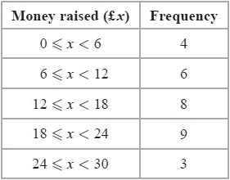

Work out an estimate for the total amount of money raised by the students in class 9Y.

£ ...........................................................

**(Total for question = 3 marks)**

**Q50.**

The table gives information about the number of males in each age group in a survey of 100 males working in Singapore in 2014.

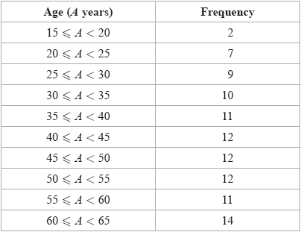

(a)  Complete the cumulative frequency table.

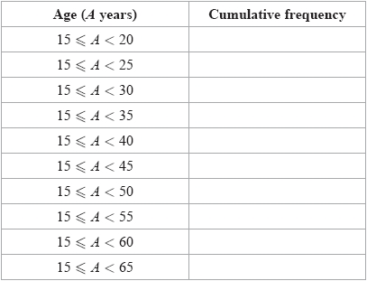

**(1)**

(b)  On the grid, draw a cumulative frequency graph for your table.

**(2)**

(c)  Use your graph to find an estimate for the lower quartile.

........................................................... years

**(2)**

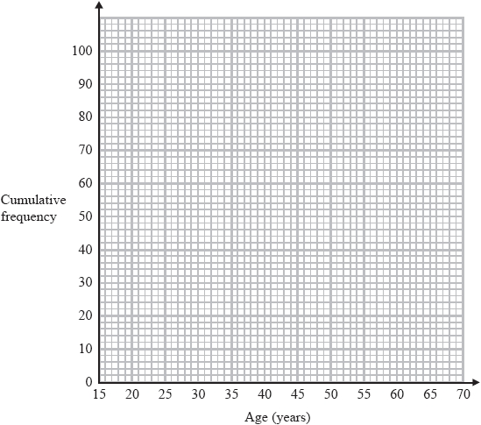

The total number of males aged under 65 working in Singapore in 2014 was 1 200 000

Using this information and your graph,

(d)  work out an estimate for the number of males working in Singapore in 2014 who were less than 52 years old.

...........................................................

**(3)**

**(Total for question = 8 marks)**

**End of questions**