Correlation

A correlation is the relationship between 2 variables, it can be positive or negative

A positive correlation occurs when an increase in one factor causes an increase in another factor for example sunnier weather increases sales of ice-cream, there is a positive correlation between sunshine and ice-cream sales.

A negative correlation occurs when an increase in one factor leads to a decrease in another e.g. an increase in a disease in one area of the world may affect the number of people travelling to that part of the world.

The relationship is usually given in terms of a value between -1 and +1. Sometimes there is no relationship at all between the factors and this is just described as no correlation

A minus figure represents a negative correlation and a positive figure represents a positive correlation.

A strong correlation (positive or negative) would be over 0.5 where a weak correlation would be less than 0.5

For each of the following values explain identify the type of correlation and explain what it means.

|  |  |  |
| --- | --- | --- |
| 1 | - 0.2 |  |
| 2 | 0.8 |  |
| 3 | 0 |  |
| 4 | - 0.7 |  |
| 5 | 0.1 |  |
| 6 | - 0.4 |  |

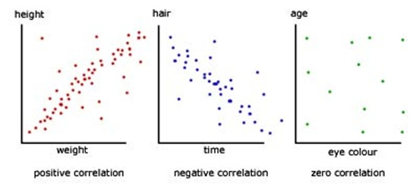This information can be expressed on a chart like the ones below showing the relationship between 2 variables such as height, weight, age, eye colour etc. For example there is a positive correlation between height and weight – the taller a person is, the more they weigh, or between hair colour and time – the longer a person is alive the less colour their hair has (they ‘go grey’).

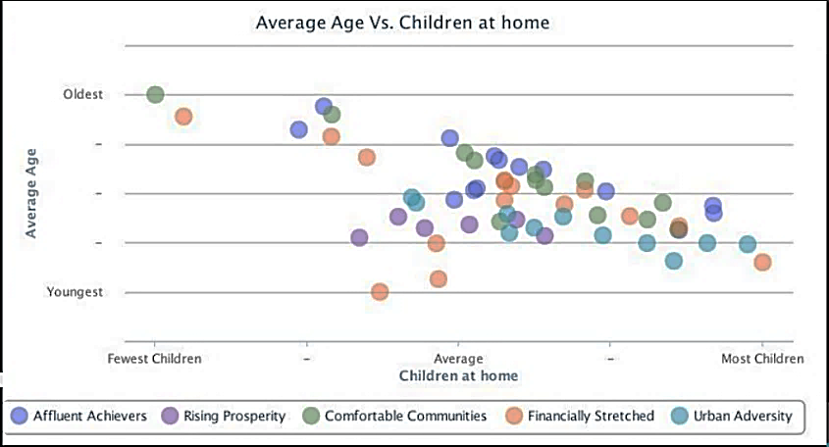In business terms the firm might look at the characteristics of consumers in the market. The charts on the following pages are taken from information on the Acorn research website, they show the relationship between 2 variables.

Describe the correlation shown in this chart.

_____________________________________________________________________________________________________________________________________________________________________________________________________________________________________________

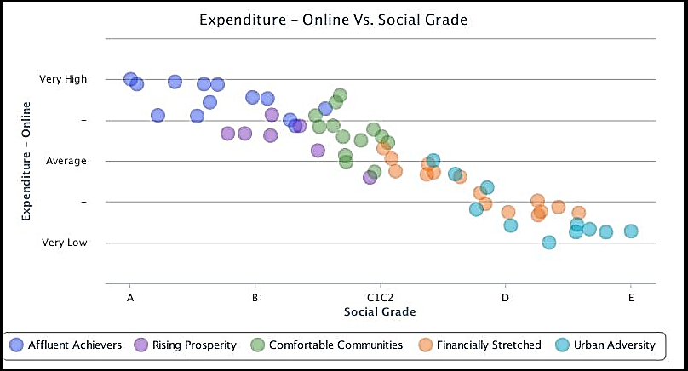

Describe the correlation shown in this chart.

_____________________________________________________________________________________________________________________________________________________________________________________________________________________________________________

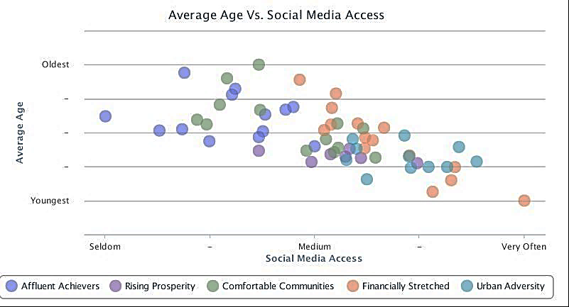

What does this information tell you about the relationship between age and social media access in the different consumer groups?

____________________________________________________________________________________________________________________________________________________________________________________________________________________________________________________________________________________________________________________________

Explain how this information might be of use to a business (6 marks)

________________________________________________________________________________________________________________________________________________________________________________________________________________________________________________________________________________________________________________________________________________________________________________________________________________________________________________________________________________________________________________________________________________________________________________________________________________________________________________________