**Fish ventilation: /8**

**Q1.**

Gills are the site of gas exchange in fish.

The table shows some information for five species of fish.

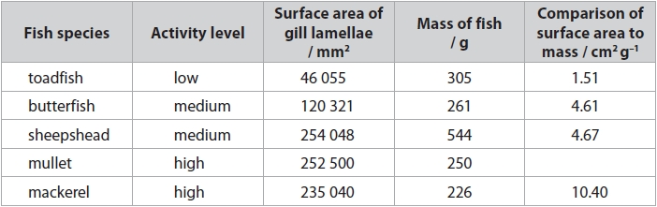

(i)   The comparison of surface area to mass of mullet is

**(1)**

   **A**    1010 cm2 g–1

   **B**    10.10 cm2 g–1

   **C**    1.01 cm2 g–1

   **D**    0.99 cm2 g–1

(ii)  Analyse the data to explain the difference in the activity levels of these fish species.

**(3)**

.............................................................................................................................................

.............................................................................................................................................

.............................................................................................................................................

.............................................................................................................................................

.............................................................................................................................................

.............................................................................................................................................

.............................................................................................................................................

.............................................................................................................................................

.............................................................................................................................................

.............................................................................................................................................

.............................................................................................................................................

**(Total for question = 4 marks)**

**Q2.**

Gills are the site of gas exchange in fish.

Water polluted with heavy metal ions can cause the death of fish.

The photographs show cross-sections of the lamellae from a fish caught in unpolluted water and from a fish caught in water polluted with heavy metal ions.

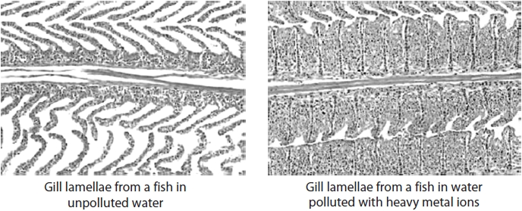

Use the photographs to explain why fish die in water polluted with heavy metal ions.

**(2)**

.............................................................................................................................................

.............................................................................................................................................

.............................................................................................................................................

.............................................................................................................................................

**(Total for question = 2 marks)**

**Q3.**

Gills are the site of gas exchange in fish.

The diagram shows some of the gill lamellae from a bony fish.

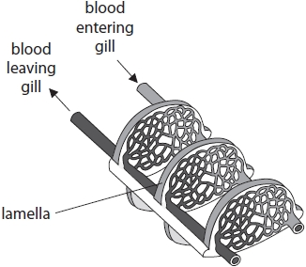

Draw **one** arrow on the diagram to show the direction of water flow across the lamellae.

**(1)**

**(Total for question = 1 mark)**

**Q4.**

The diagram shows a section through the head of a bony fish.

The graph shows the pressure changes in the buccal cavity and opercular cavity during ventilation.

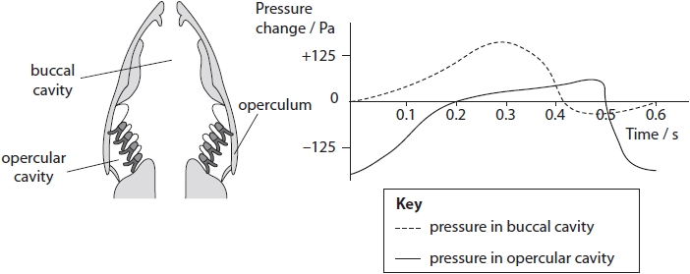

The operculum will be closed between

**(1)**

   **A**    0.4 s and 0.5 s

   **B**    0.0 s and 0.4 s

   **C**    0.4 s and 0.6 s

   **D**    0.2 s and 0.4 s

**(Total for question = 1 mark)**

**Mark Scheme**

Q1.

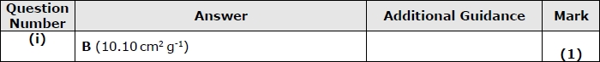

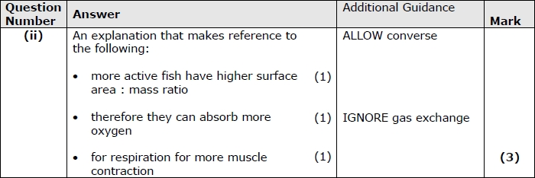

**Q2.**

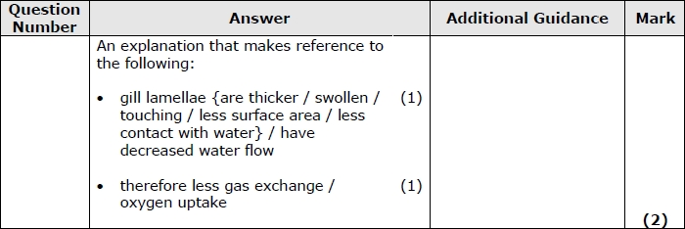

**Q3.**

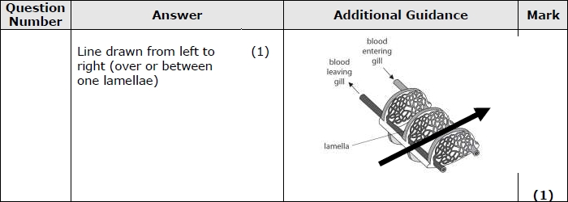

**Q4.**

