

**Marking Scheme**

**Straight Lines 2 Perpendicular Lines**

**Q1.**

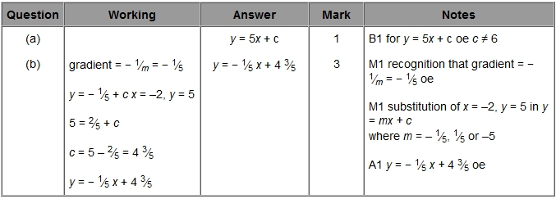

**Q2.**

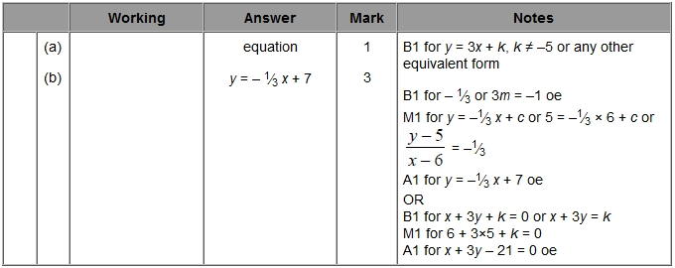

**Q3.**

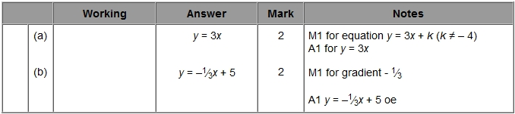

**Q4.**

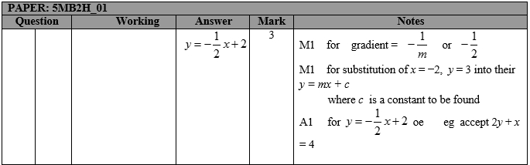

**Q5.**

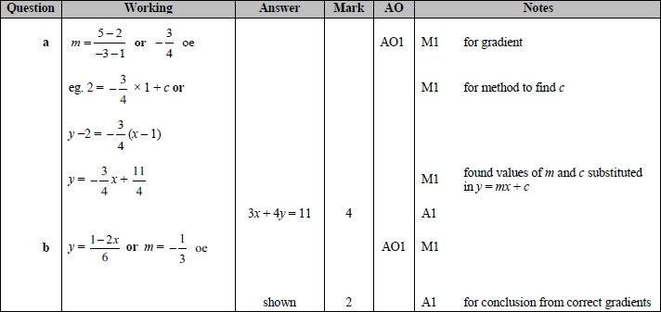

**Q6.**

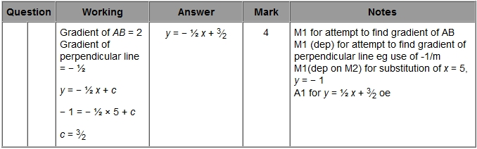

**Q7.**

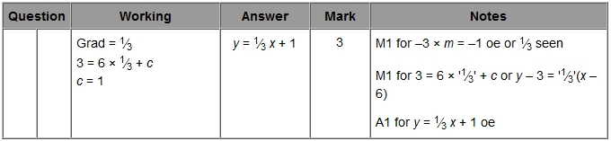

**Q8.**

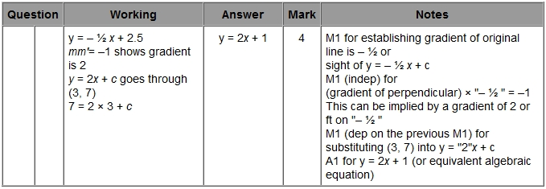

**Q9.**

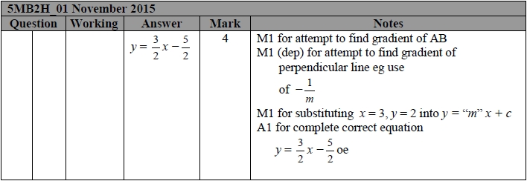

**Q10.**

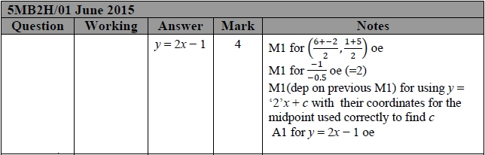

**Q11.**

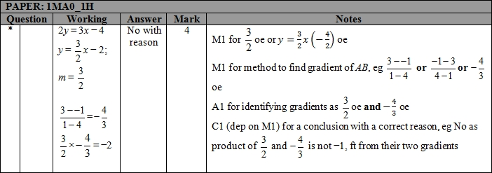

**Q12.**

| **Paper: 1MA1/1H** | | | | | |
| --- | --- | --- | --- | --- | --- |
| **Question** | | **Working** | **Answer** | **Mark** | **Notes** |
|  |  |  | *y* =  −2*x* + 21 | P1 | shows evidence of understanding that *AC* is perpendicular to *DB*, or states the gradient of *DB* as 0.5 oe |
|  |  |  |  | P1 | shows a process to find the gradient of a perp. line e.g. use of  or states *y* = −2*x* + c or states the gradient of AC as −2 |
|  |  |  |  | P1 | (dep on P2) for sub. of *x* = 5, *y* = 11 into *y* = *mx* + *c* where *m* is their found gradient for AC. |
|  |  |  |  | A1 | oe |

**Q13.**

| **Mock Paper 1MA1: 2H** | | | | | |
| --- | --- | --- | --- | --- | --- |
| **Question** | | **Working** | **Answer** | **Mark** | **Notes** |
|  |  |  | *y =* −4*x* + 5 | 5 | P1 for appropriate process to find gradient  e.g.  (=)  P1 process to find *y* coordinate 7 +  × 5 (= 9)  or *x* coordinate − 9 +  × 20 (= −1)  P1 method to find gradient of line *L*  (= −4)  M1 substitution of found values for *x*, *y* and *m* into equation for straight line  A1 *y =* – 4*x* + 5 |