**If Statement Exercises**

1. Write a program that will ask the user to input a number between 50 and 60.  Give a response which tells the user if the number is “within range” or “too high” or “too low”.
2. Write a program which will ask the user to enter two football teams and a score for one followed by the score for the other.  It should then calculate how many points each team will get (3 points for a win, 1 for a draw and 0 if they lose).
3. Create a program which will ask the user to enter the number of questions in a test and also the number the student scored in that test.  It should work out the percentage they scored.  For instance, if the student got 12 correct out of 20 then they scored 60%.  It should also work out if they passed the test and show a suitable message if they got 50% or more in the test and a different message telling them they failed the test if they scored under 50%.
4. Create the following code:   
    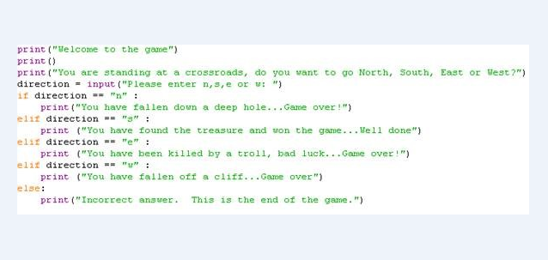
5. Try out the game and then make improvements to it so that it does not end after the first round.