Year 1 Sociology

**Paper 1: Education with Theory & Methods**



Education

Booklet 6: Educational Policies

Name:_____________________________

Specification Content:

**What you need to know for Education in your Paper 1 exam:**

You will be expected to:

* The role and functions of the education system, including its relationship to the economy and to class structure
* Differential educational achievement of social groups by social class, gender and ethnicity in contemporary society
* Relationships and processes within schools, with particular reference to teacher/pupil relationships, pupil identities and subcultures, the hidden curriculum, and the organisation of teaching and learning
* The significance of educational policies, including policies of selection, marketisation and privatisation, and policies to achieve greater equality of opportunity or outcome, for an understanding of the structure, role, impact and experience of and access to education; the impact of globalisation on educational policy.

|  |  |  |  |  |
| --- | --- | --- | --- | --- |
| **Questions may be based specifically on the following areas:** | Do I have completed Notes? | Have I made revision Notes? | Have I memorised this info? | Have I practised exam style questions? |
| The impact of educational policies of selection, marketisation and privatisation, such as the tripartite system and the post-1988 education system, in relation to educational standards and class differences |  |  |  |  |
| The impact of educational policies aimed at achieving greater equality of opportunity or outcome e.g. the comprehensive system, compensatory education policies, education action zones and tuition fees |  |  |  |  |
| Educational policies in relation to gender and ethnic differences and their impact e.g. GIST, WISE and multicultural education |  |  |  |  |
| Different sociological explanations of the impact of educational policies, e.g. in relation to parentocracy and differences in economic and cultural capital |  |  |  |  |
| The impact of globalisation on educational policy |  |  |  |  |

Exam Structure:

**This topic will appear on Paper 1 at A Level**

The A-level Paper 1 will be 2 hours long, contain 80 marks and be worth a third of your A Level. You will be assessed via short answer and extended writing questions in the following areas:

* [](http://www.google.co.uk/url?sa=i&rct=j&q=&esrc=s&source=images&cd=&cad=rja&uact=8&ved=0ahUKEwiH17rsm6rNAhUMBcAKHYIYCW0QjRwIBw&url=http://firearmsafetycanada.com/?page_id=12&psig=AFQjCNEdDWy4gaTupewTvc6I4kTb1sWMrQ&ust=1466086461052204)**Education**: short answer and extended writing worth 50 marks
* **Methods In Context**: extended writing worth 20 marks
* **Theory and Methods**: extended writing worth 10 marks

**What is educational policy?**

'Educational policy' refers to the plans for education introduced by government, through Acts of Parliament, together with instructions and recommendations to schools and local authorities. For example the 2010 Academies Act which allowed all state schools to become academies.

Educational policies have three main aims:

* ***Economic efficiency:*** developing the talents of young people to improve the skills of the labour force so Britain maintains a successful position in the world economy. This involves making the education system meet the needs of industry and employers through more emphasis on vocational education, apprenticeships. This can help overcome the rising unemployment rates.
* ***Raising educational standards***
* ***Creating equality of educational opportunity in a meritocratic society***: in a meritocratic society, most people's occupational positions (jobs) and pay are allocated mainly on the basis of their talents, abilities, qualifications and skills. Equality of educational opportunity means everyone should have the same chance of developing and earning those qualifications, by ensuring everyone has the same access to and chances of success in education.

**Policies to improve equality of opportunity in access to education**

**1870- 1944- A brief History**

Until the 19th century, the state spent no public money on education; education was available only to the small minority who could afford to send their children to fee paying schools or where charities or churches set up their own schools.

In 1891 elementary education became free to all and in 1918 the leaving age rose to 14. However, schooling did little to alter people’s ascribed status: working class were only educated to a basic level in literacy and numeracy

**What happened next? Selection:**

**1944- 1965 The Tripartite System**

After the Second World War the Butlers Education Act was introduced which produced a ‘tripartite system of selection based on mertiocracy.

Butlers Education Act 1944... read page 77 and explain how the tripartite system and selection changed education

**It sounds like a good system BUT**



[This Photo](https://commons.wikimedia.org/wiki/File:Emoji_u1f44e.svg) by Unknown Author is licensed under [CC BY-SA](https://creativecommons.org/licenses/by-sa/3.0/)

**Evaluation of the Tripartite System**

* Some say it did emphasise meritocracy-should achieve status through effort and ability (the principle of meritocracy was the basis for this policy)
* Made schooling dependent on ability
* Rather than using meritocracy, the tripartite system and the 11+ ***reproduced*** class inequality by making the two social classes go to two difference types of school that offered unequal opportunities. Grammar schools, attended by only 20% (mostly attended by middle-class), were seen as the most prestigious type of school as it taught academic subjects that led to university and well-paid jobs. However, the 75% of pupils who attended secondary moderns (mostly working-class) were seen as 'failures'. Some were not allowed to take exams, so were denied opportunities to progress.
* The system also reproduced gender inequality by requiring girls to gain higher marks than boys in the 11+ to obtain a grammar school place, as there were fewer girls' grammar school places.
* The tripartite system also ***legitimated*** (justified) inequality through ideology that ability is inborn. It was thus argued that ability could be measured early on in life, through the 11+. However, in reality children's environment greatly affects their chances of success.
* For most pupils only two types of school were available - grammar and secondary moderns. Few technical schools were built because of the cost of equipping them.
* A number of reports (Crowther Report, 1959) suggested that a lot of working-class talent was being wasted (by placing them in secondary moderns) and the system was producing too few skilled workers.

**What happened next? 1965- 1979 Comprehensive Schools**

As the tripartite system did not succeed in creating equality of opportunity (tackle class divide) Comprehensive Schools were introduced to overcome the class divide. The 11+ was abolished along with the grammars and secondary moderns, to be replaced by comprehensive schools that all pupils within the area could attend. All pupils would attend regardless of their class, gender or ability to help produce a more meritocratic education system. It was believed that by educating pupils in the same place, children would have equality of opportunity and class divisions would be broken down.

**AO3: Evaluation of Comprehensive Schools**

|  |  |
| --- | --- |
| **Strengths** | **Weaknesses** |
| **Functionalists would say**  **CG5B** | **thumbs downBut Marxists would say** |

**What happened after 1988 - Marketisation**

Marketisation refers to the process of introducing market forces of consumer choice and competition between suppliers into areas run by the state, such as education. Marketisation has created an 'education market' by:

* reducing direct state control over education
* increasing both competition between schools and parental choice school.

**1988 Education Reform Act (p78 of textbook)**

Marketisation has become a central theme of government educational policy since the 1988 Education Reform Act (ERA), introduced by Margaret Thatcher’s Conservative government and reflects the ideas of the New right. From 1997, New Labour governments of Tony Blair and Gordon Brown followed similar policies. From 2010, the Conservative-Liberal Democrat coalition government took marketisation even further, for example by creating academies and free schools.

The New Right favour marketisation. *Why does the New Right favour marketisation policies?*

**Policies that promote marketisation include...**

|  |  |
| --- | --- |
| **Key Elements** | **Description** |
| *Parentocracy* | Miriam David 1993 describes marketized education as ‘parentocracy’ – meaning rule by parents. Power shifts from producers (teachers and school) to the consumers (parents). Tis gives more choice and raises standards.  Give some examples of policies which promote marketisation. |
| **Evaluation (AO3):**  BUT Ball and Whitty claim marketisation has actually made inequality worse as methods such as league tables reproduce class inequality as this creates inequality between schools. Remember – if some schools are better than others this gives middle class parents the chance to get their kids into the better schools.  Ball also claims that ‘parentocracy’ is a myth as not all parents have the same freedom of choice about where to send their children. |
| *League tables and cream-skimming* | If exam results are published these schools become more in demand.  Explain what Will Bartlett (1993) says about this.  Cream skimming  Silt shifting  What happens to the schools with bad results and poor league table positions? |
| *The funding formula* | Schools are allocated funding based on how many pupils they attract. Popular schools get more money and get better then may get more selective and be able to afford more experienced teachers. |
| **Evaluation (AO3):**  **What did the study in 2012 of international patterns of educational inequality find?** |

More about parents

Gerwitz: parental choice

Marketisation advantages middle class parents. They have the economic and cultural capital (do you remember what these terms mean?) to be in a better position to choose ‘good schools’ for their children.

Sharon Gerwitz

Studied 14 London Secondary Schools. Found that differences in economic and social capital had a big impact on school choices.

She found 3 types of parent

1. Priveleged – skilled choosers
2. Disconnected – local choosers
3. Semi-skilled choosers.

Can you describe each type?

|  |  |
| --- | --- |
| Priveleged – skilled choosers |  |
| Disconnected – local choosers |  |
| Semi-skilled choosers |  |

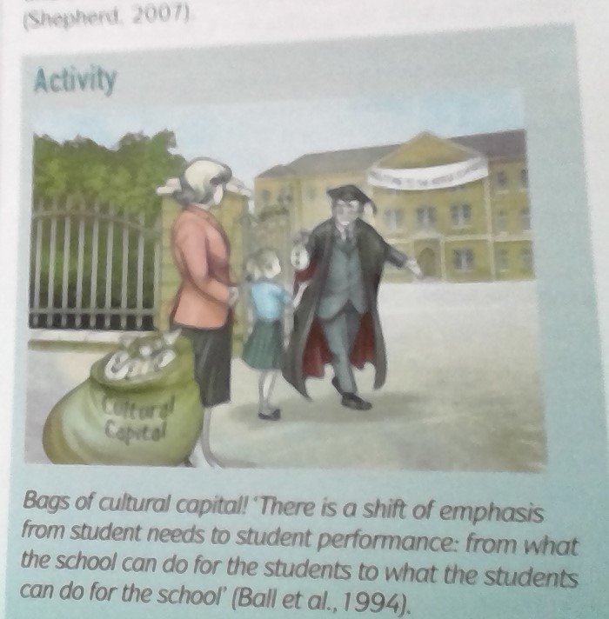

As the cartoon above shows, Ball is concerned that by giving parents more power, parents of advantaged children will get more benefits as they can manipulate the system and other pupils will lose even more ground.

**1997-2010 New Labour policies**

While Marketisation policies tended to increase inequality, the New Labour governments of 1997 to 2010 also introduced a number of policies aimed at reducing it. These included:

* Designating some deprived areas as **Education Action Zones** and providing them with additional resources. They were funded by central government with additional funding from businesses and were run by an Action forum of parents, local schools, businesses and local government. Some initiatives were homework and breakfast clubs.
* The **Aim Higher programme** to raise aspirations of groups who were under-represented in higher education.
* **Educational Maintenance Allowance (EMA):** payments to students (up to £30/week) from low-income backgrounds to encourage them to stay on after 16 to gain better qualifications.
* Introduction of the **National Literacy Strategy**, literacy and numeracy hours, and reducing primary school class sizes. It is claimed these policies are of greater benefit to disadvantaged groups and so help to reduce inequality.
* **City academies** were created to give a fresh start to struggling inner-city schools with mainly working-class pupils.
* Increased **funding** for state education and higher education (grants for universities for low-income families).
* **Tuition fees** labour introduced these to pay for expanding universities and to try and offer more places so disadvantages pupils could access university.

**BUT** research has suggested that pupils from deprived families struggled more because of the cost attached to going to university so were less likely to.

**A03: Evaluation of the New labour policies and inequality**

* Critics like Benn (2012) see a contradiction between New Labour's policies to tackle inequality and its commitment to marketisation - something she calls a 'New Labour' paradox.

For example, despite introducing EMAs to encourage poorer students to stay in education, Labour also introduced tuition fees for higher education that may deter them from going to university.

* New Labour governments neither abolished fee-paying private schools, nor removed their charitable status (estimated to be worth over £165 million per year)

**2010+ Coalition government policies**

**David Cameron** *‘excellence, competition and innovation’* by freeing schools from the *‘dead hand of the state’*

The Conservative-Liberal Democrat Coalition government elected in 2010 speeded up the move away from an education system based largely on comprehensive schools run by local authorities. Its policies have been strongly influenced by the New Right ideas of reducing the role of state in the provision of education through **marketisation** and **privatisation.** Through policies such as academies and free schools. They also increased tuition fees for universities.

Read P81 and complete below

|  |  |
| --- | --- |
| **Policy** | **Description** |
| ***Academies*** |  |
| ***Free schools*** |  |

**Coalition policies and inequality**

While the Conservative-Liberal Democrat coalition's marketisation policies are said to have increased inequality, they also introduced policies aimed at reducing it. (Remember compensatory education?)

**TASK** - Summarise the following policies and how they have created more equality to working-class pupils (p 82)

* **Free school meals -**
* **The Pupil Premium -**

**AO3***: How has Ofsted (2012) challenged Pupil Premium (pg. 82)*

**AO3***: What is the coalition government's 'austerity' programme done; and how does this challenge their policies on reducing inequality in education? (pg. 82)*

**Privatisation of Education**

*Define what is meant by the term privatisation?*

**Examples of the privatisation of the education system**.

ESI = ‘educational services industry’

Private companies are used to build schools, provide supply teachers etc.

Building companies often set up very profitable contracts with authorities which can be 25 year contracts. These also are very profitable. Some companies make up to 10 times what they would make on other projects but local authorities are obliged to enter into these agreements as there is not central government funding available.

Many senior officials like advisors and Headteachers have left education to set up consultancy companies and private sector education businesses.

**AO3: Evaluation of privatisation**

|  |  |
| --- | --- |
| **Advantages of privatisation** | **Disadvantages of privatisation** |
| **Where there is competition for contracts some believe this can raise standards and local authorities can shop around.** | **Free schools have not improved standards.**  **Rise in tuition fees has not increased places at universities**  **When things are privatised there is no central control so this can lead to improvements or to reduction in quality. There have been examples of corruption in Academies with headteachers not managing budgets, paying themselves inflated salaries etc** |

**Globalisation and Educational Policy**

*What is globalisation?*

The forces of globalisation are having increasing effects on the formation of education policy, and national governments often draw on a mix of policies from all over the world.

Globalisation has impacted on educational policy in two main ways: the privatisation and marketisation of education; and the use of international comparisons to form policies:

|  |
| --- |
| Provide three examples of private companies in the education system which are foreign owned according to Ball (2007).   * . * . * .   Often, private companies are exporting UK education policy to other countries (for example, Ofsted-type inspections) and then providing the services to deliver the polices. |
| **Cola-isation of schools**  Explain how else the private sector is penetrating education  Vending machines and brand loyalty  Tesco    As education becomes more of a commodity the state loses more control BALL ‘*more and more areas of education are now subject to business practices…..the ratcheting up of policy over time opens up more education services for profit’*  Hall agrees as a Marxist and says that as public services are handed over to private capitalists the driving up of standards is a myth to legitimise turning education into a source of private profit.  **Theresa May and Grammar schools**  Theresa May was keen to introduce Grammar schools with an emphasis on meritocracy. She thought this would give everyone an equal chance to succeed but as mentioned above we know that this is not always the case and it is difficult to create a ‘tutor proof’ test. There is a concern that children from poorer backgrounds who cannot prepare for these exams would be dumped into ‘sink schools’  This never happened following a general election the policy disappeared. |

**Policies on gender and ethnicity**





**Some evaluation of attempts by education policy to solve social class gender and ethnicity inequality in school**

1. **Douglas 1964, 1970 carried out a long term study looking at social class and education. In 1946 he selected 5362 British children who were born in the first week of March, he followed their educational careers until 1962. He divided them up in terms of ability (measured by IQ tests) and divided them up in terms of social class. He found that in the ‘high ability’ group 50 % of pupils from the lower working class left secondary school at the end of year 11, compared to 33 % from upper working class and 10% from the upper middle class. He concluded that the single most important factor in this was parents’ interest in their children’s education. More visits to school, conversations with teachers and primary socialisation which is more stimulating.**
2. **Nel Keddie looked at the ‘myth of cultural deprivation’ showing that cultural deprivation may not be an explanation for working class underachievement. She believed that children from low income families are seen by teachers as ‘uneducable’ as teachers have soaked up this myth so may be labelled by staff perceptions rather than by external factors.**
3. **Becky Francis studied the classroom and found that school is gendered, girls get less attention from teachers, boys are more aggressive in the playground and may dominate space. Poligies to encourage girls to choose science etc may not be able to tackle this larger cultural problem.**
4. **Tony Sewell looked at black pupils and external reasons for underachievement such as peer group anti-education subcultures and gangs and single parent families so multicultural education policies may not help. Also teachers were found to single out black pupils for punishment more often so we can see that the policies above may not target these problems.**
5. **Mirza looks at the myth of black female underachievement. She found that black women are often underestimated and that they often achieve well and have high self esteem.**

**Coalition government: From 2010**

**Education Reform Act**

**Comprehensive Schools:**

**New Labour Policies:**

**Policies aimed to reduce inequalities**

**The Tripartite System:**

**1944 Butler’s Education Act**

1940 1965 1979-80s 1988 1997 2010+ **⇨**

[](http://www.google.co.uk/url?sa=i&rct=j&q=&esrc=s&frm=1&source=images&cd=&cad=rja&uact=8&ved=0CAcQjRw&url=http://jbrunetfoto.net/els-meus-ulls-als-teus-ulls/&ei=QlxwVb3QOMfr7Ab8woKgAg&bvm=bv.94911696,d.ZGU&psig=AFQjCNGs759j8UDMrfTUVK0GgakJ-ZqH0w&ust=1433513346104570)**Eye on the exam**

Q.1

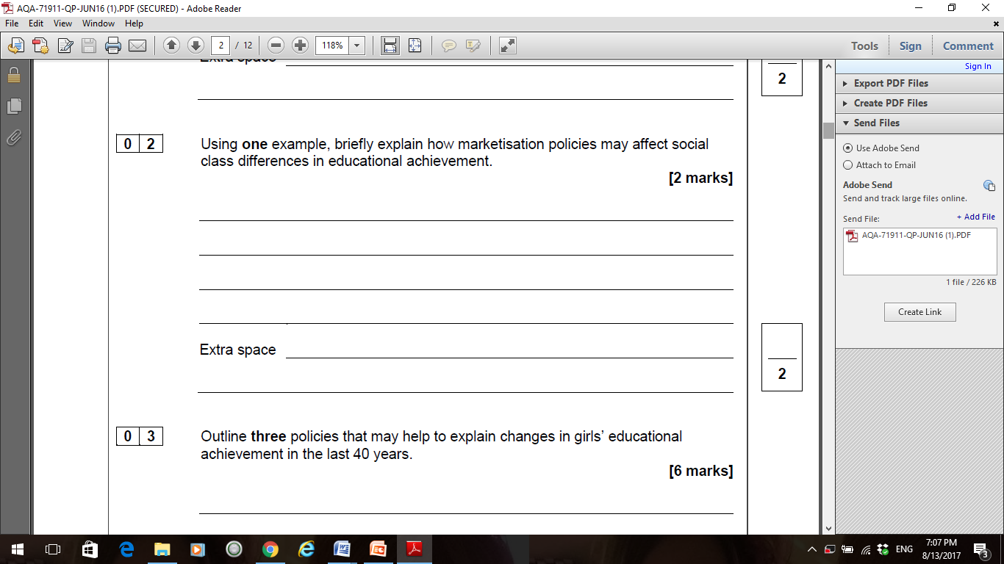

Q.2

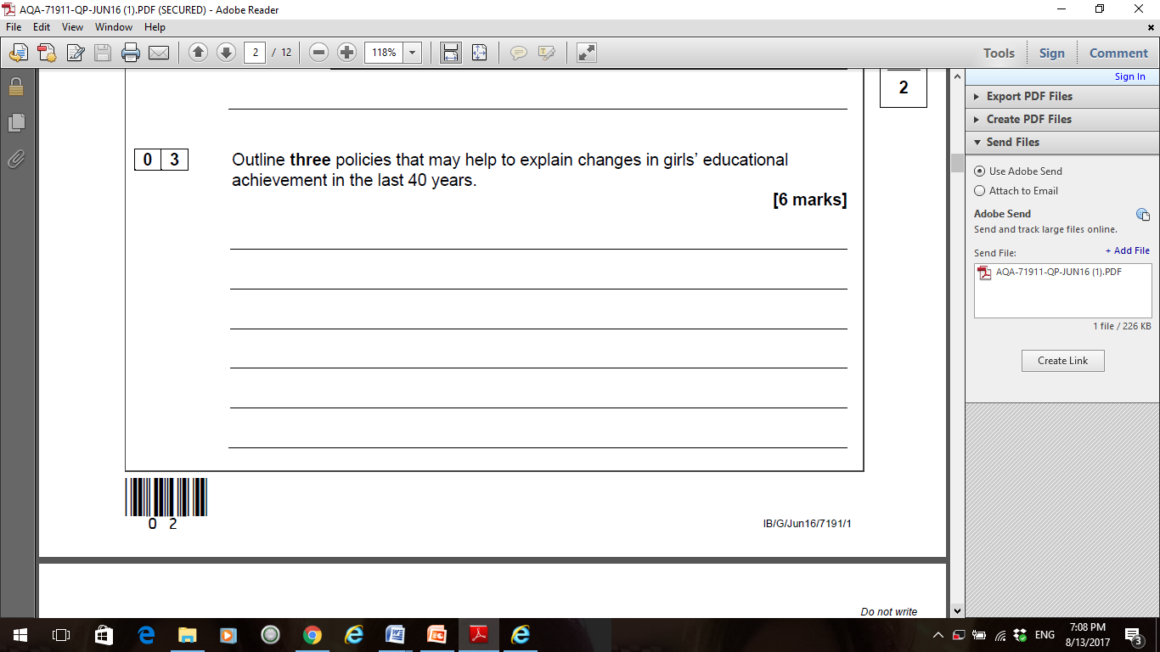

……………………………………………………………………………………………………………………………………………………………………………………………………………………………………………………………………………………………………………………………………………………………………………………………………………………………………………………………………………………………………………………………………………………………………………………………………………………………………………………………………………………………………………………………………………………………………………………………………………………………………………………………………………………………………………………………………………………………………………………………………………………………………………………………………………………………………………………………………………………………………………………………………………………………………………………………………………………………………………………………………………………………………………………………………………………………………………………………………………………………………………………………………………………………………………………………………………………………………………………………………………………………………………………………………………………………………………………………………………………………………………………………………………………………………………………………………………………………………………………………………………………………………………………………………………………………………………………………………………………………………………………………………………………………………………………………………………………………………………………………………………………………………………………………………………………………………………………………………………………………..

Q.3

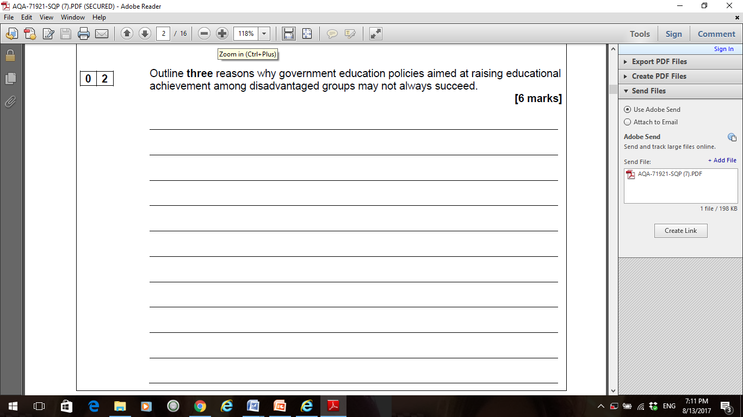

……………………………………………………………………………………………………………………………………………………………………………………………………………………………………………………………………………………………………………………………………………………………………………………………………………………………………………………………………………………………………………………………………………………………………………………………………………………………………………………………………………………………………………………………………………………………………………………………………………………………………………………………………………………………………………………………………………………………………………………………………………………………………………………………………………………………………………………………………………………………………………………………………………………………………………………………………………………………………………………………………………………………………………………………………………………………………………………………………………………………………………………………………………………………………………………………………………………………………………………………………………………………………………………………………………………………………………………………………………………………………………………………………………………………………………………………………………………………………………………………………………………………………………………………………………………………………………………………………………………………………………………………………………………………………………………………………………………………………………………………………………………………………………………………………………………………………………………………………………………………..

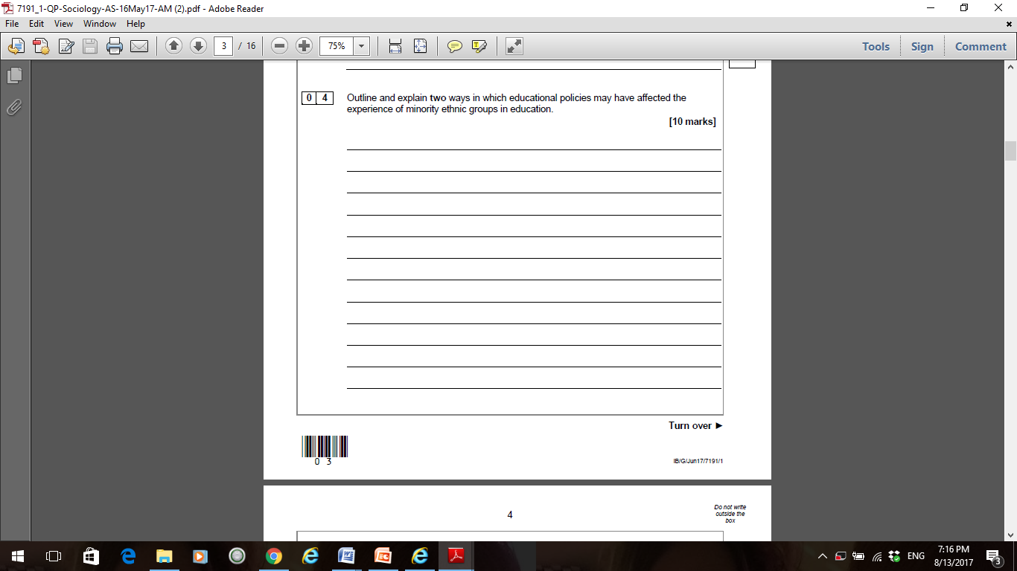



Q.5

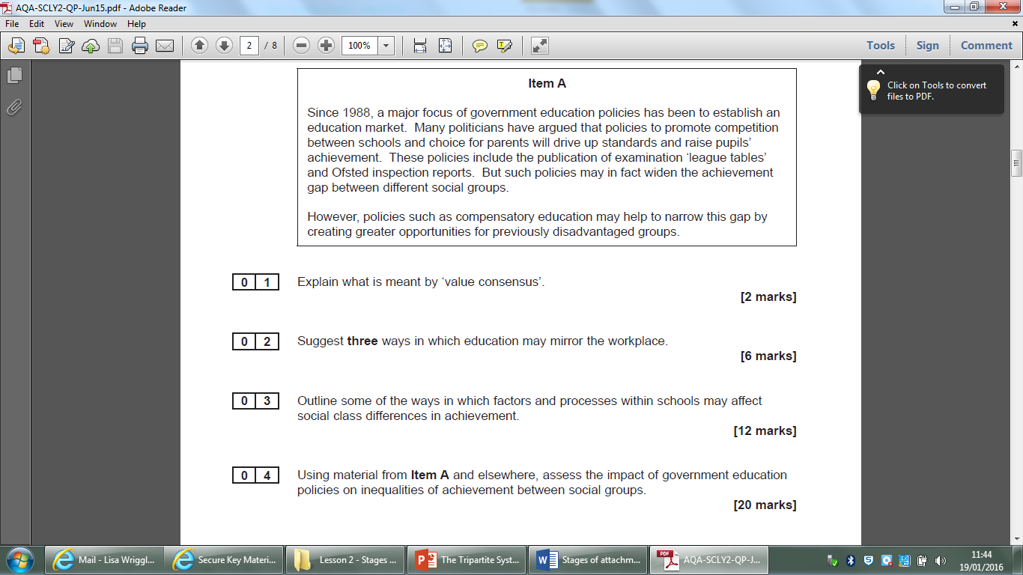



(30 marks)