Year 2 Sociology

**Paper 3: Crime and Deviance with Theory & Methods**

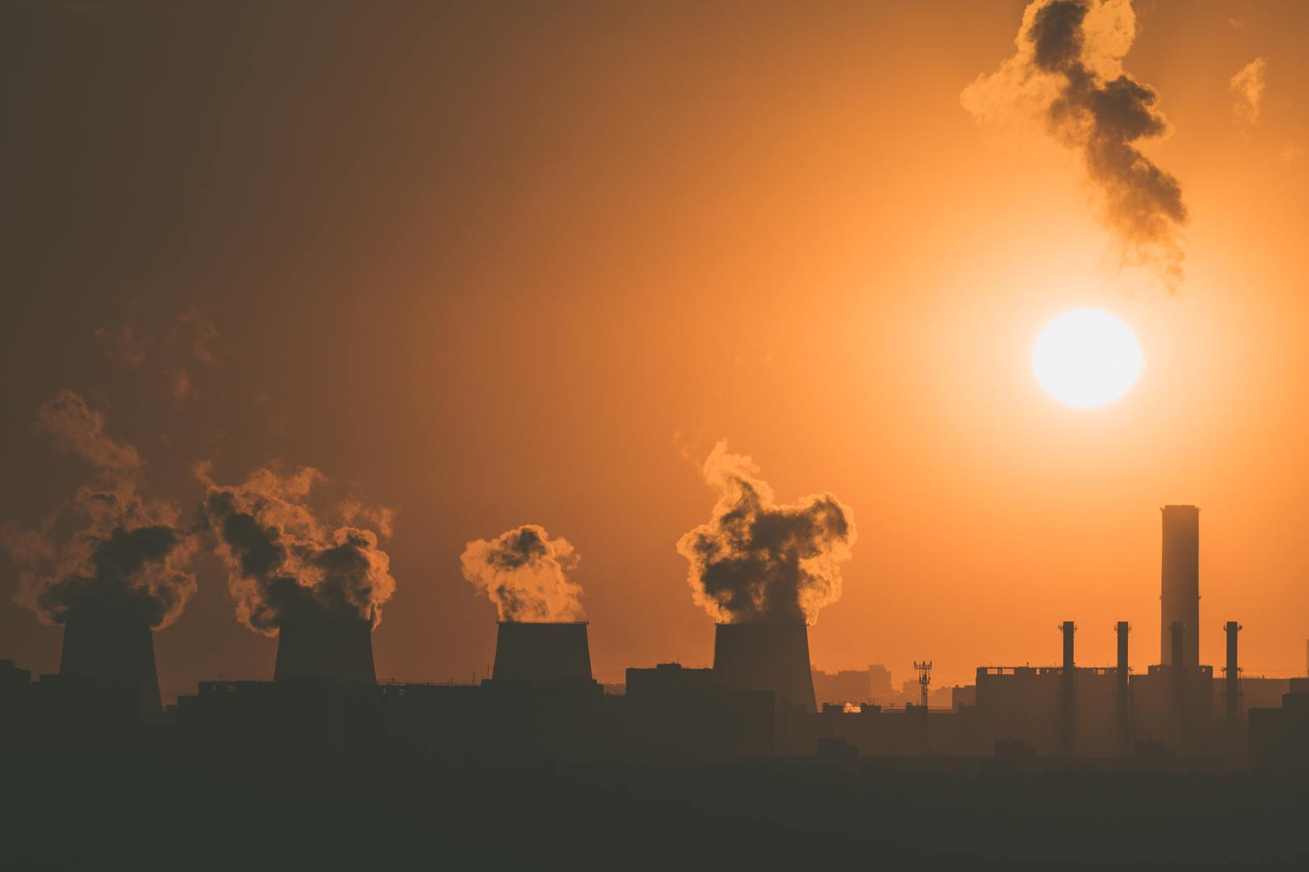

 Booklet 7 part 3: Globalisation and crime in contemporary society; the media and crime; green crime; human rights and state crimes.

Part 3 – green crime.

Name ______________________________

Specification Content:

What you need to know for **Crime and Deviance** in your Paper 3 exam.

Students are expected to be familiar with sociological explanations of the following content:

* globalisation and crime in contemporary society; the media and crime; green crime; human rights and state crimes

|  |  |  |  |  |  |
| --- | --- | --- | --- | --- | --- |
| **Questions may be based specifically on the following areas:** | | Do I have completed Notes? | Have I made revision Notes? | Have I memorised this info? | Have I practised exam style questions? |
| Globalisation | Globalisation and crime in contemporary society, eg transnational organised crime, global criminal organisations, global capitalism and crimes of the powerful.  **Castells, Held, Taylor, Hobbs & Dunningham, Glenny** |  |  |  |  |
| Media | The media and crime, eg media representations of crime, the media as a cause of crime and moral panics.  **S.Cohen, Young, Jewkes, McRobbie & Thornton** |  |  |  |  |
| Green crime | Green crime, eg types of green crime and green criminology.  **South, Beck, White** |  |  |  |  |
| Human rights | Human rights and state crimes, eg war, genocide and torture, and human rights abuses.  **McLaughlin, H & J Schwendinger** |  |  |  |  |

Exam Structure:

**These topics will appear in paper 3 of the A’Level.** 2 hour written exam 80 marks in total (50 for this bit)

* 33.3% of A-level

Crime and Deviance: short answer and extended writing, 50 marks (4 marks, 6 marks, 10 marks, 30 marks)

Green or environmental crime is crime against the environment. It is linked to globalisation in many ways. The world is divided into nation states but the planet is one single eco-system. Atmospheric pollution from one industry in one country could turn into acid rain in another.

Examples might include

* Climate change
* Waste disposal
* Nuclear power
* Genetically modified crops
* Extinction of endangered species

Where have we met Green Crime before? (p134 for more info)

Is Green Crime illegal?

It is difficult to define Green Crime as crime. Some actions may be illegal in some countries but not in others. Laws and regulations may change over time.

‘Global risk society’ and the environment

Threats to the environment are man-made not natural.

Beck argues that in the past environmental disasters were of natural origin (droughts / famine, flooding) BUT in ‘late-modern’ societies there are new kinds of risks which come through science and technology. Our society we can provide adequate resources for everyone BUT we have new ‘manufactured risks’ as we have a big increase in technology and productivity. Many of these risks include harm to the environment eg global warming. These risks are global not local so Beck calls late modern society the ‘global risk‘ society.

Case study Mozambique 2010

White illustrates the globalised character of environmental harm by the way transnational companies move manufacturing operations to the ‘Global South’ (developing countries eg Brazil, India, China, Turkey) to avoid pollution laws. They may illegally dump European waste or send it for processing in developing countries.

Who commits Green crime?



States

Individualss



Organised crime

Private business

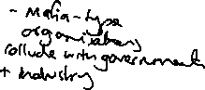

Who are the victims?

Wolf points out that there are inequalities in the distribution of harm. Working class, poor, and minority ethnic groups are more likely to be victims of Green crime. Those in the developing world are more at risk.



Green criminology

What if pollution is actually perfectly legal? What do criminologists say?



Governments make laws so what is legal in one country may not be legal in another so companies could just move. Governments make the rules so they can choose not to criminalise activities that make them money.

Traditional criminology has not been concerned with Green Crime. Criminology looks at criminal law and in most cases no law has been broken. There is an advantage of this approach in that our definitions are clear.



Green criminology takes a more radical approach looking at *harm* rather than *law*. Rob White argues that criminology should look at any action which harms the physical environment and / or the humans and animals within it – even if no law is broken. We would call ‘green criminology’ a ‘transgressive’ criminology as it oversteps (or transgresses) the boundaries of traditions criminology to include new issues. Zemiology = the ‘study of harms’.



White also claims that green crime arises because transnational companies and nation states have an *anthropocentric* view of the world (this means a view that only *their* humans are important). Their most important consideration is that their own citizens have well-being through economic development and the environment is secondary to this.



White suggests another view of harm is more useful *ecocentric* this would see humans and their environment as interdependent so that when the environment is harmed humans are also harmed. White thinks the ecocentric view should be the basis for judging environmental harm.



Explanations for Green crime

Wolf – same as ordinary crime. Rational choice, strain, control and Marxist theories. Individuals and companies are motivated to break rules or commit harm because the rewards are great. Eg reducing financial cost, personal hassle associated with responsible disposal of household waste, weak sanctions and offences not really being regarded as wrong.

Marxist approach

Remember work done earlier in the course on ‘crimes of the powerful’ (Pearce)? Companies will aim to minimise cost and maximise profits. Green criminologists would argue that those in power can shape the law and define what is a crime. Snider argues that states are reluctant to pass laws relating to pollution etc that would impact on private businesses and would only stop when pressured by public opposition / environmental crises. They will strengthen these laws reluctantly and enforce them weakly. Like white collar crime and corporate crime in general, environmental crime has less stigma than conventional crimes.

Types of green crime?

|  |  |
| --- | --- |
| Primary South identifies 4 types | Secondary South identifies two types |
|  |  |

Problems with researching Green Crime for sociologists (use Brown 510)

|  |  |
| --- | --- |
| 1. Different laws |  |
| 1. Different definitions |  |
| 1. Difficulties in measurement |  |
| 1. Use of case studies |  |

Is Green Criminology a good approach ?

Recognises the growing importance of environmental issues and the need to address these. Puts green crime in a wider context of state crime and corporate crime and links to ‘manufactured risk’ and ‘global risk society’ (Beck)

By focussing on a broader definition of harm rather than legally defined crimes it is hard to define the boundaries of this area of study. It is more about values than what can be established objectively?

Eye on the exam.

Outline **two** problems in measuring green crime (4)

**10 MARK – USING THE ITEM**

**Item A**

Some commentators argue that harm to the environment is an inevitable part of late modern society. Since no laws are broken, they do not consider it to be a crime. For others, the harm we do to the environment, often in the name of progress, is not just damage but green crime. Environmental damage does not respect national borders. There are many different types of green crime, all of which are related to human activities.

Applying material from **Item A**, analyse **two** ways in which green crime and globalisation may be related. **[10 marks]**