

**Higher IGCSE (9 – 1) Revision Pack**

**Arcs, Sectors and Segments**

**Name --------------------------------**

**Questions**

**Q1.**

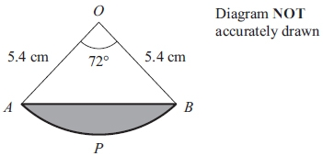

The diagram shows a sector *OAPB* of a circle, centre *O*.  
*AB* is a chord of the circle.  
*OA* = *OB* = 5.4 cm.  
 Angle *AOB* = 72º

Calculate the area of the shaded segment *APB*.  
 Give your answer correct to 3 significant figures.

...........................................................cm2

**(Total for question = 5 marks)**

**Q2.**

Here is a shape.

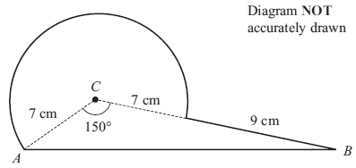

The shape is made from triangle *ABC* and a sector of a circle, centre *C* and radius *CA*.  
*CA* = 7 cm.  
*CB* = 16 cm.  
 Angle *ACB* = 150°

Calculate the area of the shape.   
Give your answer correct to 3 significant figures.

...........................................................cm2

**(Total for question = 6 marks)**

**Q3.**

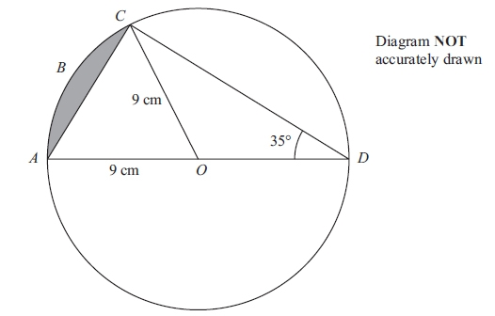

*AOD* is a diameter of a circle, with centre *O* and radius 9 cm.   
*ABC* is an arc of the circle.   
*AC* is a chord.   
Angle *ADC* = 35°

Calculate the area of the shaded segment.   
Give your answer correct to 3 significant figures.

........................................................... cm2

**(Total for question is 6 marks)**

**Q4.**

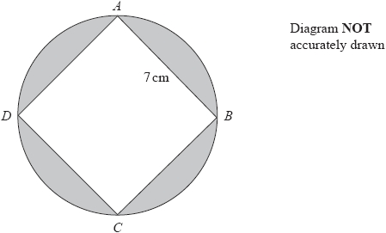

*A*, *B*, *C* and *D* are points on a circle.   
*ABCD* is a square of side 7 cm.

Work out the total area of the shaded regions.   
Give your answer correct to the nearest whole number.

........................................................... cm2

**(Total for question = 5 marks)**

**Q5.**

The diagram shows a sector *OAPB* of a circle, centre *O*.

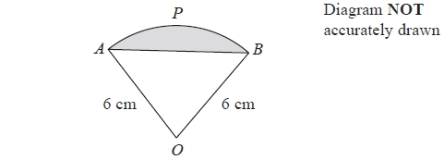

*AB* is a chord of the circle.   
*OA* = *OB* = 6 cm.

The area of sector *OAPB* is 5π cm2

Calculate the perimeter of the shaded segment.   
Give your answer correct to 3 significant figures.

........................................................... cm

**(Total for question = 6 marks)**

**Q6.**

The diagram shows sector *OAB* of a circle, centre *O*.

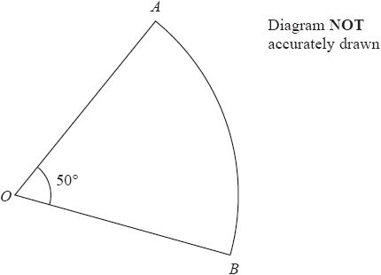

Angle *AOB* = 50°   
Sector *OAB* has area 20π cm2

Calculate the perimeter of sector *OAB*.   
Give your answer correct to 3 significant figures.

........................................................... cm

**(Total for question = 5 marks)**

**Q7.**

The diagram shows triangle *KLM*.

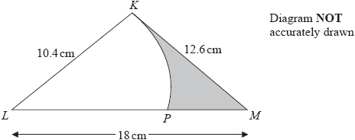

*KLP* is a sector of a circle with centre *L* and radius 10.4 cm.   
The region of the triangle outside the sector is shown shaded in the diagram.

Calculate the area of the shaded region.   
Give your answer correct to 3 significant figures.

........................................................... cm2

**(Total for question = 5 marks)**

**Q8.**

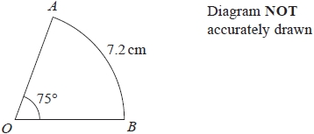

The diagram shows a sector *OAB* of a circle, centre *O*.

Angle *AOB* = 75°   
Length of arc *AB* = 7.2 cm

Calculate the area of the sector.   
Give your answer correct to 3 significant figures.

........................................................... cm2

**(Total for question = 4 marks)**

**Q9.**

The shape *OABC* is made from a triangle and a sector of a circle.

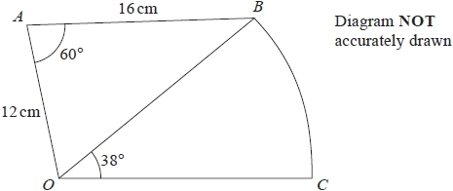

*OAB* is a triangle.   
*OBC* is a sector of a circle, centre *O*.

*OA* = 12 cm   
*AB* = 16 cm   
Angle *OAB* = 60°   
Angle *BOC* = 38°

Work out the area of *OABC*.   
Give your answer correct to 3 significant figures.

........................................................... cm2

**(Total for question = 5 marks)**

**Q10.**

The diagram shows a sector *OBC* of a circle with centre *O* and radius (6 + *x*) cm.

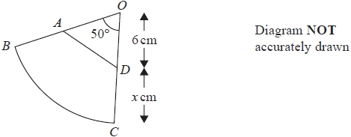

*A* is the point on *OB* and *D* is the point on *OC* such that *OA* = *OD* = 6 cm

Angle *BOC* = 50°

Given that

the perimeter of sector *OBC* = 2 × the perimeter of triangle *OAD*

find the value of *x*.   
Give your answer correct to 3 significant figures.

*x* = ...........................................................

**(Total for question = 6 marks)**

**Q11.**

The diagram shows a metal plate.

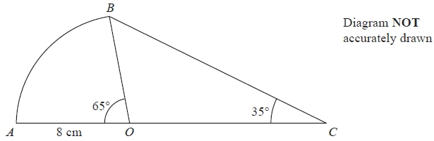

The metal plate is made from a sector *OAB* of a circle, centre *O*, and a triangle *OCB*.

Angle *AOB* = 65° Angle *OCB* = 35°   
*OA* = *OB* = 8 cm.   
*AOC* is a straight line.

(a)   Calculate the length of *BC*.   
Give your answer correct to 3 significant figures.

........................................................... cm

**(3)**

(b)   Calculate the total area of the metal plate.   
Give your answer correct to 3 significant figures.

........................................................... cm2

**(4)**

**(Total for Question is 7 marks)**

**Q12.**

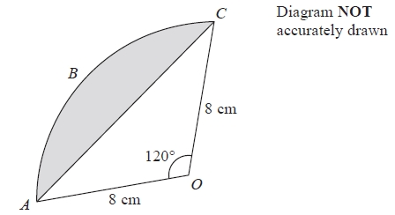

*ABC* is an arc of a circle with centre *O* and radius 8 cm.   
*AC* is a chord of the circle.   
Angle *AOC* = 120°

Calculate the perimeter of the shaded segment.   
Give your answer correct to 3 significant figures.

........................................................... cm

**(Total for question = 5 marks)**

**Q13.**

The diagram shows a shaded shape *ABCD* made from a semicircle *ABC* and a   
right-angled triangle *ACD*.

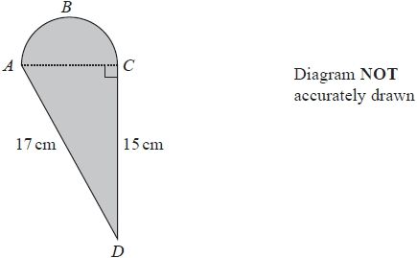

*AC* is the diameter of the semicircle *ABC*.

Work out the perimeter of the shaded shape.   
Give your answer correct to 3 significant figures.

........................................................... cm

**(Total for question = 5 marks)**

**Q14.**

The diagram shows a right-angled triangle.

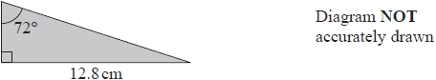

Five of these triangles are put together to make a shape.

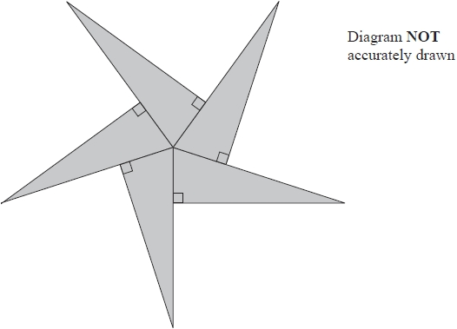

Calculate the perimeter of the shape.   
Give your answer correct to 3 significant figures.

........................................................... cm

**(Total for question = 5 marks)**

**Q15.**

The diagram shows a right-angled triangle.

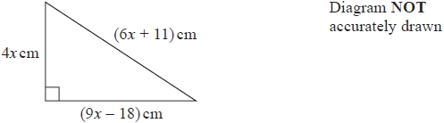

The perimeter of the triangle is 126 cm.

Work out the area of the triangle.

........................................................... cm2

**(Total for question = 4 marks)**

**End of questions**