

**Higher IGCSE (9 – 1) Revision Pack**

**Angles and Geometrical Reasoning**

**Name --------------------------------**

**Questions**

**Q1.**

The diagram shows a triangle.

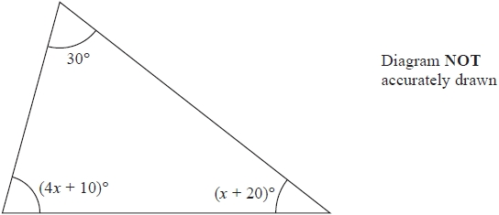

Work out the value of *x*.

*x* = ...........................................................

**(Total for question = 4 marks)**

**Q2.**

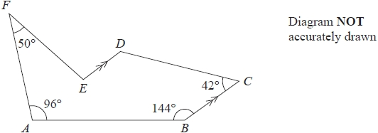

The diagram shows a hexagon *ABCDEF*.   
*BC* is parallel to *ED*.

Work out the size of the obtuse angle *DEF*.

........................................................... °

**(Total for question = 5 marks)**

**Q3.**

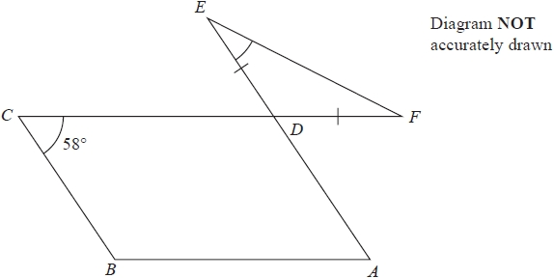

The diagram shows a parallelogram *ABCD* and an isosceles triangle *DEF* in which *DE* = *DF*

*CDF* and *ADE* are straight lines.   
Angle *BCD* = 58°

Work out the size of angle *DEF*.   
Give a reason for each stage of your working.

........................................................... °

**(Total for question = 5 marks)**

**Q4.**

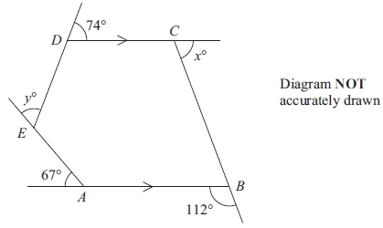

The diagram shows a pentagon *ABCDE*.  
*DC* is parallel to *AB*.

The size of an exterior angle at *A* is 67  
 The size of an exterior angle at *B* is 112  
 The size of an exterior angle at *C* is *x*  
 The size of an exterior angle at *D* is 74  
 The size of an exterior angle at *E* is *y*

(a) (i) Work out the value of *x*.

*x* = ...........................................................

(ii) Work out the value of *y*.

*y* = ...........................................................

**(4)**

(b) Work out the sum of the interior angles of the pentagon *ABCDE*.

...........................................................°

**(2)**

**(Total for question = 6 marks)**

**Q5.**

Work out the size of each exterior angle of a regular polygon with 15 sides.

........................................................... °

**(Total for Question is 2 marks)**

**Q6.**

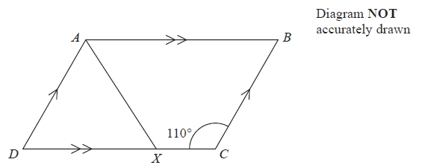

*ABCD* is a parallelogram.   
Angle *DCB* = 110°   
*X* is the point on *DC* such that *AX* bisects the angle *DAB*.

Calculate the size of angle *AXC*.

........................................................... °

**(Total for question = 4 marks)**

**Q7.**

Here is a regular 10-sided polygon.

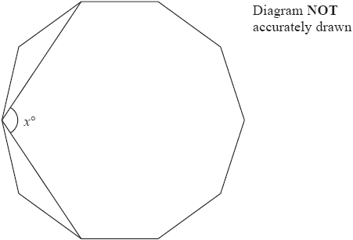

Work out the value of *x*.   
Show your working clearly.

*x* = ...........................................................

**(Total for question = 4 marks)**

**Q8.**

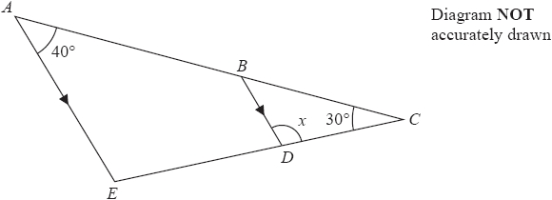

*ABC* and *EDC* are straight lines.   
*AE* is parallel to *BD*.   
Angle *EAC* = 40°   
Angle *ACE* = 30°   
  
Work out the size of angle *x*.   
Give reasons for your answer.

*x* = ........................................................... °

**(Total for question = 3 marks)**

**Q9.**

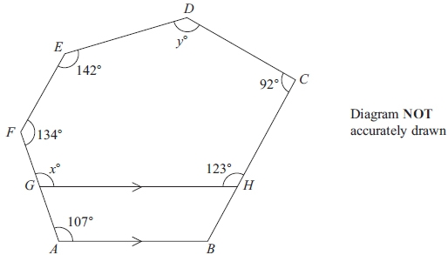

*ABCDEF* is a hexagon.  
*G* is a point on *AF*.  
*H* is a point on *BC*.  
*GH* is parallel to *AB*.

(a) Give a reason why *x* = 107

      ..............................................................................................................................................

**(1)**

(b) Work out the value of *y*.

*y* = ...........................................................

**(4)**

**(Total for question = 5 marks)**

**Q10.**

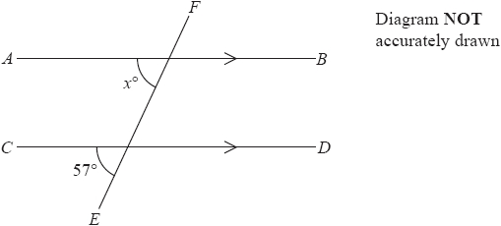

*AB* is parallel to *CD*  
*EF* is a straight line.

(a)  (i)  Find the value of *x*

*x* = ...........................................................

(ii)  Give a reason for your answer.

.............................................................................................................................................

.............................................................................................................................................

**(2)**

Here is a pentagon.

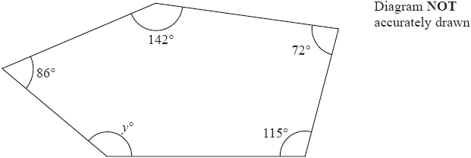

(b)  Work out the value of *y*.

*y* = ...........................................................

**(3)**

**(Total for question = 5 marks)**

**Q11.**

Each interior angle of a regular polygon is 156°

Work out the number of sides of the polygon.

...........................................................

**(Total for question = 3 marks)**

**Q12.**

Work out the size of an exterior angle of a regular polygon with 8 sides.

........................................................... °

**(Total for question = 2 marks)**

**Q13.**

The size of each interior angle of a regular polygon with *n* sides is 140°

Work out the size of each interior angle of a regular polygon with 2*n* sides.

........................................................... °

**(Total for question = 5 marks)**

**Q14.**

(a)  Find the sum of the interior angles of a polygon with 7 sides.

........................................................... °

**(2)**

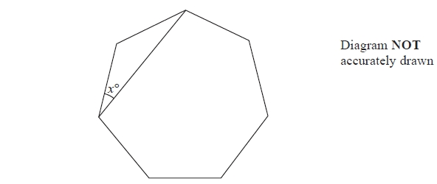

The diagram shows a regular polygon with 7 sides.

(b)  Work out the value of *x*.   
       Give your answer correct to 1 decimal place.

...........................................................

**(2)**

**(Total for question = 4 marks)**

**Q15.**

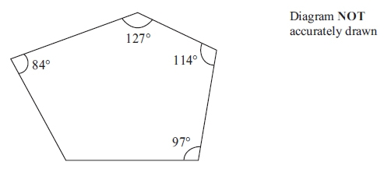

Four of the angles of a pentagon are 97°, 114°, 127° and 84°.

Work out the size of the fifth angle.

...........................................................°

**(2)**

**(Total for question = 4 marks)**

**Q16.**



The diagram shows part of a regular polygon.   
The interior angle and the exterior angle at a vertex are marked.   
The size of the interior angle is 7 times the size of the exterior angle.

Work out the number of sides of the polygon.

...........................................................

**(Total for Question is 3 marks)**

**Q17.**

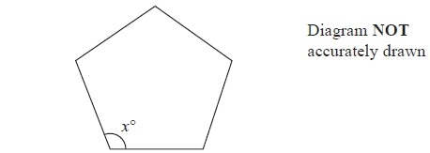

The diagram shows a regular 5-sided polygon.

(a)  Work out the value of *x*.

*x* = ...........................................................

**(2)**

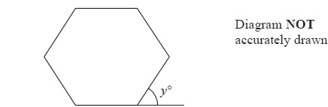

The diagram shows a regular 6-sided polygon.

(b)  Work out the value of *y*.

*y* = ...........................................................

**(2)**

**(Total for Question is 4 marks)**

**Q18.**

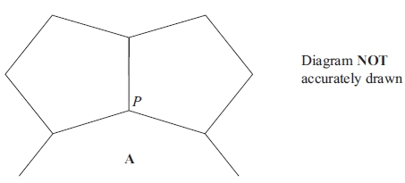

The diagram shows two congruent regular pentagons and part of a regular *n*-sided  
 polygon **A**.  
 Two sides of each of the regular pentagons and two sides of **A** meet at the point *P*.

Calculate the value of *n*.  
 Show your working clearly.

*n* = ...........................................................

**(Total for question = 5 marks)**

**Q19.**

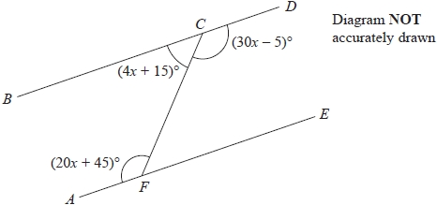

*BCD* and *AFE* are straight lines.

Show that *BCD* is parallel to *AFE*.   
Give reasons for your working.

**(Total for question = 5 marks)**

**Q20.**

Here is a 10-sided polygon.

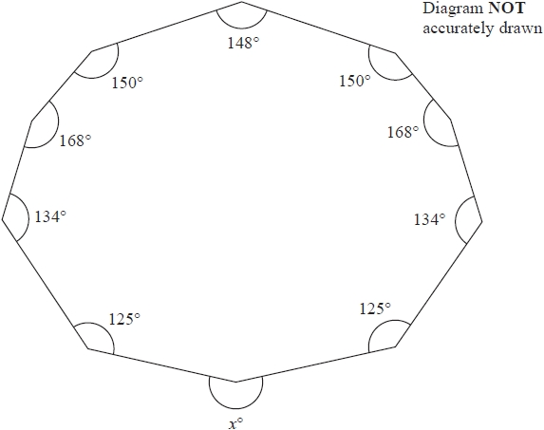

Work out the value of *x*.

*x* = ...........................................................

**(Total for question = 4 marks)**

**Q21.**

The diagram shows an incomplete regular polygon.

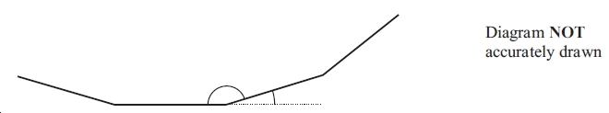

The size of each interior angle is 140 degrees greater than the size of each exterior angle.

Work out the number of sides the regular polygon has.

...............................

**(Total for question = 4 marks)**

**Q22.**

The diagram shows two congruent regular pentagons drawn inside a regular octagon.

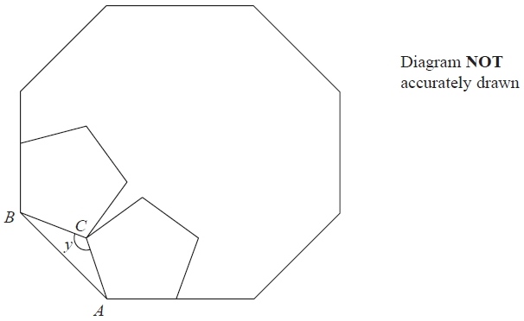

One side of each pentagon lies along a side of the octagon.

*AB* is a side of the octagon.   
*AC* is a side of one of the pentagons.   
*BC* is a side of the other pentagon.

Work out the size of angle *y*.   
Show your working clearly.

........................................................... °

**(Total for question = 5 marks)**

**Q23.**

Each exterior angle of a regular polygon is 15°

(a)  How many sides has the regular polygon?

...........................................................

**(2)**

The diagram shows 3 identical regular pentagons.

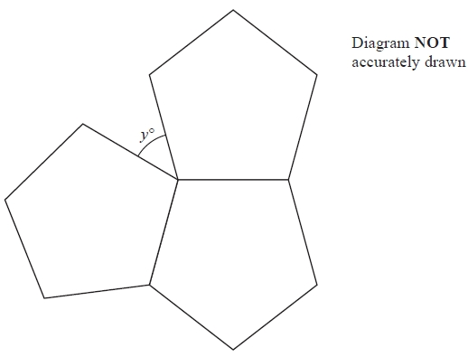

(b)  Work out the value of *y*.

*y* = ...........................................................

**(3)**

**(Total for question = 5 marks)**

**Q24.**

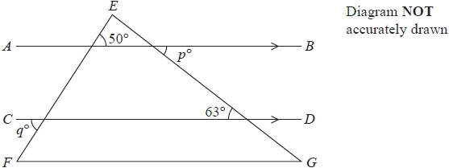

*EFG* is a triangle.   
*AB* is parallel to *CD*.

(a)  Write down the value of *p*

*p* = ...........................................................

**(1)**

(b)  Write down the value of *q*

*q* = ...........................................................

**(1)**

Here is a hexagon.

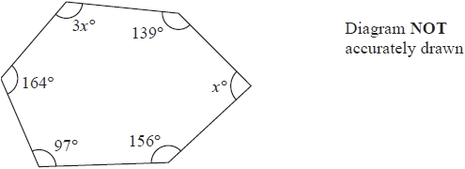

(c)  Work out the value of *x*

*x* = ...........................................................

**(3)**

**(Total for question = 5 marks)**

**Q25.**

Each exterior angle of a regular polygon is 18°

Work out the number of sides of this regular polygon.

...........................................................

**(Total for question = 2 marks)**

**Q26.**

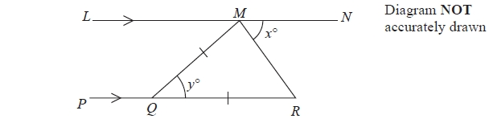

*LMN* is parallel to *PQR*.   
*QM* = *QR*.   
Angle *RMN* = *x*°   
Angle *MQR* = *y*°

(a)  Write down an expression for *y* in terms of *x*.

*y* = ...........................................................

**(2)**

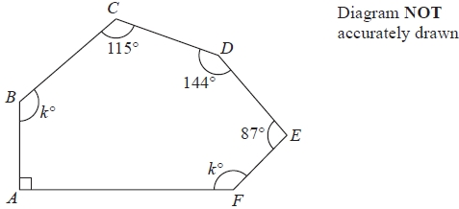

*ABCDEF* is a hexagon.

(b)  Work out the value of *k*.

*k* = ...........................................................

**(4)**

**(Total for question = 6 marks)**

**End of questions**