**The Iliad – Book 9**

**Read lines 1-51**

‘…so the Greek morale was shattered.’ Sketch the simile used to illustrate this state of panic, including as much detail as possible.

Select three quotes that demonstrate that Agamemnon is demoralized and three that show Diomedes remains resolute:

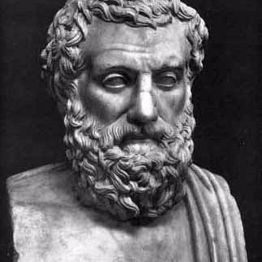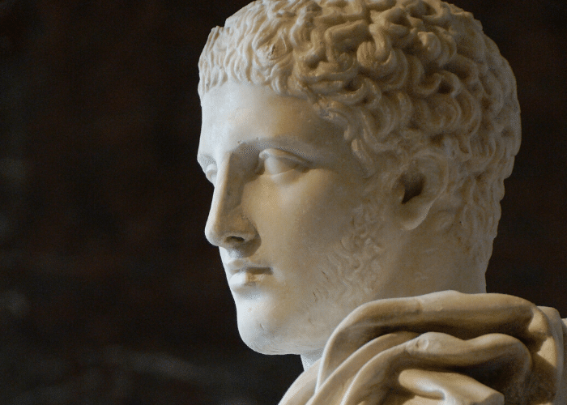

Why does Diomedes think he has the right to rebuke Agamemnon?

What has he done since he last spoke to Agamemnon to justify him suggesting he has proved himself to all the Achaeans?



How does Agamemnon realise he has been a victim of *ate*?

**Read lines 52-182**

How does Nestor compare Diomedes’ right to speak to his own?

**Nestor**

**Diomedes**

What **two** things do we learn about the Achaean nighttime defences?

How does Nestor begin by complementing Agamemnon and then shift to giving advice?

|  |  |
| --- | --- |
| Complement | Advice |
|  | Provide *xenia*: |
|  | Reconcile with Achilles: |



How does Agamemnon admit he has been a victim of *ate* again?

What does Agamemnon say he will do to bring Achilles back on side?

Why do you think the following men are chosen for the embassy:

***Phoenix:***

***Ajax:***

***Odysseus:***

Why do you think Nestor glanced ‘with an especial eye for Odysseus’?

**Read lines 183-224**

What impression do you get of Achilles as the envoys arrive at his tent?

List all the things done in the offering of *xenia* by Achilles and Patroclus:



**Read lines 225-429**

How do the following images represent Odysseus’ key arguments for Achilles to rejoin the fray? Explain why you think they might affect Achilles.

|  |  |
| --- | --- |
| Cartoon zeus holding thunderbolt Royalty Free Vector Image |  |
| Toxic masculinity fostered by misreadings of the classics |  |
| Ancient greek old man with a staff Royalty Free Vector Image |  |
| Download Gift Present Emoji Icon | Emoji Island |  |
| Mario Puzo at 100: The Godfather author never met a real gangster, but his  mafia melodrama remains timeless | The Independent |  |

Summarise all of Odysseus’ arguments and Achilles’ own feelings in the following diagram. For each of Achilles’ responses, find a single quote that epitomises it and write it next to the diagram.



**Odysseus’ arguments:**

**Achilles**

**Odysseus’ arguments:**

**BLAH**

**BLAH**

**BLAH**

***Ate***

**Achilles**

How well do you think Achilles addresses each of Odysseus’ arguments?

**Read lines 430-624**

Divide Phoenix’s story of how he came to be in Phthia into six parts. On either side, explain how the paragraphs either side of this story mirror one another in content.

|  |  |  |
| --- | --- | --- |
|  |  |  |
|  |  |  |

How and why is the theme of father and son explored in Phoenix’s opening story and accompanying moral?

In one colour, describe how and why people respect the Litae, and in another colour describe how this applies to Achilles.

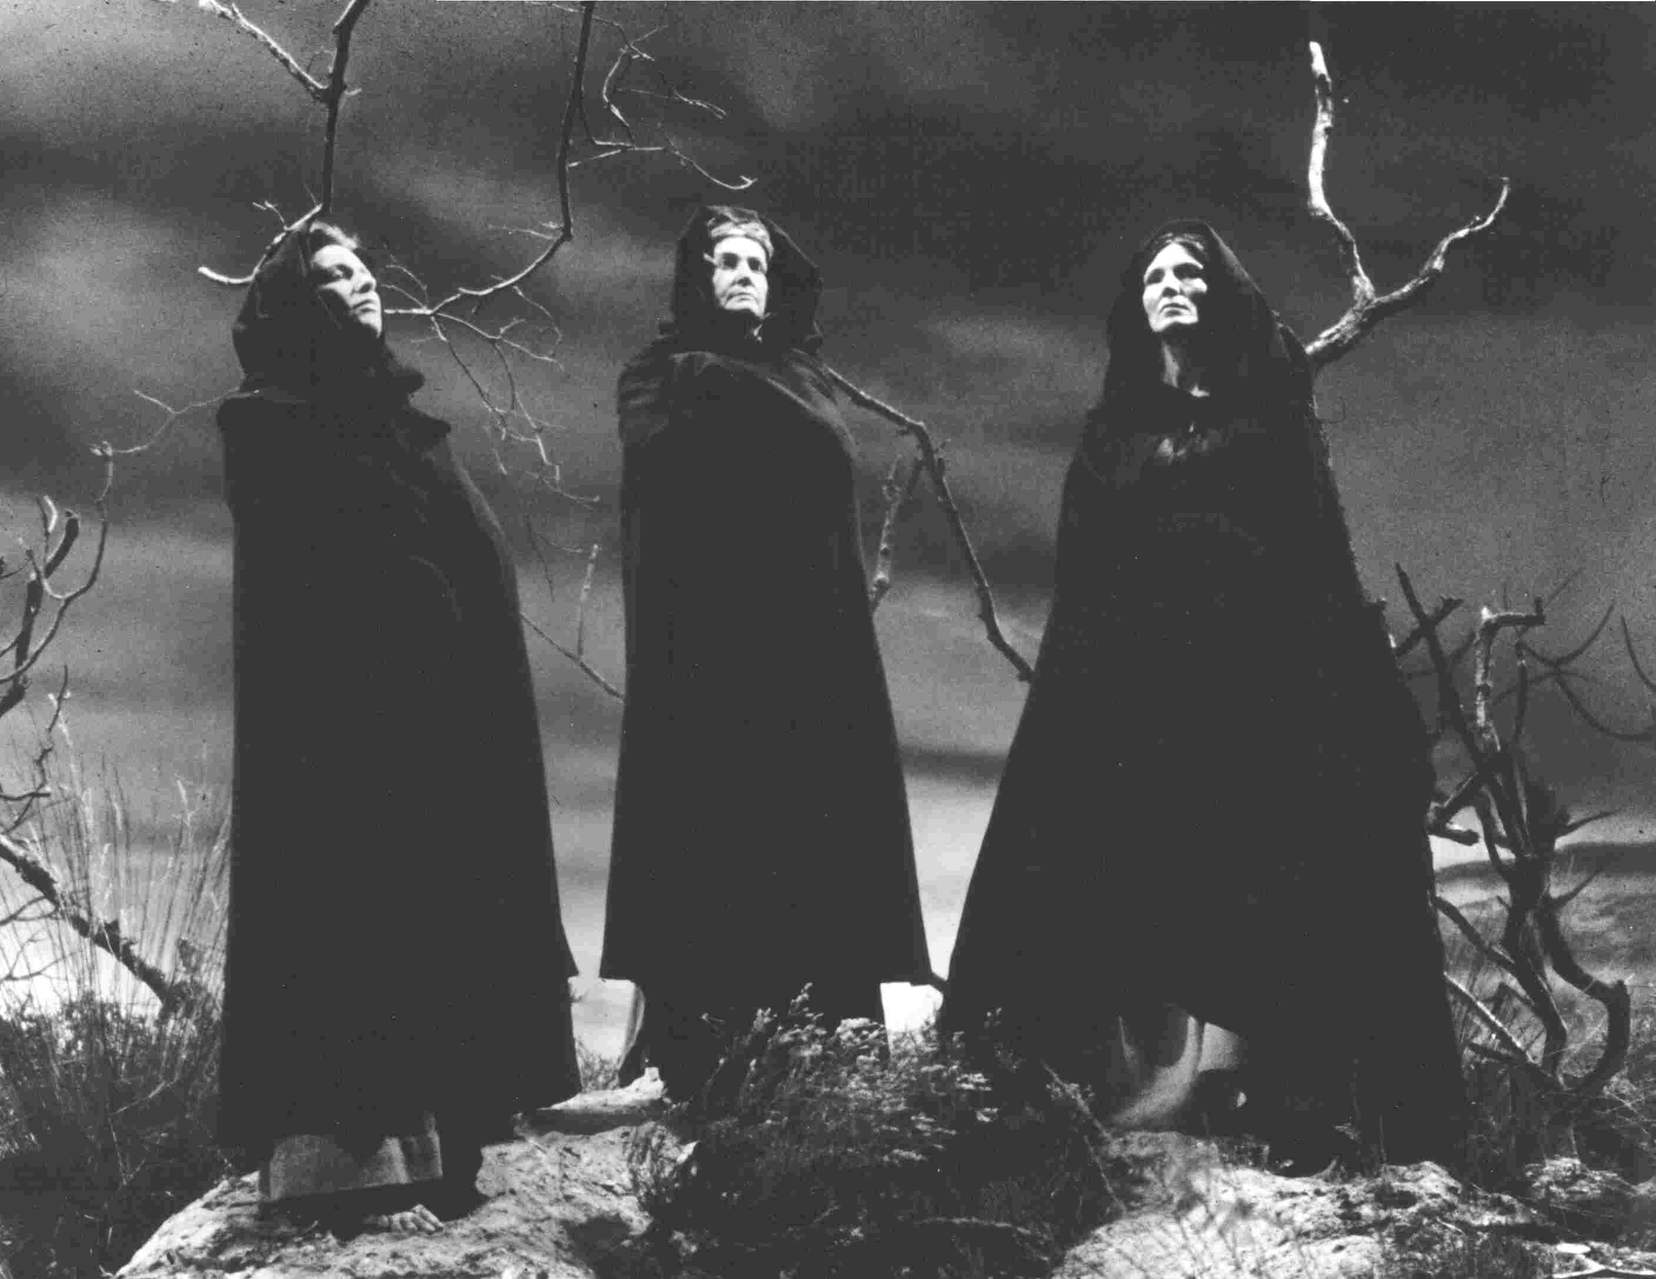

What parallels can you find between the story of Meleager and Achilles’ own situation? Try to list as many as you possibly can.

**Meleager**

**Achilles**

What details of the story of Meleager do you know, which Homer has missed out?

Do you think that the story of Meleager fits well into Phoenix’s speech?

How can you tell that Phoenix is dear to Achilles from the way he responds to him?

**Read lines 625-658**

What is Ajax’s opening tactic when speaking?

Complete the following to summarise Ajax’s basic point:



**EVERYONE ELSE WHEN… ACHILLES WHEN…**

Mark where you think Achilles’ anger is after **each** speech he hears. Explain your choices in detail.

**Read lines 659-712**

What atmosphere do you think Homer tries to convey in describing Achilles’ tent as he, Phoenix and Patroclus retire?

How does each of the characters respond to the next?

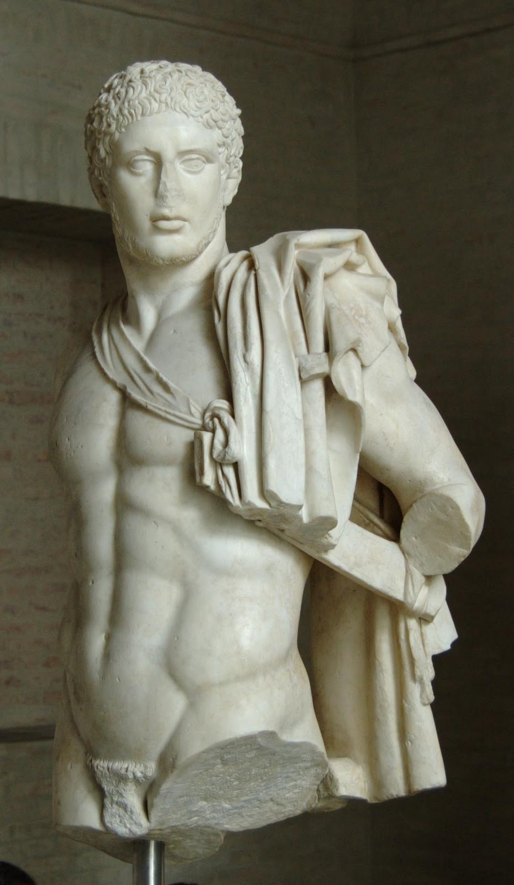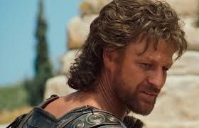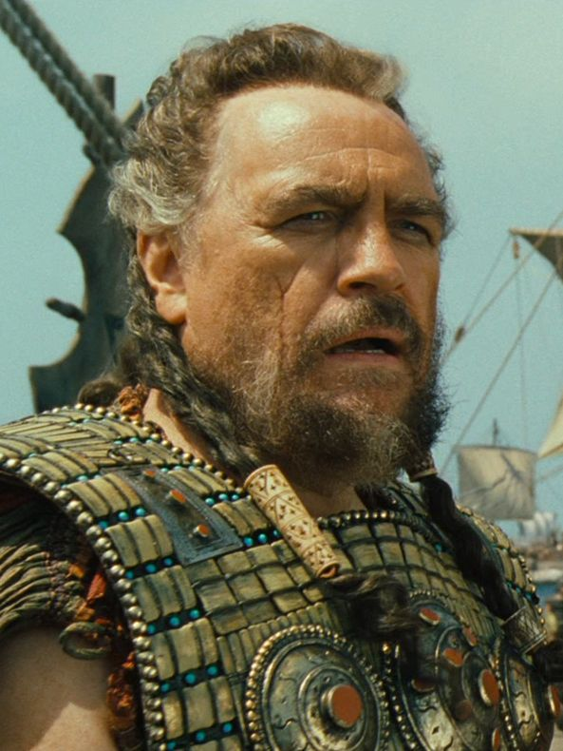

**Agememnon Odysseus Diomedes**

Create a bar graph to show how compelling you think the arguments of the three envoys were. The height of the bar should reflect the quality of their arguments and inside you should explain what impressed you about their speeches:

**Quality**

**Ajax**

**Phoenix**

**Odysseus**