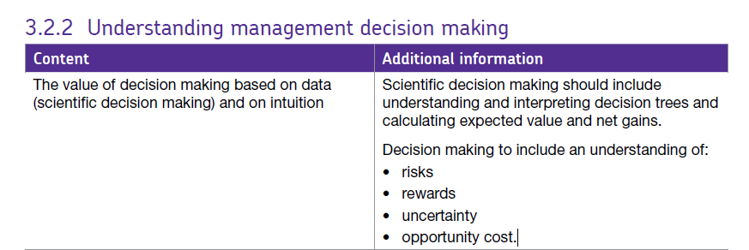3.2.2 Influences on Decision Making

The approach taken to making business decisions is influenced by a variety of factors, the key ones of which are outlined below:

**Business Objectives / Budgets**

Objectives and budget are the background against which decisions are made, a culture of strong budgetary control would encourage more data & evidence-driven decisions

**Organisational Structure - Who Makes the Decisions?**

Who has authority to take decisions? Are employees to empowered to take decisions to deliver more responsive customer service - is decision-making centralised or decentralised?

**Attitude to Risk**

Is risk-taking encouraged and are there penalties for poor decisions?

**Availability & Reliability of Data**

Is sufficient data available to support a scientific approach and are management comfortable with using scientific methods? Do they have the right skills and experience?

**The External Environment**

How fast is the external environment changing?

Do the uncertainties in the external environment make scientific approaches less reliable?

# Scientific Decision Making

The scientific approach to decision-making involves the use of data and logic as opposed to hunch and intuition.

## What is Scientific Decision Making?

All business decisions involve some uncertainty. However businesses and managers increasingly want to reduce that uncertainty and risk by applying logic to decision-making, supported by relevant data.

Scientific decision-making involves the use of:

* Data mining and big data to source relevant data to inform decisions
* Application of software logic and predictive models to analyse scenarios
* Forecasts to consider the possible implications of business decisions

Quite a few of the models you explore as a business student can be linked to scientific decision-making (although they also involve some qualitative judgement), including:

* Decision trees
* Investment appraisal
* Sales forecasting
* Sensitivity analysis
* Network analysis

## Reasons Why Scientific Decision Making is Becoming More Popular

* More widespread availability of data
* Greater sophistication of data analytics & skills / experience of data analysts
* Management expectation that data will be used wherever possible, particularly where a decision is significant to the business

# Hunch and Intuition in Decision Making

Many business decisions are taken not just on the basis of data and analysis, but using the intuition or hunch of the decision maker.

Intuition refers to the use of "gut feeling" to make decisions rather than rely on a more scientific approach using data and other quantitative evidence, supported by logical, rational decision-making models.

The potential advantages of hunch and intuition in decision-making include:

**Speed** - decision-making can be instant, rather than waiting for the results of scientific data analysis!

**Based on personal experience:** data isn't always reliable and a manager may feel more comfortable with the gut feeling if it seems to contradict the results suggested by data

Of course intuition and hunch is pretty unsuitable for certain business decisions, particularly those that involve a higher degree of risk for a business (e.g. a new product, takeover or other major investment).

Often intuition and hunch are combined with scientific approaches to reach a sensible decision.

A good example is investment appraisal. The scientific element involves identifying and quantifying the investment costs and returns. The intuition is based on determining the appropriate discount factors to apply and managerial judgement to interpret the results.

# Opportunity Costs and Trade-Offs

Opportunity cost is the cost of missing out on the next best alternative. In other words, opportunity cost represents the benefits that could have been gained by taking a different decision.

All businesses have to make choices - and those choices have implications.

In business, resources are usually scarce or limited. Decision are made under circumstances of uncertainty and taking one course of action or decision may affect business ability to take an alternative action.

Opportunity cost measures the cost of a choice made in terms of the next best alternative foregone or sacrificed.

**Examples of Opportunity Cost in the Business & Economic Environment**

**Work-leisure choices**

The opportunity cost of deciding not to work an extra ten hours a week is the lost wages given up.

**Government spending priorities**

The opportunity cost of the government spending an extra £10 billion on investment in National Health Service might be that £10 billion less is available for spending on education or defence equipment.

**Investing today for consumption tomorrow**

The opportunity cost of an economy investing resources in new capital goods is the production of consumer goods given up for today.

**Use of scarce farming land**

The opportunity cost of using farmland to grow wheat for bio-fuel means that there is less wheat available for food production, causing food prices to rise

**Trade-offs**

A trade-off arises where having more of one thing potentially results in having less of another. The table below lists some examples of how trade-offs often arise in business - as a result of resource scarcity.