Year 1 Sociology

**Paper 1: Education with Theory and Methods**





Education

Booklet 3: Differential Educational Achievement of Social Groups: **Social Class**

Name:_____________________________Class:________

Specification Content:

**What you need to know for Education in your Paper 1 exam:**

You will be expected to:

* The role and functions of the education system, including its relationship to the economy and to class structure
* Differential educational achievement of social groups by social class, gender and ethnicity in contemporary society
* Relationships and processes within schools, with particular reference to teacher/pupil relationships, pupil identities and subcultures, the hidden curriculum, and the organisation of teaching and learning
* The significance of educational policies, including policies of selection, marketisation and privatisation, and policies to achieve greater equality of opportunity or outcome, for an understanding of the structure, role, impact and experience of and access to education; the impact of globalisation on educational policy.

|  |  |  |  |  |  |
| --- | --- | --- | --- | --- | --- |
| **Questions may be based specifically on the following areas:** | | Do I have completed Notes? | Have I made revision Notes? | Have I memorised this info? | Have I practised exam style questions? |
| **Social class differences and achievement** | Patterns and trends in educational achievement by social class e.g. in relation to GCSE results |  |  |  |  |
| External factors: explanations of class differences e.g cultural deprivation, material deprivation and cultural capital; plus evaluation |  |  |  |  |
| Internal factors: teacher labelling, self-fulfilling prophecy, pupil subcultures and pupils’ class identities |  |  |  |  |
| **Gender differences and achievement** | Patterns and trends in educational achievement by gender e.g. in relation to GCSE results |  |  |  |  |
| External factors: changes in the family and labour market affecting women and men; influence of feminism |  |  |  |  |
| Internal factors: curriculum selection and marketisation, feminism of education, pupil subcultures, gender identities, subject choice |  |  |  |  |
| **Ethnic differences and achievement** | Patterns and trends in educational achievement by ethnicity e.g. in relation to GCSE results |  |  |  |  |
| External factors: cultural deprivation, material deprivation and racism in wider society |  |  |  |  |
| Internal factors: racist labelling, self-fulfilling prophecy, pupil subcultural responses, ethnic identities, institutional racism, ethnocentric curriculum |  |  |  |  |

Exam Structure:

**This topic will appear on Paper 1 at A Level**

The A-level Paper 1 will be 2 hours long, contain 80 marks and be worth a third of your A Level. You will be assessed via short answer and extended writing questions in the following areas:

* [](http://www.google.co.uk/url?sa=i&rct=j&q=&esrc=s&source=images&cd=&cad=rja&uact=8&ved=0ahUKEwiH17rsm6rNAhUMBcAKHYIYCW0QjRwIBw&url=http://firearmsafetycanada.com/?page_id=12&psig=AFQjCNEdDWy4gaTupewTvc6I4kTb1sWMrQ&ust=1466086461052204)**Education**: short answer and extended writing worth 50 marks
* **Methods In Context**: extended writing worth 20 marks
* **Theory and Methods**: extended writing worth 10 marks

**Area 1: Social Class Differences and Achievement**

**By the end of this section, should be able to:**

* **Identify trends in achievement by class**
* **Define Material and Cultural Deprivation**
* **Understand the differences between internal and external factors**
* **Explain and evaluate how Material Deprivation and Cultural Deprivation could lead to class differences in achievement**

Some things to consider.

Rich thick kids do better than poor clever children

(Micheal Gove when he was in charge of education)

Rich thick kids do better than poor clever children

(Micheal Gove when he was in charge of education)

Rich thick kids do better than poor clever children

(Micheal Gove when he was in charge of education)

[](https://www.bing.com/images/search?q=Michael+Gove#&FORM=IARRTH&ufn=Michael+Gove&stid=c12951d9-25c7-062e-3e0c-288ac8a6d91e&cbn=EntityAnswer&cbi=0&FORM=IARRTH)

Rich thick kids do better than poor clever children

(Micheal Gove when he was in charge of education)

Patterns and trends in educational achievement by social class

* In 2003, less than 40% of children from working class backgrounds achieved five or more GCSE A*-C, whereas more than 65% of children from middle class backgrounds achieved this - 24% difference between the classes.
* In 2005, 86% of children from higher classes remained in full time education after 16 years old, compared to 62% from working class; and 59% of 19 year olds from middle classes complete higher education (university) compared with 19% of working class children.

Source: Youth cohort study and longitudinal study of young people in England, 2010

What 3 facts surprise you the most?

Can you summarise the facts you have looked at above?

Before we start looking at the theory how might you explain these differences?

**Meritocracy – a reminder**

Do you think Britain is a meritocracy?

|  |  |
| --- | --- |
| Yes? | No? |
|  |  |

Explaining social class differences in educational achievement:

**Sociologists have identified 2 types of factors which might cause differences in achievement.**

1. **External factors** - these are factors outside of the school, such as influences in the family, neighbourhood, home background and wider society.
2. **Internal factors** - these are factors within the school itself, such as what goes on inside school, and how what happens in schools can affect the progress of pupils there.

The explanations we will cover are:

|  |  |
| --- | --- |
| **External factors** | **Internal factors** |
| 1. Material deprivation | 1. Teacher labelling |
| 1. Cultural deprivation | 1. Self-fulfilling preachy |
| 1. Cultural capital | 1. Pupil subcultures |
|  | 1. Pupils' class identities |

**External factors**

**Cultural Deprivation**

Cultural Deprivation: refers to lacking or being deficient in the attitudes, values, knowledge, linguistic ability or lifestyles necessary to succeed in the education system.

Some sociologists argue that the gap in educational achievement between social classes is the result of cultural deprivation. Cultural deprivation theorists argue that many working-class families fail to socialise their children adequately and they fail to acquire the basic values, attitudes and skills need for educational success. There are three main aspects of cultural deprivation: language, parents' education and working-class subcultures.

1. **PARENTS** 

Many studies have found that parental encouragement is the most important factor in educational success.

* Douglas 1964
* Goodman and Gregg (2010)
* Gorard, See and Davies (2012) all agree
* **Key Study: Attitudes - Douglas (1964):**
* Douglas (1964) found that working-class parents placed less value on education. As a result, they were less ambitious for their children, gave them less encouragement and took less interest in their education. They visited schools less often(either because they feel intimidated or unable to attend due to long working hours or transport costs) and were less likely to discuss their children's progress with teachers. As a result, their children had lower levels of motivation and achievement. In contrast, it was found that middle-class parents, on the whole, show more interest in their child's education, regularly attend parent's evenings, more interested with their exam and career choices, and encouraged their children to stay at school beyond the minimum leaving age.
* Feinstein (1998) found that working-class parents' lack of interest was the main reason for their children's underachievement and was even more important than financial hardship or factors within the school. He suggested that middle-class children are more successful because their parents provide them with the necessary motivation, discipline and support.
* Sociologists believe that middle class parents tend to be better educated so can give their children an advantage and socialise them into the right kind of children to succeed in school.
  + Consistent discipline
  + High expectations
  + Reading to children / paining / helping with homework.
  + Encourage them to stay on at school.
  + Confident with teachers so can disagree with them or complain easily.
* Bernstein and Young (1967) found that middle-class mothers are more likely to buy educational toys, book and activities that encourage reasoning skills and stimulate intellectual development. Working-class parents are more likely to lack these resources and this means children from such homes start school without the intellectual skills needed to progress.

1. LANGUAGE

Language is an essential part of the process of education and the way in which parents communicate with their children affects their cognitive (intellectual) development and their ability to benefit from the process of schooling.

**Hubbs-Tait et al. (2002)** found that where parents use language that challenge their children to evaluate their own understanding or abilities (e.g. "what do you think?"), cognitive performance improves. Feinstein (2008) found that educated parents were more likely to use language in this way. By contrast, less educated parents use language in ways that requires children to make simple descriptive statements ("what's the animal called?"). This results in lower performance.

**Bereiter and Englemann (1966)** claimed that the language used in working-class homes is deficient. They communicate by gestures, single words or disjointed phrases. As a result, they fail to develop the adequate language skills and grow up incapable of abstract thinking.

*Why could this affect their achievement in schools?*

**Key Study: Speech Codes - Bernstein (1975):**

Basil Bernstein (1975) identifies differences between working-class and middle-class language that influence achievement. He found two types of speech:

**Restricted code** - is the speech code typically used by the working class. It has limited vocabulary and is based on the use of short, grammatically simple sentences. Speech is predicable and may involve only a single word, or gesture. It is descriptive and context-bound: that is, the speaker assumes that the listener shares the same set of experiences.

**Elaborated code** - is typically used by the middle-class. It has wider vocabulary and is based on longer, grammatically more complex sentences. Speech is used to communicate abstract ideas; and is context-free: the speaker does not assume the listener shares the same experiences, and so use language to spell out their meanings explicitly for the listener

Elaborated code is the speech pattern used in the education system (by teachers, textbooks, exams); it is also more effective for engaging in higher order skills such as analysis and evaluation. As a result middle-class pupils are at an advantage because they are already familiar with the language of schooling while working-class pupils begin their education at a disadvantage and are likely to feel excluded by this unfamiliar world. Bernstein suggests that schools fail to teach working-class pupils how to use the elaborated code; consequently they underachieve in comparison to their middle-class counterparts.

**See p 19 of textbook for a clear example of the difference between these ‘codes’**

**BUT / HOWEVER / CONVERSELY**

Bernstein recognises it is the school - not just the home that influences children's achievement.

There are wide differences within the middle classes in the language they use so not this simple.

Is working class speech ‘inferior’ or more efficient?

1. WORKING CLASS SUBCULTURE

Cultural Deprivation theorists argue that lack of parental interest in their children's education reflects the sub-cultural values of the working-class. A subculture is a group whose attitudes and values differ from those of the mainstream culture. Generally, working-class parents have different goals, beliefs, attitudes and values from the rest of society and this is why their children fail at school.

**Key Study: working-class subcultures - Sugarman (1970):**

Barry Sugarman(1970) argues that working-class subculture has four key features that act as a barrier to educational achievement see p 20 for information.

**TASK**: complete the following table

|  |  |  |  |
| --- | --- | --- | --- |
| **Feature** | | **Working-class view** | **Middle-class view** |
| **Fatalism** |  | |  |
| **Collectivism** |  | |  |
| **Immediate Gratification** |  | |  |
| **Present-time orientation** |  | |  |

Working-class pupils internalise the beliefs and values of the subculture through the socialisation process and this results in them underachieving at school. Sugarman argues that these values stem from the fact that middle-class jobs are secure careers offering prospects and continuous individual advancement. This encourages ambition, long-term planning and willingness to invest time and effort in gaining qualifications. Working-class jobs, by contrast, are less secure, have no career structure for progression for promotion n and pay peaking at an early age. As a result, parents pass these values of their class to their children through **primary socialisation**: middle-class values equip children for success whereas working-class values fail to do so.

Hyman agrees that pupils don’t believe they will benefit from education so don’t try.

Evaluation: Criticisms of Cultural Deprivation

**BUT / HOWEVER / CONVERSELY**

* Are working class people ‘fatalistic’ or just realistic?
* These studies are mainly based on questionnaires which focusses on similarities and ignored differences.
* Are there other reasons these parents did not attend parents’ evenings etc so appeared uninterested?

What might be the strengths and weaknesses of using questionnaires for this kind of study? How would a sociologist find the disengaged parents?



**Nell Keddie (1973)** argues cultural deprivation is a ‘myth’ and sees it as a victim-blaming approach. She says that a child cannot be ‘deprived’ of its own culture and that working class culture is different rather than inferior. Working class failure is due to the education system being dominated by middle class values.

In order to improve the performance of the working class, we need to change the education system. Keddie argues that the anti-working class prejudices of teachers should be challenged and they should be encouraged to recognise and build on the strengths of working class culture rather than dismiss it so readily as being deprived.

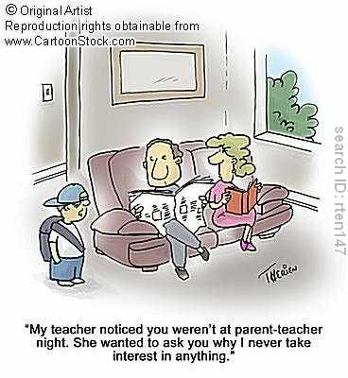

**Tessa Blackstone and Jo Mortimore (1994)** argued that working class parents attend fewer parents’ evening because they work longer or less regular hours or because they are put off by the middle class atmosphere of the school, not because they are uninterested in their child’s education. They argue that research into cultural deprivation has not measured parental interest in education adequately. Teachers' assessments have often been used and these may not reflect the real level of interest of parents.

To think about…..should we be trying to convert working class parents into middle class parents or should we change our education system instead (Whitty 2002)

Summarise the ‘cultural deprivation’ argument in your own words.

**Can we cure ‘cultural deprivation’?**

**Dealing with Cultural Deprivation…**

Compensatory Education

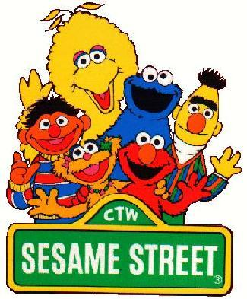This is a policy designed to tackle the problem of cultural deprivation by providing extra resources to schools and communities in deprived areas. They attempt to intervene in the early socialisation of children to compensate for the deprivation they experience at home.

Operation Head Start

This was a multi-billion dollar scheme in America which began in the 1960s. Its aim was ‘planned enrichment’ of the deprived child’s environment to develop learning skills and instil achievement motivation.

It included parenting classes, setting up nursery classes, home visits by health visitors and educational psychologists.

Sesame Street was part of Operation Headstart

The TV programme Sesame Street was initially part of the Head Start, providing a means of transmitting values, attitudes and skills needed for educational success, such as the importance of punctuality, numeracy and literacy.

In Britain Educational Priority Areas were created in the 1960s, *Education Action Zones* in the 1990s and *Sure Start* in 2000. The latter aims to tackle poverty and social exclusion, by 2010 there was 3,500 Sure Start Children’s Centres, all children in the most disadvantaged areas had access to one. This initiative was rebranded as *Excellence in Cities* in 2005. The aim is to work with parents to promote physical, intellectual and social development of babies and young children in order to break the cycle of disadvantage. Schools in these areas were given extra money and teachers to help become better schools, and to improve the educational performance of the most disadvantaged young people, by raising their levels of educational achievement and boosting their aspirations, confidence and self-esteem. One of its goals is to improve children’s abilities to learn by encouraging stimulating play, improving language skills and early identification and support of children with special needs.

**HOWEVER…**

**Evaluation**: Power and Whitty (2008) found that such reforms did not work, and failed to make a significant impact on the achievement gaps between advantaged and disadvantaged schools and their students.

While the evidence shows that schooling can lessen the impact of deprivation on children’s progress, its influence is limited by factors beyond the control of the school system, and children’s performance can be affected by forces outside the school – in their families, communities and neighbourhoods.

**Material Deprivation**

Material Deprivation: refers to poverty and a lack of basic necessities such as adequate diet, housing, clothing or the money to buy these things.

Although schooling and further education are free to the age of 19 (though there are fees for higher education), material deprivation factors outside the school like poverty and low wages, diet, health and housing can all have important direct effects on how well individuals do at school. Indicators of material deprivation like these make an important contribution to explaining the pattern of working-class underachievement in education.

If school is free, why do children from families with more money do better?

C:\Users\TEMP\AppData\Local\Microsoft\Windows\Temporary Internet Files\Content.IE5\P6UQDH23\MC900199839[1].wmfFacts and Figures:

Poverty is closely linked to educational achievement, for example:

* According to the Department of Education (2012), a third of pupils are eligible for free school meals (FSM) – a widely used measure of child poverty – achieve five or more GCSEs at A*-C including English and Maths.
* Jan Flaherty (2004) found money problems in the family are a significant factor in younger children’s non-attendance at school.
* Exclusion and truancy are more likely in children from poorer families, and those who are excluded are less likely to return to mainstream education
* 90% of ‘failing’ schools are located in deprived areas.

The following factors are examples of how material deprivation can affect working-class achievement:

**Housing**

Poor housing can affect pupils’ achievement

Families living in temporary (e.g. Bed and Breakfasts) will have to **move frequently** resulting in changes of school and disrupted education

Cold/damp housing can cause **ill health** e.g. respiratory illnesses

**Development** can be impaired through a lack of space for safe play and exploration

**Overcrowding** makes it hard for a child to study; they will have less room for educational activities; nowhere to do homework; disturbed sleep from sharing bedrooms

**Health and welfare** e.g. overcrowded homes run a greater risk of accidents

Families in temporary accommodation suffer more psychological distress, infections and accidents

*Why do you think these* ***indirect*** *factors can affect pupils’ achievement?*

**Diet and Health**

Diet: Howard (2001) found that young people from poorer homes have lower intakes of energy, vitamins and minerals. Poor nutrition affects health, for example weakening the immune system and lowering children’s energy levels. This may result in absences from school due to illness, and difficulties in concentrating in class.

Health: Wilkinson (1996) found that children from poorer homes are also more likely to suffer with emotional or behavioural problems. He found that among 10 year olds, the lower the social class the higher the rate of hyperactivity, anxiety and conduct disorders, all of which are likely to have a negative effect on the child’s education.

Blanden and Machin found children from low income families are more likely to engage in ‘externalising’ behaviours (such as fighting and temper tantrums), which are likely to disrupt their schooling.

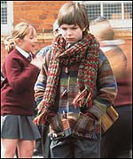**Financial support and the cost of schooling**

Equipment

School trips.

Costs of items such as transport, uniform, books, computers, calculators, and sports, music and art equipment, places a heavy burden on poor families. As a result children have to settle for 'hand-me-downs' and cheaper equipments, which could lead to these pupils feeling isolated, stigmatised or bullied by peers which can affect their self-esteem. Flaherty found that 20% of pupils entitled to free school meals (FSM) did not take up their entitlement for fear of being stigmatised.

Smith and Noble (1995) found that poverty acts as a barrier to learning in other areas, such as inability to afford private schooling or tuition, and poorer quality local schools (as a result of being out of the catchment area of the high achieving schools).

Poorer students may need to work e.g. babysitting, cleaning, paper rounds; to help the family out financially and this can have a negative impact on their schoolwork. Since the Coalition Government abolished Education Maintenance Allowance (EMA) (£20 a week given to pupils from low-income homes as an incentive to continuing at school past 16 years old), this could explain why many working-class pupils drop out of school at 16 years old.

Also, the cost of higher education can also explain why working-class pupils leave school early. The costs of going to university (tuition fees, books, living expenses, debts) deter many working-class students from going to university. UCAS (2012) found that since increases in tuition fees from 2012 to £9000 per year, the number of UK applicants fell by 8.6%. Furthermore, working-class students who do go to university are likely to receive less financial support from their families. A National Union of Students (2010) online survey of 3,863 university students found that 81% of those from the highest social class received help from home, opposed to only 43% of those from the lowest class. Financial factors can also restrict working class students to applying to local universities so they can live at home which gives them less opportunity to the highest state universities. Students from poorer backgrounds often had to work part-time to fund their studies, making it more difficult for them to get higher-class degrees

Catchment areas – richer parents may be able to buy houses nearer good schools. 

**Material Deprivation (summary)**

**TASK:** Fill in the gaps with the missing words below:

|  |  |  |
| --- | --- | --- |
| marginalised | meritocratic | Ritz |
| mortgage | affluent | diets |
| 7 | Material Deprivation | private |
| redistribute | attainment | transportation |
| Marxists | confidence | overcrowded |
| choice | work | stress |

_____________________________means a lack of money and the things that money can buy. For many this means poverty and the effects of poverty. _____________ argue that poverty is a condition which the working class face as a result of exploitation at work by the capitalist class. Many sociologists believe that money has a great impact on educational _____________________and behaviour.

A very significant impact is upon the choices within schools. Bull calls this the costs of “free education”. This refers to the things which are assumed by the education system to be possessed by the education system. In theory education is free to all students; this is the basis of a ______________________social order. However there are things like the cost of school trips, revision guides, computers, specialist clothing for sports, music equipment and lessons, the cost of school uniform and so on which are necessary for success. Indeed the lack of these things may not just deny working class students access to success in a direct way but it may also serve to undermine the students ____________________ in themselves and this will also undermine attainment as they come to feel ________________________ from the school. Tess Ridge (2002) examined poverty from the child’s perspective, her research highlights the importance children place on ‘fitting in’ to the extent where 20% of those eligible for free school meals do not take up their entitlement for fear of being bullied.

Heath (1980) described an additional material factor. He argued that the cost of staying on after 16 was a great deterrent to working class participation in further and higher education. Working class students were expected by their parents to go to ___________ and provide some money for the family as a whole. Some were not expected but they still felt the pressure to help out the family. Many working class families could not afford to support their children; this hidden cost was something which did not affect the more __________________middle class. The National Audit Office (2002) found that working-class students spent twice as much time in paid employment than their middle-class counterparts. This may account for the higher dropout rate for universities with a large proportion of working class pupils; the dropout rate is 13% at Sunderland which has a large intake of working class compared to a dropout rate of 1.4% at Oxford where over 40% of pupils come from __________________schools.

It is also clear from a great deal of recent research that part time jobs adversely affect attainment. Jobs mean less time spent on homework and revision. Middle class students feel less pressure to seek part time jobs and will do fewer hours as they have more wealth. There are studies which describe (working class) students falling asleep in class as a consequence of getting up too early or working too late. At exam time middle class parents can afford to tell their child to stop working.

For those with money _____________ abounds. Poverty stops choice and education is turning into a market place where those with money can exercise choice. The wealthy can afford private education where class sizes and resources are the envy of most state schools. They can afford to choose a school some distance away as they can pay the additional _________________________costs-they can buy their way out of a bad school. There is a growing phenomena of selection by __________________ as it costs more to live in areas with good schools. Finally, if their child is failing at Maths or French the middle class can afford a private tutor. These choices are not the choices of the poor; the poor are constrained by their poverty. The freedom of the poor is the freedom of the beggar to dine at the _________.

The poor are also affected by their living conditions. They have ______________________ accommodation and they are unlikely to have a quiet place to study. Children who lack a quiet place to study are, at the age of ____, already 9 months behind in their reading age. Overcrowding may also be associated with disturbed sleep, for example if children share bedrooms with their siblings, this could make it difficult to concentrate at school. In addition to this damp, overcrowded houses are likely to produce disease and sickness. Time away from school will mean that working class students will fall behind. Working class students also suffer from poorer ____________as it costs more to eat healthily-especially in working class areas. Marilyn Howard (2001) notes that young people from poorer homes have lower intakes of energy, vitamins and minerals, this will affect their mental (and physical) development and educational progress. It will also mean further absence due to sickness. Poverty may also mean that children live in temporary accommodation, this may mean they have to move schools and adds to the psychological _____________that the child and family suffer from.

Overall educational attainment is directly affected by poverty. Working class children do not have a fair chance, and the failure of working class children is not due to their lack of intelligence or unwillingness to work hard. The only solution to these problems and to create equal opportunities is to address their poverty, ________________________wealth and make meritocracy a reality.

**Cultural Capital**

Some sociologists accept that culture can play a part in educational achievement, not because the working-class lack an adequate culture but because the education system is essentially fixed in favour of people with upper- or middle-class backgrounds.

**Pierre Bourdieu (1984)** was a Marxist, who saw the culture of the school as giving an inbuilt advantage to middle-class children. He argues that each social class possesses its own cultural framework or set of ideas, which he calls a **habitus**. This habitus its achieved through socialisation in the family. The dominant class has the power to impose its own habitus in the education system, so what counts as educational knowledge is not the 'culture of society as a whole', but that of the dominant social class. As the education system uses a middle-class habitus, this explains why the middle-class are more able to access and achieve well, at the expense of the working-class. He believes that your parents' possession (or lack) of one of three types of capital can affect your achievement in the education system:

* Cultural capital
* Economic capital
* Social capital

**TASK**: Match up the correct definition to the example and its impact in the role of educational achievement.

|  |  |  |  |  |
| --- | --- | --- | --- | --- |
| **Definition** |  | **Example** |  | **Role in education** |
| **Cultural capital:**  Possession of educational qualifications, knowledge of arts and literature, and lifestyles, which are valued in society | Knowing teachers, head-teachers, professors socially | Paying for private education or additional tuition. |
| **Economic capital:**  Ownership of wealth | Owning valuable houses, shares, having an income. | Knowledge and experience to help children with school work. Educationally stimulating home environment - children become more familiar with the knowledge that is valued in schools. |
| **Social capital:**  Possession of valuable social contacts | Degree-level qualifications or higher educational holidays, knowledge of classic art and literature. | May help with admission to the best educational institutions or finding expert help. |

Bourdieu argues that the possession of cultural capital can equip students to meet the demands of the school curriculum and can be turned into educational capital (gaining educational qualifications), which can in turn lead to possession of economic capital (material advantages like a high income). Similarly, wealthier parents can convert their economic capital into educational capital by sending their children to private schools and paying for extra tuition.

**Internal factors**

Whilst we have seen that the external factors (factors outside the education system) play an important part in creating social class differences in educational achievement; we also need to examine the internal factors and processes *within* the school in causing these class differences. Many of these involve the daily face-to-face interactions between teachers and pupils, and among peer groups.

|  |  |
| --- | --- |
| **Internal factor** | **Explanation (How/Why does it affect achievement between working-class and middle-class students** |
| **Teacher Labelling:**  To attach a label / definition to a pupil. Teachers may label pupils as bright, trouble maker etc. | *Key studies****:*** *Becker (1971); Dunne and Gazeley (2008); Rist (1970)* |
| **Self-fulfilling prophecy:**  A prediction that comes true, simply because a positive/negative label has been made | *Key study: Rosenthal and Jacobson (1968)* |
| **Streaming:**  Where children are separated into different ability group or classes called ‘streams’, and then taught separately from the others for all subjects. | *Key study: Gillborn and Youdell (2001)* |
| **Pupil Subcultures:**  A group of pupils who share similar values and behaviour patterns. | *Key study: Lacey (1970); Ball (1981)* |
| **Pupils’ class identities:**  The individual’s sense of self, influenced by socialisation and interactions with others | *Key studies: Bourdieu (1984); Archer (2010); Ingram (2009)* |

**JANE ELLIOT AND KEDDIE!**

**Eye on the exam…**

****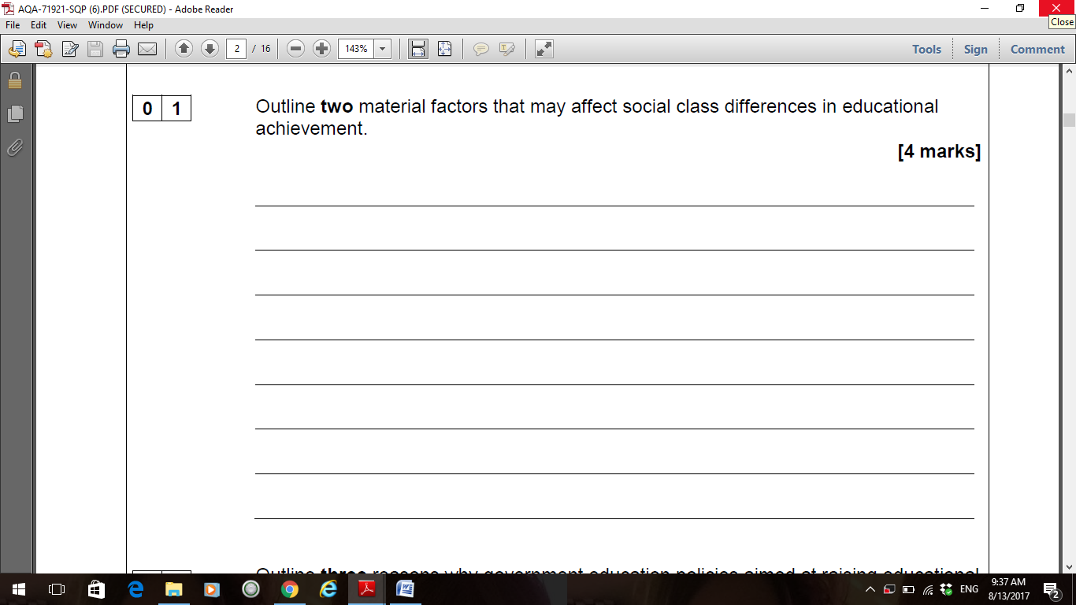

/ 4

**Peer assessment**

Swap your answer to question 1 with your partner and mark their answer out of 4, using the mark scheme below:

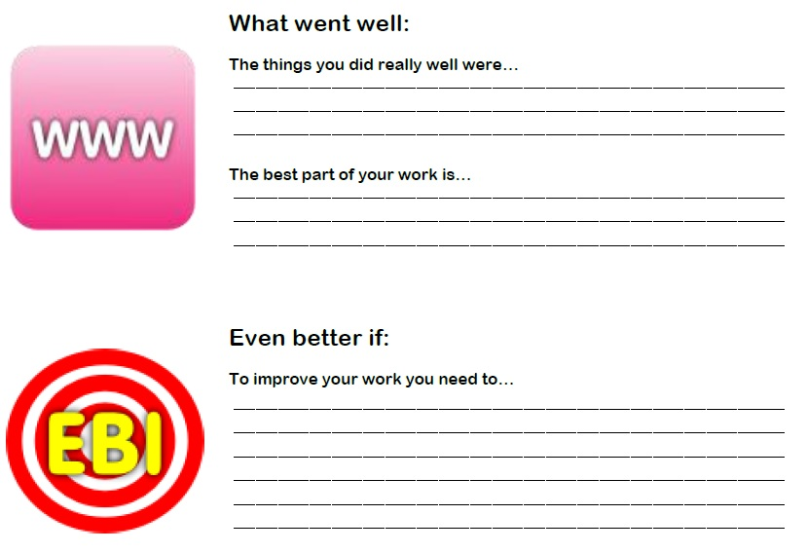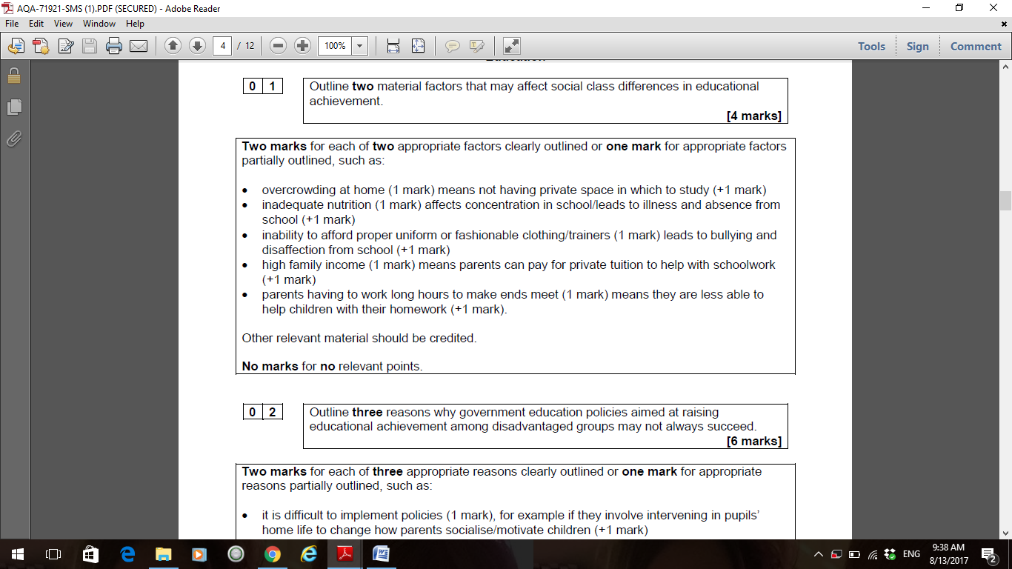

**Marking Tip:**

* Award one mark to *identify* **(AO1)** the material factor (e.g. housing, diet, income)
* Award a further mark for a brief *explanation* **(AO2)** how this factor affects social class differences (between middle/working class)

**Q.2** Outline three ways in which home factors can affect social class differences in educational achievement (6 marks)

……………………………………………………………………………………………………………………………………………………………………………………………………………………………………………………………………………………………………………………………………………………………………………………………………………………………………………………………………………………………………………………………………………………………………………………………………………………………………………………………………………………………………………………………………………………………………………………………………………………………………………………………………………………………………………………………………………………………………………………………………………………………………………………………………………………………………………………………………………………………………………………………………………………………………………………………………………………………………………………………………………………………………………………………………………………………………………………………………………………………………………………………………………………………………………………………………………………………………………………………………………………………………………………………………………………………………………………………………………………………………………………………………………………………………………………………………………………………………………………………………………………………………………………………………………………………………………………………………………………………………………………………………………………………………………………………………………………………………………………………………………………………………………………………………………………………………………………………………………………………..

**Q.3** Analyse **two** reasons why educational policies might lead to working-class pupils falling further behind middle-class pupils in education (10 marks)

(*answer this when you have completed Booklet 6:Educational policies - think about whether middle class have more opportunity to manipulate the system)*

……………………………………………………………………………………………………………………………………………………………………………………………………………………………………………………………………………………………………………………………………………………………………………………………………………………………………………………………………………………………………………………………………………………………………………………………………………………………………………………………………………………………………………………………………………………………………………………………………………………………………………………………………………………………………………………………………………………………………………………………………………………………………………………………………………………………………………………………………………………………………………………………………………………………………………………………………………………………………………………………………………………………………………………………………………………………………………………………………………………………………………………………………………………………………………………………………………………………………………………………………………………………………………………………………………………………………………………………………………………………………………………………………………………………………………………………………………………………………………………………………………………………………………………………………………………………………………………………………………………………………………………………………………………………………………………………………………………………………………………………………………………………………………………………………………………………………………………………………………………………..

……………………………………………………………………………………………………………………………………………………………………………………………………………………………………………………………………………………………………………………………………………………………………………………………………………………………………………………………………………………………………………………………………………………………………………………………………………………………………………………………………………………………………………………………………………………………………………………………………………………………………………………………………………………………………………………………………………………………………………………………………………………………………………………………………………………………………………………………………………………………………………………………………………………………………………………………………………………………………………………………………………………………………………………………………………………………………………………………………………………………………………………………………………………………………………………………………………………………………………………………………………………………………………………………………………………………………………………………………………………………………………………………………………………………………………………………………………………………………………………………………………………………………………………………………………………………………………………………………………………………………………………………………………………………………………………………………………………………………………………………………………………………………………………………………………………………………………………………………………………………..

…………………………………………………………………………………………………………………………………………………………………………………………………………………………………………………………………………………………………………………………………………………………………………………………………………………………………………………………………………………………………………………………………………………………………………………………………………………………………………………………………………………………………………………………………………………………………………………………………………………………………………………………………………………………………………………………………………………………………………………………………………………………………………………………………………………………………………………………………………………………………………………………………………………………………………………………………………………………………………………………………………………………………………………………………………………………………………………………………………………………………………………………………………………………………………………………….....................................................................

**Q.4**

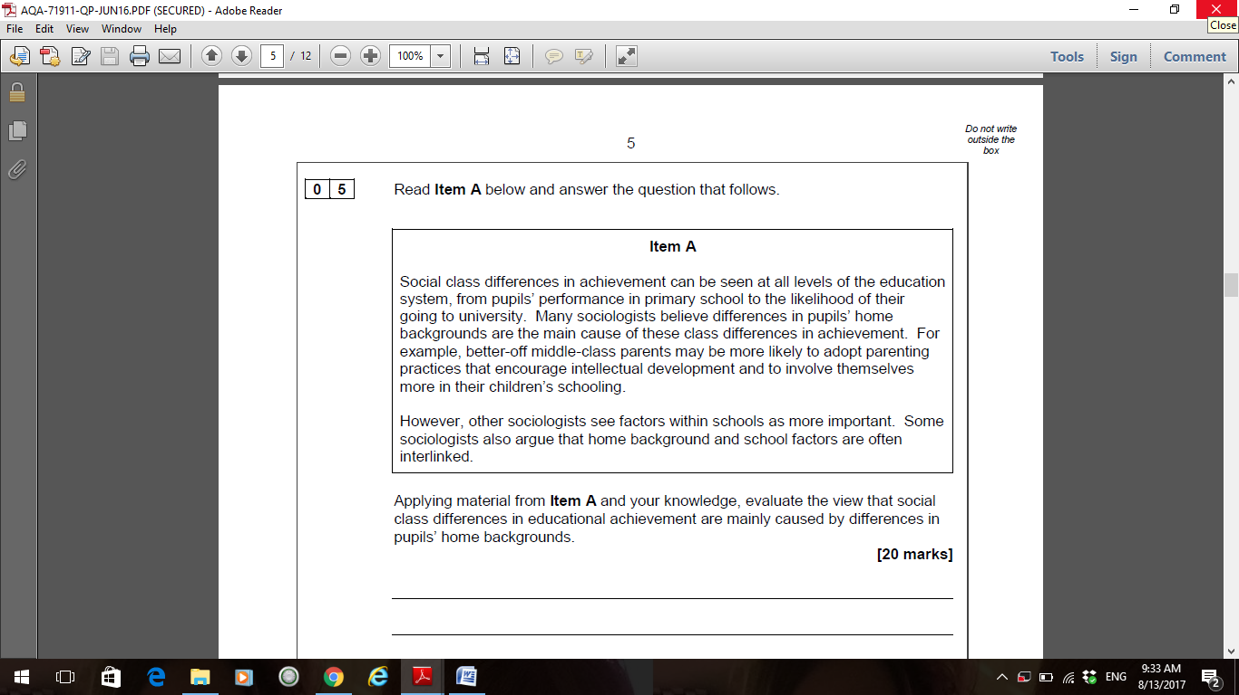

(30 marks)

[](http://www.google.co.uk/url?sa=i&rct=j&q=&esrc=s&source=images&cd=&cad=rja&uact=8&ved=0ahUKEwjcx9X3r_fUAhWHvhQKHTWPAAMQjRwIBw&url=http://clipartix.com/thumbs-up-clipart-image-1312/&psig=AFQjCNEp0QMnruLLNmhrVGD-uuOhoilNQQ&ust=1499523882339254)Examiner’s Advice:

**AO1** – Identify the home background explanation

**AO2** – How does this affect pupils’ social class differences in educational achievement?

**AO3** – Can this function be supported / criticised? Counter argued with internal (school) factors.

Aim to spend 45 mintutes on this question. The question focuses on external (home) factors, but you should include internal factors as evaluation (AO3). Explain the external factors (cultural deprivation, marterial deprivation, cultural capital) and how each one affects achievement. REMEMBER to compare between working-class and middle-class achievement. Whilst you are focusing on the external factors, you should use the internal factors to evaluate the external ones. For example, cultural deprivation theory blames pupils’ speech codes, but arguably it is teachers’ labelling of pupils’ speech as inadequate that causes underachievement. Avoid simply lisitng internal and external factors without simply linking them.

**Essay plan**

**Poorest pupils 'two years behind when they sit GCSEs'**

3 August 2017

**The very poorest children in England have fallen even further behind their non-disadvantaged classmates since 2007, research says.**

The Education Policy Institute study suggests the most disadvantaged pupils are more than two years behind their classmates when they sit their GCSEs.

These children were those entitled to free school meals for 80% of their time at secondary school.

The Education Secretary has warned of a social mobility emergency.

And in a recent speech, Justine Greening highlighted some areas of the country with an "entrenched disadvantage" - where low skills and poor employment were found in a downward spiral alongside underachieving schools.

The EPI [**report,**](https://epi.org.uk/wp-content/uploads/2017/07/closing-the-gap-web.pdf) Closing the Gap? acknowledged the disadvantage gap had been entrenched in the education system for generations and that successive governments had tried to tackle it.

It analysed official data on GCSE, other test results and pupil background from the national pupil database and distinguished two groups of pupils whose results it compared with all other state school pupils.

As well as the most disadvantaged or persistently poor, researchers looked at disadvantaged pupils - those who have been on free school meals at some point.

And researchers converted academic results into months ahead and behind to make it easier to understand.

**Slow pace**

It found the attainment gap between persistently poor pupils and their non-disadvantaged peers had widened by 0.3 months to 24.3 months over the past decade.

However, the achievement gap between disadvantaged children and their classmates was found to be narrowing - but at a very slow rate.

The report said: "Despite significant investment and targeted intervention programmes, the gap between disadvantaged 16-year-old pupils and their peers has only narrowed by three months of learning between 2007 and 2016.

"In 2016, the gap nationally, at the end of secondary school, was still 19.3 months.

"In fact, disadvantaged pupils fall behind their more affluent peers by around two months each year over the course of secondary school."

It adds: "At current trends, we estimate that it would take around 50 years for the disadvantage gap to close completely by the time pupils take their GCSEs."

**Analysis by Hannah Richardson**

Children from the poorest backgrounds are often dogged by low expectations with the low aspirations their parents have for them and their own low hopes and poor levels of self-confidence.

Before these children even reach school they tend to be months behind their reception classmates.

They are less likely to have suitable books at home, to have space to do homework or learn to read and parents with time and tenacity to help them with it.

So as school progresses, the gap in achievement between them and more financially stable peers tends to widen.

While their wealthier friends gain confidence from dance, drama and sports classes, poorer pupils struggle to gain the vocabulary needed to express themselves in class.

It is hardly surprising that by the time they do their GCSEs, these children on average need an extra two years of study to get to the point academically that their more comfortably off peers have already reached.

The disadvantage gap was generally smaller in London, southern England and eastern England (16 to 18 months), while in the East Midlands and the Humber, northern England and south-west England, the gap is significantly larger, at 22 months by the end of the GCSE year, the report found.

In the Isle of Wight, disadvantaged pupils were found to be well over two years (29 months) behind their peers by the end of secondary school.

Darlington, Derby, Luton, South Tyneside and Thurrock also performed poorly, despite successive attempts to address the issue.

It added: "The present government has acknowledged this burning problem and is seeking to address it, including through a focus on 'Opportunity Areas'.

"This could be a good start, but there are dozens of other areas up and down the country not covered by these areas where social mobility is stagnating or even worsening."

Researchers also acknowledged that 40% the achievement gap between the poorest pupils and others opens up before children even reach school and argued that this is where resources should be focused.

**'Cash starved'**

National Union of Teachers assistant general secretary Avis Gilmore said unless investment and the correct interventions are in place, the attainment gap between disadvantaged pupils and their peers would continue.

"Local authorities and schools are being starved of cash resulting in the closure of - or cutbacks to - many essential support services for those pupils most in need."

Chris Keates, general secretary of the NASUWT teachers' union, said factors common among pupils who are falling behind include child poverty, insecure housing, poor physical and mental health among families and job insecurity.

"These have all seen an increase as a result of the government's austerity programme and reforms to welfare."

The Department for Education said it is targeting almost £2.5bn this year through the Pupil Premium to help schools raise the attainment of disadvantaged pupils.

It also highlighted that it is running a £72m programme to create opportunities for young people in areas where disadvantaged people struggled to progress.

**Questions:**

**Q1. What does this article tell us about class and achievement levels in school?**

**Q2. What factors (internal / external) have been identified which explains why poor pupils are underachieving?**

**Q3. Is it just a pupil’s class which affects their achievement? Explain why / why not?**