

**Foundation IGCSE (9 – 1) Revision Pack**

**Sets**

**Name --------------------------------**

**Questions**

**Q1.**

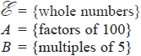

List the members of the set



...........................................................

**(Total for question = 2 marks)**

**Q2.**



(a)  Complete the following sentence.

All the numbers in set *C* are ........................................................... of 3

**(1)**

(b)  List the members of the set

(i)



...........................................................

(ii)



...........................................................

**(2)**

(c)  Explain why



.............................................................................................................................................

**(1)**

**(Total for question = 4 marks)**

**Q3.**

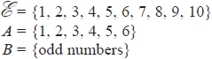

(a)  List the members of



...........................................................

**(1)**

*C* is a set such that   
The set *C* has 4 members.



(b)  List the members of one possible set *C*

...........................................................

**(2)**

**(Total for question = 3 marks)**

**Q4.**

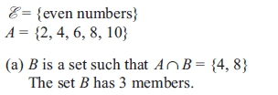

List the members of one possible set *B*.

...........................................................

**(2)**



List the members of one possible set *C*.

...........................................................

**(1)**

**(Total for question = 3 marks)**

**Q5.**

*S* = s, q, u, a, r, e  
*V* = a, e, i, o, u



List the members of the set

(i) S ∩ V

...........................................................

(ii) S ∪ V

...........................................................

**(Total for question = 2 marks)**

**Q6.**

(a) *A* = {s, u, p, e, r  
 *B* = {c, o, m, p, u, t, e, r



List the members of the set

(i) A ∩ B

...........................................................

(ii) A ∪ B

...........................................................

**(2)**

(b) *X* = prime numbers

*Y* = factors of 12

Is it true that X ∪ Y = ∅?

Tick () the appropriate box.



Explain your answer.

 ..............................................................................................................................................

**(1)**

**(Total for question = 3 marks)**

**Q7.**

Here is a Venn diagram.

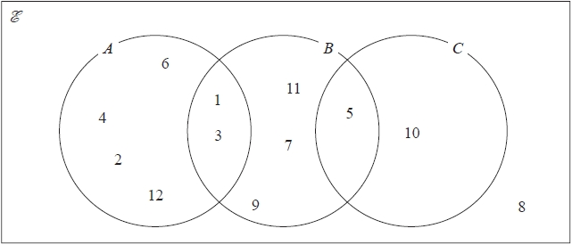

(a)  Write down the numbers that are in the set

(i)  *A*

...........................................................

(ii)  *B* ∪ *C*

...........................................................

**(2)**

Brian writes down the statement *A* ∩ *C* = Ø

(b)  Is Brian's statement correct?

You must give a reason for your answer.

.............................................................................................................................................

.............................................................................................................................................

**(1)**

One of the numbers in the Venn diagram is picked at random.

(c)  Find the probability that this number is in set *C*′

...........................................................

**(2)**

**(Total for question = 5 marks)**

**Q8.**

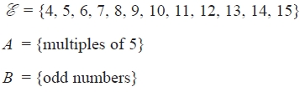

(a)  List the members of the set

(i)  *A* ∩ *B*

...........................................................

(ii)  *A* ∪ *B*

...........................................................

**(2)**

The set *C* has 6 members and *B* ∩ *C* = ∅

(b)  List the members of set *C*.

...........................................................

**(2)**

**(Total for question = 4 marks)**

**Q9.**



(a)  List the members of the set

(i)  *P* ∩ *I*

...........................................................

(ii)  *P* ∪ *I*

...........................................................

**(2)**



(b)  Is it true that *I* ∩ *F* = *∅* ?

Tick the appropriate box.



Explain your answer.

.............................................................................................................................................

**(1)**

**(Total for question = 3 marks)**

**Q10.**



List the members of the set

(i)



...........................................................

(ii)



...........................................................

**(Total for question = 2 marks)**

**Q11.**

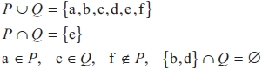

(a)  List the members of the set *P*.

...........................................................

**(2)**

(b)  List the members of the set *Q*.

...........................................................

**(1)**

**(Total for question = 3 marks)**

**Q12.**

= 1, 2, 3, 4, 5, 6, 7, 8, 9, 10



*A* = even numbers

*B* = multiples of 3

(a)  List the members of set *B*.

..........................................................

**(1)**

(b)  Find *A* ∪ *B*.

..........................................................

**(1)**

(c)  Find *A* ∩ *B*.

..........................................................

**(1)**

*x* is a member of



*x* ∈ *B*

*x* ∉ *A*

(d)  What are the possible values of *x*?

..........................................................

**(2)**

**(Total for question = 5 marks)**

**Q13.**

= positive whole numbers less than 19  
*A* = odd numbers  
*B* = multiples of 5  
*C* = multiples of 4



(a)  List the members of the set

(i)   *A* ∩ *B*

...........................................................

(ii)  *BC*



...........................................................

**(2)**

*D* = prime numbers



(b)  Is it true that *B* ∩ *D* = Ø ?

Tick () the appropriate box.



Explain your answer.

.............................................................................................................................................

**(1)**

**(Total for question = 3 marks)**

**Q14.**

*S* = c, h, i, n, a                *V* = i, t, a, l, y



List the elements of the set

(i)  *S*  *V*



...........................................................

(ii)  *S*  *V*



...........................................................

**(Total for question = 2 marks)**

**Q15.**

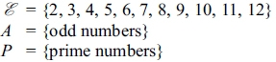

(a) List the members of the set

(i)



............................................................

(ii)



............................................................

**(2)**

(b) (i) Is it true that    
Tick () the appropriate box.



(ii) Explain your answer.

      ..............................................................................................................................................

 ..............................................................................................................................................

**(1)**

**(Total for question = 3 marks)**

**Q16.**

= 1, 2, 3, 4, 5, 6, 7, 8, 9



*A* = 1, 3, 5, 7



*B* = 2, 4, 6, 8



(a)   Explain why *A* ∩ *B* = ∅

.............................................................................................................................................

.............................................................................................................................................

**(1)**

*x*  and *x* ∉ *A* ∪ *B*



(b)   Write down the value of *x*.

...........................................................

**(1)**

*A* ∩ *C* = 3, 7, *B* ∩ *C* = 8 and *A* ∪ *B* ∪ *C* =



(c)   List all the members of *C*.

...........................................................

**(2)**

**(Total for Question is 4 marks)**

**Q17.**

(a)   *A* = p, r, a, g, u, e



*B* = p, a, r, i, s



*C* = b, u, d, a, p, e, s, t



List the members of the set

(i)   *A* ∩ *B*

...........................................................

(ii)   *B* ∪ *C*

...........................................................

**(2)**

(b)   *D* = r, o, m, e



*E* = l, i, s, b, o, n



*F* = b, e, r, l, i, n



Put one of the letters *D*, *E* or *F* in the box below to make the statement correct.

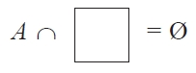

Explain your answer.

.............................................................................................................................................

**(1)**

**(Total for Question is 3 marks)**

**Q18.**

= {positive whole numbers **less than** 13



*A* = {even numbers



*B* = {multiples of 3



*C* = {prime numbers



(a)  List the members of the set

(i)  *A*  *B*



...........................................................

(ii)  *B*  *C*



...........................................................

**(2)**

(b)  Is it true that 14 *A*?



Tick () the appropriate box.

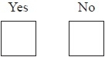

Explain your answer.

.............................................................................................................................................

**(1)**

**(Total for Question is 3 marks)**

**Q19.**

= {even numbers



*A* = {factors of 8



*B* = {factors of 20



List the members of *A*  *B*



...........................................................

**(Total for Question is 2 marks)**

**Q20.**

= {Students in Year 12}  
*G* = {Students who study German}  
*F* = {Students who study French}  
*M* = {Students who study Maths}



(i)



Use this information to write a statement about the students who study German   
in Year 12

      ..............................................................................................................................................

(ii) Preety is a student in Year 12

Preety ∉ *F*.

Use this information to write a statement about Preety.

      ..............................................................................................................................................

**(2)**

(b)



List all the members of set *B*.

...........................................................

**(2)**

**(Total for question is 4 marks)**

**Mark Scheme**

Q1.

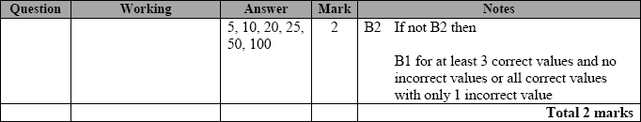

**Q2.**

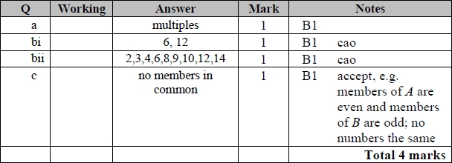

**Q3.**

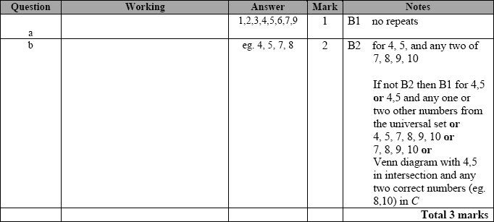

**Q4.**

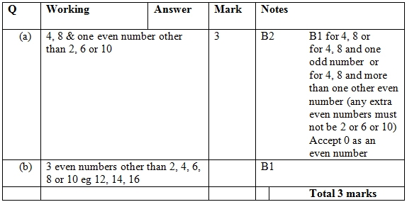

**Q5.**

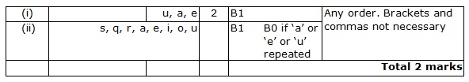

**Q6.**

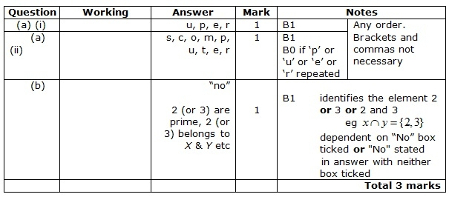

**Q7.**

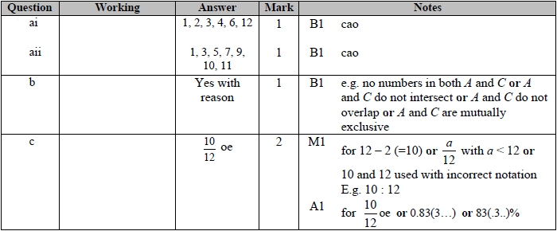

**Q8.**

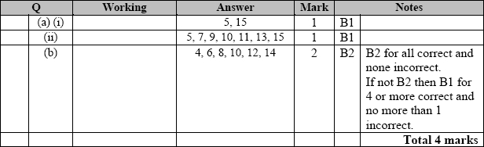

**Q9.**

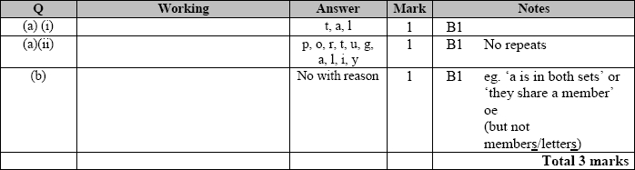

**Q10.**

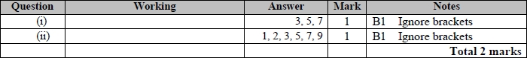

**Q11.**

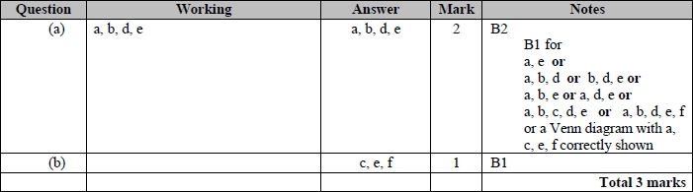

**Q12.**

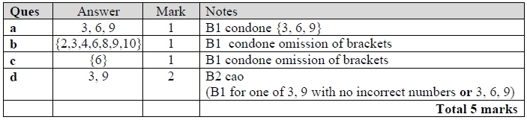

**Q13.**

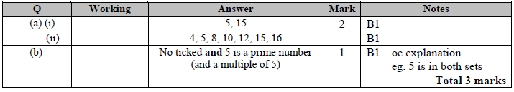

**Q14.**

The correct answer, unless clearly obtained by an incorrect method, should be taken to imply a correct method.

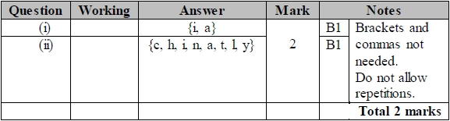

**Q15.**

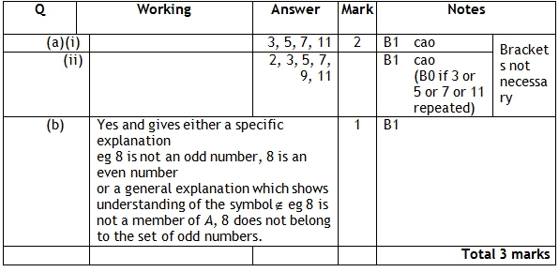

**Q16.**

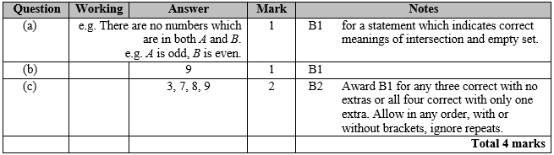

**Q17.**

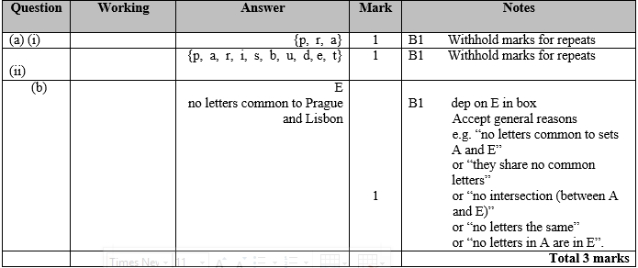

**Q18.**

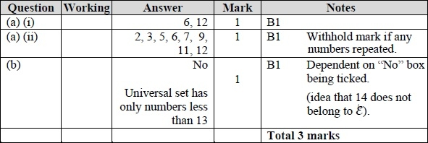

**Q19.**



**Q20.**

