A Level Chemistry Required Practicals Revision Summary

Topic | Required practical |  | Notes
3.1.2: Amount of substance | 1 | Make up a volumetric solution  CGP Y1 p49 | Method tips to ensure accurate concentration:  - Re-weigh bottle and calculate mass of solid by difference (some may be left in bottle)  - Wash the stirring rod into the flask / beaker after use  - Wash the beaker into the flask after transfer  - Wash the filter funnel into the flask  - Use a teat pipette to make up to the mark on flask  - Bottom of the meniscus is on the graduation mark  - Mix / shake the final solution in the flask by inverting.
 | 1 | Carry out a simple  acid-base titration  CGP Y1 p50 | To ensure accuracy:  - Rinse pipette & burette with solutions  - Read from bottom of meniscus  - Watch out for air bubbles  - Few drops of indicator only  - Swirl contents of flask to ensure good mixing  - Add slowly near the end point  - Rinse conical flask with distilled water near end point to ensure all solutions are in flask to react  - Use while tile to aid seeing colour change of indicator  - First rough unless shown to be concordant.
3.1.4: Energetics | 2 | Measurement of an enthalpy change  CGP Y1 p106-107 | Two solutions or solid reactant added to solution.  Use insulated container with lid to minimise heat loss or gain.  Stir throughout to ensure even mixing.  Plot data & draw 2 lines of best fit then extrapolate back to the time when the reactants were mixed to find the temperature change.
3.1.5: Kinetics | 3 | Investigation of how the rate of a reaction changes with temperature  CGP Y1 p119 | The main problem with kinetics practicals is any variation in temperature will have a large effect on the rate, this can be minimised by controlling the temperature of all reactants by using a thermostatically controlled water bath.

3.2.2: Group 2  3.2.3: Group 7 | 4 | Carry out simple test-tube reactions to identify cations and anions  CGP Y1 p156 & p165-166 | Exact quantities not necessary as it is qualitative testing.  Descriptions:  - Colour  - State e.g. precipitate (ppt) or solution (aq)  - Describe change e.g. re-dissolving  - No visible change  If solution is coloured and masks colour of precipitate, decant solution and wash precipitate.  Standard tests and expected results:  Carbonate ions  Test: dilute hydrochloric acid then test gas with limewater  Result: goes cloudy (due to CO₂)  Sulphate ions  dilute hydrochloric then barium chloride solution  Result: white precipitate – BaSO₄(s)  Chloride, bromide and iodide ions  Test: dilute nitric acid then silver nitrate solution  Results:  chloride - white precipitate (AgCl)  bromide - cream precipitate (AgBr)  iodide - yellow precipitate (AgI)  Further test: addition of ammonia solutions  Results:  chloride - precipitate dissolves in dil. NH₃  bromide - precipitate dissolves in conc. NH₃  iodide - precipitate insoluble in dil. & conc. NH₃.
3.3.5: Alcohols | 5 | Distillation of a product from a reaction  CGP Y1 p228-229 | To allow separation of a volatile liquid from another liquid, the product of the reaction is collected.  Anti-bumping granules in the flask are a safety measure to prevent vigorous or uneven boiling through the release of large gas bubbles. They ensure only small bubbles are formed.  Distillation  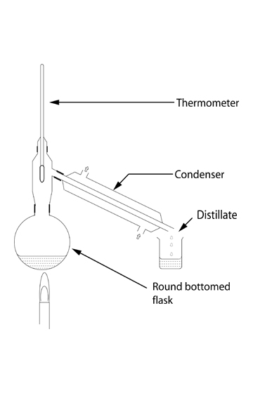  Refluxing  Don’t confuse with distillation. In this technique the volatile product condenses back into the flask so isn’t isolated and it reacts further.  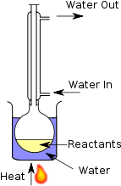
3.3.6: Organic analysis | 6 | Tests for alcohol, aldehyde, alkene and carboxylic acid | Standard tests and expected results:  Alcohol  Test: metallic sodium  Result: effervescence (due to H₂)  1^{O}/2^{O} alcohol  Test: Acidified potassium dichromate  Result: orange to green  Aldehyde  Test: Fehling’s solution  Result: red precipitate  Test: Tollens’ solution  Result: silver mirror  Alkene (unsaturation)  Test: bromine water  Result: decolourises (turns colourless due to addition of bromine to alkene)  Carboxylic acid  Test: solid sodium hydrogencarbonate  Result: effervescence (due to CO₂)  Haloalkane  Test: sodium hydroxide then warm and add nitric acid followed by silver nitrate solution  Results:  chloride - white precipitate (AgCl)  bromide - cream precipitate (AgBr)  iodide - yellow precipitate (AgI)
3.1.9:  Rate equations | 7a | Measuring the rate of reaction by an initial rate method  CGP Y2 p58 | Time colour change – blue-black iodine  Plot graph: log10 (1/t) (y) against log10 V (x)  Choose points near opposite ends of the line.  Measure gradient (to find rate) = y/x
 | 7b | Measuring the rate of reaction by a continuous monitoring method  CGP Y2 p42 | Reaction between magnesium and hydrochloric acid, the volume hydrogen gas produced is measured continuously at regular time intervals to monitor the rate of the reaction.  Methods of measuring the volume of gas:  Using a gas syringe  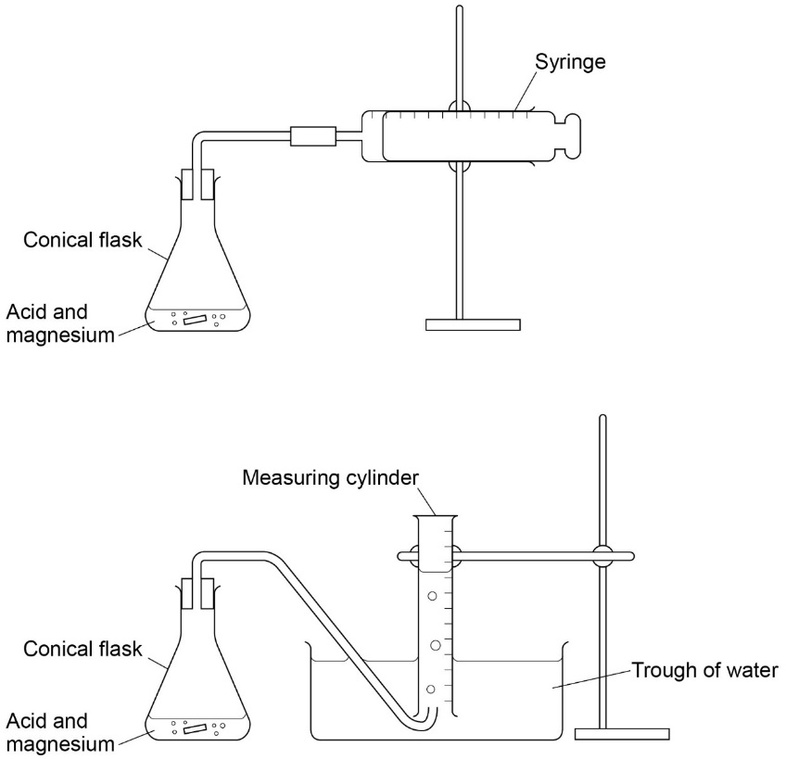  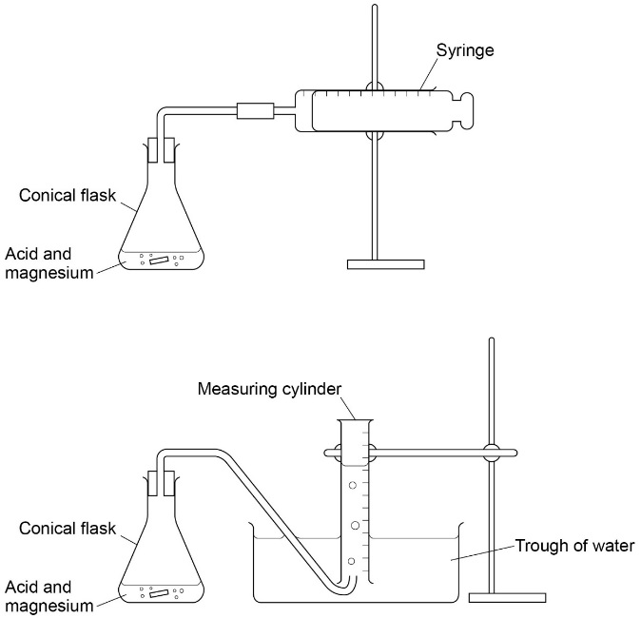  Using a water trough – alternative method  Graph:  Plot volume of hydrogen produced (y-axis) against time.  Draw a line of best fit.  Draw a tangent to each line at time, t = 0 s  Calculate the gradient of each tangent in order to deduce the rate of each reaction.
3.1.11: Electrode potential and cells | 8 | Measuring the EMF of an electrochemical cell  CGP Y2 p79 | A cell produces electricity from a chemical reaction when two different metals are connected by a wire and placed in an electrolyte.  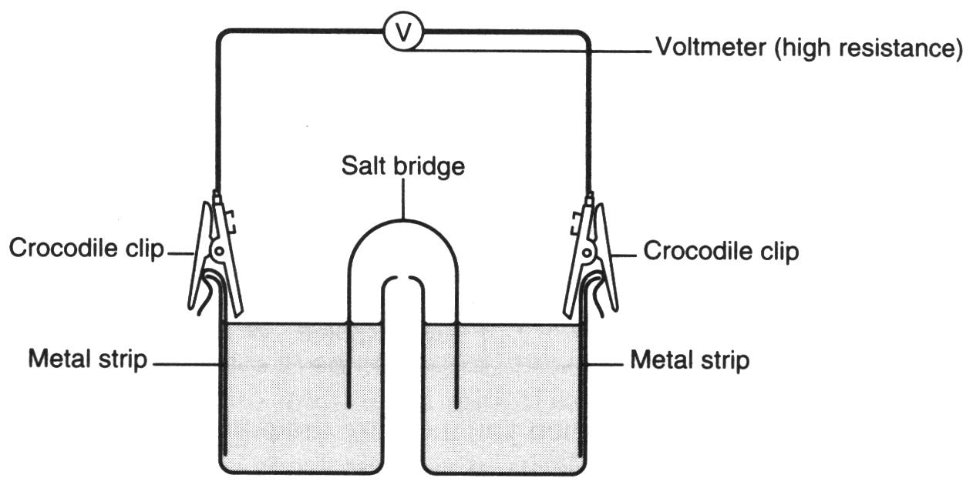  Salt bridge - allows transfer of charge between each half cell.  Sandpaper - to remove any metal oxide that may have formed on the surface of metal.  Electrolyte – substance dissolved in water or molten which can carry electrical charge because the liquid contains ions that are free to move.

3.1.12:  Acids and bases | 9 | Investigate how pH changes when a weak acid reacts with a strong base and when a strong acid reacts with a weak base  CGP Y2 p106-109 | Calibration of pH meter – check pH readings against buffers of known pH.  Calibration graph: recorded pH reading (x axis) against the pH of the buffer solution.  Record pH after each addition of alkali.  Obtain correct pH reading from calibration graph.  S-curve graph: corrected pH values (y) against volume (x).
3.3.9: Carboxylic acids | 10a | Preparation of a pure organic solid  CGP Y2 p195 | Aspirin is prepared by the acylation of salicylic acid using ethanoic anhydride as the acylating agent.  Recrystallisation technique - filter under reduced pressure.  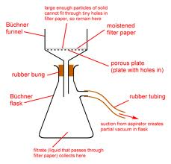
 |  | Test of its purity  CGP Y2 p195 | The purity of an organic solid can be determined in part by measuring its melting point and comparing the value with the known melting point.  A pure dry solid will melt at a precise temperature whereas an impure solid will melt over a range of temperatures which are lower than the melting point of the pure solid.  Heat a small quantity of the solid in a thin-walled melting point tube using an oil bath (not water – temperature too low) or in melting point apparatus.  Test first to establish approximate melting point, then repeat and heat slowly near the melting point until the solid collapses into a liquid without any change in temperature.  The method will not work if the solid decomposes on heating.  Subsequent heating of other samples can be done more slowly.  If heat too fast too high a melting point will be determined.  If melting point is measured at a temperature that does not match the published temperature it’s because temperature on thermometer is not the same as the sample.
 | 10b | Preparation of a pure organic liquid  CGP Y2 p193-194 | Reflux to produce ester followed by distillation to isolate it.  See earlier notes on the techniques and use of anti-bumping granules.  Separating funnel – used to separate immiscible liquids.  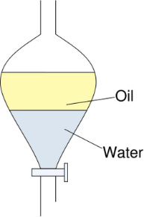  Solution sodium carbonate added to react with any acid catalyst, this will stop the reaction and remove the acid. Separating funnel is stopped and inverted several time to ensure acid and carbonate react. Carbon dioxide gas is produced in the neutralisation reaction.
3.2.6:  Reactions of ions | 11 | Carry out simple test-tube reactions to identify transition metal ions in aqueous solution  CGP Y2 p162-163 | Learn the colour changes and states (solution or precipitate) for each reaction – see notes given.
3.3.16: Chromatography | 12 | Separation of species by thin-layer chromatography  CGP Y2 p265 | Use pencil to draw base line.  Place multiple small spots to produce a concentrated spot of the compounds to be used by repeated application followed by drying.  Mark a reference spot (known compound).  Mark a spot of unknown substance.  Place in chromatography tank; ensure that the spots are above the solvent.  Cover with lid to saturate the atmosphere with the solvent, the lid prevents evaporation.  Allow time for the solvent to run up the chromatography plate, so it reaches just below the end of the paper.  Use locating agent to find spots, e.g. ninhydrin, UV light.  Compare the unknown compound with the reference compound or use R_{f} values.  Calculate R_{f} value  - measure distance solvent has travelled and from the baseline to solvent front  - measure distance each compound has travelled from baseline to centre of each spot.
3.2.5:  Transition metals | Extra | Colorimetry | Sample of know concentration of a coloured solution placed in colorimeter to obtain an absorbance reading.  Solution must have an intense colour:  - Can intensify by reacting with another reagent  - If too intense can dilute with water.  Plot graph: absorbance (y) against concentration (x)  Measure absorbance of unknown and use the graph to obtain the concentration value.
 | Extra | Redox titration | Acidified with sulphuric acid to prevent oxidation of potassium manganate(VII) to MnO₂ – a brown solid.  Potassium manganate(VII) self indicating.  Read from top of meniscus.  End point pale pink (permanent pink colour).

Other information
Graphs:
- Use a sensible scale so plotted points cover ½ a page
- May have negative numbers – make sure the scale goes down
- Don’t need to start at zero – use a broken scale
- Label axes with measurement & units
- Plot carefully (± one small square)
  - Use a pencil!
- Line of best fit may be a straight line but look out for obvious curve
  - Use a long ruler (no kinks or double lines!)
  - Miss out anomalous results
  - May not go through origin
  - But it may!
- Readings from graph:
  - Use ruler & pencil to mark given value and show value read form the graph

Formula:
- If using formula they must be correct

Hazards & risks:
- Know common hazards & precautions to minimise risks:
  - Flammable or explosive – keep away from naked flame
  - Corrosive – wear gloves/avoid contact with hands
  - Toxic – wear gloves
- Safety glasses & lab coats are assumed they will be ignored as an answer
- Anti-bumping granules prevent vigorous/uneven boiling – produce small bubbles

Errors & calculations:
- Repeats used because a single reading could be flawed or anomalous
  - Improves reliability of results
- Testing from different batches eliminates fact that different batches could vary or
be contaminated
- Calculating equipment errors = margin of error / quantity measured x 100
  - total errors = sum of individual equipment errors
  - If reactant is in excess errors not important
  - Smaller quantities have bigger errors
        - To reduce errors use larger quantities or more precise measuring equipment
- Calculating experimental errors = (true value – experimental value) / true value x 100
  - No sign needed

