Year 2 Sociology

**Paper 3: Crime and Deviance with Theory & Methods**



 Booklet 7 part 2: Globalisation and crime in contemporary society; the media and crime; green crime; human rights and state crimes.

Part 2 – the media and crime.

Name ______________________________

Specification Content:

What you need to know for **Crime and Deviance** in your Paper 3 exam.

Students are expected to be familiar with sociological explanations of the following content:

* globalisation and crime in contemporary society; the media and crime; green crime; human rights and state crimes

|  |  |  |  |  |  |
| --- | --- | --- | --- | --- | --- |
| **Questions may be based specifically on the following areas:** | | Do I have completed Notes? | Have I made revision Notes? | Have I memorised this info? | Have I practised exam style questions? |
| Globalisation | Globalisation and crime in contemporary society, eg transnational organised crime, global criminal organisations, global capitalism and crimes of the powerful.  **Castells, Held, Taylor, Hobbs & Dunningham, Glenny** |  |  |  |  |
| Media | The media and crime, eg media representations of crime, the media as a cause of crime and moral panics.  **S.Cohen, Young, Jewkes, McRobbie & Thornton** |  |  |  |  |
| Green crime | Green crime, eg types of green crime and green criminology.  **South, Beck, White** |  |  |  |  |
| Human rights | Human rights and state crimes, eg war, genocide and torture, and human rights abuses.  **McLaughlin, H & J Schwendinger** |  |  |  |  |

Exam Structure:

**These topics will appear in paper 3 of the A’Level.** 2 hour written exam 80 marks in total (50 for this bit)

* 33.3% of A-level

Crime and Deviance: short answer and extended writing, 50 marks (4 marks, 6 marks, 10 marks, 30 marks)

Where have we met crime and the media already?

Deviant amplification spiral Cohen mods and rocker.

Labelling and ethnicity and crime, black youth linked to gangs and gun crime – media / music.

Crime and deviance in popular culture. What did you find from your internet / tv listings search?

Crime and deviance have long been major themes in popular culture. They are staple parts of the media diet. Crimewatch presents dramatized reconstructions, shows like ‘Police, Camera, Action us real footage as entertainment. Hawyard and Young argue that advertisers have turned images of crime and deviance into tools for selling products into the consumer market (gansta rap, video games like ‘Grand Theft Auto’ use street gang culture and represent crime as something cool. Some designer gear like hoodies are seen as a symbol of deviance.

Crime and deviance makes up what % of news coverage? 30%

Views of crime are often distorted in the media. Give 3 examples from page 123

There has been a shift in the kind of crime that the media focus on. According to Schlesinger and Tumber in the 1960s the focus was on murders and petty crime. But my the 1990s the media were more interested in drugs, child abuse, terrorism, football hooliganism and mugging.

Sex crimes seem to be a preoccupation Soothill and Walby found that newspaper reporting of rape cases increased from a quarter of all cases in 1951 to over a third in 1985. The focus was often on a ‘sex fiend’ or ‘beast’ which resulted in the distorted picture that these crimes are usually linked to serial attacks by strangers which is not the reality when in fact the perpetrator is often known to the victim.

News values and crime coverage

We have to remember that our news is a social construction. News does not simply exist ‘out there’ waiting to be gathered up by journalists. Cohen and Young claim that our news in *manufactured* rather than being discovered. This is based on ‘news values’ which are the values by which journalists decide if a story is newsworthy. If a crime meets these criteria it is more likely to be reported.

What are the key ‘news values’? Highlight the ones which could apply to crime.

Crime and fiction

These give us a lot of knowledge about crime.

How are fictional representations of crime different from official statistics?

Property crime is underrepresented. Fictional sex crimes are committed by psychopathic strangers not acquaintances. Fictional policemen are successful.

How does fictional crime represent recent trends?

Reality crime shows feature non-white underclass. Police are increasingly being shown as corrupt. Victims have become more central to media crime audiences are encouraged to identify with their suffering.

Does the media cause crime?

Backwards law

* People base their knowledge of the criminal justice system on the media (crime fiction etc) rather than on experience.
* Surette suggests there is a backwards law where the media constructs crime and deviance which is the opposite of reality.
  + Over exaggerates sex, drug and violent crime.
  + Under represents common property crime.
  + Police effectiveness is over exaggerated.
  + Exaggeration of risk of being a victim if you are a higher status white person.

*Left realists would say that the media reporting of crime disguises the reality that both offenders and victims are mainly from working class. White collar crimes are concealed and are rarely reported.*

Agenda setting

* The influence in the media on what we think about and discuss is known as ‘agenda setting’
* People can only form opinions about what they have been informed about and the media chose what crime to report.
* Therefore the media influences what people believe about crime and deviance regardless of whether or not these are accurate.

The media may cause crime in the following ways

* Imitation
* Arousal
* Desensitisation
* Transmitting knowledge of criminal techniques
* Advertising
* Portraying police as incompetent
* Glamourising offending.

However many studies suggest that the impact of the media on crime is small.

The media may cause more fear

* Exaggerate risks to certain groups eg young women and old people.

Media, relative deprivation and strain theory

* The media can make to poor feel poorer through advertising etc. This idea of relative deprivation can feel exaggerated and can increase the feeling of pressure to achieve socially approved goals perhaps through illegitimate means where legitimate means are not available.

Cutural criminology

Hayward and Young see society as saturated by the media. We are tangled up in digital images, including images of crime. There is a blurring between the image of crime and the reality of crime so it is difficult to separate the two. The way that the media represents crime may actually create crime.

Moral Panics

Moral entrepreneurs are people who disapprove of particular behaviour and may use the media to put pressure on the authorities to do something. This results in the creation of a ‘moral panic’. This usually leads to a crackdown. The crackdown identifies more deviance, there are calls for tougher action and a ‘deviance amplification spiral’ is created.

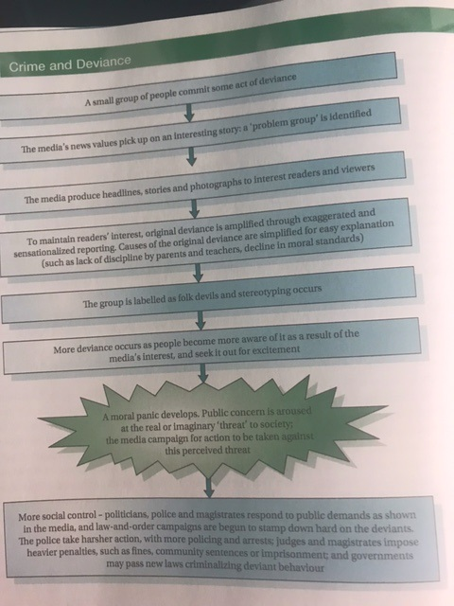

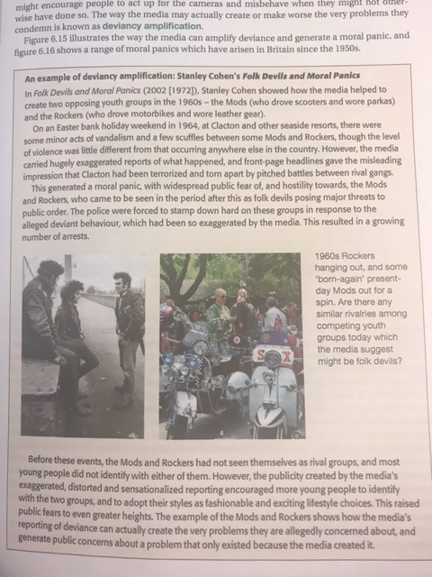

More evidence in support of the theory of moral panic



Cohen says that moral panics often occur at time of social change, reflecting the anxieties that many people feel when accepted values are undermined. The moral panic here was a result of what he calls **boundary crisis** where there was an uncertainty about where the boundary lay between acceptable and unacceptable behaviour at a time of change. A **folk devil** gives a focus to anxieties about social disorder.

**Functionalists**  would see moral panics as ways of responding to **anomie** created by change. If we have a folk devil the media raises collective consciousness and reasserts social controls when central values are threatened.

**Neo-Marxists** such as Stuart Hall look at moral panics in the context of capitalism. He looks at mugging in the 1970s which was used by the media to distract from the crisis of capitalism, divide the working class on racial grounds and legitimate more authoritarian rule.

Is this concept of ‘moral panic’ still relevant today?



[This Photo](https://de.wikipedia.org/wiki/Datei:SMirC-thumbsdown.svg) by Unknown Author is licensed under [CC BY-SA](https://creativecommons.org/licenses/by-sa/3.0/)

McRobbie and Thornton suggest that this is no longer a useful way to understand crime. Our news and media is constant now. There is competition between different types of media so the kind of reporting that would once have caused a moral panic has now changed. There is such a range of sources that people are more sceptical of mainstream media reporting and less likely to believe them. As our news is changing all the time crime reports have a much shorter shelf life and people move on more quickly. They say we have moral panics all the time. Lifestyle choices that would have been condemned in the past such as single motherhood are no longer universally frowned upon so it is harder for the media to create panics.

Cyber crime

Jewkes says that new types of media actually cause moral panic about the media as dangerous itself rather than the media creating panic about crimes. For example the internet has been accused of undermining public morality and corrupting the young. The same can be said of cinema, television, computer games when they were new. The internet creates the possibility for a number of crimes. According to Jewkes – the internet allowed for conventional crimes and ‘new crimes using new tools’

Give some examples of internet crimes? Use page 128

In summary

1. The media gives a distorted view of crime.
2. Some think the media causes crime.
3. The media can cause moral panic

Space for your own summary of these three points below.

Eye on the exam

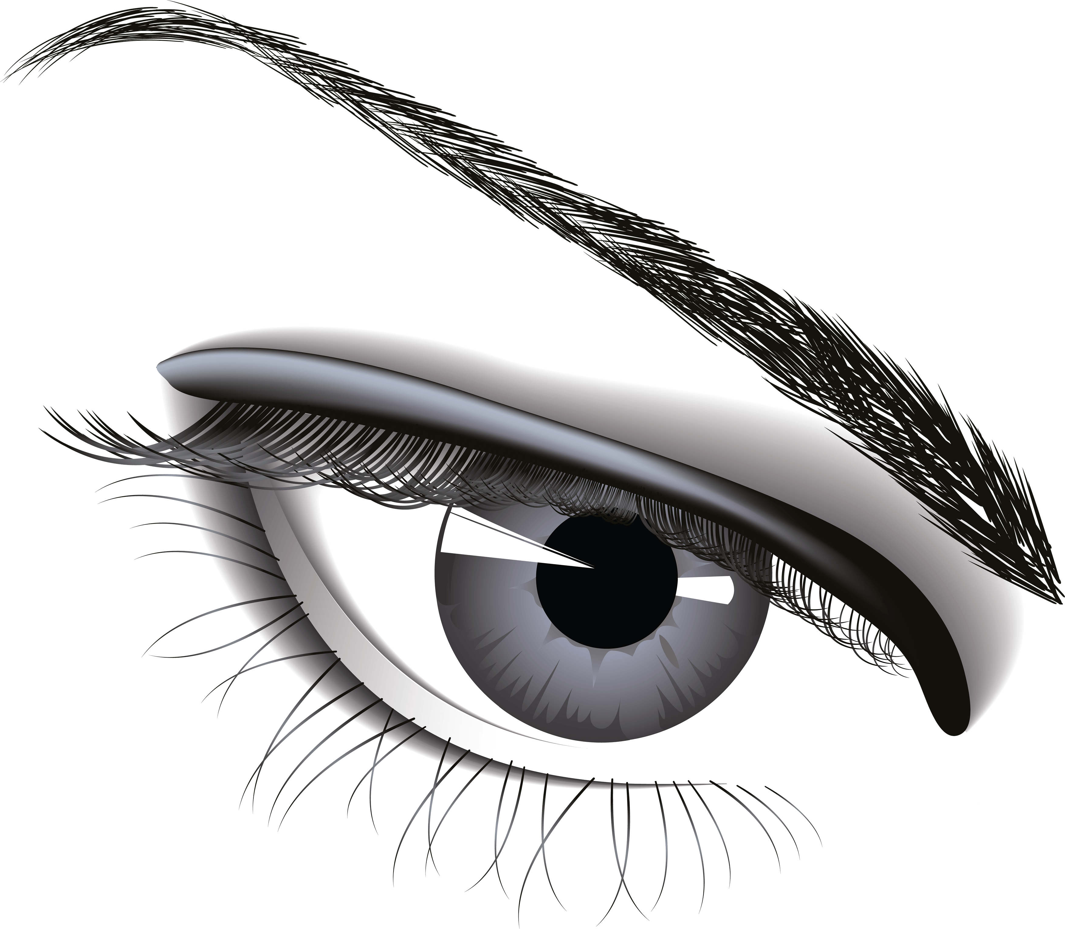

[This Photo](https://freepngimg.com/png/7683-eye-png-image) by Unknown Author is licensed under [CC BY-NC](https://creativecommons.org/licenses/by-nc/3.0/)

1. Outline **two** ways in which media representations of crime may not reflect reality (4).
2. Read **the text** in the box below and answer the question that follows.

The media often portray role models with glamorous lifestyles. The news also frequently exaggerates the reporting of events.

The media may contribute to an increase in crime.

Applying material from **the text** above, analyse **two** ways that the media may contribute to an increase in crime (10 marks)

1. Read **the text** in the box below and answer the question that follows.

Much media output is devoted to crime but the media offers a distorted portrayal of crime and criminals. The media are also often seen as causing crime, for example by creating a sense of relative deprivation or causing moral panics. The new media also provide opportunities both for committing crime and for policing it.

Applying material from **the text** above and your knowledge, evaluate sociological contributions to our understanding of the relationship between crime and the media (30)