**Chromosomes: Basics**

* In **eukaryotic** cells, the **nucleus** contains thread-like structures called **chromosomes**
* Chromosomes are made from highly coiled strands of relatively long DNA. Each chromosome is made from one DNA molecule
* In the body cells of **diploid** organisms, chromosomes are normally found in pairs
* One chromosome from each pair is **inherited** from the mother, the other from the father
* Different species of organisms have different numbers of chromosomes in their nuclei
  + Humans have 46 chromosomes in the nucleus of all their body cells, found in 23 pairs
  + Horses have 64 chromosomes in 32 pairs
  + Red blood cells are an exception – they lose their nuclei and therefore have no chromosomes
* Before a cell can divide, its genetic material needs to be doubled. This results in the characteristic ‘X’ shaped chromosomes we see in micrographs of cells preparing to divide

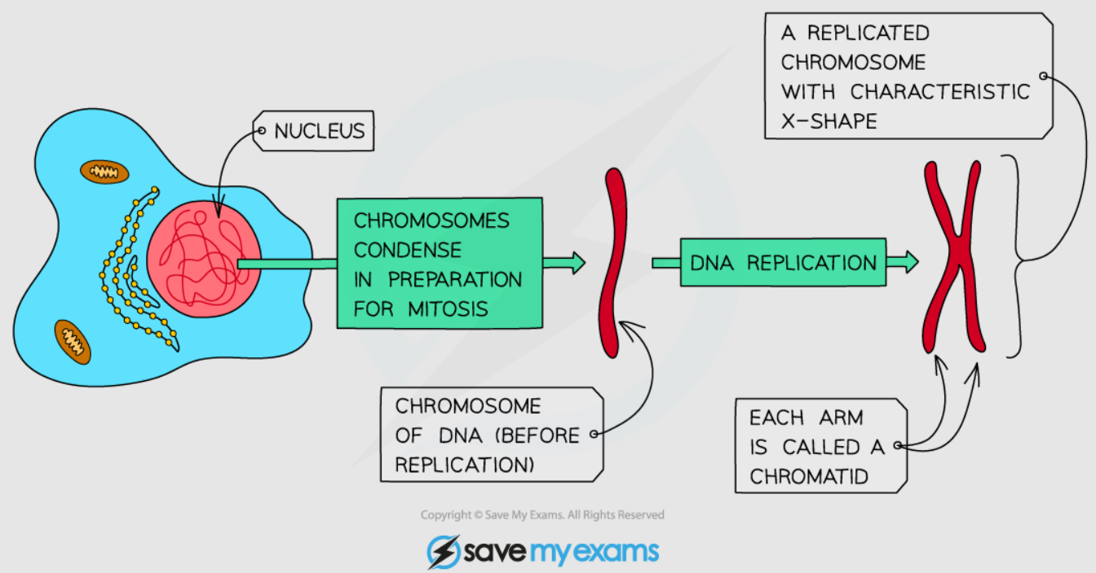

***Chromosomes are usually uncoiled, when a cell prepares to divide they fold up into ‘worm-like’ structures that we recognise***

**The Cell Cycle**

* Mitosis is a **stage** in the cell cycle when the nucleus divides
* The**cell cycle** is a series of stages in the life cycle of a cell
* During the **growth phase** of the cell cycle, the genetic material of the cell (chromosomes) is doubled
* Two copies of each chromosome are produced; these initially remain attached to each other with each strand called a chromatid
* The chromatids will eventually be divided between the two genetically identical daughter cells that form from the dividing cell
* During the growth phase, the number of subcellular structures (such as ribosomes and mitochondria) also increases

**The Process of Mitosis**

* For a multicellular organism to grow, cells must divide by mitosis to produce two new identical daughter cells
* During mitosis, one chromosome from each set is pulled to each end of the cell, and a new nucleus forms around each group of chromosomes
* After this, the cytoplasm and cell membranes divide in a process known as cytokinesis. This results in the formation of two genetically identical daughter cells

[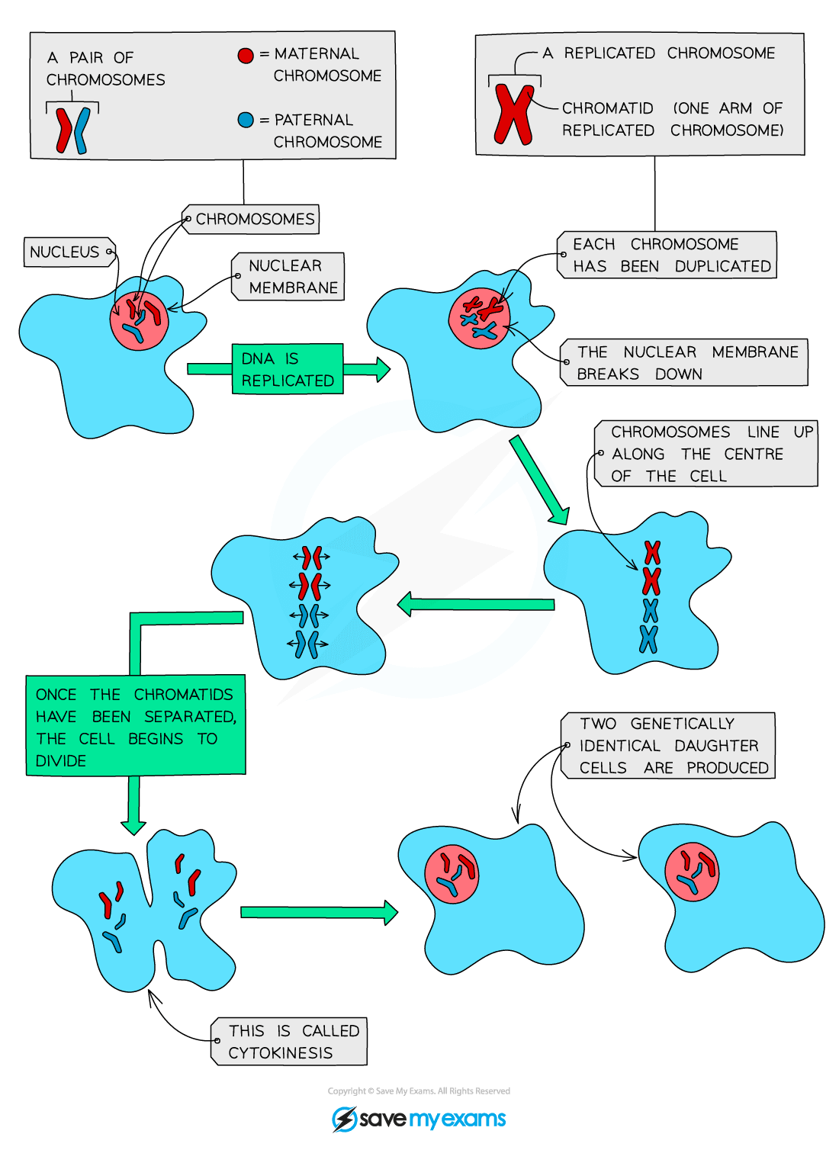](https://cdn.savemyexams.co.uk/wp-content/uploads/2020/01/Mitosis.png)

***Diagram showing the process of cell division by mitosis***

* So, if a human cell with 46 chromosomes in 23 pairs needs to divide by mitosis:
  + Its 46 chromosomes are doubled, so that there are two copies of each of the 46 chromosomes (or 92 chromatids) in total in the cell
    - The number of ribosomes and mitochondria subcellular structures also increases
  + During mitosis, the chromatids are pulled apart, with a complete set of 46 chromosomes in 23 pairs moving to each end of the cell
  + The cytoplasm and cell membrane divide, forming two new daughter cells

**Exam Tip**

You do not need to know the names or phases of mitosis (such as prophase) – so don’t write about them in your AQA GCSE exam. Doing so will not earn you credit and will only waste valuable time. But you do need to appreciate the three overall stages of the cell cycle:

* Growth phase (chromosome doubling and subcellular structures increase)
* Mitosis
* Cytokinesis (division of cytoplasm and the cell membrane)

**The Role of Mitosis**

* Cell division by mitosis is important in the **growth** and **development** of multicellular organisms
* When a sperm cell fertilises an egg cell in human reproduction, the resulting zygote cell that forms divides by mitosis, with each subsequent cell produced dividing in the same way to form an embryo
* As the embryo continues to grow in size, with the cells dividing by mitosis (and differentiating), a fetus forms
* Therefore, for a multicellular organism to grow, cells have to divide by mitosis to produce an increase in cell number

**Exam Tip**

In your exams, expect to see micrographs of either animal or plant cells in different stages of mitosis, you need to be able to recognise and describe what might be occurring in the images.

Cells that are not actively dividing should be easy to identify as their chromosomes will be unravelled and look non-distinct (they’ll appear like strands of thread).

**Calculating Cell Cycle**

* You may also be asked to use observations of how many cells are in each stage of the cell cycle to estimate how long each stage of the cell cycle lasts

**Worked Example  
Cell Cycle Length**

[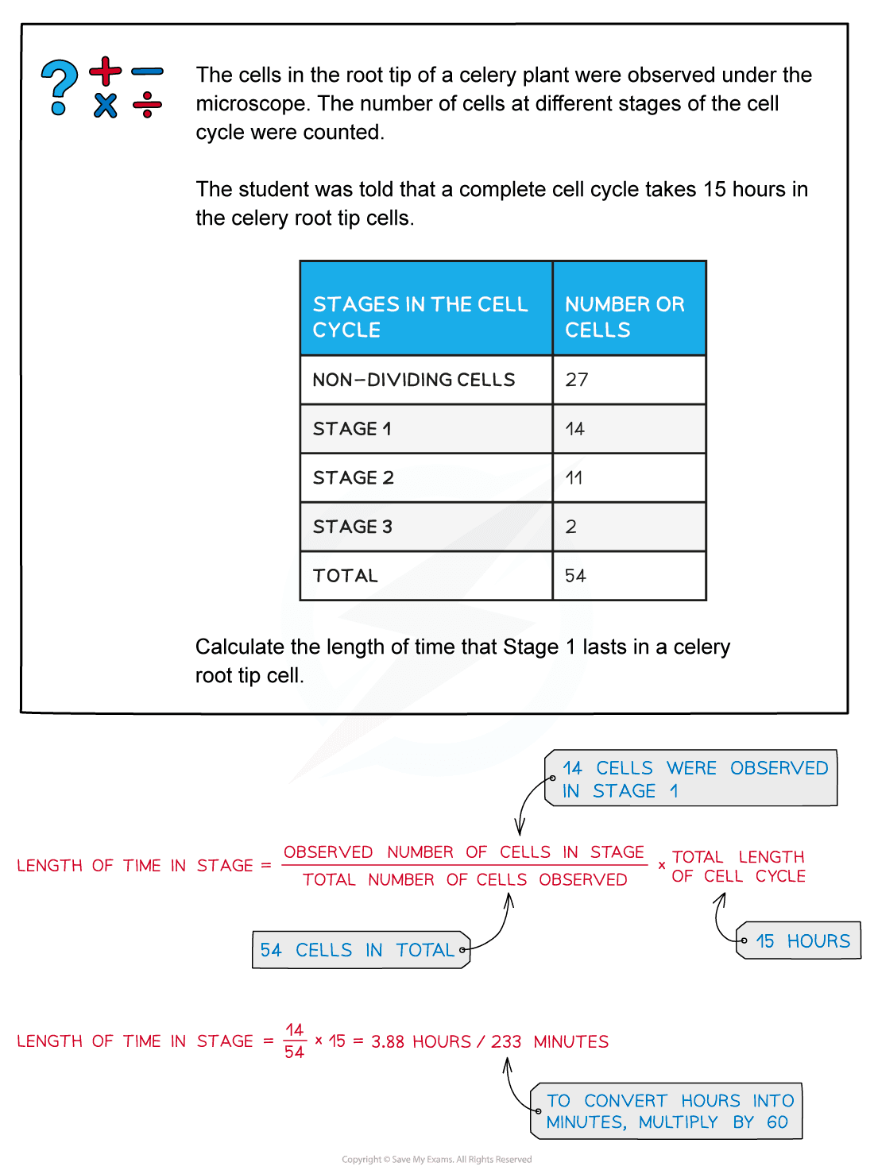](https://cdn.savemyexams.co.uk/wp-content/uploads/2020/07/Worked-example-cell-cycle-length.png)