**Flowcharts**

**What is a flowchart?**

* **A flowchart is** a graphical representation of the operations involved in a data processing system **,** the operations performed within the system and the sequence in which they are performed

**What is a flowchart made of?**

* **Symbols :** used to represent particular operations or data
* **flow lines :**indicate the sequence of operations.

**Each symbol has a particular meaning and used for a specific purpose**

|  |  |
| --- | --- |
| http://schoolnet.gov.mt/joe.vella/fctermin.gif | Start/Stop of Program flow |
| http://schoolnet.gov.mt/joe.vella/fcprint.gif | **Input / Output Operation**  For example:  Input number  print total |
| http://schoolnet.gov.mt/joe.vella/fcconnec.gif | **Connector** : to connect between 2 or more lines |
| http://schoolnet.gov.mt/joe.vella/fcprocess.gif | Process to be performed  For example  (Total=number1+number2) |
| http://schoolnet.gov.mt/joe.vella/fcyn.gif | Decision / Comparison Operation/If statement *Note that one arrow goes into the symbol*  *And two go out.* |

*Any operation that happens within the computer goes through* ***3 main stages***

1. **Input** (the user inserts something into the computer)

2. **Process** (executed by the CPU according to the input)

3. **Output** (the result of the process)

**Exercise 1**

|  |  |  |
| --- | --- | --- |
| Fill in the table below. Choose a number between 1 and 10 for X and Y. Find the total of two numbers. | | Create a Flowchart to calculate how many doughnuts Homer didn’t eat before falling asleep. He started with X and ate Y doughnuts! |
| http://schoolnet.gov.mt/joe.vella/fc1.gif | Input  Value of X=  Value of Y= |  |
| Process  Total = X+Y  Total = + . |
| Output  Print Total =_________ |



**Exercise 2**

|  |  |
| --- | --- |
| Create a flow chart to find out how many days Homer has gone without any accidents |  |
|  | Input |
| Process |
| Output |

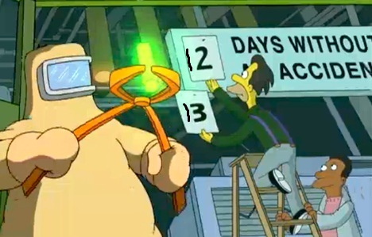

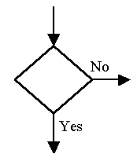**Exercise 3**

If the problem has 2 answers that are decided according to a condition you will be using an if statement and this symbol

|  |  |
| --- | --- |
| Bart has done some tests and Lisa wants to work out if he has passed or failed. Input a mark. Print 'Fail' if it is less than 50, otherwise print 'Pass'. | |
|  | Input |
| Process |
| Output |

