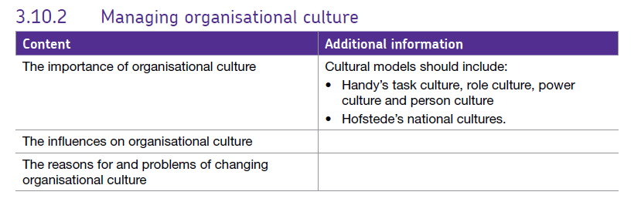3.10.2 Managing organisational culture

The culture of an organisation is its personality, it’s often described as “the way we do things here” and varies greatly from business to business. For example Google may have a very different culture and ‘way of doing things’ to a business such as the Morgan Motor Company.

Look at these 2 videos;

[Building a Morgan car](https://www.morgan-motor.co.uk/building-morgan-44-80-years-4-minutes/)

[Inside Google offices](https://www.youtube.com/watch?v=5g_YsLR1wZo)

What do you think are the key elements of their business cultures or ‘the way they do things’?

Some aspects of their cultures are similar but many are different.

The culture of any business is formed over time, the only people who truly know the culture of the business are the people who work there or are owners in some form - the internal stakeholders, external stakeholders have a different perspective as they only see part of the picture.

Culture can be:

## Positive culture - leads to increased productivity, better employee morale and the ability to keep skilled workers.

## Negative culture - created when the employer thinks that he is the creator of products or services and everything should be under his control. An employer’s perspective can change the whole work place from positive to negative. The impact of negative culture at work place is that it causes a resistance to change.

## Toxic culture – where a workplace is marked by significant drama and infighting, where personal battles often harm productivity, a toxic work environment negatively impacts the viability of an organization

## Dynamic culture – a culture which is always evolving / never static due to the changing nature of the business and its environment – always trying to be trending in the right direction

The culture of a business can have a dramatic effect on the motivation and productivity of the workforce and the levels of absenteeism and labour turnover.

Examples of different cultures:

## Links re: culture at Zappos.

# <https://www.zapposinsights.com/>

<https://youtu.be/-uINIExpJ3I>

<https://www.tutor2u.net/business/blog/organisational-culture-tony-hsieh-on-zappos-core-values-and-culture>

## Links re: culture at Ikea

<https://www.youtube.com/watch?v=wNqq6FSQy70>

<https://www.youtube.com/watch?v=yV3onm20-Ls>

<http://www.telegraph.co.uk/finance/9643996/Welcome-to-Ikea-town.html>

## Other examples:

<http://uk.businessinsider.com/the-20-uk-best-companies-for-workplace-culture-as-voted-by-employees-2017-10>

<https://www.entrepreneur.com/article/249174>

# Theories about culture:

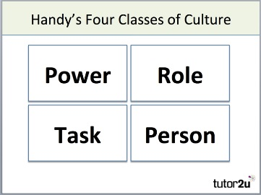Charles Handy identified types of culture:

* **Power culture**
* **Role culture**
* **Task culture**
* **Person culture**

## Power Culture

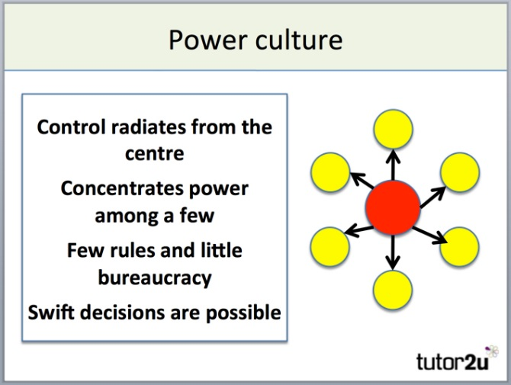In an organisation with a power culture, power is held by just a few individuals whose influence spreads throughout the organisation. There are few rules and regulations in a power culture. What those with power decide is what happens.

Employees are judged by what they achieve rather than how they do things or how they act. A consequence of this can be quick decision-making, even if those decisions aren't in the best long-term interests of the organisation.

A power culture is usually a strong culture, though it can swiftly turn toxic. The collapse of Enron, Lehman Brothers and RBS is often attributed to a strong power culture.

## Role Culture

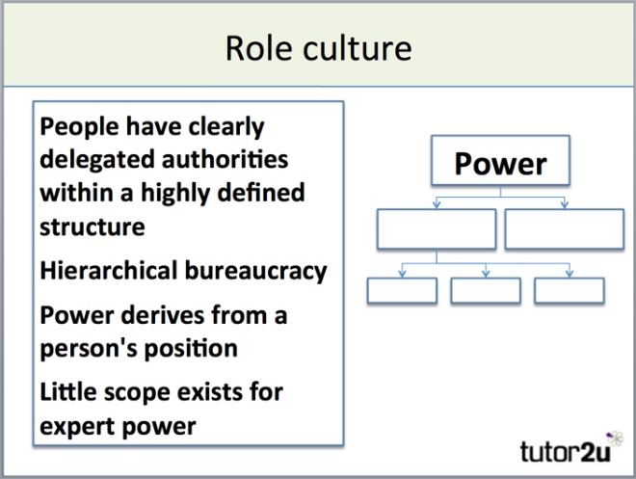Organisations with a role culture are based on rules. They are highly controlled, with everyone in the organisation knowing what their roles and responsibilities are. Power in a role culture is determined by a person's position (role) in the organisational structure.

Role cultures are built on detailed organisational structures which are typically tall (not flat) with a long chain of command.

A consequence is that decision-making in role cultures can often be painfully-slow and the organisation is less likely to take risks. In short, organisations with role cultures tend to be very bureaucratic.

## Task Culture

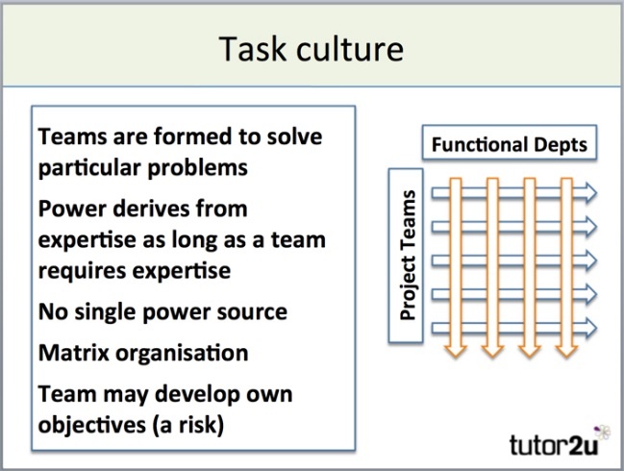Task culture forms when teams in an organisation are formed to address specific problems or progress projects. The task is the important thing, so power within the team will often shift depending on the mix of the team members and the status of the problem or project.

Whether the task culture proves effective will largely be determined by the team dynamic. With the right mix of skills, personalities and leadership, working in teams can be incredibly productive and creative.

## Person Culture

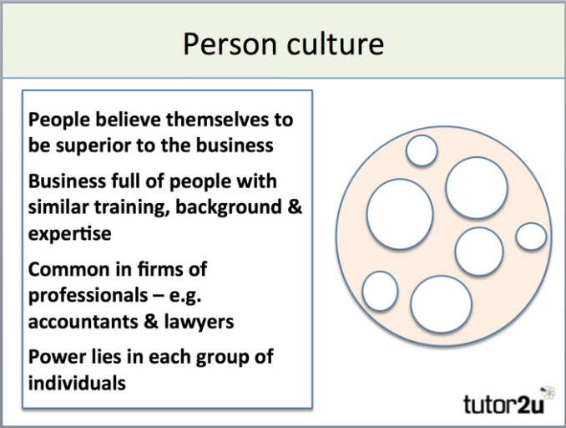

In organisations with person cultures, individuals very much see themselves as unique and superior to the organisation. The organisation simply exists in order for people to work.

An organisation with a person culture is really just a collection of individuals who happen to be working for the same organisation.

# Hofstede’s national cultures.

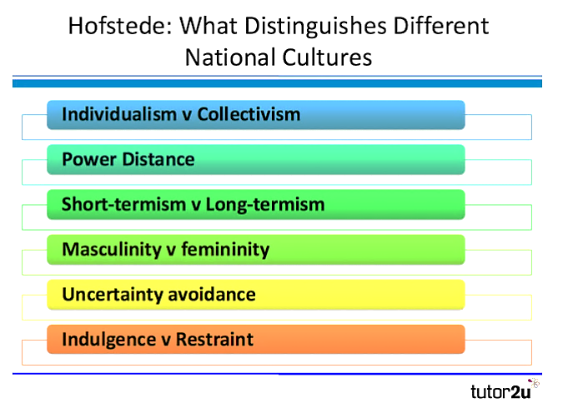Hofstede defined organisational culture as an idea system which is largely shared between members of an organisation. He carried out studies at IBM where he looked at the characteristics of working culture in different countries; the data can then be used to compare a workforce in one country against a workforce in a different country. Each country was scored between 1 – 120 for each characteristic, the higher the score the more the workers in that country exhibited a characteristic. The 6 characteristics are shown below.

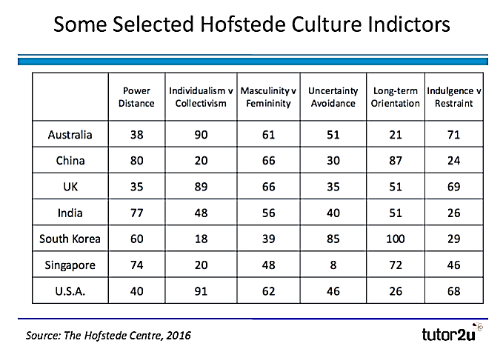Hofstede found that cultural differences matter in business and affect how managers in one country will operate differently to those in another. Overall his findings suggest that greater business success can be achieved by adapting the leadership / management style to the characteristics of a particular country. Some of his findings are shown below.

## Power distance -

The extent to which power is equally distributed in society and how widely society accepts this distribution. High PD culture is often related to strong leaders, highly autocratic cultures and would require a more autocratic style of leadership.

A low PD score indicates that the culture favours businesses where power is devolved – flatter structures

We can see from the table that **countries such as South Korea and China tend to favour more autocratic structures whereas the USA and Australia tend to favour more democratic or laissez-faire management.**

## Individualism –

Refers to how strong people’s ties are within the community. Countries with high scores tend to have workers who value their free time and have less interpersonal connection or value it less, workers value freedom and there is high expectation of reward. A low score here suggests a society where there are strong community bonds; work is often done for its intrinsic value so the need for specific financial rewards is less important. In these countries change often has to be introduced slowly as tradition is highly valued.

**Countries with low Individualism scores include –**

**Countries with high Individualism scores include –**

## Masculinity versus feminism –

This shows the extent to which society sticks to traditional male / female roles. A high score here suggests that men are generally seen as provider, assertive / authoritative and there are clear distinctions between male / female roles. A low scoring country is one in which men and women are more equal, there are many powerful / successful female roles, men are more sensitive and emotional and it’s more accepted for them to have caring roles. **The highest scoring country here is Japan and the lowest is Sweden.**

**Countries with low M v F scores include –**

**Countries with high M v F scores include –**

## Uncertainty avoidance index –

This refers to how anxious workers feel when they are in unknown situations. A high score here suggests that workers like structure and organisation and clear rules / chains of command. A low score suggests employees who don’t mind change and can cope easily when unusual events take place or if changes have to be completed quickly, business attitudes tend to be informal. **Belgium has a particularly high uncertainty avoidance score.**

**Countries with low uncertainty avoidance scores include –**

**Countries with high uncertainty avoidance scores include –**

## Long term orientation -

This refers to the value which society places on traditions and values.

In a country with a high score there is much greater emphasis on social obligations, family and community in general whereas in a county with a low score there is much greater promotion of equality, self-actualisation is important – fulfilling a person’s potential rather than focus on money and power.

**USA and UK have low scores for long-term orientation.**

## Indulgence v restraint.

In countries with a low indulgence score freedom of speech and leisure are seen as less important whereas in those with a high indulgence score freedom to express yourself and use your free time however you want are seen as more important.

**Countries with low indulgence scores include Eastern Europe, Asia and predominantly Muslim countries. Higher scores are seen in Australia, the UK and the USA.**

# Applications of national cultures.

Some examples of cases where the Hofstede Model on national culture can be applied:   
  
**Leadership**  
”Culture” can provide us with many answers about how and why people behave differently around the globe. One explanation is that people have very different views on "what is a good boss", or on”how teams should be led”.

A major challenge in developing intercultural management competence is the fact that there is no "one way" to lead. This is especially relevant as all "new" and growing markets have something in common, they can be characterised as hierarchical cultures.  Many companies may realise that the leadership styles/guidelines they have been practicing might not be suitable for these cultures.

**Change Management**  
The preparation and implementation of change is highly culturally sensitive. Often change is implemented incorrectly for the culture – ignoring behavioural issues such as resistance.

**Customer services**  
Many companies fail to gain maximum value from their customer service. High costs often offset the envisioned cost-savings, and culture is one of the most important reasons for failure when establishing customer service centres across geographical borders, both due to managing cultural differences, but also due to differences in customer cultures.

**Marketing**  
Because all aspects of consumer behaviour are culture-bound, there is an increased need to identify and understand this and its impact on global marketing and advertising. Hofstede's work can explain the differences in consumer behaviour across countries and can be a guide to increase efficiency in global marketing.

**Outsourcing**  
Outsourcing is a very important strategic issue for most of the world's leading companies; however, it’s much more complex than just taking advantage of low wages in some emerging countries. Companies should not rush blindly into outsourcing, but need to plan it carefully. Managers are concerned with the coordination of resources (material, financial, and human) for the effective and efficient achievement of business objectives. However, what may be an effective and efficient way of coordination in one country may prove to be ineffective or inefficient in another.  
 **Recruitment**  
For international organisations, recruiting the right people is of paramount importance. Coping with the complex international environment requires organisations to employ the people with the competences they need. HR and recruitment departments, therefore, develop profiles containing these desired competences.

Such profiles usually contain a listing of skills and character traits. Interestingly enough, however, organisations rarely consider the fact that the degree to which skills and traits are desirable differs from one country to another. The impact of management skills is culture-specific. Management techniques or leadership styles that work in one national culture do not necessarily work elsewhere.  
  
**Virtual Teams**Working virtually is increasingly the norm, no matter which sector you work in. National culture has a big impact on this, because often a virtual team is also a cross-cultural team. Cultural diversity may manifest itself as differences in preference for and satisfaction with tasks, technology, outcomes, leadership style, decision-making process, relative contributions and communication practices of team members.

## How would you describe the culture of these businesses and why?

### Sometimes firms need to try and change their culture, this might be because

* Business may be very product-orientated rather than market orientated and may not be competitive
* The business may be inefficient due to lack of focus – not being goal orientated
* 2 firms may have merged with different cultures and they need to find a new way of working
* Declining profits or market share mean that the company must address how it works

## Other influences on culture:

* The nature of the market
* The stage of the business and its size, management and staffing
* The degree of regulation (is it very bureaucratic?)
* Finance available
* Location (national /international)

## Problems of changing organisational culture

### Staffing issues:

* Staff are used to their way of working and may not want to change
* All staff need to believe the change is going to happen – not feel they can possibly stop change
* people will not like having their job role changed
* staff will need training in new protocols

### External environment:

External factors e.g. Brexit may mean that the business has to change how it operates in order to compete and survive.

### Change in ownership:

If there is a merger or takeover then the firms have to reach a consensus about the values and methods of working, this can take time and can lead to staff demotivation depending what is agreed.

### Rapid expansion/ retrenchment:

Can be difficult to control and to maintain the vision for staff. If growth happens quickly staff may develop their own ways of working and their own cultural norms to cope and these may not fit in with the whole firm’s vision. Retrenchment can leave staff with uncertainty and can therefore lead to morale problems and avoidance of / resistance to change.

Some of these problems can be solved relatively easily using the following model in conjunction with Kotter and Schlesinger’s theories about resistance to change and ways to overcome it…

## Strong v Weak Culture

When you visit a range of businesses you soon get a sense of the strength of the business culture. If a culture can be measured as then how might this show itself?

**Signs of a strong organisational culture include:**

* Staff understand and respond to culture
* Little need for policies and procedures
* Consistent behaviour
* Culture is embedded

**Evidence that points to a weak organisational culture include:**

* Little alignment with business values
* Inconsistent behaviour
* A need for extensive bureaucracy & procedure

# **Assessing the importance of organisational culture.**

#### Culture can be an asset

Organisations can have a big impact on society through their values and beliefs and can exert influence on large numbers of people setting trends and informing people. Culture can support a brand e.g. Waitrose or Body Shop.

#### Culture can reduce conflict and uncertainty within the firm.

People understand the norms of the culture and can then get on with working within it. If workers do not understand the culture they will question it and come into conflict.

#### Co-ordinating and controlling

Specific methods of working become part of the nature of the firm and therefore employees “know where they stand” There are expectations and preconceived ideas based on the type of organisation, power and authority will be generally recognised within the firm.

#### Improving motivation

Individuals working within a firm with a strong culture generally are more motivated because they have structure. Employees will understand how promotions, demotions, bonuses etc are decided upon and will have a greater tendency to be loyal if they accept the firm’s structure and embrace it. Culture can determine how staff treat each other and can therefore aid motivation.