**3.2.2 Group 2 – alkaline earth metals**

**AS Link:**

**3.1.1 – Atomic structure**

**3.1.3 – Bonding**

**3.2.1 – Periodicity**

|  |  |  |
| --- | --- | --- |
| The elements in group 2 of the periodic table are sometimes called the **alkaline earth metals** because their oxides and hydroxides are **alkaline**. They are similar to group 1 metals but **less reactive**. Beryllium is not typical so it’s not considered. |  |  |

**Trends in physical properties**

Electron arrangement

Outer electrons in **s-orbital**

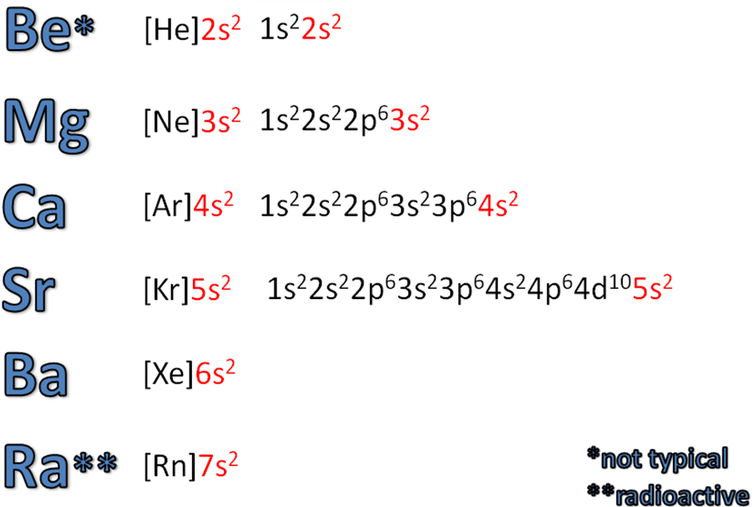

There are trends in their physical properties **going down the group**:

|  |  |
| --- | --- |
| * **Atomic radius** – increases   + Due to the **increasing number of shells**, so outer most electron is further away from nucleus |  |
| * **1st Ionisation energy** – decreases   + As the atomic radius increases the outer electrons become **more shielded** so there is **less attraction** for the electrons to the nucleus |  |
| * **Melting point** – decreases   + All metals with **high melting points**, typical of a giant metallic structure   + **Number** of **delocalised** **electrons** is the **same**   + But **ions get bigger** so the **delocalised electrons** are **further away** from the nucleus   + This **decrease** in **charge-to-size** ratio results in **less attraction** for the delocalised electrons   + So the strength of the **metallic bond weakens** | Mg has a lower melting point because it has a different crystal structure |

***Sheet: Group 2 – Physical trends***

***Application: CGP154 PQ1-2***

***Fact recall: CGP154 Q1-3***

**Trends in chemical properties**

Group 2 metal are oxidised in all their reactions, from state 0 to +2, forming 2+ ions.

M → M2+ + 2e-

0 +2

**Example CGP155**

Ca → Ca2+ + 2e-

0 +2

Reactions with water

As we go down group their reactivity increases because the outer electrons are at a greater distance, with more shielding so they are lost more easily.

General equation: **M(s) + 2H2O(l) →M(OH)2(aq) + H2(g)**

Magnesium reacts **slowly** with cold **water**: Mg(s) + 2H2O(l) → Mg(OH)2(s) + H2(g)

But **rapidly** with **steam** to produce an **oxide**: Mg(s) + H2O(g) → **MgO(s)** + H2(g)

Calcium reacts **more rapidly** with cold **water**: Ca(s) + 2H2O(l) → Ca(OH)2(aq) + H2(g)

Barium reacts **more violently** with cold **water**: Ba(s) + 2H2O(l) → Ba(OH)2(aq) + H2(g)

***Demo: Reaction with water***

* Mg – very slow
* Ca – collect hydrogen gas to test & show solution is alkali with indicator
* Ba – vigorous

***Demo: Reaction with steam***

* Mg – more vigorous, bright white light with white solid magnesium oxide produced.

***Sheet: Group 2 metals and water***

**Reactivity increases** as you go **down** the **group**.

**Reason**:

The **atoms** get **bigger** down the group as there is one more electron shell is added. The **outer electron** is therefore **further** **from** the **nucleus** and there is **more shielding** so it’s **more easily lost** when the atoms react as there is a **weaker attraction**.

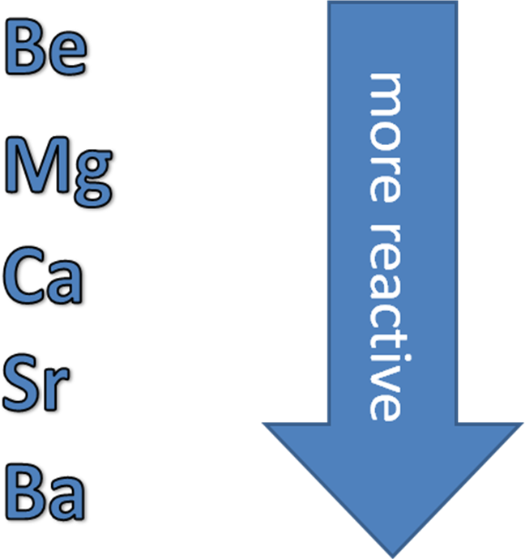

Solubility of group 2 compounds

If the **product** of a reaction in an aqueous solution is **soluble** the **water** molecules **separate** and surround the **ions**, so it appears **transparent**. If the **product** is **insoluble** then the water is **unable** to **separate** the ions and a **precipitate** is formed.

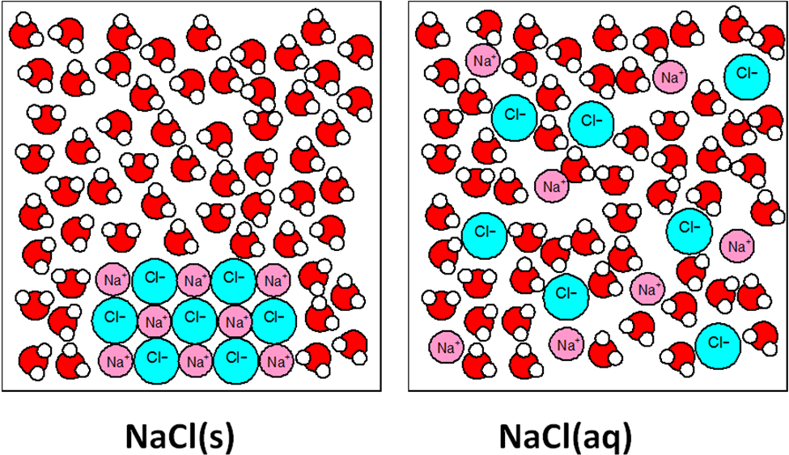

If **sodium hydroxide** or **sulphuric acid** are **added** to solutions containing group 2 metal ions the resulting **products will show the solubility** of the **compounds formed**.

|  |  |  |  |  |
| --- | --- | --- | --- | --- |
|  |  |  |  | Mg2+  Mg2+  Mg2+  Mg2+  Mg2+ |
|  |  |  |  |  |
| MgCl2(aq) | + | NaOH(aq) | → | **Mg(OH)2(s)** + NaCl(aq)  precipitate |
|  |  |  |  |  |
|  |  |  |  |  |
|  |  |  |  |  |
| BaCl2(aq) | + | NaOH(aq) | → | **no visible change**  soluble |
|  |  |  |  |  |
|  |  |  |  |  |
|  |  |  |  |  |
| Mg(NO3)2(aq) | + | H2SO4(aq) | → | **no visible change**  soluble |
|  |  |  |  |  |
|  |  |  |  |  |
|  |  |  |  |  |
| Ba(NO3)2(aq) | + | H2SO4(aq) | → | **BaSO4(s)** + HNO3(aq)  precipitate |

***Prac: Making hydroxide and sulphate compounds by precipitation***

**Summary - solubility**

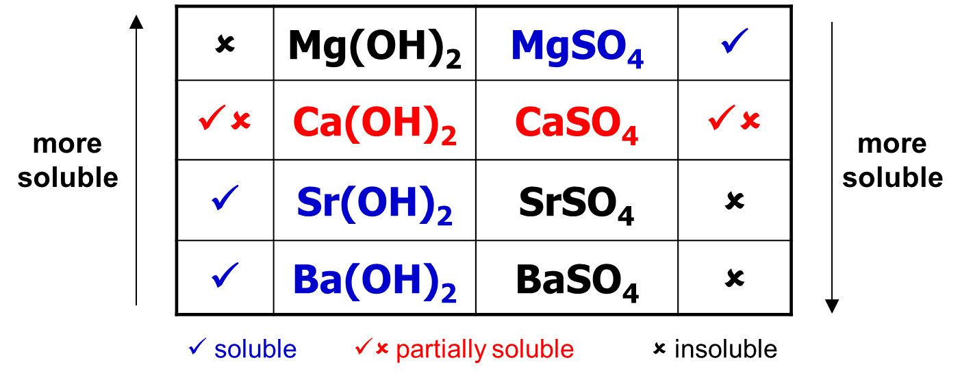

Solubility

There is a clear **trend in solubility** of the group 2 hydroxides and sulphate compounds.

|  |  |
| --- | --- |
| Hydroxides | Sulphates |
|  |  |
| General equation:  **M(OH)2(s) + aq → M2+(aq) + 2OH-(aq)** | General equation:  **MSO4 (s) + aq → M2+ (aq) + SO42- (aq)** |

**Uses the alkaline earth metal and their compounds**

Use of magnesium metal

**Magnesium** is used in part of the process to **extract titanium** from its ore. Titanium(IV) oxide (TiO2) is converted to titanium(IV) chloride (TiCl4) by heating it with steam and a stream of chlorine gas. The **titanium chloride** is then purified by fractional distillation, before being **reduced** by **magnesium** in a furnace at 1000oC.

TiCl4(g) + 2Mg(l) → Ti(s) + 2MgCl2(l)

Use of calcium carbonate and oxide

Producing electricity by burning fossil fuels also produces **sulphur dioxide** which if allowed into the atmosphere can cause **acid rain**. The acidic sulphur dioxide can be removed from flue gases by reacting it with an alkali. **Calcium carbonate** and **calcium oxide** can both be used to **neutralise** the acid. A slurry is made by mixing them with water and this is sprayed onto the gases, the sulphur dioxide reacts with it to produce calcium sulphite. This can be used to make plaster of Paris, plasterboards and pots for broken bones.

CaO(s) + SO2(g) → CaSO3(s)

CaCO3(s) + SO2(g) → CaSO3(s) + CO2(g)

Uses of hydroxides

**Magnesium hydroxide**, Mg(OH)2 is almost **insoluble** so has these uses.

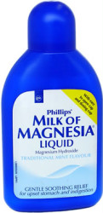

* **Milk of Magnesia** (sold as a suspension in water) is an **antacid** indigestion remedy.

Mg(OH)2(s) + H+(aq) → Mg2+(aq) + 2H2O(aq)

It is also a mild laxative for the relief of constipation.

**Calcium hydroxide**, Ca(OH)2 – mostly soluble so it has these uses.

* **Reduce soil acidity** to enable a wider range of crops to grow   
  (this is often a mixture of calcium carbonate and calcium hydroxide).

Provide **calcium ions** essential to plant growth.



* **Limewater** for the test of **carbon dioxide** give white precipitate of calcium carbonate.

Ca(OH)2(s) + CO2(g) → **CaCO3(s)** + 2H2O(l)

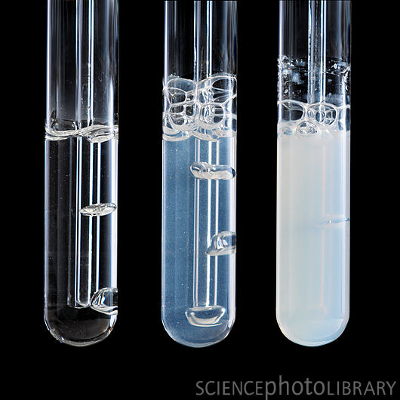

Uses of sulphates

**Magnesium sulphate**, MgSO4.7H2O – exists as a hydrated soluble salt with this use.

* **Epsom salts** is a mild laxative and can be used as bath salts.

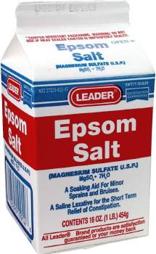

**Barium sulphate**, BaSO4 – it is toxic but insoluble so has these uses.

* **A ‘barium meal’** can be taken by mouth and due to heavy barium atom which absorbs

x-rays and allows **investigations of the digestive system.**

* + Barium compounds are **highly toxic** but it’s **safe** **because** barium sulphate is **insoluble**, so it **can’t be absorbed.**

|  |  |
| --- | --- |
|  |  |

* **Test for sulphates ions** in solution in laboratory
  + Solution is acidify using **HNO3 or HCl** which **reacts** with any **carbonate ions** as barium carbonate is also a white precipitate

2H+(aq) + CO32-(aq) → CO2(g) + H2O(l)

***Demo: Reaction carbonates with acid***

* + Solution of **barium chloride** is added
  + If sulphate ions are present a **white precipitate** of **barium sulphate** is formed

Ba2+(aq) + SO42-(aq) → BaSO4(s)

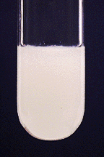

***Demo: Testing for sulphates***

***Starter: 4.2 – Group 2 trends***

***Application: CGP157 PQ1-2***

***Fact recall: CGP157 Q1-8***

***Sheet: Group 2 PPQ 1-2***

***Exam questions: Oxford p158-159 Q1-7***