Themes of the Aeneid
Read the information in the introduction to the text, pp. 1-10.
Rome’s Imperial Destiny | Love of the Countryside
The origins of Rome and its rise to power through their ancestors, culminating in the Augustan Age.  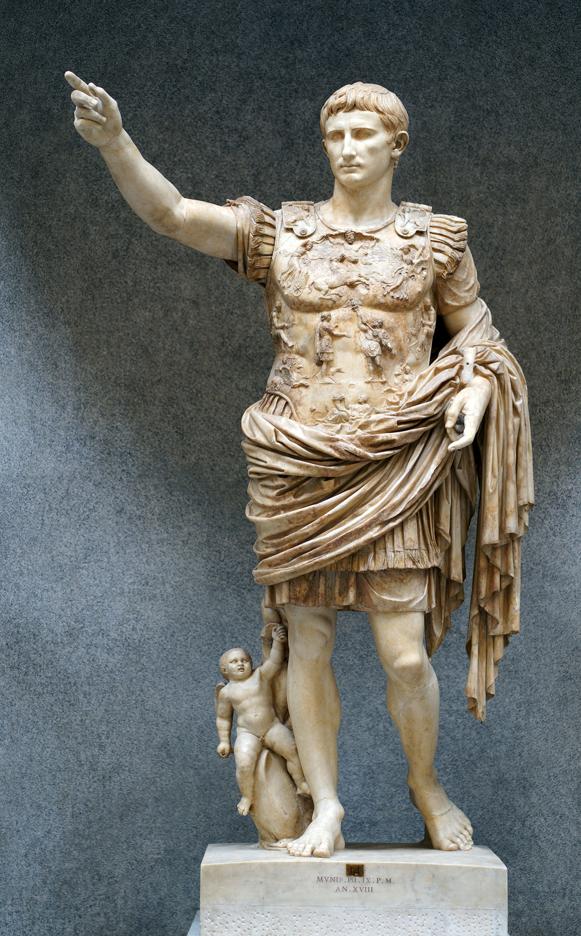  . |   The art of farming and poetry extolling the beauty of the countryside.
The Tragedy of War | The Epic Tradition
The loss felt during war time by loved ones of the fallen, influenced by Virgil’s experience of the civil wars.  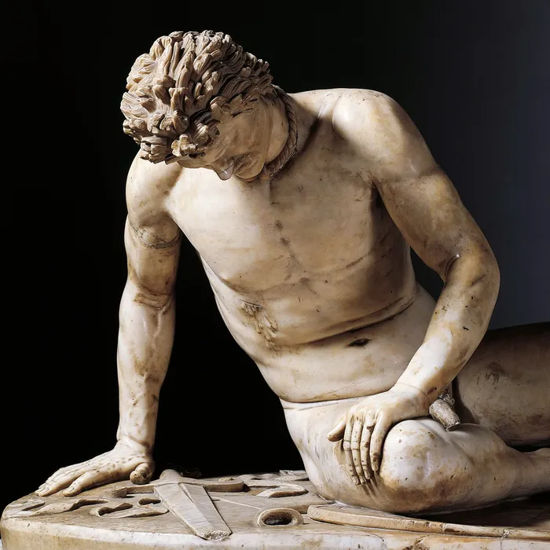 | 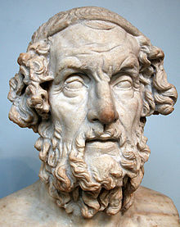  The world of myth told through the genre of epic and typified by the writing of Homer.

