

**IGCSE (9 – 1) Revision Pack**

**Fractions, decimals, ratio and proportion**

**Name --------------------------------**

**Questions**

  
**Q1.**

(a)  Show that

**(2)**

  
(b)  Show that

**(3)**

**(Total for Question is 5 marks)**

**Q2.**

(a)  Show that

**(2)**

(b)  Show that

**(3)**

**(Total for question = 5 marks)**

**Q3.**

Show that

**(Total for question = 2 marks)**

**Q4.**

(a)  Show that

**(2)**

(b)  Show that

**(3)**

**(Total for question = 5 marks)**

**Q5.**

Show that

**(Total for question = 3 marks)**

**Q6.**

In a box,

number of red buttons : number of blue buttons = 5 : 3

number of blue buttons : number of green buttons = 1 : 2

There are 48 green buttons in the box.

Work out the number of red buttons in the box.

...........................................................

**(Total for question = 4 marks)**

**Q7.**

There are 12 481 people at a concert.   
8906 of these people are adults.   
The rest of the people are children.   
 of the children are boys.

Work out the number of girls at the concert.

...........................................................

**(Total for question = 4 marks)**

**Q8.**

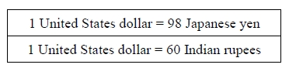

(a)  Change 85 United States dollars into Japanese yen.

........................................................... Japanese yen

**(2)**

(b)  Change 784 Japanese yen into Indian rupees.

........................................................... Indian rupees

**(2)**

**(Total for question = 4 marks)**

**Q9.**

John changes £450 to euros.

The exchange rate is £1 = 1.16 euros.

(a)  Change £450 to euros.

........................................................... euros

**(2)**

When in Amsterdam, John uses his credit card to pay for a ring costing 850 euros.

He has to pay a bank charge of £3.50 for using his credit card in addition to the cost of the ring.

(b)  Work out the total cost, in pounds (£), of the ring and the bank charge.

£ ...........................................................

**(3)**

**(Total for question = 5 marks)**

**Q10.**

(a)  Write   as a mixed number.

...........................................................

**(1)**

(b)  Show that 

  
  
  
  
  
**(1)**

(c)  Show that

**(2)**

**(Total for question = 4 marks)**

**Q11.**



(a) Alain changes 450 euros into Canadian dollars.   
How many Canadian dollars should he receive?

............................................................Canadian dollars

**(2)**

(b) Isabella changes 840 Canadian dollars into euros.   
How many euros should she receive?

............................................................euros

**(2)**



(c) How many cents is 1 Canadian dollar worth?

............................................................cents

**(2)**

**(Total for question = 6 marks)**

**Q12.**

(a) Write down the value of the 7 in the number 26.478

...........................................................

**(1)**

(b) Write these numbers in order of size.

Start with the smallest number.



...........................................................

**(1)**

(c) Write 2.792 correct to 1 decimal place.

...........................................................

**(1)**

(d) Find the number which is halfway between 2.7 and 3.5

...........................................................

**(1)**

(e) Write 0.07 as a percentage.

........................................................... %

**(1)**

**(Total for question is 5 marks)**

**Q13.**

(a)  Write down the value of the 3 in the number 7.432

...........................................................

(b)  Round 7.432 to the nearest whole number.

...........................................................

**(1)**

(c)  Write down the number which is exactly halfway between 0.7 and 0.8

...........................................................

**(1)**

(d)  Write these numbers in order of size.

Start with the smallest number.

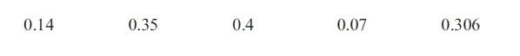

      ..............................................................................................................................................

**(1)**

(e)  Write 0.31 as a fraction.

...........................................................

**(1)**

**(Total for question = 5 marks)**

**Q14.**

(a)  Write as a decimal.

**(1)**

(b)  Write 0.7 as a percentage.

%

**(1)**

(c)  Write  as a decimal.

**(1)**

(d)  Shade 75% of this diagram.

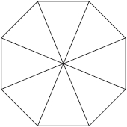

**(1)**

21% of the people on a train are asleep.

(e)  What percentage of the people on the train are not asleep?

%

**(1)**

**(Total for question = 5 marks)**

**Q15.**

(a)   Write 0.04 as a percentage.

........................................................... %

**(1)**

(b)   Work out 3⁄7 of 224

...........................................................

**(2)**

(c)   Find the cube root of 2744

...........................................................

**(1)**

(d)   Find the value of 45

...........................................................

**(1)**

**(Total for Question is 5 marks)**

**Q16.**

(a)  Write 0.8 as a percentage.

........................................................... %

**(1)**

(b)  Write 0.023 as a fraction.

...........................................................

**(1)**

(c)  Write 5.6382 correct to 2 decimal places.

...........................................................

**(1)**

(d)  Work out

Give your answer as a decimal.

...........................................................

**(2)**

(e)  Work out of 56.8 kg.

........................................................... kg

**(2)**

**(Total for question = 7 marks)**

**Q17.**

(a)  Write these decimals in order of size.   
Start with the smallest decimal.

0.501     0.51     0.5     0.55

.............................................................................................................................................

**(1)**

(b)  Write 0.3 as a fraction.

...........................................................

**(1)**

(c)  Write 0.46832 correct to 2 decimal places.

...........................................................

**(1)**

**(Total for question = 3 marks)**

**Q18.**

Here are five decimal numbers.

0.16     0.06     0.007     0.41     0.032

(a)  Write 0.41 as a fraction.

...........................................................

**(1)**

(b)  Write 0.16 as a percentage.

........................................................... %

**(1)**

(c)  Write down the smallest of the five numbers.

...........................................................

**(1)**

**(Total for Question is 3 marks)**

**Q19.**

Jack, Kate and Lila share some money in the ratios 5 : 9 : 6  
 In total, Jack and Kate receive £56

Work out the amount of money Lila receives.

£ ...........................................................

**(Total for question = 3 marks)**

**Q20.**

The perimeter of a triangle is 90 cm.  
The lengths of the sides of the triangle are in the ratios 3 : 5 : 7

Work out the length of the longest side of the triangle.

............................................................ cm

**(Total for question = 3 marks)**

**Q21.**

(a) Show that 4/5 ÷ 7/15 = 15/7

**(2)**

(b) Show that 51/4 − 12/3 = 37/12

**(3)**

**(Total for question = 5 marks)**

**Q22.**

Show that    

**(Total for question = 2 marks)**

**Q23.**

Work out the difference between the largest share and the smallest share when 3450 yen is divided in the ratios 2 : 6 : 7

........................................................... yen

**(Total for question = 3 marks)**

**Q24.**

Show that

**(Total for question = 3 marks)**

**Q25.**

Lisa, Max and Punita share £240 in the ratio 3 : 4 : 8

How much more money than Lisa does Punita get?

£...........................................................

**(Total for question = 3 marks)**

**Q26.**

(a)  Find a fraction which is equivalent to

...........................................................

**(1)**

(b)  Write as a decimal.

...........................................................

**(1)**

(c)  Write as a percentage.

......................................................... %

**(1)**

(d)  Mathsville School has 875 students.



of the students are girls.

  
(i)  Work out of 875

(ii)  Work out the fraction of the students who are boys.

...........................................................

8% of the students were born in May.

(iii)  Work out 8% of 875

...........................................................

**(5)**

**(Total for Question is 8 marks)**

**Q27.**

Nicole went on holiday from Paris to South Africa.  
The exchange rate was 1 euro = 9.54 Rand.

(a) Nicole changed 600 euros into Rand.

How many Rand did she get?

........................................................... Rand

**(2)**

(b) Her flight took off at 20 30 Paris time and landed at 08 15 Paris time the next day.

How long was the flight in hours and minutes?

.............................. hours .............................. minutes

**(3)**

Nicole returned to Paris after her holiday.  
The exchange rate had changed to 1 euro = 9.80 Rand.

(c) Nicole changed 1470 Rand into euros.

How many euros did she get?

........................................................... euros

**(2)**

**(Total for question = 7 marks)**

**Q28.**

A school has 840 pupils and 40 teachers.

(a)  Find the ratio of the number of pupils to the number of teachers.   
 Give your ratio in the form *n* : 1

........................................................... : 1

**(2)**

In Year 11 at the school, the ratio of the number of pupils who study Chemistry to the number of pupils who study Physics is 3 : 2

(b)  105 pupils in Year 11 study Chemistry.

Work out the number of pupils in Year 11 who study Physics.

...........................................................

**(2)**

For the 105 pupils who study Chemistry, the ratio of the number of boys to the number of girls is 4 : 3

(c)  Work out the number of girls in Year 11 who study Chemistry.

...........................................................

**(2)**

**(Total for Question is 6 marks)**

**Q29.**

In a school, there are 320 girls and 500 boys.

(a)  Write down the ratio of the number of girls to the number of boys.   
       Give your ratio in its simplest form.

...........................................................

**(2)**

In a different school, there is a total of 640 children.   
In this school, the ratio of the number of girls to the number of boys is 7 : 9

(b)  How many boys are there in this school?

...........................................................

**(2)**

**(Total for question = 4 marks)**

**Q30.**

Here is a rectangle made from centimetre squares.

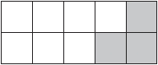

(a)  Find the area of this rectangle.

........................................................... cm2

**(1)**

(b)  What percentage of the rectangle is shaded?

........................................................... %

**(1)**

60% of a triangle is shaded.

(c)  What percentage of the triangle is not shaded?

........................................................... %

**(1)**

(d)  Write 60% as a decimal.

...........................................................

**(1)**

(e)  Change 60% to a fraction.

Give your answer in its simplest form.

...........................................................

**(2)**

**(Total for question = 6 marks)**

**Q31.**

(a)  Which one of these fractions is equivalent to ?



...........................................................

**(1)**

(b)  Work out  of 840 kg.

........................................................... kg

**(2)**

There are 240 cars in a car park.   
96 of these cars are red.

(c)  What fraction of the cars in the car park are red?

Give your fraction in its simplest form.

...........................................................

**(2)**

 of a number is 8

(d)  What is the number?

...........................................................

**(2)**

**(Total for question = 7 marks)**

**Q32.**

A total of 1200 passengers are booked to go on a cruise ship.

70% of the passengers will get on the ship at Southampton.

 of the passengers will get on the ship at Lisbon.

The rest of the passengers will get on the ship at Venice.

(a)  How many passengers will get on the ship at Venice?

...........................................................

**(3)**

There are 1200 passengers on the ship and 900 crew on the ship.

(b)  Write down the ratio of the number of passengers to the number of crew.   
Give your ratio in its simplest form.

...........................................................

**(2)**

**(Total for question = 5 marks)**

**Q33.**

Rectangle **A** is made from centimetre squares.

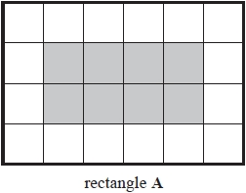

(a)  What fraction of rectangle **A** is shaded?

...........................................................

**(1)**

Rectangle **B** is made from centimetre squares.

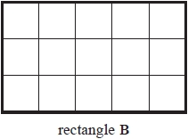

(b)  Shade 20% of rectangle **B**.

**(1)**

(c)  Work out 30% of 185

...........................................................

**(2)**

**(Total for question = 4 marks)**

**Q34.**

(a)  Work out of 72 kg.

........................................................... kg

**(2)**

  
(b)  Show that

**(2)**

**(Total for question = 4 marks)**

**Q35.**

The table gives information about the numbers of medals won by Australia and Great Britain in the 2012 Paralympic Games.

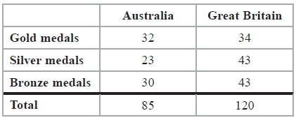

(a)   What fraction of the total number of medals won by Australia were gold medals?

...........................................................

**(1)**

(b)   Write down the ratio of the total number of medals won by Australia to the total number of medals won by Great Britain.   
Give your ratio in its simplest form.

...........................................................

**(2)**

(c)   In the 2012 Paralympic Games, the total number of gold and silver medals won by Brazil was 35   
 The ratio of the number of gold medals that Brazil won to the number of silver medals that Brazil won was 3 : 2

How many silver medals were won by Brazil?

...........................................................

**(2)**

(d)   In the 2012 Paralympic Games, the ratio of the total number of medals won by the   
Ukraine to the total number of medals won by Great Britain was 7 : 10

Great Britain won a total of 120 medals.   
What was the total number of medals won by the Ukraine?

...........................................................

**(2)**

**(Total for Question is 7 marks)**

**Q36.**

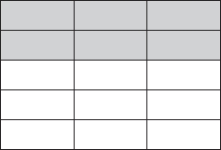

(a)  What fraction of this shape is shaded?   
Write your fraction in its simplest form.

...........................................................

**(2)**

  
(b) Write as a percentage.

...........................................................%

**(1)**

(c) Write as a decimal.

...........................................................

**(1)**

42% of the houses in a street have gardens.

(d)  What percentage of the houses in the street do **not** have gardens?

...........................................................%

**(1)**

(e)  Write a number on the dotted line so that the calculation is correct.

........................................................... ÷ 4.7 = 1.5

**(1)**

**(Total for question = 6 marks)**

**Q37.**

Here is a shape made of squares.



(a)  Write down the fraction of the shape that is shaded.

..........................................................

**(1)**

of the people in a room are female.

(b)  What fraction of the people in the room are male?

..........................................................

**(1)**

(c)  Write as a decimal.

..........................................................

**(1)**

**(Total for question = 3 marks)**

**Q38.**

(a) (i)  What fraction of this shape is shaded?

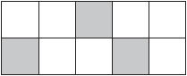

...........................................................

(ii)  Write your fraction as a decimal.

...........................................................

**(2)**

(b)  Find a fraction that is equivalent to 

...........................................................

**(1)**

(c)  Write 65% as a decimal.

...........................................................

**(1)**

72% of a shape is coloured red.   
The rest of the shape is coloured blue.

(d)  What percentage of the shape is coloured blue?

........................................................... %

**(1)**

**(Total for question = 5 marks)**

**Q39.**

(a)  Work out 10% of 180

...........................................................

**(1)**

  
(b)  Work out of 160 yuan.

........................................................... yuan

**(1)**

  
(c)  Shade of this shape.

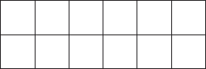

**(1)**

**(Total for question = 3 marks)**

**Q40.**

(a)   Work out 40% of 20

...........................................................

**(2)**

Here are four numbers.

0.43        3⁄7        43.8%        7⁄16

(b)   Write these numbers in order of size.   
 Start with the smallest number.

...........................................................

**(2)**

**(Total for Question is 4 marks)**

**Q41.**

The water in a fish tank is treated by using 5 millilitres of AquaGuard for every 10 litres of water in the tank.

(a)   Write down the ratio of the volume of AquaGuard used to the volume of water in the tank. Give your answer in the form 1 : *n*

1 : ...........................................................

**(2)**

A tank contains 96 litres of water.

(b)   Work out the volume of AquaGuard that should be used.   
Give your answer in millilitres.

........................................................... millilitres

**(2)**

**(Total for Question is 4 marks)**

**Q42.**

In a survey of 120 cars, 3/8 of the cars were red.

Work out 3/8 of 120

...........................................................

**(Total for question = 2 marks)**

**Q43.**

Work out the value of

Give your answer as a decimal.

...........................................................

**(Total for question is 2 marks)**

**Q44.**

There are 20 students in a class.  
12 of the students are girls.

(a) Write 12 out of 20 as a fraction.   
Give your fraction in its simplest form.

...........................................................

**(2)**

(b) Find the ratio of the number of girls to the number of boys.   
Give your ratio in the form *n* : 1

........................................................... : 1

**(2)**

**(Total for question = 4 marks)**

**Q45.**

(a)

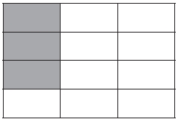

(i) What fraction of this shape is shaded?   
Give your fraction in its simplest form.

...........................................................

(ii) Write your answer to part (i) as a decimal.

...........................................................

**(3)**

(b)

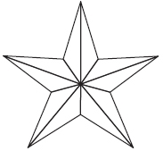

(i) Shade 20% of this shape.

(ii) What percentage of the shape is unshaded?

...........................................................%

**(2)**

**(Total for question = 5 marks)**

**Q46.**

(a)  Write  as a mixed number.

**(1)**

There are 84 animals in a field.

10 of the animals are horses.   
45 of the animals are sheep.   
The rest of the animals are cows.

(b)  What fraction of the animals in the field are cows?

**(2)**

(c)  Write these fractions in order of size.

Start with the smallest fraction.



**(2)**

(d)  Show that

**(2)**

**(Total for question = 7 marks)**

**Q47.**

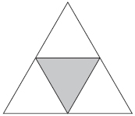

(a) What fraction of this shape is shaded?

...........................................................

**(1)**

(b) Write your answer to part (a) as a percentage.

...........................................................%

**(1)**



(c) On the shape, draw all the lines of symmetry.

**(2)**

**(Total for question = 4 marks)**

**Mark Scheme**

Q1.

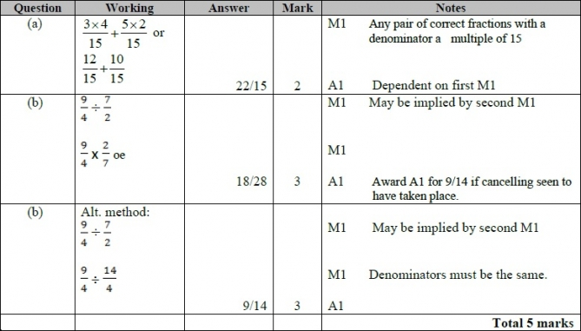

**Q2.**

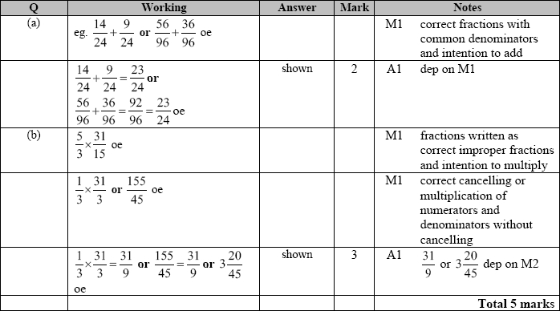

**Q3.**

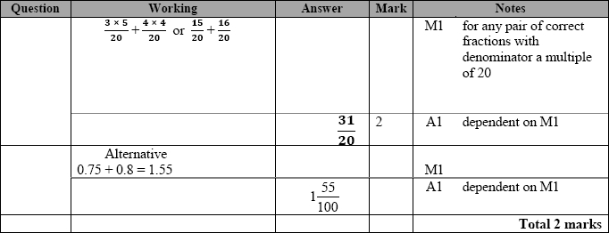

**Q4.**

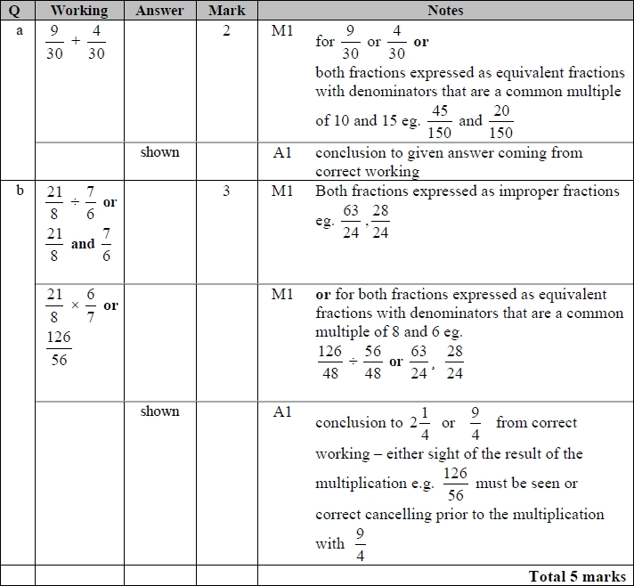

**Q5.**

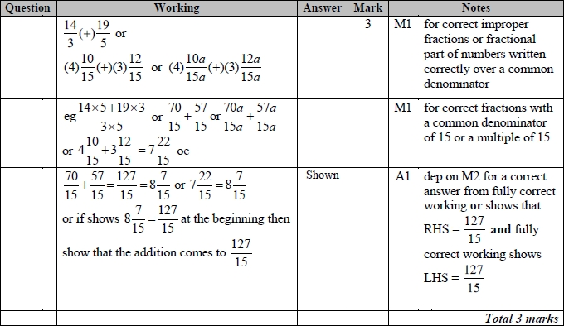

**Q6.**

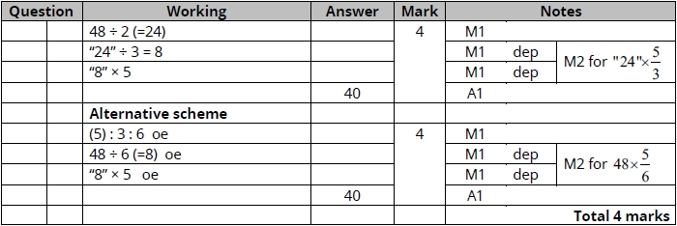

**Q7.**

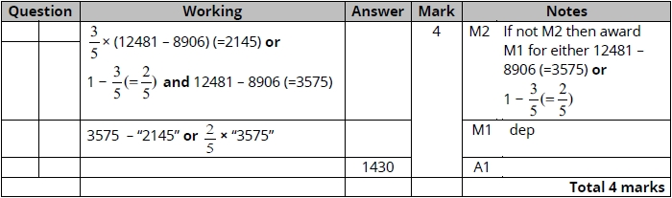

**Q8.**

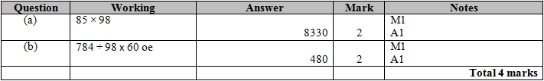

**Q9.**

For all questions, the correct answer, unless clearly obtained by an incorrect method, should be taken to imply a correct method.

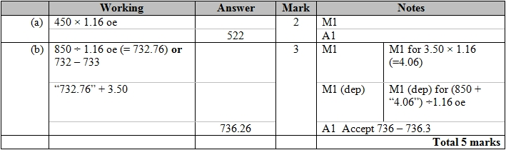

**Q10.**

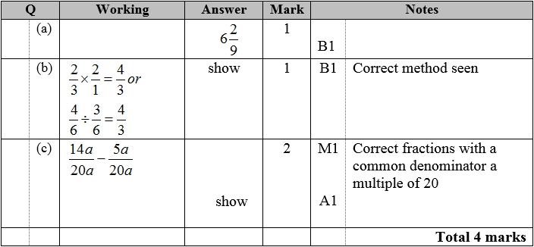

**Q11.**

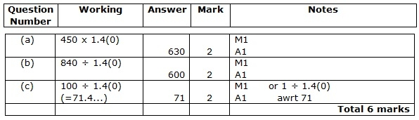

**Q12.**

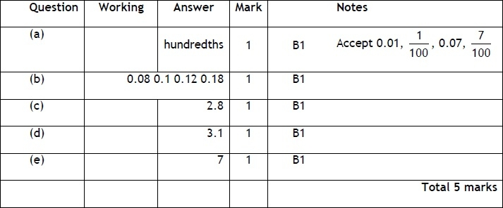

**Q13.**

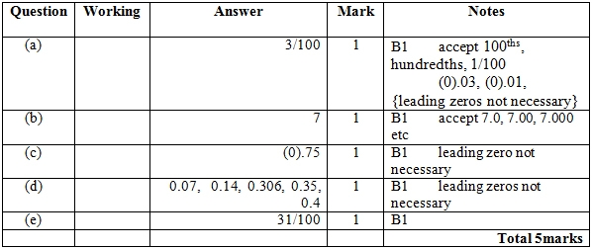

**Q14.**

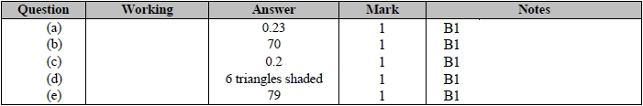

**Q15.**

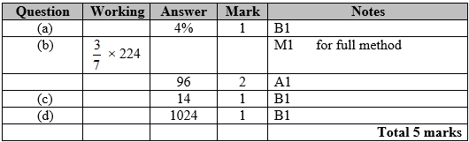

**Q16.**

Apart from question 18c where the mark scheme states otherwise, the correct answer, unless clearly obtained by an incorrect method, should be taken to imply a correct method.

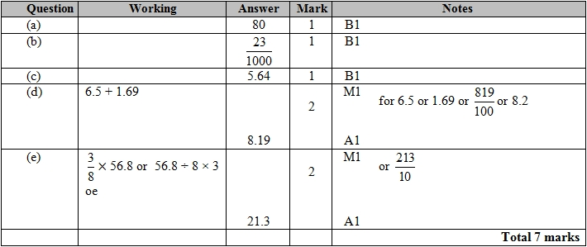

**Q17.**

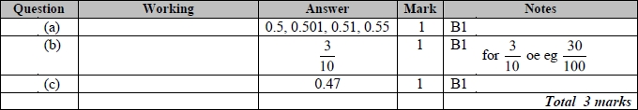

**Q18.**

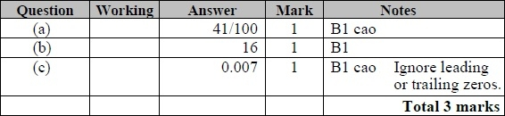

**Q19.**

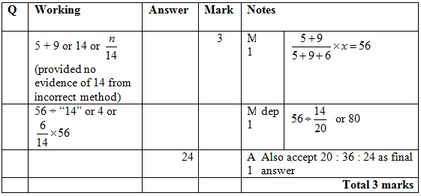

**Q20.**

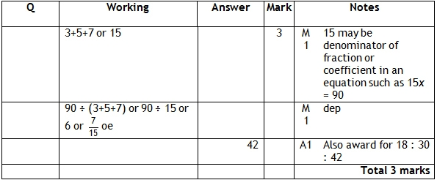

**Q21.**

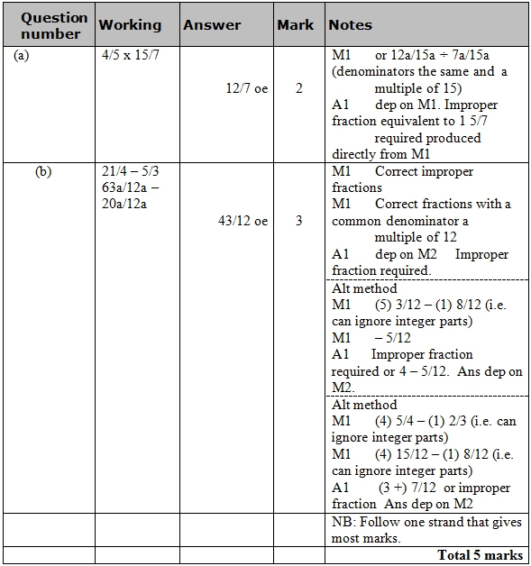

**Q22.**

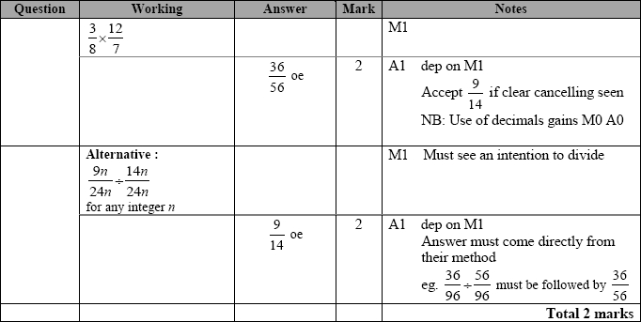

**Q23.**

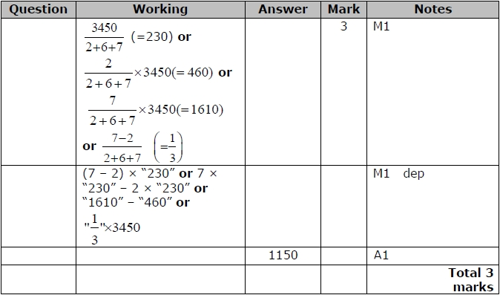

**Q24.**

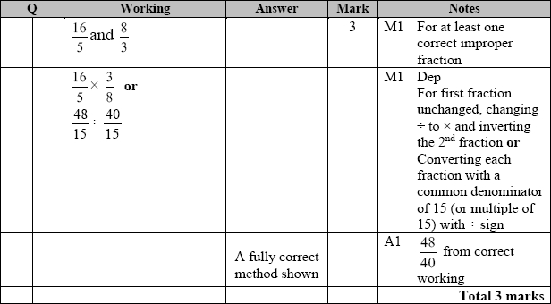

**Q25.**

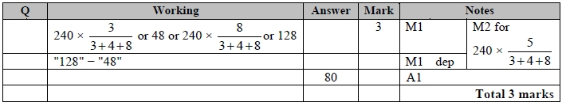

**Q26.**

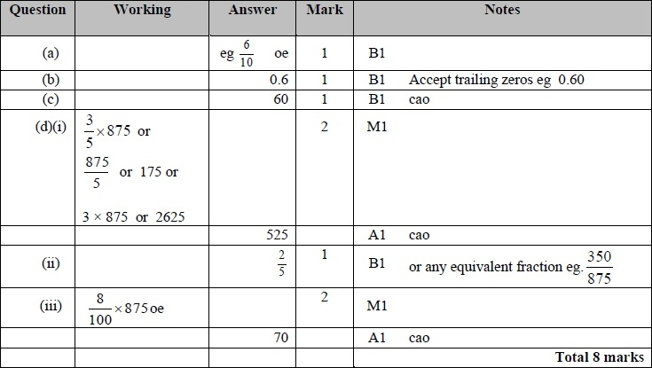

**Q27.**

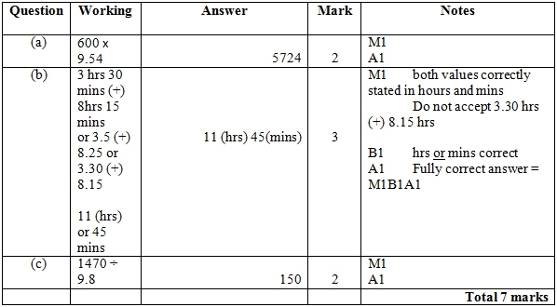

**Q28.**

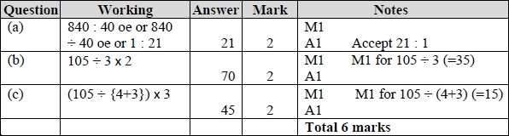

**Q29.**

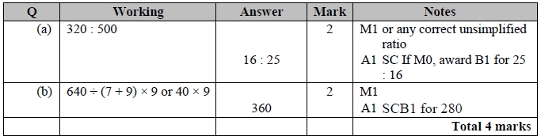

**Q30.**

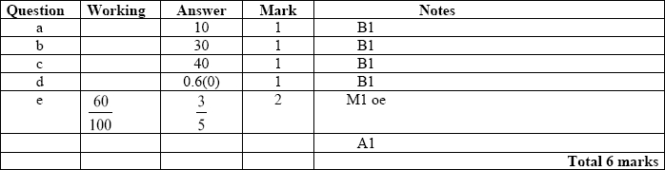

**Q31.**

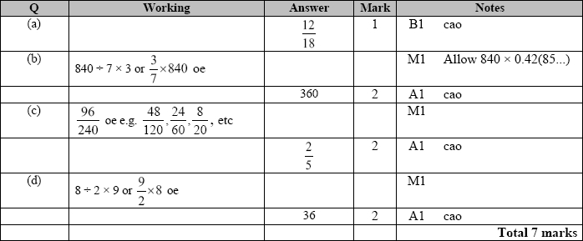

**Q32.**

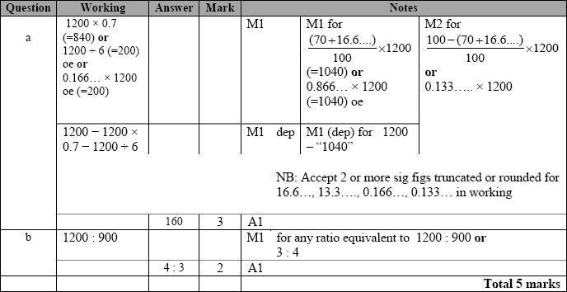

**Q33.**

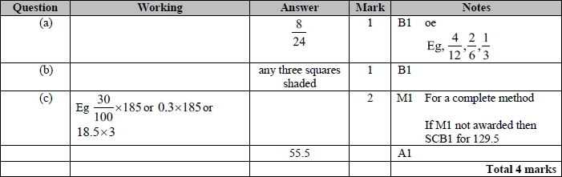

**Q34.**

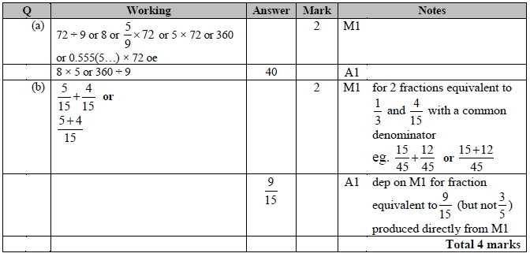

**Q35.**

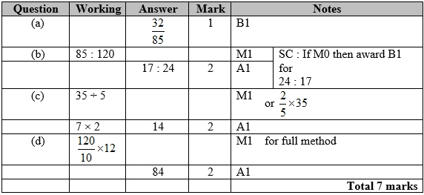

**Q36.**

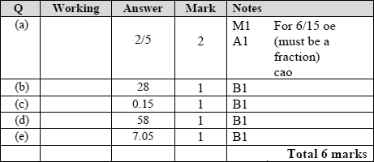

**Q37.**

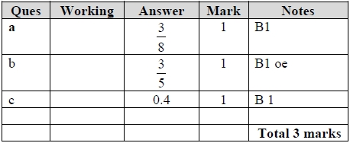

**Q38.**

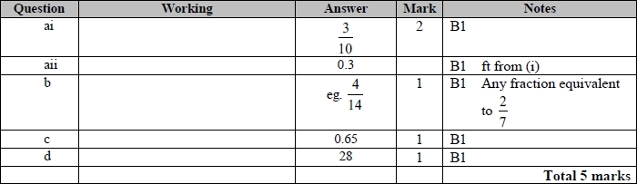

**Q39.**

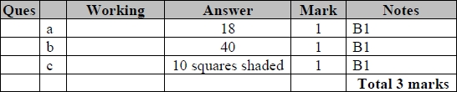

**Q40.**

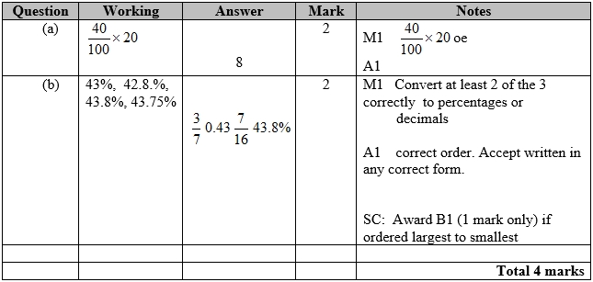

**Q41.**

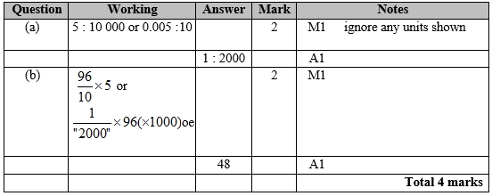

**Q42.**

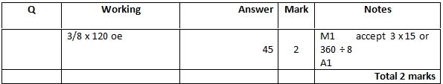

**Q43.**

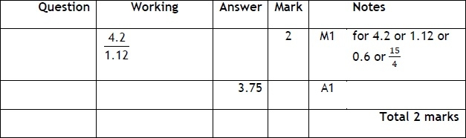

**Q44.**

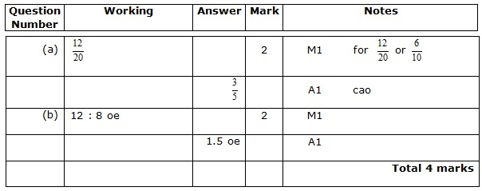

**Q45.**

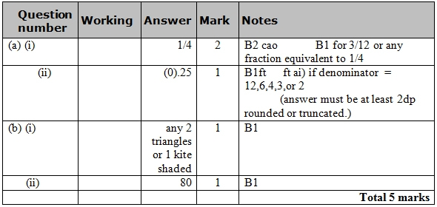

**Q46.**

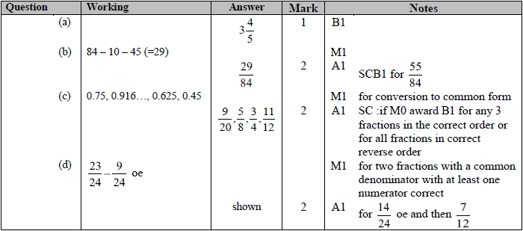

**Q47.**

