3.8.2 How to compete -

Porter’s generic strategies

Competitive advantage

Bowman’s clock

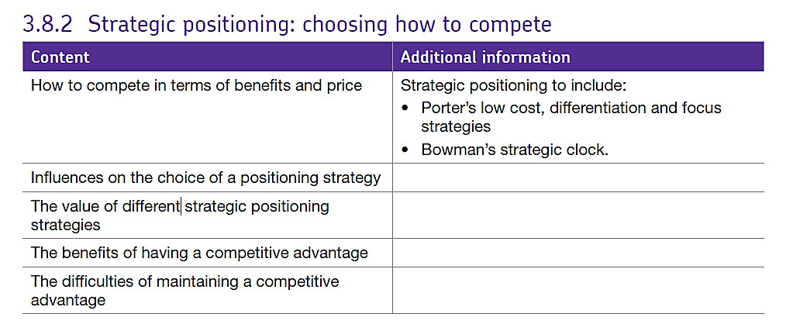

Strategic positioning refers to the firm’s decisions about how to compete in its market in relation to the benefits their product offers and their pricing strategies.

Firm’s really want to gain the best advantage over their competitors in order that their target market think they represent the best value for money and choose to buy their product. There are several ways to think about this. Some firms will consider whether they want to focus on price or quality and this is summed up in Porter’s generic strategies for competitive advantage.

## Porter's Generic Strategies for Competitive Advantage

The key strategic challenge for most businesses is to find a way of achieving a **sustainable competitive advantage**over the other competing products and firms in a market. A **competitive advantage** is an advantage over competitors gained by offering consumers greater value, either by means of lower prices or by providing greater benefits and service that justifies higher prices.

Porter suggested four "generic" business strategies that could be adopted in order to gain competitive advantage. The strategies relate to the extent to which the **scope**of a business' activities are narrow – (in a small number of markets or in a niche) versus broad (across a large market) and the extent to which a business seeks to differentiate its products.

The four strategies are summarised in the figure below:

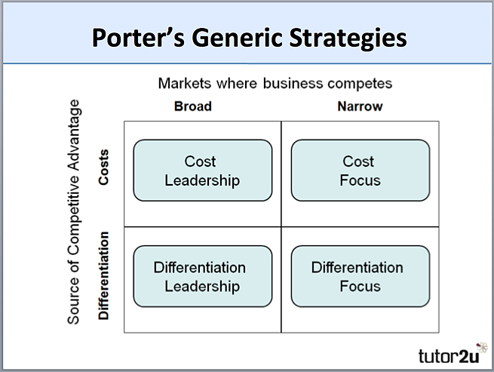

The differentiation and cost leadership strategies seek competitive advantage in a broad range of market or industry segments. By contrast, the differentiation focus and cost focus strategies are adopted in a narrow market or industry.

### Cost Leadership

With this strategy, the objective is to become the **lowest-cost producer in the industry**.

The traditional method to achieve this objective is to produce on a large scale which enables the business to exploit economies of scale.

Why is cost leadership potentially so important? Many (perhaps all) market segments in the industry are supplied with the emphasis placed on minimising costs. If the achieved selling price can at least equal (or near) the average for the market, then the lowest-cost producer will (in theory) enjoy the best profits.

This strategy is usually associated with large-scale businesses offering "standard" products with relatively **little differentiation** that are readily acceptable to the majority of customers. Occasionally, a low-cost leader will also discount its product to maximise sales, particularly if it has a significant cost advantage over the competition and, in doing so, it can further increase its market share.

A strategy of cost leadership requires close cooperation between all the functional areas of a business. To be the lowest-cost producer, a firm is likely to achieve or use several of the following:

* High levels of productivity
* High capacity utilisation
* Use of bargaining power to negotiate the lowest prices for production inputs
* Lean production methods (e.g. JIT)
* Effective use of technology in the production process
* Access to the most effective distribution channels

### Cost Focus

Here a business seeks a lower-cost advantage in just one or a small number of market segments.

The product will be basic - perhaps a similar product to the higher-priced and featured market leader, but acceptable to sufficient consumers. Such products are often called "me-too's".

### Differentiation Focus

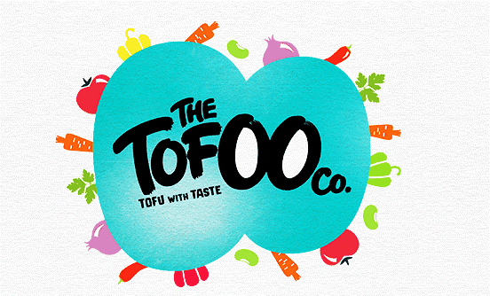In the differentiation focus strategy, a business aims to differentiate within **just one or a small number of target market segments.**

The special customer needs of the segment mean that there are opportunities to provide products that are clearly different from competitors who may be targeting a broader group of customers.

The important issue for any business adopting this strategy is to ensure that customers really do have different needs and wants - in other words that there is a valid basis for differentiation - and that existing competitor products are not meeting those needs and wants.

Differentiation focus is the classic niche marketing strategy. Many small businesses are able to establish themselves in a niche market segment using this strategy, achieving higher prices than un-differentiated products through specialist expertise or other ways to add value for customers. There are many successful examples of differentiation focus, a good one is Tyrrells Crisps which focused on the smaller hand-fried, premium segment of the crisps industry.

### Differentiation Leadership

With differentiation leadership, the business targets much larger markets and aims to achieve **competitive advantage through differentiation across the whole of an industry.**

This strategy involves selecting one or more criteria used by buyers in a market - and then positioning the business uniquely to meet those criteria. This strategy is usually associated with charging a **premium price** for the product - often to reflect the higher production costs and extra value-added features provided for the consumer.

Differentiation is about charging a premium price that more than covers the additional production costs, and about giving customers clear reasons to prefer the product over other, less differentiated products.

There are several ways in which this can be achieved, though it is not easy and it requires substantial and sustained marketing investment. The methods include:

* Superior product quality (features, benefits, durability, reliability)
* Branding (strong customer recognition & desire; brand loyalty)
* Industry-wide distribution across all major channels (i.e. the product or brand is an essential item to be stocked by retailers)
* Consistent promotional support – often dominated by advertising, sponsorship etc

Great examples of a differentiation leadership include global brands like Nike and Mercedes. These brands achieve significant economies of scale, but they do not rely on a cost leadership strategy to compete. Their business and brands are built on persuading customers to become brand loyal and paying a premium for their products.

### Benefits of competitive advantage.

Firms with competitive advantages are often able to achieve higher sales, this should lead to higher profitability and so improve the firm’s market cap. pleasing shareholders.

Products with high competitive advantage often have faster sales growth esp. when they launch newer products or extension strategies as people want to be the first to have the latest product, with the additional capital gained through higher profits they can develop other products and maintain their competitive advantage. This increase in sales, investment and production can also lead to higher capacity utilisation, economies of scale and larger financial reserves with which to survive a downturn in the economy.

### Drawbacks of Competitive advantage.

However, it can be difficult to maintain completive advantage, the cost of innovating and marketing can be high and there will be an opportunity cost for any business in this position. Consumers’ expectations will be high and, if not met, they may stray away from the brand.

## Bowman’s strategic clock

Bowman’s Strategic Clock is a model that explores the options for **strategic positioning** – i.e. how a product should be positioned to give it the most competitive position in the market.

The purpose of the clock is to illustrate that a business will have a variety of options of how to position a product based on two dimensions – **price**and **perceived value**.

The Strategic Clock looks like this:

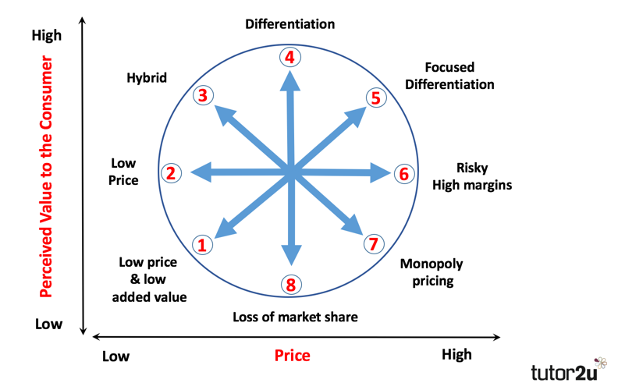

**Low Price and Low Value Added (Position 1)**

Not a very competitive position for a business. The product is not differentiated and the customer perceives very little value, despite a low price. This is a bargain basement strategy. The only way to remain competitive is to be as “cheap as chips” and hope that no-one else is able to undercut you.

**Low Price (Position 2)**

Businesses positioning themselves here look to be the **low-cost leaders** in a market. A strategy of **cost minimisation** is required for this to be successful, often associated with economies of scale. Profit margins on each product are low, but the high volume of output can still generate high overall profits. Competition amongst businesses with a low price position is usually intense – often involving price wars.

**Hybrid (Position 3)**

As the name implies, a hybrid position involves some element of low price (relative to the competition), but also some product differentiation. The aim is to persuade consumers that there is good added value through the combination of a reasonable price and acceptable product differentiation. This can be a very effective positioning strategy, particularly if the added value involved is offered consistently.

**Differentiation (Position 4)**

The aim of a differentiation strategy is to offer customers the highest level of perceived added value. Branding plays a key role in this strategy, as does product quality. A high quality product with strong brand awareness and loyalty is perhaps best-placed to achieve the relatively prices and added-value that a differentiation strategy requires.

**Focused Differentiation (Position 5)**

This strategy aims to position a product at the highest price levels, where customers buy the product because of the high perceived value. This the positioning strategy adopted by luxury brands, who aim to achieve premium prices by highly targeted segmentation, promotion and distribution. Done successfully, this strategy can lead to very high profit margins, but only the very best products and brands can sustain the strategy in the long-term.

**Risky High Margins (Position 6)**

This is a high risk positioning strategy that you might argue is doomed to failure – eventually. With this strategy, the business sets high prices without offering anything extra in terms of perceived value. If customers continue to buy at these high prices, the profits can be high. But, eventually customers will find a better-positioned product that offers more perceived value for the same or lower price. Other than in the short-term, this is an uncompetitive strategy. Being able to sell for a price premium without justification is tough in any normal competitive market.

**Monopoly Pricing (Position 7)**

Where there is a monopoly in a market, there is only one business offering the product. The monopolist doesn’t need to be too concerned about what value the customer perceives in the product – the only choice they have is to buy or not. There are no alternatives. In theory the monopolist can set whatever price they wish. Fortunately, in most countries, monopolies are tightly regulated to prevent them from setting prices as they wish.

**Loss of Market Share (Position 8)**

This position is a recipe for disaster in any competitive market. Setting a middle-range or standard price for a product with low perceived value is unlikely to win over many consumers who will have much better options (e.g. higher value for the same price from other competitors).

**Overview**

Looking at the Strategy Clock in overview, you should be able to see that three of the positions (6, 7 and 8) are uncompetitive. These are the ones where price is greater than perceived value. Provided that the market is operating competitively, there will always be competitors that offer a higher perceived value for the same price, or the same perceived value for a lower price.

