**The Iliad – Book 10**

**Read lines 1-71**

How are the two brothers shown acting in a similar way at the start of this book?

What do we learn about Agamemnon’s authority over his brother and both their relationship with the Achaeans

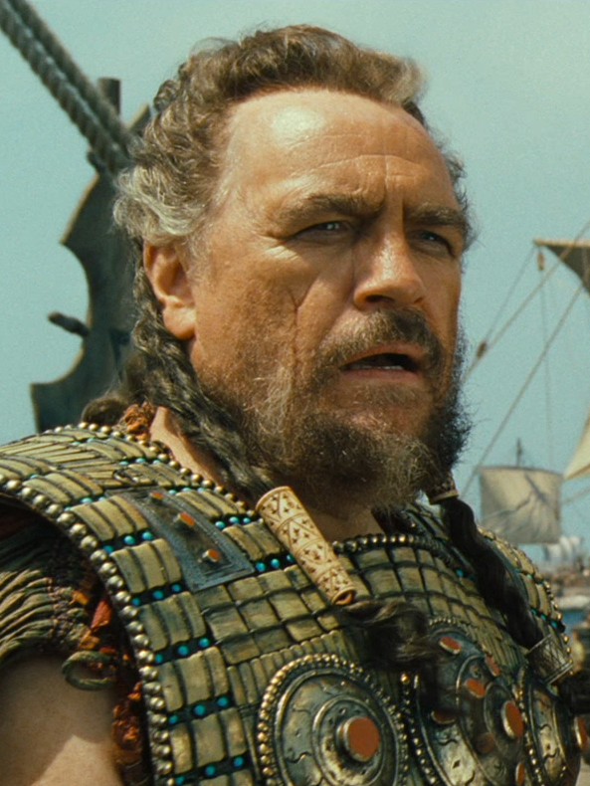

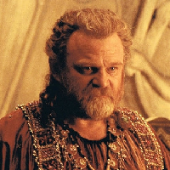

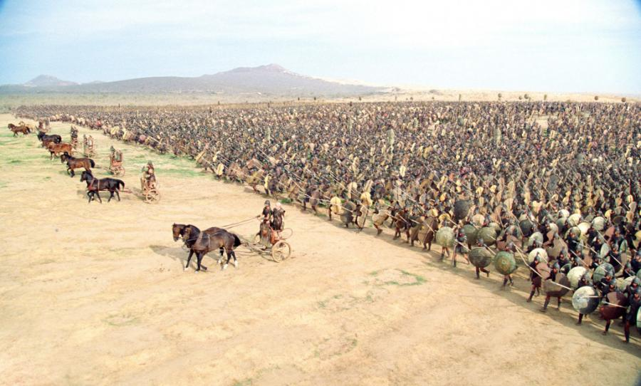

What has impressed Agamemnon about Hector?

**Read lines 72-130**

Select four quotes that show that Agamemnon is in distress and explain how they show this:

|  |  |
| --- | --- |
| **Quote:** | **Explanation:** |
|  |  |
|  |  |
|  |  |
|  |  |

Nestor’s assumption about Menelaus:

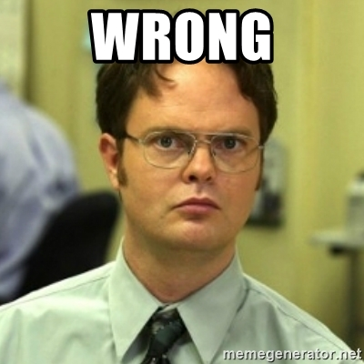

Agamemnon’s correction

Support this meme from quotes by Agamemnon and Nestor:

**Read lines 131-193**

How does Nestor’s visit to Odysseus and Diomedes follow the following formula:

|  |  |  |  |
| --- | --- | --- | --- |
|  |  | Description of the scene around Diomedes’ tent: | Description of scene at the guards’ post |
|  | Exchange between Nestor and Odysseus: | Exchange between Nestor and Diomedes: | Exchange between Nestor and the guards: |
|  | They decide where to go next: | They decide where to go next |  |
| Description of Nestor dressing: | Description of Odysseus dressing | Description of Diomedes dressing |  |

Diomedes and Odysseus turn out to be the central characters of this book. But how does Nestor’s relationship with the two show how they differ?

**Read lines 194-271**

How does Nestor try to convince the Achaean heroes to volunteer for the night mission:

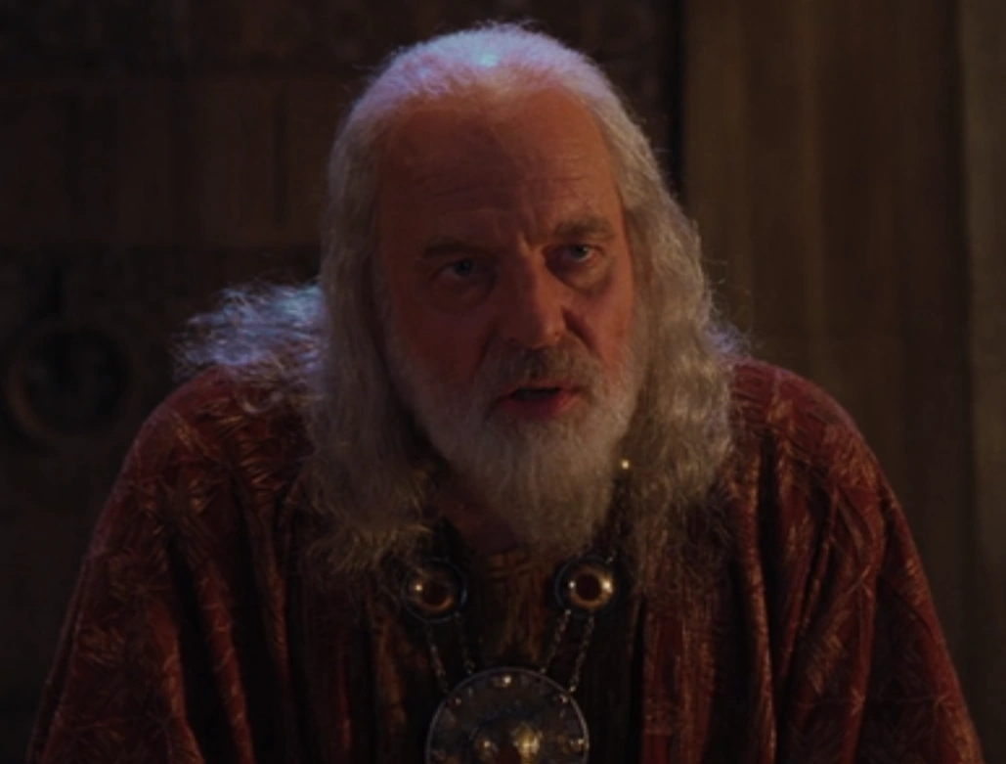

List all the heroes who volunteer and number them in order of who you think would be the most suitable for Nestor’s night mission:



Why do you think Agamemnon does not volunteer and what do we learn about his relationship with his brother here?

Why does Diomedes choose Odysseus as his companion? How does Odysseus’ response instantly prove him right?

|  |  |
| --- | --- |
| Diomedes’ Reasons: | Odysseus’ Response: |
|  |  |

Why is it that Meriones and Thrasymedes are the two to arm Diomedes and Odysseus?

How does their equipment differ? Is this incidental or telling in your opinion?

**Read lines 272-298**

How does their setting off again justify Diomedes’ reasoning for choosing Odysseus?

Whose petition to Athena do you think is the more convincing?

**Diomedes**

**Odysseus**

Diomedes’ reference to the story about his father has come up before (cf 4.382-398 & 5.803-808). Why do you think this story keeps recurring?

**Read lines 299-340**

What similarities does Hector’s proposed mission have with that of Nestor?

What impression do you get of Dolon from his introduction? Is he a good candidate for a night mission?

In what ways does this passage demonstrate the *hubris* of Dolon?

**Read lines 341-464**

Sketch Odysseus’ plan in four steps when he sees Dolon coming:

|  |  |  |  |
| --- | --- | --- | --- |
|  |  |  |  |

Odysseus and Diomedes make a good pair, with the former contributing his intelligence, the latter his physical prowess. How are both show in the following ways:

**Odysseus’ Plan:**

**Diomedes’ Chase:**



**Odysseus’ Interrogation:**

**Diomedes’ Execution of Dolon:**



**Odysseus’ Votive to Athena:**

How does the chase simile not only reflect the action, but also the character of the people involved:

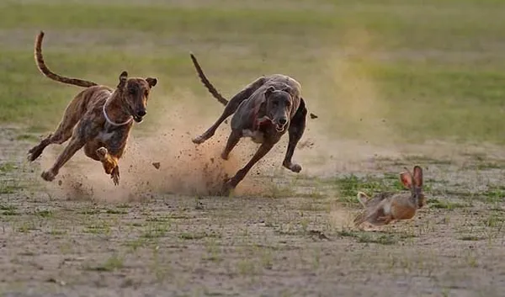

Select four quotes that show that Dolon is a coward and explain how they show this:

|  |  |
| --- | --- |
| **Quote:** | **Explanation:** |
|  |  |
|  |  |
|  |  |
|  |  |

What is it about Dolon’s description of the Thracians that will appeal to his two captors?

**Read lines 465-579**

Yet again, the two heroes make a good pair and work together according to their particular strengths. How do these play out?

|  |  |
| --- | --- |
| Odysseus’ Intelligence: | Diomedes’ Fighting Skill: |
|  |  |

The death of King Rhesus is the subject of one of Euripedes’ tragedies (the only surviving tragedy taken from the Iliad). What would make this into a good tragic play?

How do the following deities intervene at the climax of this adventure?

|  |  |
| --- | --- |
| **Deity:** | **Intervention:** |
| ArtStation - Athena # Greek Mythology # Goddess of War # my virsion !!,  anita chaudhary |  |
| Apollo/Apollo - God of the Sun |  |

How do the following aspects of the conclusion add to heroic nature of Diomedes and Odysseus’ return?

|  |  |
| --- | --- |
| The Chase |  |
| Nestor’s Reception |  |
| Athena’s Votive |  |
| Their Recuperation |  |

**Appendix: The Boar’s-Tusk Helmet**

Context

This item has become famous after discoveries in Mycenae and other Bronze Age settlements uncovered a style of helmet very closely paralleled to the description in *Iliad* 10. This type of helmet was no longer in use during Homer’s own day, and so it certainly was part of the older oral tradition. It may have seemed exotic to Homer’s audience, which might go so way to explaining its inclusion, since the item plays no part in the narrative despite its lengthy description.

Significant Items

In Homeric literature, items often receive detailed attention. Most significantly is the shield of Achilles in *Iliad* 18. Odysseus’ bow in *Odyssey* 21. Descriptions often include:

* Visual details
* A back story

How would the following features pique the audience’s interest?

The way it has been constructed is intricate and intricately described:

It describes a type of item long since out of use:

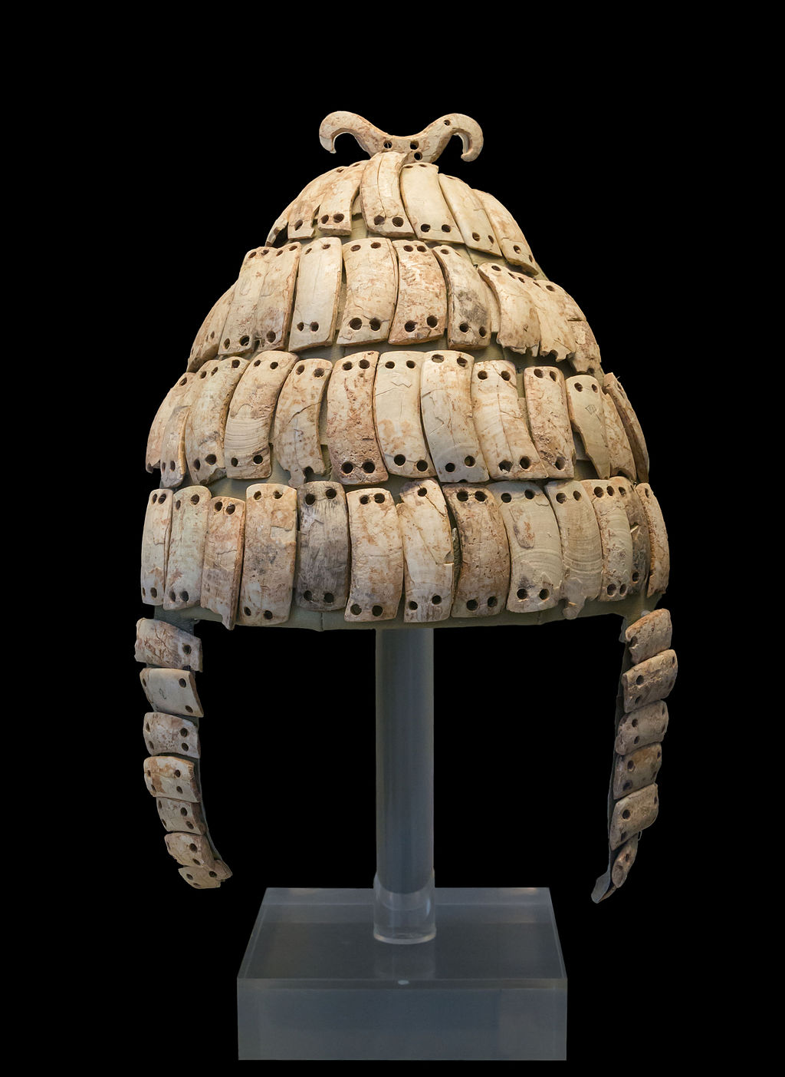

It’s back story involves

familiar characters

(Amyntor cf *Iliad* 9.448;

Autolycus cf *Odyssey*

19.395):

*Northern Greece – Southern Peloponnese – Crete*

It’s back story involves an

extensive journey around

the Greek world:

*Northern Greece – Southern Peloponnese – Crete*

**Practice Question**

But Diomedes was in no hurry, wondering what was the most daring thing he could do next – get hold of the chariot where the ornamented armour lay and drag it out by the shaft? Hoist it up and carry it off? Kill more Thracians? These thoughts were racing through his mind when Athene came up to him and said:

‘Son of great-hearted Tydaeus, think about getting home to the hollow ships, or you may reach them in full flight. Some other god may wake the Trojans.’

So she spoke, and Diomedes, recognizing the voice of the goddess, mounted at once. Odysseus struck the horses with his bow, and off they flew to the Greek ships.

None of this escaped the watchful eye of Apollo lord of the silver bow. When he saw how Athene was dancing attendance on Diomedes, he was enraged with her and descended on the great Trojan army, where he roused one of the Thracian advisors, Hippocoön, a brave kinsman of Rhesus. Hippocoön leapt up from sleep and, when he saw the empty places where the horses had been standing and men gasping out their lives in hideous carnage, he shrieked and called on his dear companion by name. Utter chaos ensued as shouting Trojans came running to gaze, appalled, on the terrible things the two men had done before escaping back to the hollow ships.

Explain why this passage is a dramatic piece of writing. Use references to **Passage A** to support your answer. **[10]**